Dishanth Iyer

Feb 15, 2022

Foundations of Programming: Python

Assignment 05

<https://github.com/dishiyer/IntroToProg-Python/>

Assignment 05: Lists and Dictionaries

The fifth assignment focused on creating a script using lists and dictionaries. The assignment further expanded on previous assignments by creating lists and key value pairs to access the list.

# Preparing for Assignment

In preparation for completing the assignment, I followed the Assignment04.docx step by step to gather an understanding of the following:

1. Difference between list and dictionary
2. Difference between index and key
3. Reading data from lists and dictionaries
4. Separation of concerns
5. Functions to organize code
6. Templates and scripts
7. Error-handling with try and except
8. GitHub

In order to do so, I reviewed the module video, the references and websites. I also reviewed the textbook material.

# Performing the Assignment

I followed the instructions to create the Folders in the C: drive and creating the Assignment starter script. In addition, I installed PyCharm and followed the directions to setup the environment and directory. I tried to use comments in script to remind myself about the organization and purpose of the code. I also watched the videos for the class to get an understanding of what is expected. I finally finished the assignment by uploading to GitHub

## Create Python script

I created the Python script using the PyCharm IDE. I tried to add comments to explain the code as well.

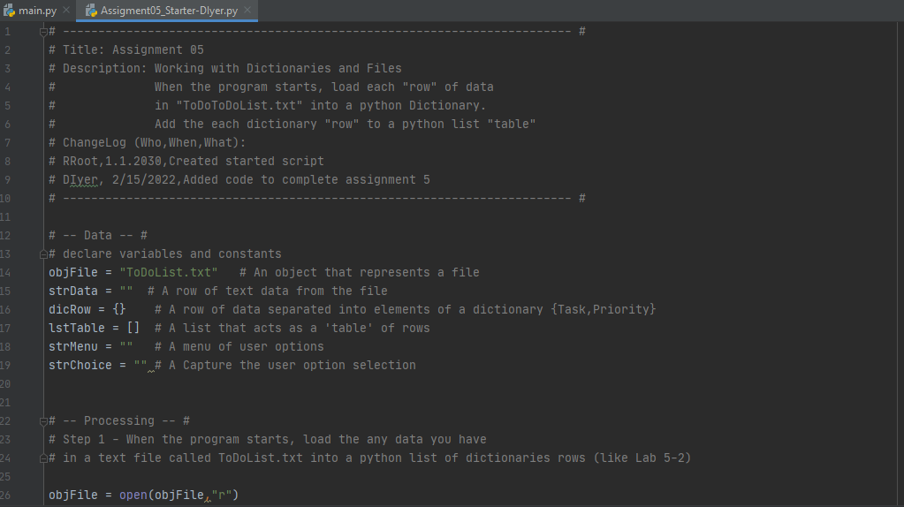

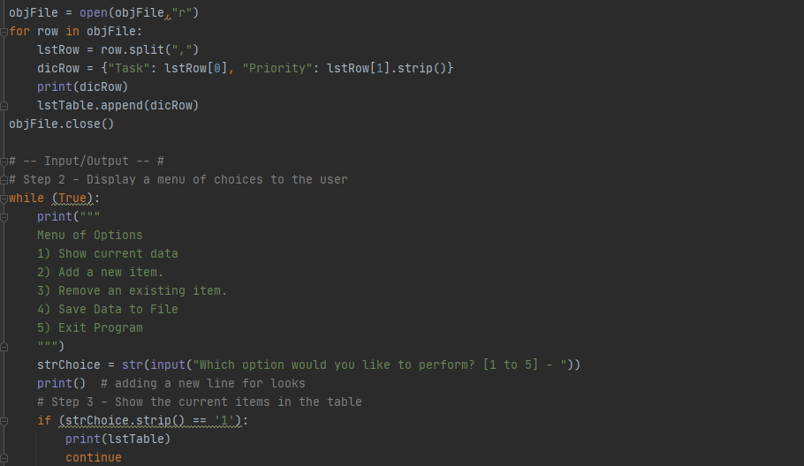

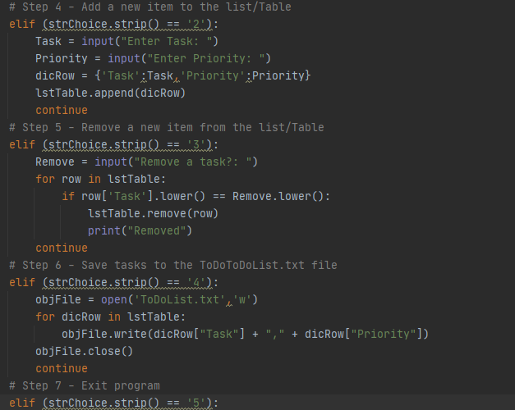

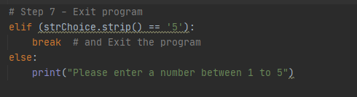

Utilizing the notes from the TA session and understanding how to add data to a list and remove data from a list, I was able to complete the assignment.

## Test Script

I tested the script within the IDE using the ‘Run’ function. The script executed successfully. The test also output the text file.

Below is a PDF output of the “Run” window results from PyCharm.

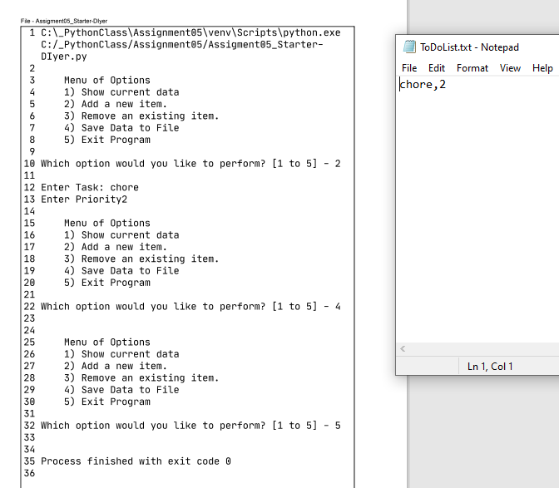

## Run Script

Once I was confident enough, I opened the Command Prompt in Windows and ran the script.

My code works as intended and resembles the screenshot in Assignment04.