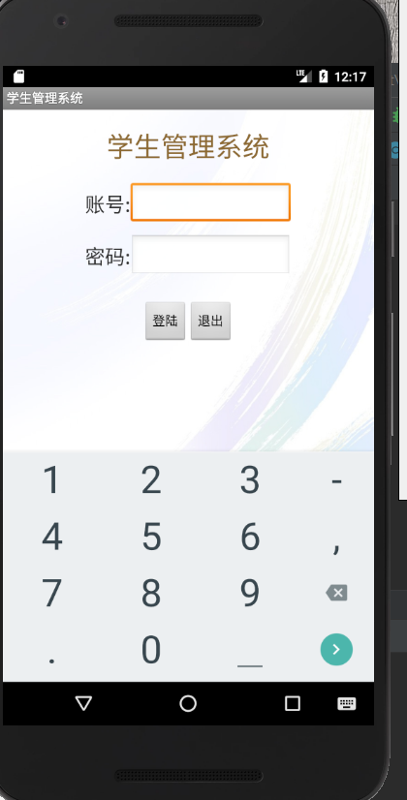

**进入界面登录账号密码，由于本系统没有注册功能，教师登录账号便在StudentManage\app\src\main\java\com\example\fxy\studentmanage\activity\Login.java文件里，分别为以下几个**

Tb_teacher tb_teacher1 = new Tb_teacher(1585, "赵莲芬", "1585", "13452958203", "zlf@scse.com.cn");

Tb_teacher tb_teacher2 = new Tb_teacher(1581, "甘卫民", "1581", "15829384900", "gwm@scse.com.cn");

Tb_teacher tb_teacher3 = new Tb_teacher(1090, "覃忠台", "1090", "15503920472", "qzt@scse.com.cn");

Tb_teacher tb_teacher4 = new Tb_teacher(1708, "黄小平", "1708", "18792847265", "hxp@scse.com.cn");

Tb_teacher tb_teacher5 = new Tb_teacher(1813, "刘鸣", "1813", "14356683921", "lm@scse.com.cn");

**登录成功后进入界面可看到如下的结果：**

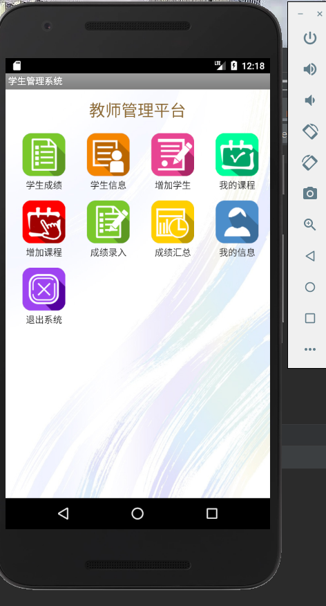

**教师选择点击增加课程如下图：**

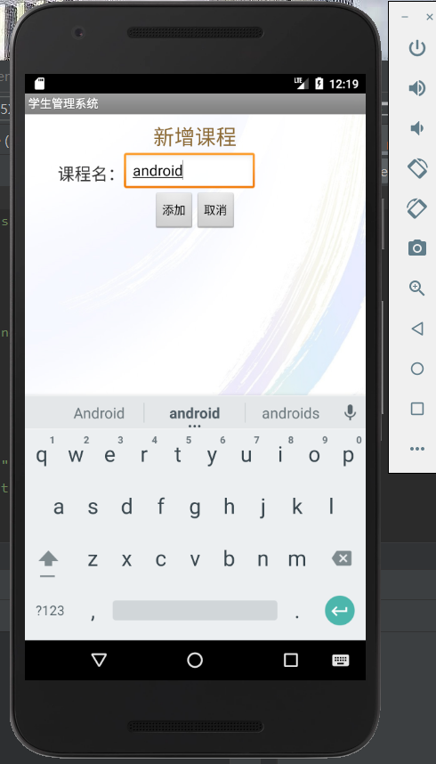

**保存成功后，退出活动进入添加学生，可以看到如下图**

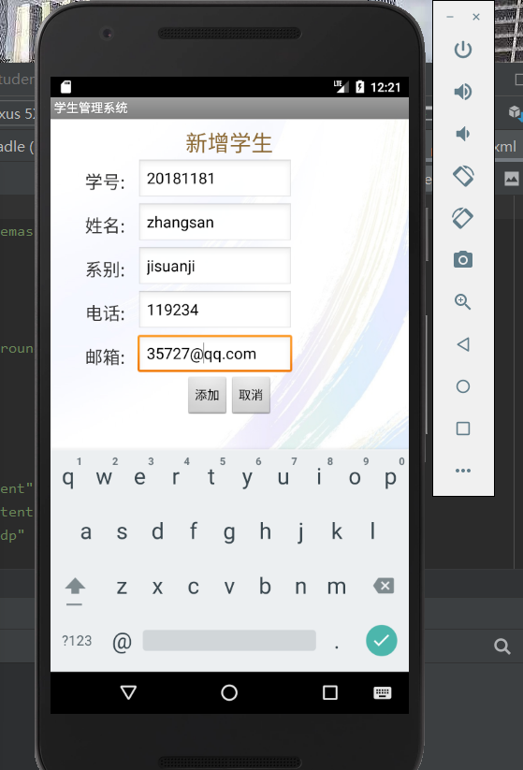

**退出活动，点击添加成绩录入，如下图**

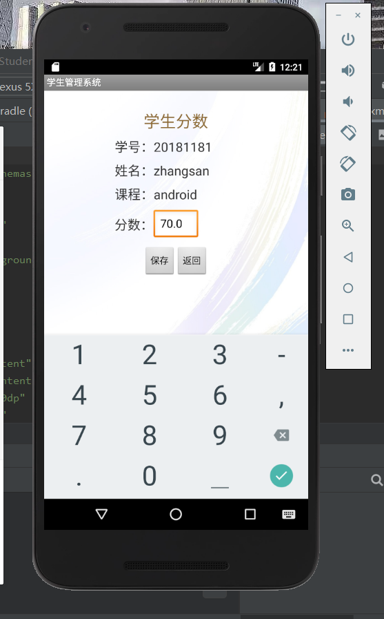

**当成绩录入之后，选择成绩查询，便可得到如下图**

