**Invention Disclosure Form**

**-----------------------------------------------------------------------------------------------**

1.Proposed title of the invention:

Dynamic Crime Trend Notification System for Proactive Community Safety"

2. Proposed abstract of the invention:

The Dynamic Crime Trend Notification System is a novel feature designed to enhance public safety by providing real-time alerts to law enforcement personnel and community members about emerging crime trends in specific areas. Leveraging geospatial data analysis and customizable alert settings, this system enables timely responses and proactive measures to address sudden spikes or unusual patterns in criminal activity. Key features include real-time monitoring, customizable alerts, geospatial information integration, actionable insights provision, and a feedback loop mechanism, making it a comprehensive tool for proactive crime prevention.

3. Key words:

Dynamic Crime Trend Notification System

Real-time alerts

Geospatial data analysis

Customizable alert settings

Criminal activity

Automated notifications

Actionable insights

Predictive capabilities

4. Background of the present Invention (Introduction of your invention)

The Dynamic Crime Trend Notification System continuously monitors incoming crime data and analyzes it to identify trends and patterns. When a significant change is detected, such as a sudden increase in a particular type of crime or a new hotspot emerging, the system triggers automated notifications to alert recipients. Users can customize their notification preferences based on their roles and responsibilities, with options to receive alerts for all types of crimes or only incidents occurring in their neighborhoods. The notifications include geospatial information, such as the location and type of crime, as well as the time and date of occurrence, enabling recipients to quickly assess the situation and take appropriate actions. In addition to providing alerts, the system offers actionable insights and recommendations for responding to the identified crime trends, such as suggested patrol routes or crime prevention tips. Users have the option to provide feedback on the effectiveness of the notifications and the actions taken in response to them, facilitating continuous improvement of the system's algorithms and predictive capabilities.

The Dynamic Crime Trend Notification System continuously monitors incoming crime data and analyzes it to identify trends and patterns. When a significant change is detected, such as a sudden increase in a particular type of crime or a new hotspot emerging, the system triggers automated notifications to alert recipients. Users can customize their notification preferences based on their roles and responsibilities, with options to receive alerts for all types of crimes or only incidents occurring in their neighborhoods. The notifications include geospatial information, such as the location and type of crime, as well as the time and date of occurrence, enabling recipients to quickly assess the situation and take appropriate actions. In addition to providing alerts, the system offers actionable insights and recommendations for responding to the identified crime trends, such as suggested patrol routes or crime prevention tips. Users have the option to provide feedback on the effectiveness of the notifications and the actions taken in response to them, facilitating continuous improvement of the system's algorithms and predictive capabilities.

5. What problems does the invention address:

Delayed Response to Emerging Crime Trends.

Lack of Customization in Crime Alerts.

Insufficient Geospatial Information.

Lack of Actionable Insights and Recommendations.

Ineffective Feedback Mechanisms.

Difficulty in Identifying Crime Hotspots.

By addressing these problems, the Dynamic Crime Trend Notification System enhances public safety through timely, relevant, and actionable crime alerts. This system supports law enforcement and community members in their efforts to prevent and respond to criminal activity more effectively.

6. Detailed Drawings / figures / Block Diagrams.

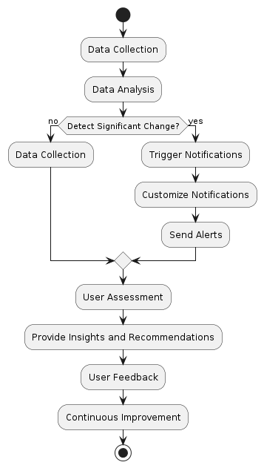

7. Provide an elaborated description

The process begins with data collection, where raw data is systematically gathered from various sources according to predefined methods. This data undergoes rigorous analysis to uncover meaningful insights and patterns in the next phase. At the critical juncture of "Detect Significant Change?", the system evaluates whether there has been a notable deviation or event in the analyzed data. If no significant change is identified, the system resumes data collection to update its analysis continuously. Conversely, upon detecting a significant change, the system initiates a sequence of actions: triggering tailored notifications based on the nature and impact of the change, customizing alerts as necessary, and promptly sending them through appropriate channels. Stakeholders then assess these notifications, leveraging the insights and recommendations provided by the system to understand the implications of the detected change. This assessment is crucial as it informs decision-making and potentially triggers feedback loops to enhance the overall process through continuous improvement efforts. The cycle concludes with stakeholders providing feedback, which feeds back into refining the data analysis methods, notification strategies, and overall process effectiveness, ensuring a dynamic and responsive operational framework.

8. Proposed claims:

The proposed Dynamic Crime Trend Notification System is designed to enhance public safety by providing real-time alerts about emerging crime trends through sophisticated geospatial data analysis. Users can customize alert settings based on their specific roles and interests, enabling tailored and timely notifications. The system monitors various types of criminal activity and triggers automated notifications when significant changes or unusual patterns are detected. This proactive approach empowers stakeholders with the necessary tools and information to address and prevent crime, ultimately contributing to a safer society. Additionally, a feedback loop mechanism allows users to provide input on the effectiveness of the notifications and actions taken, facilitating continuous improvement and refinement of the system’s predictive capabilities.

1. References (if any)

Some website that we used to find the related content are :

National Crime Records Bureau (NCRB), Ministry of Home Affairs, SpringerLink, IEEE Xplore, Google Scholar, Elsevier, ResearchGate .

1. Inventors Details

|  |  |  |  |  |
| --- | --- | --- | --- | --- |
| Full Name | Nationality | Full Affiliation / Address | Email ID | Mobile Number |
| Shreesh Bhardwaj | Indian |  | bhardwajshreesh049@gmail.com | 6395176997 |
| Rohit Vishwakarma | Indian |  | vishwakarmarohit443@gmail.com | 7007049458 |
| Shashwat Singh | Indian |  | shashwatsingh029@gmail.com | 9120512200 |

1. Applicant Details (ABES Engineering College, Ghaziabad)