**YPK Biotech Ltd. Requirement**

**Introduce:**

This is a company’s website, the website focus on introduce their company and products.

YBK is consistently in development of animal feed additives and ferments with leading edge biotechnology for sustaining ecosystem balance, improving the efficiency of animal growth, meat quality and etc..

**Customer Requirement:**

1. Their market in China, but they come from Taiwan, so they want to use **Traditional Chinese** first, but it will use the simplified Chinese and English in the future.
2. The main colors of website are **green** and **blue**, of cause you can use yellow color or others, customer hope the concept of the website is “Nature”, so the blue mean sky, and the green mean grasslands.
3. The Index page keep simple and high quality, no need too complicate.

**Module:**

There are six modules in this website, so there are six links in menu also.

1. **Index (首頁):**

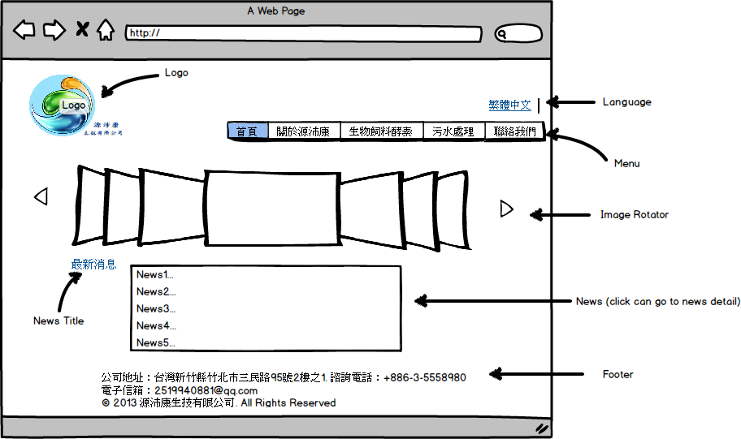

* **Image Rotator**: use 6 pictures and jquery do image rotator, can change next or previous picture manually, then every 5 seconds change next one automatically.
* **Language**: Only show tradition Chinese(繁體中文) first.
* **News**: The news lists (最新消息) only show 5 news title, and click title can redirect to news detail.
* **Menu**: There are 5 links in menu (首頁, 關於源沛康, 生物飼料酵素, 污水處理, 最新消息, 聯絡我們), then the link be highlight by module.

1. About YPK Biotech Ltd. (關於源沛康):

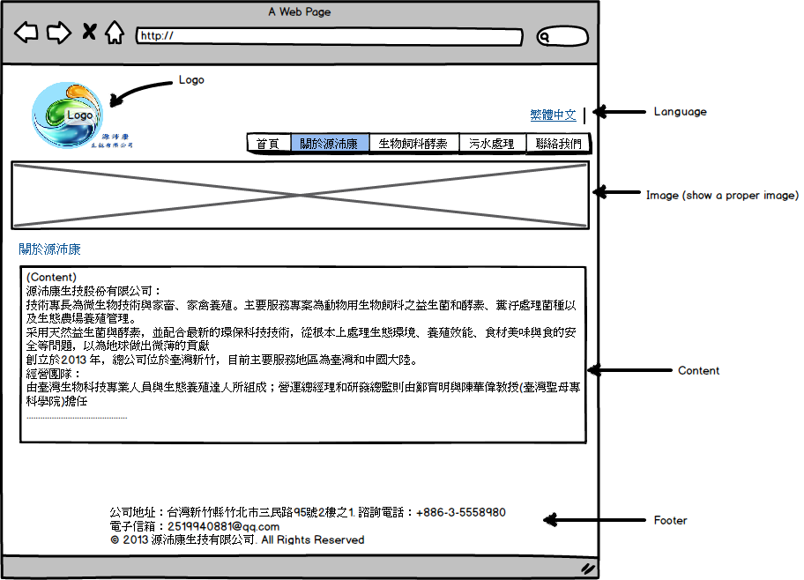

* **Image**: show a proper image for “About YPK Biotech Ltd.”
* **Content**: please refer the page 3 and 4 in the file “01 About YPK Biotech Ltd.ppt” (power point).

Ps: please refer the “Memo.txt”, then go to my cloud HD and go into “YPK files” folder.

|  |  |
| --- | --- |
| [Page 3] Introduce and business team  aboutus_01.jpg | [Page 4] business concept and vision  aboutus_02.jpg |

1. Animal feed and ferments (生物飼料酵素):
2. Sewage disposal (污水處理):
3. News:
4. Contact us(聯絡我們):