**YPK Biotech Ltd. Requirement**

**Introduce:**

This is a company’s website, the website focus on introduce their company and products.

YBKis consistently in development of animal feed additives and ferments with leading edge biotechnology for sustaining ecosystem balance, improving the efficiency of animal growth, meat quality and etc..

**Customer Requirement:**

1. Their market in China, but they come from Taiwan, so they want to use **Traditional Chinese** first, but it will use the simplified Chinese and English in the future.
2. The main colors of website are**green** and **blue**, of cause you can use yellow color or others, customer hope the concept of the website is “Nature”, so the blue mean sky, and the green mean grasslands.
3. The Index page keep simple and high quality, no need too complicate.

**Module:**

There are six modules in this website, so there are six links in menu also.

1. **Index (首頁):**

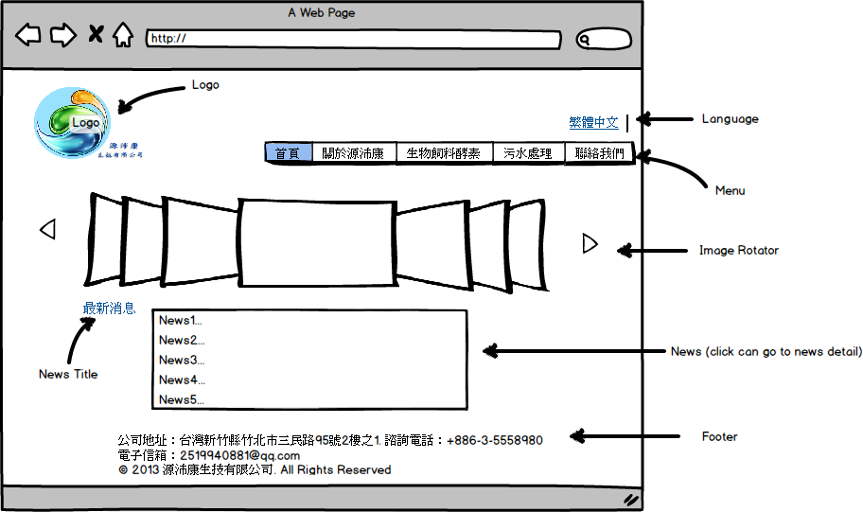

* **Image Rotator**: use 6 pictures and jquery do image rotator, can change next or previous picture manually, then every 5 seconds change next one automatically.
* **Language**: Only show tradition Chinese(繁體中文) first.
* **News**: The news lists (最新消息)only show 5 news title, and click title can redirect to news detail.
* **Menu**: There are 5 links in menu(首頁, 關於源沛康, 生物飼料酵素, 污水處理, 最新消息, 聯絡我們), then the link be highlight by module.

1. **About YPK Biotech Ltd. (關於源沛康):**

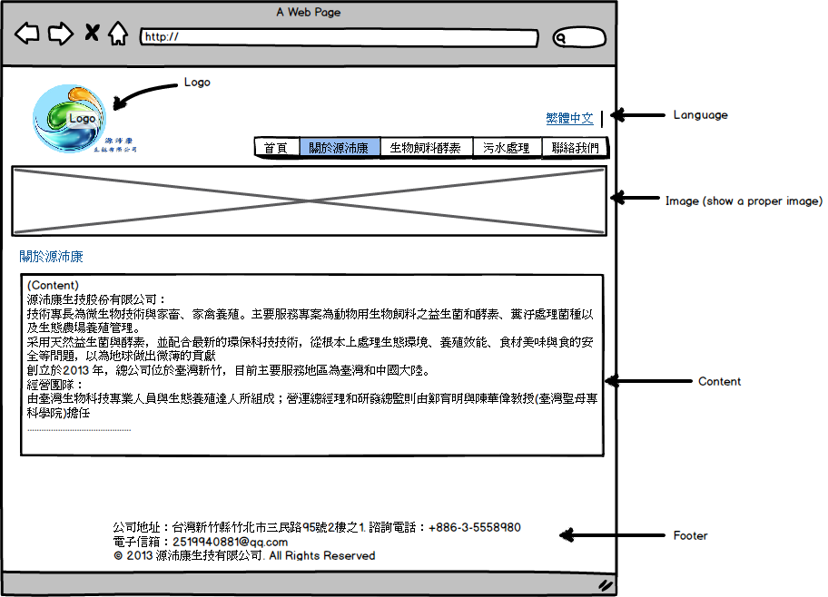

* **Image**: show a proper image for “About YPK Biotech Ltd.”
* **Content**: please refer the page 3 and 4 in the file “01 About YPK Biotech Ltd.ppt” (power point).

Ps: please refer the “Memo.txt”, then go to my cloud HD and go into “YPK files” folder.

|  |  |
| --- | --- |
| [Page 3] Introduce and business team  aboutus_01.jpg | [Page 4] business concept and vision  aboutus_02.jpg |

1. **Animal feed and ferments (生物飼料酵素):**

There are two part in生物飼料酵素: 1.畜沛康(for animal) 2.禽沛康 (For fowl)

1. 畜沛康功效(Animal efficacy):

This is default page , When user click “生物飼料酵素” on menu, then it will show this page.

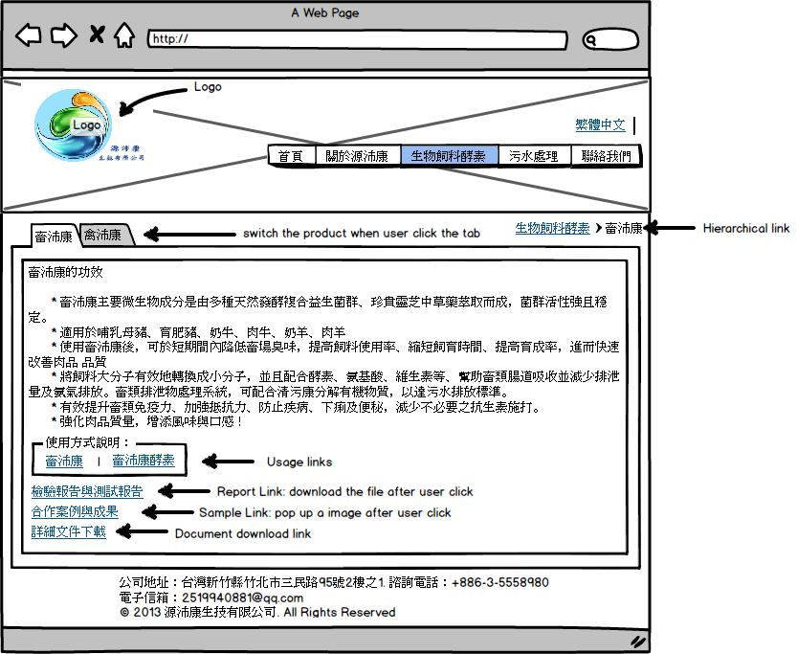

* **Tab:** User can click the tab and switch the product, there are two tabs in this module,

1. 畜沛康(for animal) 2.禽沛康 (For fowl), when you go to different tab, then the hierarchical link will change also. Ex: 生物飼料酵素>畜沛康 or生物飼料酵素>禽沛康.

* **Usage Links:** There are two links (1)畜沛康(Feed) (2)畜沛康酵素(Ferment).
  + **Click**畜沛康(Feed) : go to畜沛康使用方式(Feed usage).
  + **Click**畜沛康酵素(Ferment) : go to畜沛康酵素使用方式(Ferment usage).

1. 畜沛康使用說明 (Feed usage) :

* when user click “使用方式說明” of “畜沛康”,it will be linked to this page.
* First part is wording of feeding usage.

Please refer the file: Livestock/livestock\_use

* Second part is the flow chart of feeding usage.

Please refer page1 of the file: flow chart.

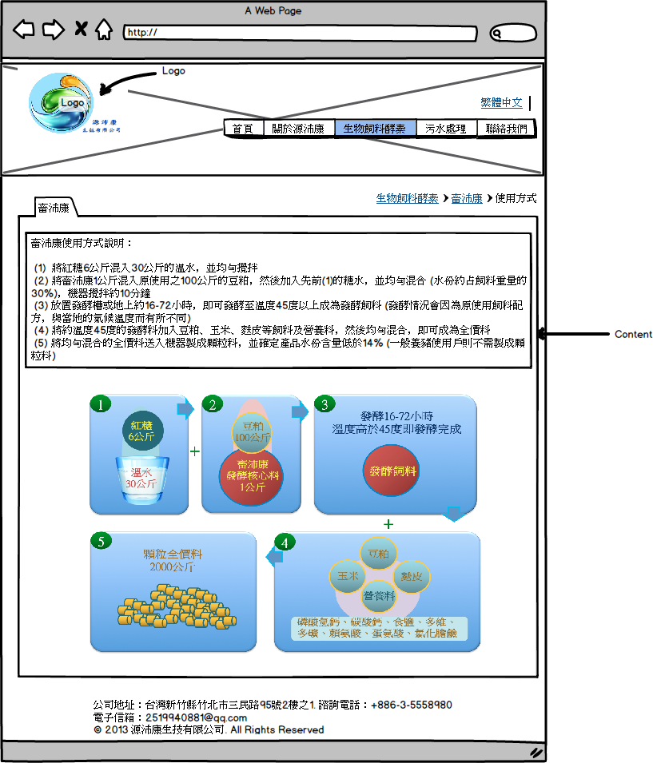

合作案例與成果co-operation case

* when user click “合作案例與成果“ of “畜沛康”, it will pop up to the picture.

Please refer the picture: Livestock/livestock\_co1

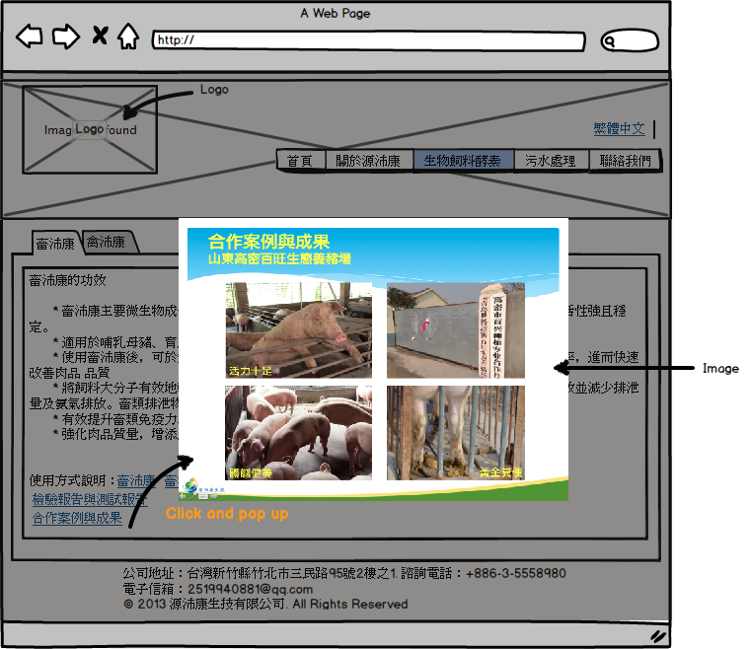

1. 禽沛康功效(Fowl efficacy):

The behavior of 禽沛康, please refer 畜沛康(Animal)

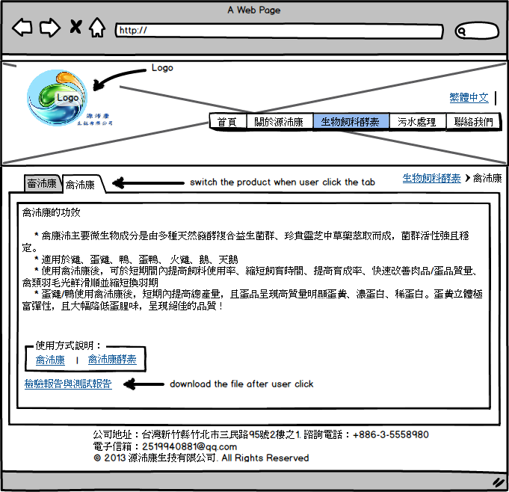

禽沛康使用說明 (Feed usage) :

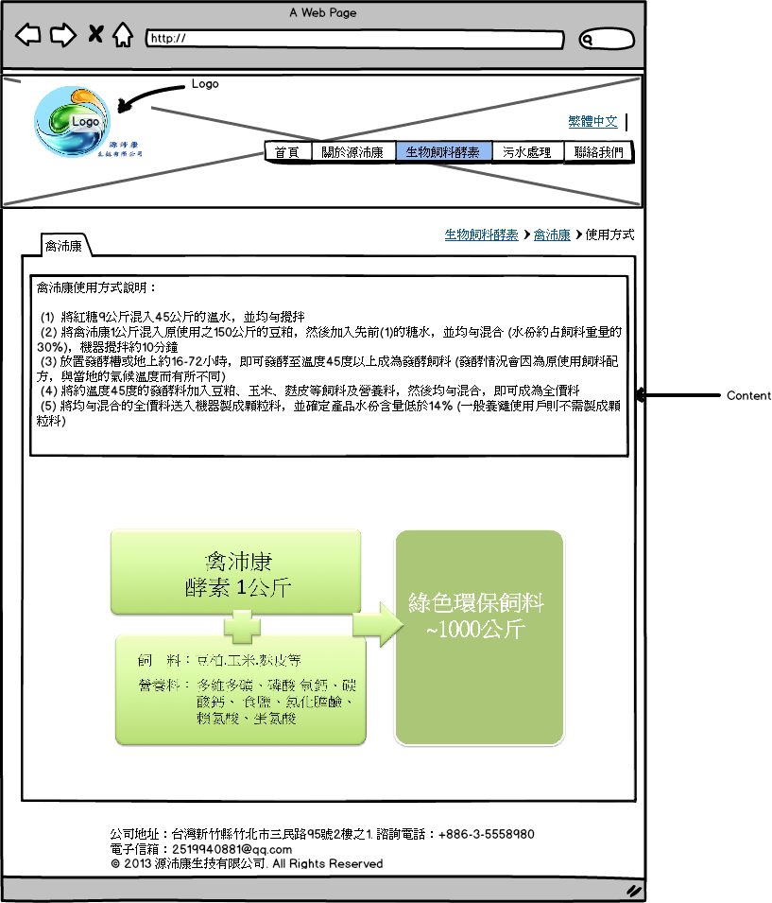

1. **Sewage disposal (污水處理):**

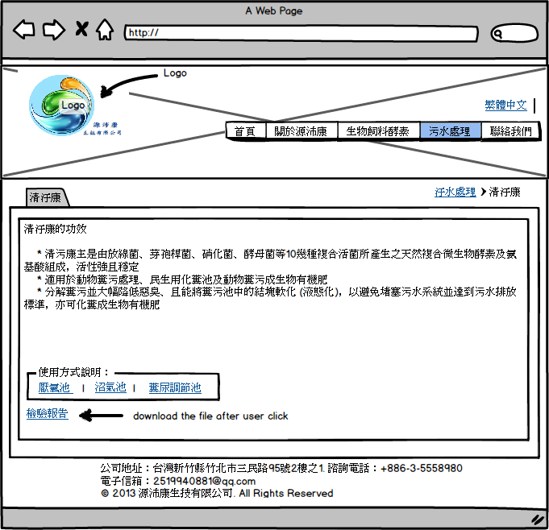

**Usage Links:** There are three kind of usages in Sewage disposal.

1厭氧池(usage1) , 2沼氣池(usage2) , 3糞尿調節池(usage3) , when user click the link, then redirect to proper page.

**Sewage disposal Usage:**

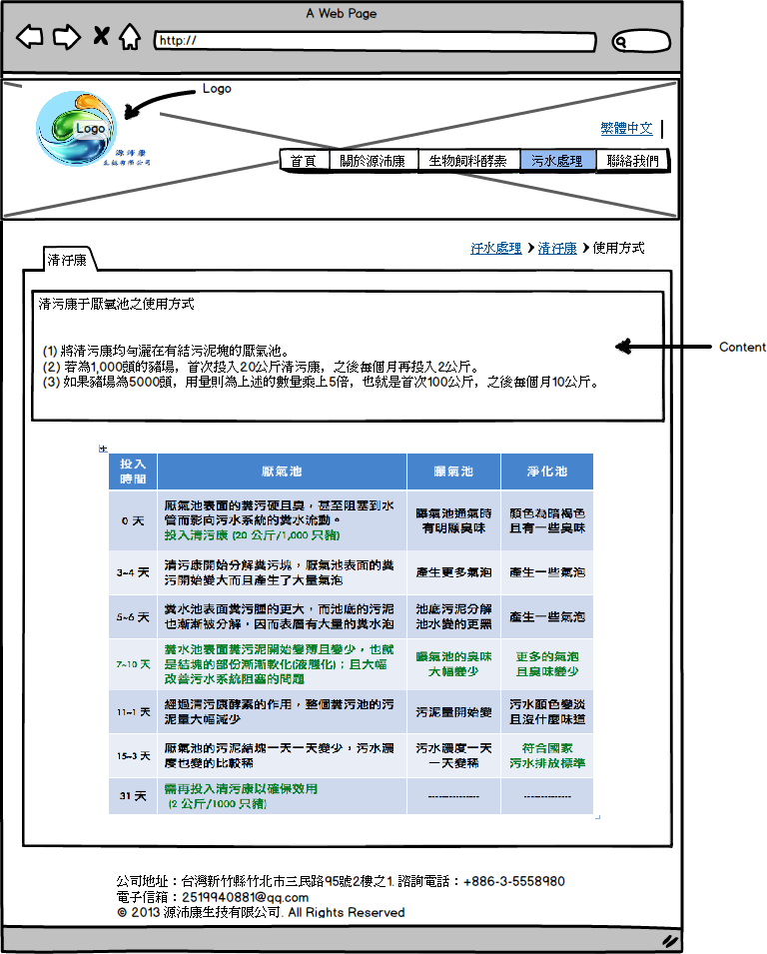

1. **Contact us(聯絡我們):**