



**PARLIAMENTARY DEBATE CHAMPIONSHIP**

PAYMENT DETAILS

Dear Participant,

The following are the modes of payment for participating in the Doon International School Parliamentary Debate Championship 2025.

# NEFT/Bank Transfer

Account Name : **Doon International School**

Bank Details : **ICICI Bank**

Branch : **SCO 31, Sector 67, Mohali**

Account No : **366901000718**

IFSC Code : **ICIC0003669**

# Alternatively, You can also scan the QR Code given below to pay the registration fee.

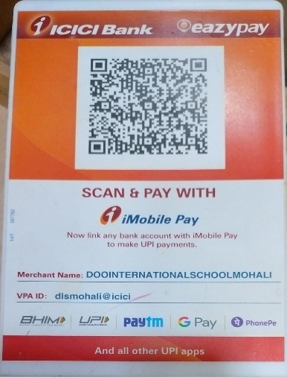

Once you complete the payment formalities, kindly attach screenshot of the payment **(containing name of the school of the team / participant)** made in the google form. **Google form link:**

<https://forms.gle/MABvKTnpH4LURpAX6>

# You are requested to make the payment for the entire team together.

Regards

Team DIS Public Speaking Society