Accelevate Leads Website

|  |  |
| --- | --- |
| Logo of Accelevate Leads | Home Who we are Our Programs Our Team Testimonials Contact Us |

**90% of Africa’s educated youth is investment potential**

Africa’s current most educated generation emerging out of universities and colleges has the highest rates of unemployment. A world bank research carried out in 2016 shows that out of the 800,000 students graduating from universities in Kenya every year, only about 70,000 are able to secure jobs. (Contents to be done as infographics)

**Who we are**

Accelevate Leads is a social enterprise whose vision is to unlock skills potential and solve real problems of the world. Our primary mission is to provide a platform for university students and graduates to gain the skills and experience required by the marketplace. We strive to reduce the high rate of unemployment amongst our most educated generation by working closely with industry players who transfer their skills in a challenge driven, solve problem environment.

We believe a younger generation equipped with knowledge and skills that solve problems are the **bridge of inequality** in Kenya and Africa.

**What we do**

Accelevate Leads organizes experiential skills training programs where students interact with personnel from various organizations. The program ensures university students and graduates acquire practical marketplace skills and experience while offering industry players affordable and sustainable research & innovation hubs.

Through corporate volunteerism, we facilitate the transference of employable skills. Through student volunteerism, we facilitate corporate ‘inhouse’ innovation hubs where students/graduates create innovative and practical solutions for real industry problems in an affordable, faster way.

By being on ground in universities and in company boardrooms investing in African businesses through the transfer of skills we deliver the following interventions;

* A hub of new innovative ideas from students.
* A reliable bridge between the Higher learning institutions and organizations.
* Transfer of skills to students and graduates from companies and organizations
* An open and combinatorial system that keeps evolving and flexible problem solvers who change with the times.
* A high performance culture that thrives on excellence, candor and change.
* A resourceful pull of performing students and graduates ready to learn and work.

**PLATFORMS**

Accelevate Leads – We bridge the broken link in skills currency between industry and academia.

Organizations – offer skills assessment tasks and strategic advice on the world of work

Academia – Opportunity to prepare market ready graduates This is in infographics, how can we better present this?

**COMPANY**

**Do you have unresolved problems/ challenges?**

**Are you in need of affordable solutions?**

**Do you want a dedicated think tank /innovation team?**

**Are you in need of skilled entry level talent?**

**Are you looking to have an impact in doing good in a sustainable all inclusive way?**

**Doing good is good business**

**ACCELEVATE LEADS**

**We strengthen industry – academia partnerships with a focus on unlocking skills potential of the students.**

**We ensure both institutions harness their true transformative potential & contribute to economic growth.**

**We produce challenge-driven, solve-problems graduates.**

**We offer a platform for innovative, practical, real-time, affordable solutions.**

**We offer in house innovation hub (skills hunt center) for up-to 1 year.**

**We offer focus groups for your products and services.**

**Doing good is good business**

**UNIVERSITY**

**Would you like to produce graduates that have employable skills?**

**Would you like your institution to be recognized as an innovation hub that moves the country towards increased prosperity?**

**Are your industry-academia partnerships aligned to the needs of the job market?**

**Does your institution adequately prepare students for the job market?**

Companies through AL present real and technically difficult problems they face in the marketplace. Companies provide staff to transfer skills and assess the output of students on a monthly basis

AL in conjunction with the university provide students that will go through the full year program. Students through AL submit their findings and practical solutions to the marketplace

We harness the “University Students” bulge as an engine of innovation and entrepreneurship for Kenya and Africa. We run “skills hunt centers” in institutions of higher learning to unlock students’ skills potential.

The “Skills Hunt Centers” are “innovation hubs” where organizations reap solutions to their nagging problems. We offer the opportunity for growth for organizations by working with the student pool to come up with innovative solutions

Our solution develops students’ intrinsic desire to solve problems and meet challenges creatively while benefiting companies with extensive research. We provide a platform for Kenya and Africa to collectively develop skills of our educated youth at a scale and a quality never imagined.

Skills Hunt - Employability Skills

***A major concern that needs urgent collective action***

We bridge the broken link in skills currency between industry and academia by equipping graduates with employability skills. Skills Hunt is a ***dual system*** that offers skills training and ***flexibility*** for students ***to study*** ***as they gain skills.*** The students have a once in a month ***scheduled*** physical commitment with the company representatives of different departments.

To hone employability skills we are continually driven by the opportunity for growth for companies we collaborate with.

Hunters Hunt – Entrepreneurship Skills

***The hunter (entrepreneur) sees a problem, hunts for a solution and bequeaths the solution with a capacity to create wealth***

Students are organized in groups of ten or less. Each group identifies a problem and is required to develop innovative business ideas. The business idea may be taken up/purchased by interested institutions or financed directly therefore offering self-employment for the student/graduate.

We are constantly curious and driven by the desire to find solution to our problems and challenges

**Events**

2019 ACTIVITIES

January – Students of 2018 Skills Hunt Program plan for Doing Good day

February 8th – Skills Hunt Summit – Disrupt inequality by doing good

Each organization participating to have a Good box in their office by February 4th and collection by Feb 12th

We introduce the Doing Good Skills Hunt Awards

March – Kick off the full year Skills Hunt Program with different companies

April 18th – Hunters Hunt Summit – 1st round of pitches

May 16th – Skills Hunt CV Workshop – Skills CV writing

June 20th – Skills Hunt Summit (CEO Conversations) – Presentations by Student Leaders on the Impact of the program

July 18th – Hunters Hunt Summit – 2nd round of pitches

August 15th – Skills Hunt Personal Branding Workshop

September 19th – Skills Hunt Summit (CEO Conversations) – Presentations by Student Leaders on the Impact of the program

October 17th – Hunters Hunt Summit – 3rd and final round of pitches

November 21st to 22nd – Skills Hunt Expo

February 8th Event – You can create the event

Here are the speakers of the event… We are yet to decide on location…

Could be the 4th Floor of UoN or KU

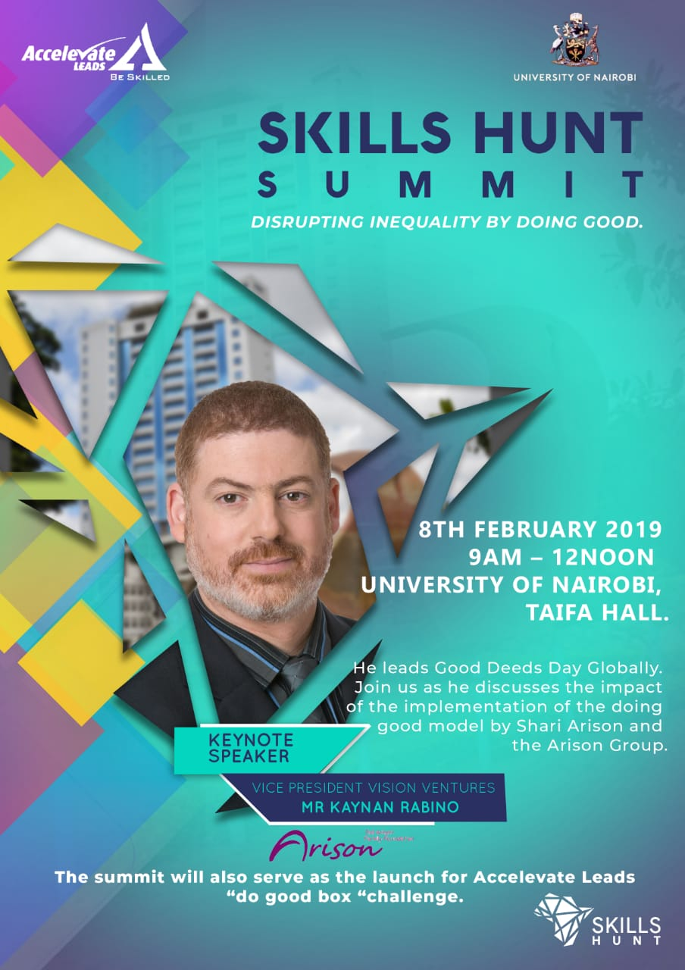

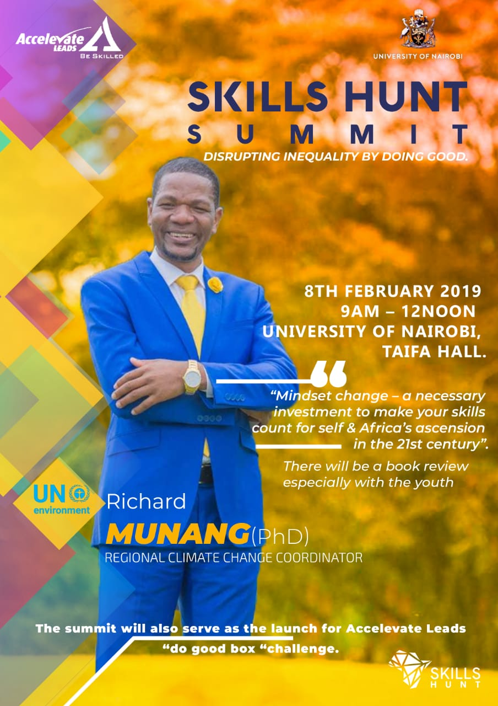

**Partnerships**

Our goal is to create meaningful and relevant partnerships that derive value and are keen to collaborate. We are interested in long term relationships that provide flexible and future proof solutions that we can build on.

With a structured approach to the challenges given and in cooperation with our partners we believe we create solutions that give optimal benefits. This implies that we get into transparent long-term relationships

Our partners: One Acre Fund, Centum, Questworks, Moringa School, Telkom, Safaricom, IBM, Kenya Medical Research Institute (KEMRI), OXFAM, Kenya Airways and growing

**Our Team**

We are a team of diverse people but common to all of us is that we are passionate about employability of young people, growth of businesses and we want to make a difference. We know that insight and creative problem solving are quicker to develop at the intersection of different ways of thinking and world views.

Eric Bakuli - Student coordinator and Social media manager

Dennis - Software Developer and IT

John Owegi – Legal and Finance

Fauzia Nia Mohammed – Program Assistant

Nicolle Ndamu – People Development

Mrs Viridiana Mutere – Founder and CEO

**Impact - Infographics**

Successful Solutions – 3

Students completed full year program – 120

Student Interactions – 3000+

Partner Companies – 10

Staff Contributors – 121 (put a graph Telkom – 50 employees; Kemri – 6 employees; Centum – 15 employees; IBM – 2 employees; Vivo Energy – 4 Employees; One Acre Fund – 20 Employees; OXFAM – 10 employees; Nairobi County – 2 Employees; AI – 2 employees.)

Years of Experience – 1

**Testimonials**

|  |  |
| --- | --- |
| Petronila Nguono  BA in sociology and conflict and peace studies  University of Nairobi | EST has helped sharpen my listening skills and equipped me to be a critical thinker. I am also at a place now where I am able to boldly take risks. My leadership and communication skills have also been sharpened. I am super confident when it comes to expressing myself because the presentations we made during the challenges made me believe in myself more than I did before. Lastly, I am better equipped to work with different personalities because the EST program exposed me to people from all walks of life and I learnt how to work alongside them during projects and this sharpened my human relations skills. |
| Luvunga Espoir  Bachelor of commerce. Major in finance  Kenyatta University | The EST Program was helpful and productive to me, today I am privileged and proud to put the program in my CV, I learned a lot through the program. The program helped me expand my thinking, groomed me to learn how to make decisions and plan for my career. When we did the decision making challenge, it improved my outlook on how I should make decisions for my business going forward in my career path. During the program I came up with a business idea and I'm thinking of pursuing it full time after school. The various skills learned, challenges attempted, seminars, and lectures from the EST program, I intend to practice them in my upcoming business. |
| Nicolle Ndamu  International Relation  USIU - Africa | The EST program is a program I would recommend to anyone who is interested in finding out what the job market wants a graduate to have. Depending on the company you pick to guide you through the year long program, the skills you gain are a great addition to your undergraduate degree. It’s a platform that sharpens leadership skills, project management skills and teamwork. Together with peers, we are challenged to solve real time problems and provide timely solution to the various projects presented by a company. |

**Contact us**

**Email:** [**skillshunt@accelevateleads.com**](mailto:skillshunt@accelevateleads.com)

**Phone: 0777311680**

Social media accounts:

Twitter: @accelevateleads

Facebook: @accelevateleads

Instagram: @accelevateleads

On the development part

**Skills and attributes to be learned and assessed will be in these three categories**

1. Self skills – Time management, self reliance, readiness to accept responsibility, resilience, and flexibility.
2. People skills – Team work, respecting others, communication, listening and questioning and networking.
3. General employment skills – Problem solving, openness to new ideas, research, a can do attitude and a drive to actualize change.

Corporate will assess the students on those three categories

Group members and peers will also assess each other on these categories and then we can do meanscore part of each challenge