Multiscale Simulation Scattering Intensity Calculator (MuSSIC)

1. Description of the Code
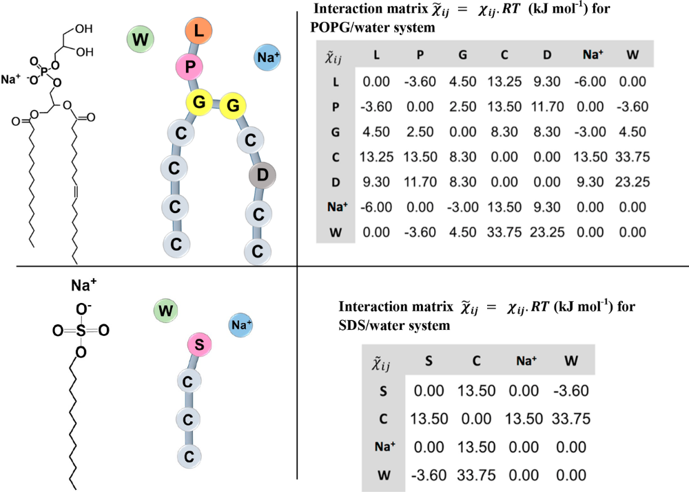
MuSSIC is a computational tool for calculation of neutron scattering for coarse grain (CG) systems (detailed description is provided in documentation). It is based on the method described by Alan Soper in his journal article on coarse-grained Empirical Potential Structure Refinement (Biochimica et Biophysica Acta 1861, 6, 2017, Pages 1652-1660). The code computes the partial pair radial distribution function and the partial pair structure factors for the trajectory provided in xyz file format. The total structure factor is the weighted sum of all partial pair structure factors. The current version of the code is available on Github page (https://github.com/disorderedmaterials/MuSSIC). Any developments or improvements in the code/method and related examples are updated on gitpage.
label_atom:
Na
S
OC
C
HC
OW
HW
num_species: 3
nmol_species
1120 1120 304000
size_per_species
42
1
12
ntypes: 7
isotopologues:
sample_1 HD
atom natural isotope
HC 1.0 0.0
HW 0.0 1.0
title: SDS+water
nframes: 100
box_length: 332.0d0 332.0d0 332.0d0
ensemble: NPT
simulation
scattering
15

2. Compilation and run
MuSSIC is a FORTRAN code and is built using gfortran compiler with openmp for parallel implementation. After downloading the sourcecode, follow the commands on terminal
>cd source_code
>make
copy the executable 'scattcg' to the desired locati>./scattcg

3. Input variables
Input variables are separated into four categories. Following table shows the example variables of each category. Section 4 gives a detailed explanation of all variables by showing input files for C10TAB in water system

Simulation parameters  Title of the system  number of frames  box dimensions  Ensemble | model parameters  Number of species  number of molecules in each species  Number of atoms per molecule  number of atom types
Scattering calculation parameters  Binning of Q in F(Q)  Binning of r in g(r)  Binning regime: linear or logarithm  Broadening parameters: OmegaDependentGaussian  Isotopologue information | Coarse grain representation  Number of CG bead types  Label of bead  beads_per_molecule  bead connectivity in the molecule

3. INPUT files
In the input file 'input.dat', one can choose the run type either 'default' or 'compare_CG'. The default runtype performs the CG scattering calculation on the CG_trajectory which is provided as an input file. The run type 'compare_CG' calculates the scattering using the atomistic trajectory and generates the CG_trajectory using CG model given in model.dat to calculate the CG scattering.
- input.dat - main input file
- model.dat - model parameters of the system
- trajectory - atomistic trajectory in xyz format (file needed in case of 'compare_CG' run type)
- CG_trajectory - coarse grain trajectory in xyz format (file needed in case of 'default' runtype; code generates this file if run type is 'compare_CG')

4.1 input.dat for C10TAB system

variable description
run: # type of the run either 'CG_compare' or 'default'
default
nproc: # number of the processors available for openmp
20
title: # title of the run (optional)
C10TAB+water
ntypes: # number of atomtypes of system
6
nframes: # number of frames in the trajectory
10
box_length: # box dimensions (Incase of NPT ensemble, box dimensions are taken for each frame from trajectory file'
159.6606d0 153.7097d0 155.2160d0
bin_width: # bin width for rdf calculation
0.03d0
ensemble: # type of ensemble either 'NVT' or 'NPT'
NPT
label_atom: # label of the atom types

N
C
HC
BR
OW
HW
scattering_lengths: # scattering lengths of the atom types and additional input
(ntypes+1) is the scattering length of deuterium
9.36d0
6.646d0
-3.739d0
6.795d0
5.803d0
-3.739d0
6.671d0

form_factor: # scattering length density distribution with in the bead
Gaussian
exchangeable_atoms: # number of exchangeable atoms and the label of the
exchangeable atom types
0
number_isotopologues: # number of isotopologues to be studied
2
isotopologues: # ratio of the isotopes in each isotopologue (isotope + natural
= 1.0) in the same sequence of atom types as defined
sample_1 DH # label of the isotopologue (first letter indicating hydrogen
in CTAB molecule and second one indicating hydrogen in water)
atom natural isotope
N 1.0 0.0
C 1.0 0.0
HC 0.0 1.0
BR 1.0 0.0
OW 1.0 0.0
HW 1.0 0.0
sample_1 HD
atom natural isotope
N 1.0 0.0
C 1.0 0.0
HC 1.0 0.0
BR 1.0 0.0
OW 1.0 0.0
HW 0.0 1.0
qmin: # minimum of Q value (usually 2*pi/box_length)
0.01d0
Isotopic_substitution:
manual # isotopic substitution can be implemented either by choosing
‘manual’ or ‘ratios’
# ‘manual’ option is be used to generate manually deuterated trajectories. Test case 4 shown in the documentation explains the results with manual deuteration for PA66. While the test case 5 shows the results obtained using ‘ratios’ option for C₁₀TAB in water (Refer to verification tests in the documentation)
(note: the current version of the code supports only one isotope of the atoms and only one isotopologue can be tested per run if using manual substitution)
qdelta: # delta in the Q scale
0.02d0
qmax: # maximum Q value
5.0d0
binning: # choice of binning regime( either 'linear' or 'log_linear')
log_linear
broadening: # type of broadening used
OmegaDependentGaussian
FWHM: # full width at half maximum for broadening
0.02d0
windowfn: # windown function used in finding S(Q)
Lorch0
endinput

4.2 model.dat for C10TAB in water

variable description
num_species # number of species/molecule types in the system
3
nmol_species # number of molecules for each molecule type
810 # C10TA molecule
810 # Br- ions
115177 # water molecules
size_per_species # number of atoms in each molecule
44 # atoms in C10TA molecule
1 # number of atoms Br- ion
3 # number of atoms in water molecule
num_CGbead_types # number of CG bead types
6
label_bead # label of CG bead types
1 N
2 C3
3 C2
4 CT
5 BR
6 W
beads_per_molecule # number of beads in each molecule
14 # number of beads in C10TA molecule
1 # number of beads in Br- ion
1 # number of beads in water molecule
bead_pairs_molecule # bead connectivity matrix of bead_types x bead_types; 1 being 'connected' and 0 being 'not connected' by a bond
0 1 1 0 0 0 # N C3 C2 CT BR W
1 0 0 0 0 0 # C3
1 0 1 1 0 0 # C2
0 0 1 0 0 0 # CT
0 0 0 0 0 0 # BR
0 0 0 0 0 0 # W
bead_radius # radii of the CG beads
0.707 (note: if the radii are provided, there is no need to provide
2.343 bond connectivity matrix. Either one of the two is required for
1.199 the radius of the CG bead)
0.707
0.707
0.676
num_atom_types_CGbead # description of the CG bead (atom types and their number)
1 # number of atom types in CG bead 'N'
1 1 # 'N' atom type number (refer to the atom type numbers in
input.dat) and number of atoms of 'N'
2 # number of atom types in CG bead 'C3'
2 1 # 'C' atom type number and number of atoms of 'C' in CG bead 'C3'
3 3 # 'H' atom type number and number of atoms of 'HC' in CG bead 'C3'
2 # number of atom types in CG bead 'C2'
2 1 # 'C' atom type number and number of atoms of 'C' in CG bead 'C2'
3 2 # 'H' atom type number and number of atoms of 'HC' in CG bead 'C2'
2 # number of atom types in CG bead 'CT'
2 1 # 'C' atom type number and number of atoms of 'C' in CG bead 'CT'
3 3 # 'H' atom type number and number of atoms of 'HC' in CG bead 'CT'
1 # number of atoms in CG bead 'BR'
4 1 # 'BR' atom type number and number of atoms of 'BR' in CG bead 'BR'
2 # number of atom types in CG bead 'W'
5 1 # 'OW' atom type number and number of atoms of 'OW' in CG bead 'W'
6 2 # 'HW' atom type number and numbe rof atoms of 'HW' in CG bead 'W'
endinput

5. OUTPUT files
#filename description

fort.7 log file printing the details of the run
CG-unweighted-*-*.gr partial pair g_{ij}(r) (* - bead types in the pair)
CG-unweighted-*-*.sq partial pair S_{ij}(Q) (* - bead types in the pair)
CG-unweigthed-total.gr unweighted total G(r)
CG-unweighted-total.sq unweighted total S(Q)
%%-weighted-*-*.sq weighted partial pair S_{ij}(Q)
(%% -isotpologue name, * - bead types in the pair)
%%-weighted-*-*.gr weighted partial pair g_{ij}(r)
(%% -isotpologue name, * - bead types in the pair)
%%-CG-weighted-total.sq weighted S(Q) (%%-isotopologue name)
%%-weighted-total.gr weighted G(r) (%%-isotopologue name)

Output files for atomisitc scattering are the same filenames without 'CG'

File name description
unweighted-*-*.gr partial pair g_{ij}(r) (* - atom types in the pair)
unweighted-*-*.sq partial pair S_{ij}(Q) (* - atom types in the pair)
unweigthed-total.gr unweighted S(Q)
unweighted-total.sq unweighted G(r)
CG-unweighted-total.sq unweighted total S(Q)
%%-weighted-*-*.sq weighted partial pair S_{ij}(Q)
(%% -isotpologue name, * - bead types in the pair)
%%-weighted-*-*.gr weighted partial pair g_{ij}(r)
(%% -isotpologue name, * - bead types in the pair)
%%-CG-weighted-total.sq weighted S(Q) (%%-isotopologue name)
%%-weighted-total.gr weighted G(r) (%%-isotopologue name)

5. Gnuplot script
A gnu plot script is available for the test systems which can be used plot the scattering curves. One has to change the file names according to the systems that is being tested.

