Notes from Dispersal Class - April 1st, Modeling Dispersal

What is the difference between phenomenological and mechanistic models?
- Can be thought of as models based on patter vs. process – phenomenological models describe a patter whereas mechanistic models try to incorporate the underlying process of dispersal

What would be some advantages of a mechanistic model over a phenomenological model?
- It depends on the question you are asking, but it is often easier to test hypothesizes about the biology of an organism using a mechanistic model
- It could be important in more applied disciplines, such as conservation biology to know what factors influence dispersal

What is a fat tailed distribution?
- The tail, or right end of a distribution, extends beyond that of a normal or Gaussian distribution
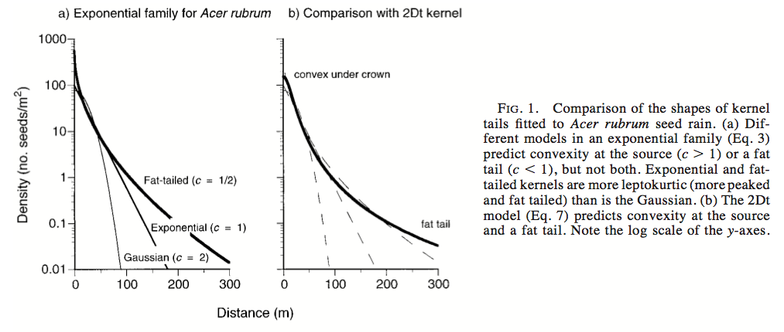
What is Brownian motion?
- Random movement of particles in a fluid, i.e. a gas particle moving in air
- The distance a molecule moves would be taken from a normal distribution
- It is often used as a null model when studying dispersal

What is a Levi walk?
- Incorporates more long distance movement than a model that uses Brownian motion because the distance a particle moves is taken from a power-law distribution
- The turning angles are taken from a uniform distribution
- Can be thought of as a fractal trajectory

Why is the Skellam paper, Random Dispersal in Theoretical Populations, from 1951 interesting?
- Showed the connection between random walks and diffusion processes
- Dispersal of small mammals, in which the random dispersal model is tested
- Modeled dispersal with population growth
- Modeled linear growth in two dimensional habitats
- Modeled logistic growth in two dimensional habitats

