To start using the BMP 085 sensor on MINIX we have to bring the service up by using the following command

/bin/service up /service/bmp085 -label bmp085.3.77 -dev /dev/bmp085b3s77 -args 'bus=3 address=0x77'

and to use the GPIO we have to run the following commands

mkdir /gpio

mount -t gpio none /gpio

OR

We can change the /usr/etc/rc file to start the services on startup

add the following lines in the “Starting i2c device drivers section” of the rc file to start bmp085 on start up

# start pP085 driver for temperature and pressure info

test -e /dev/bmp085b3s77 || \

(cd /dev && MAKEDEV bmp085b3s77)

up bmp085 -dev /dev/bmp085b3s77 \

-label bmp085.3.77 \

-args 'bus=3 address=0x77'

at the end of the file before the done add the following lines

if [ ! -d "/gpio" ];

then

mkdir "/gpio"

fi

mount -t gpio none /gpio

Access to BMP sensor and GPIO via IPC

To read the data using IPC, we have do a couple of things before we can actually read the data. We’ll need change the system configuration file /etc/system.conf.

In this we change the permissions for bmp085 service to use IPC as follows

service bmp085

{

ipc ALL;

};

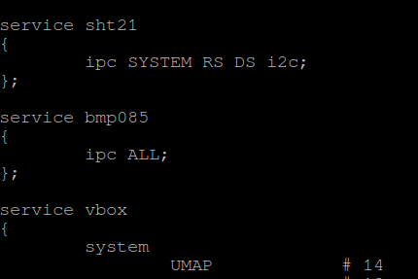

for the GPIO we change the same file as follows

service gpio

{

system

PRIVCTL # 4

IRQCTL # 19

PADCONF # 57

;

vm

SETCACHEPAGE

CLEARCACHE

;

irq

29 # GPIO module 1 (dm37xx)

30 # GPIO module 2 (dm37xx)

31 # GPIO module 3 (dm37xx)

32 # GPIO module 4 (dm37xx) / module 2a (am335x)

33 # GPIO module 5 (dm37xx) / module 2b (am335x)

34 # GPIO module 6 (dm37xx)

62 # GPIO module 3a (am335x)

63 # GPIO module 3b (am335x)

96 # GPIO module 0a (am335x)

97 # GPIO module 0b (am335x)

98 # GPIO module 1a (am335x)

99 # GPIO module 1b (am335x)

;

ipc ALL;

};

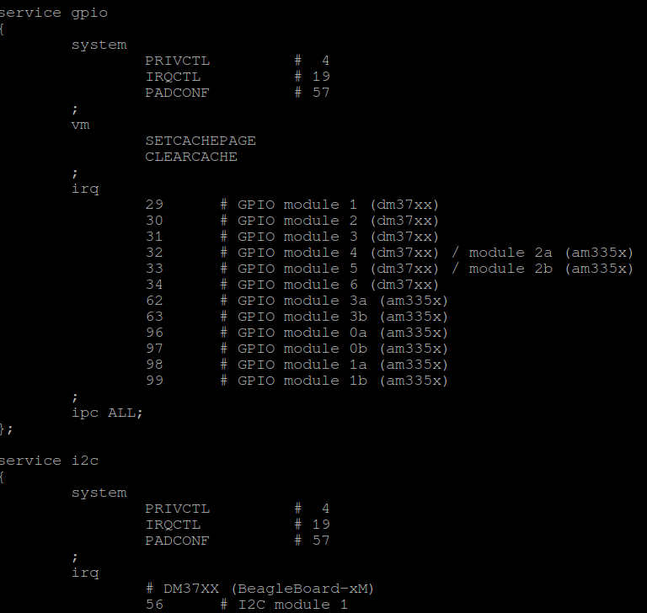

Copy the monitor.c file along with msg.h header file on to the board.

Compile it using

cc -o monitor monitor.c

Run it using ./monitor