1. After compiling the image, load the image on to a memory card using the following command

sudo dd if=minix_arm_sd.img of=/dev/mmcblk0 bs=1M oflag=direct

2. Insert the memory card into the slot and boot up the board.

3. You’ll see the auto boot menu and MINIX booting up from the memory card.

4. Once the board boots up login to the board using the following user name

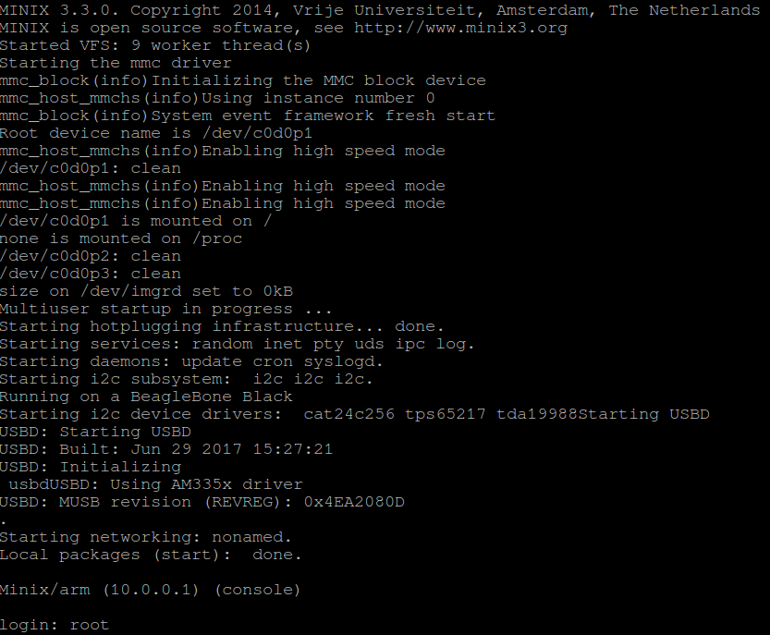

5. Now we have successfully logged into MINIX.

6. To configure Ethernet, use the command **netconf,** as follows

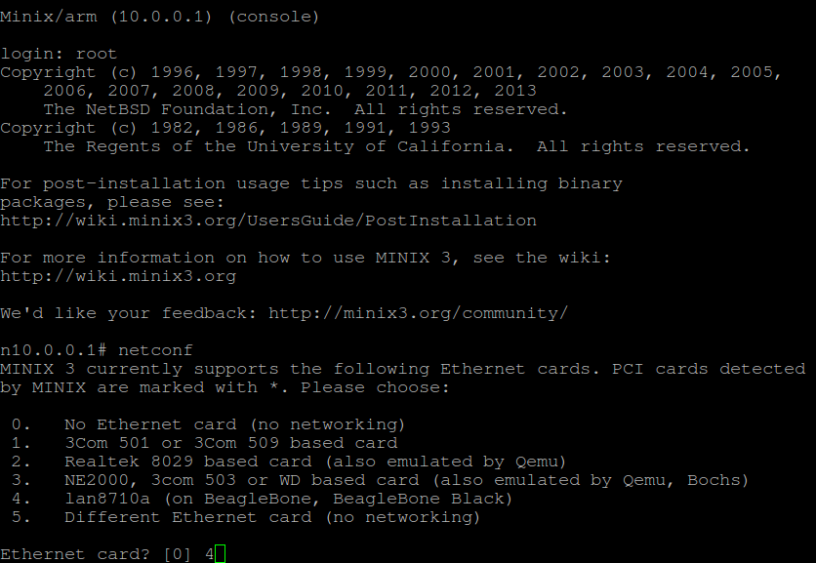

Hit enter

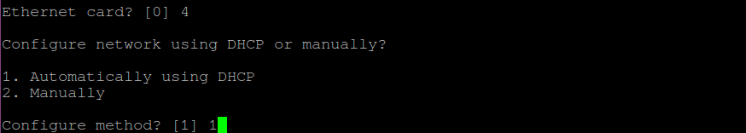

and hit enter.

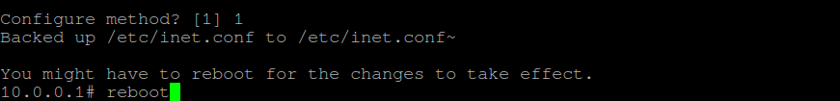

Enter reboot command hit enter to reboot the board for the settings to take place.