Software Architecture

Parsing example: MongoDB to UML

Manages the Content of the Database Formulars

Database.php
First Initialization of DatabaseToDiagram site

Index.php
DatabasetoDiagram.php
GetImportDBStart (Top Content)

Includes div:
#DBMSForm
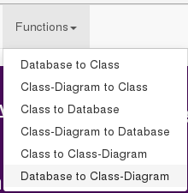

Fills #DBMSForm with Content of mysqlImportToUML.php
(getImportDB)

MysqlImportToUML.php
Calls Database.php functions with parameters to control the shown content

Calls GetImportDB(“uml“,“mysql“) in Database.php
filling #DMBSForm, with it's content

Database.php
GetImportDBStart has #DBMSForm

Onclick= setDBMSForm
Forms.js
SetDBMSForm(Selected)

MongodbImporttoUML.php
Calls getImportDB function

→getImport(“uml“,“mongodb“ )
Database.php
GetImportDB(“uml“,“mongodb“)

Mapping.js → MapToUML (because of UML Parameter)
Now the Complete Content to log into the MongoDB Database is available
Mapping.js

Mapping.js
Req/toUML.php

Calls specific file to generate for example the UML Array
Param: (user,pw,....), type
Type → mapmongo
Returns UMLARR
Uses UML Array to fill Frontend fields

