**1.0 Introduction**

**This section provides an overview of the entire requirement document. This document describes all data, functional and behavioral requirements for software.**

**1.1 Goals and objectives**

**Overall goals and software objectives are described**

* 1. **Goal:** Develop a high quality Pharmacy Management And Control System (PMACS) by April 28th, 2017 to help manage the customer accounts, transactions and inventory of a Pharmacy Company's individual store(s).

**Objective 1.1:** Create a Software Project Management Plan (SPMP) by February 24th , 2017 and continue to update it until April 28th,2017.

**Objective 1.2:** Identify software requirements and customer requirements in the Software Requirements Specification (SRS) document by March 24th, 2017. Continue to further define those requirements and update SRS until April 28th, 2017

**Objective 1.3:** Design the algorithms and tests plans that will be necessary to create PMACS. Date is TBD.

**Objective 1.4:** Based on defined algorithms, begin coding process. Based on test plans, being test process when significant amount of coding has been accomplished. Date is TBD.

**1.2 Statement of scope**

**A description of the software is presented. Major inputs, processing functionality and outputs are described without regard to implementation detail.**

Customers will provide prescription orders to be processed by the system. Customer orders will contain their system assigned account number, name and address, name of medicine, and dose. PMACS will keep a record of customer accounts and allow cashiers to search the store inventory for the medicine requested on customer orders. Upon selecting a desired item, the item name and quantity in a store and overall will be displayed. Specific users will be able to request update of inventory items, add or delete items from store and company inventory, manage prices of items, manage related items, output sales reports or enter transactions through the system. A cashier will be able to print prescription labels at the end of a transaction, and process a customer's Coupon whenever prompted with one. PMACS will calculate historical sales reports for inventory of an individual store or item based on daily, weekly, monthly, and yearly sales. In addition to those reports, there will also be a company-wide report based on inventory for all stores. Requests for updates on store inventory items will be based on the supply and demand of that item at a store and ordered by priority.

**1.3 Software context**

**The software is placed in a business or product line context. Strategic issues relevant to context are discussed. The intent is for the reader to understand the 'big picture'.**

The Pharmacy Management And Control System (PMACS) will work as a pharmacy management system to incorporate the necessary point of sale, customer management and inventory management tasks typically found in a pharmacy. PMACS will assist in ringing up customers and ensuring customers receive their prescription orders in a timely manner. The software must process customer prescription orders and initiate transactions. Inventory Manager will maintain and update inventories for company, store(s) and warehouse through PMACS. PMACS will consist of an online (during the day) and offline overnight batch process system. The batch process and online cannot run at the same time, and batch processes have to be executed in a specific sequence. The Store Manager will request restock of items based on priority and individual store will send files to the batch system for processing. Inventories will be updated in order of priority at the start of each day.

**1.4 Major constraints**

**Any business or product line constraints that will impact the manner in which the software is to be specified, designed, implemented or tested are noted here.**

1.4.1 Batch Process and online cannot occur simultaneously.

1.4.2 Creation of batch files will occur at midnight and conclude by 3am.

1.4.3 Store inventory is updated at the start of each day immediately following conclusion of the batch process, before the store opens, occurring at the latest by 5 AM.

1.4.4 All stores must be closed in order to run the batch file and send it to the warehouse.

1.4.5 Batch file process must be complete before stores can activate online system usage.

**2.0 Usage scenario**

**This section provides a usage scenario for the software. It organized information collected during requirements elicitation into use-cases.**

**2.1 User profiles**

**The profiles of all user categories are described here.**

**Cashier:** The individual that will interact with customers directly, and use the system to refill prescription orders, print labels, create customer accounts and enter transactions into the Point of Sale (POS) system. Customers will provide cashier with their prescription order(s), and the cashier will help the customer search for their customer account and fill their prescription orders. Cashiers will also notify customers if they are eligible for a refill on a past prescription based on their last refill date. Cashier's will be responsible for communicating to a customer if an item is in stock or not. Once all the medicine for a customer order has been gathered, the order will be verified by a second cashier. Cashier's will input any coupons provided by the customer and apply the percent discount to order if the coupon exists. Finally, the cashier will charge the customer and apply any Items Discounts on the entire then print a label.

**Sales Manager:** The individual that will manually activate sales reports generations, adjust promotional sales, such as Customer Coupons, Item Discounts, and manages Related items. Sales manager will access either the Run Sales Report menu or Update Promotional and Related Items menu. The Sales Manager will be able to select and view daily, weekly, monthly, and yearly sales reports generated by the PMACS. When Updating Promotions and Related Items, Sales Managers will be able to update customer Coupons, update Item Discounts and manage Related Items.

**Store Manager:** The individual that manages store information, closes out the store at the end of the day (for inventory replenishment from warehouse) and manages the threshold for the AccuStock (tm) feature. When a store is out of stock of an item, Store Manager will request for restock.

**Inventory Manager:** The individual that manages item data and store assignment. They will be in charge of handling the stock quantity of items.

**Corporate Employee:** The individual that will supply the files that will contain information about what stores to add or delete. Will run sales reports that are company wide.

**2.2 Major software functionality**

**List of software functionality matching to the functionality list in the SPMP**

Pharmacy Management System

Inventory

-> Manage Store Inventory Items

-> Display item data for individual store and company.

-> View quantity of items available at both store and company.

-> Store manager will request update of store items if item is out of stock or quantity is low.

-> If an item is consistently out of stock, a check for its threshold level will occur and set off the AccuStock feature. This will automatically order more than the requested amount.

-> If item is consistently in stock, a check for its threshold levels will occur and set off the AccuStock feature. This will automatically order less than the requested amount.

-> Sales Manager can update Company-wide discounts on items through add or delete Company-wide discount feature.

-> Sales Manager can update Related Items through coupled or uncouple items feature.

-> Inventory Manager can add inventory items to a store.

-> Inventory Manager can delete inventory items from a store.

Customer Handling

-> Customer provides prescription order containing account, name and address of patient, name of medicine, and dose.

-> Point of Sale System (POS)

-> Cashier enters customer account.

-> Update customer account information if necessary.

-> Cashier is prompted the "refill eligibility reminder" screen to remind cashier to ask customer if they would like a refill on a past prescription order based on the last refill date.

-> Item look-up occurs through an item search feature.

-> Display item data.

-> All items on order will be checked to see if they are coupled with any other item. If an item on the order is a coupled item, a screen will prompt the user.

-> All items on order will be checked to see if they have Company-wide Discount. If one item on the order has a x% discount, then that x% discount will be applied to the order as a whole.

-> If customer provides a 12-digit numerical coupon, then the Coupon will be processed and discount will be applied for that individual item.

-> Other cashier will verify prescription order before any item is refilled from store inventory.

-> Prescription refill.

-> Cashier will handle transaction by entering the cash tendered, then return the correct change to the customer through the Point Of Sales system.

-> Print labels

Reports

-> Sales Manager will manually activate the creation of individual store/item sales report.

Batch Processing

-> Generate store to warehouse inventory report.

-> Warehouse will receive batch files from stores and sort orders by store priority.

-> Warehouse will allocate inventory for stores

-> If items are not available, then a file will be created to process the order again the next day, process will keep occurring until vendor supplies warehouse with inventory.

-> Vendor will receive a report of items ordered and send an estimated arrival date.

-> Create a new store for the company.

-> Delete a store from company.

-> A file will be created to remove all inventory from store and send back to warehouse.

-> Calculate sales reports for inventory of all stores.

**2.3 Special usage considerations**

**Special requirements associated with the use of the software are presented.**

**No special requirements associated with the use of the software.**

**3.0 Data Model and Description**

**This section describes information domain for the software**

**3.1 Data Description**

**Data objects that will be managed/manipulated by the software are described in this section.**

**The data objects being manipulated by PMACS are customer accounts, orders, inventory, stores, warehouses, and coupons.**

* **Customer account objects contain an identifying account number, general information about the individual customer such as their name and address, as well as prior prescriptions fulfilled by the company.**
* **Order objects contain an identifying order number, the cashier that processed the order and the cashier that verified it, as well as additional details for the transaction such as items purchased, their quantities, and a coupon if applied.**
* **Inventory objects are the prescriptions that can be filled by the company. These contain any information about the item, such as the item’s ID number, its name, the supplying vendor, and the item it is coupled with if applicable.**
* **Stores objects hold an individual store’s details, including its number, its priority, and whether it is open to accept transactions or not.**
* **Warehouse objects identify the warehouse by ID, and relates data to items such as their reorder and expected restock dates.**
* **Coupon data objects will hold coupon related data, such as the discount percentage, the coupon number, and the expiration date.**

**3.1.1 Entity-Relationship Diagram**

**Each data object in 3.1 must appear as part of the ERD.**

**Complete ERD:**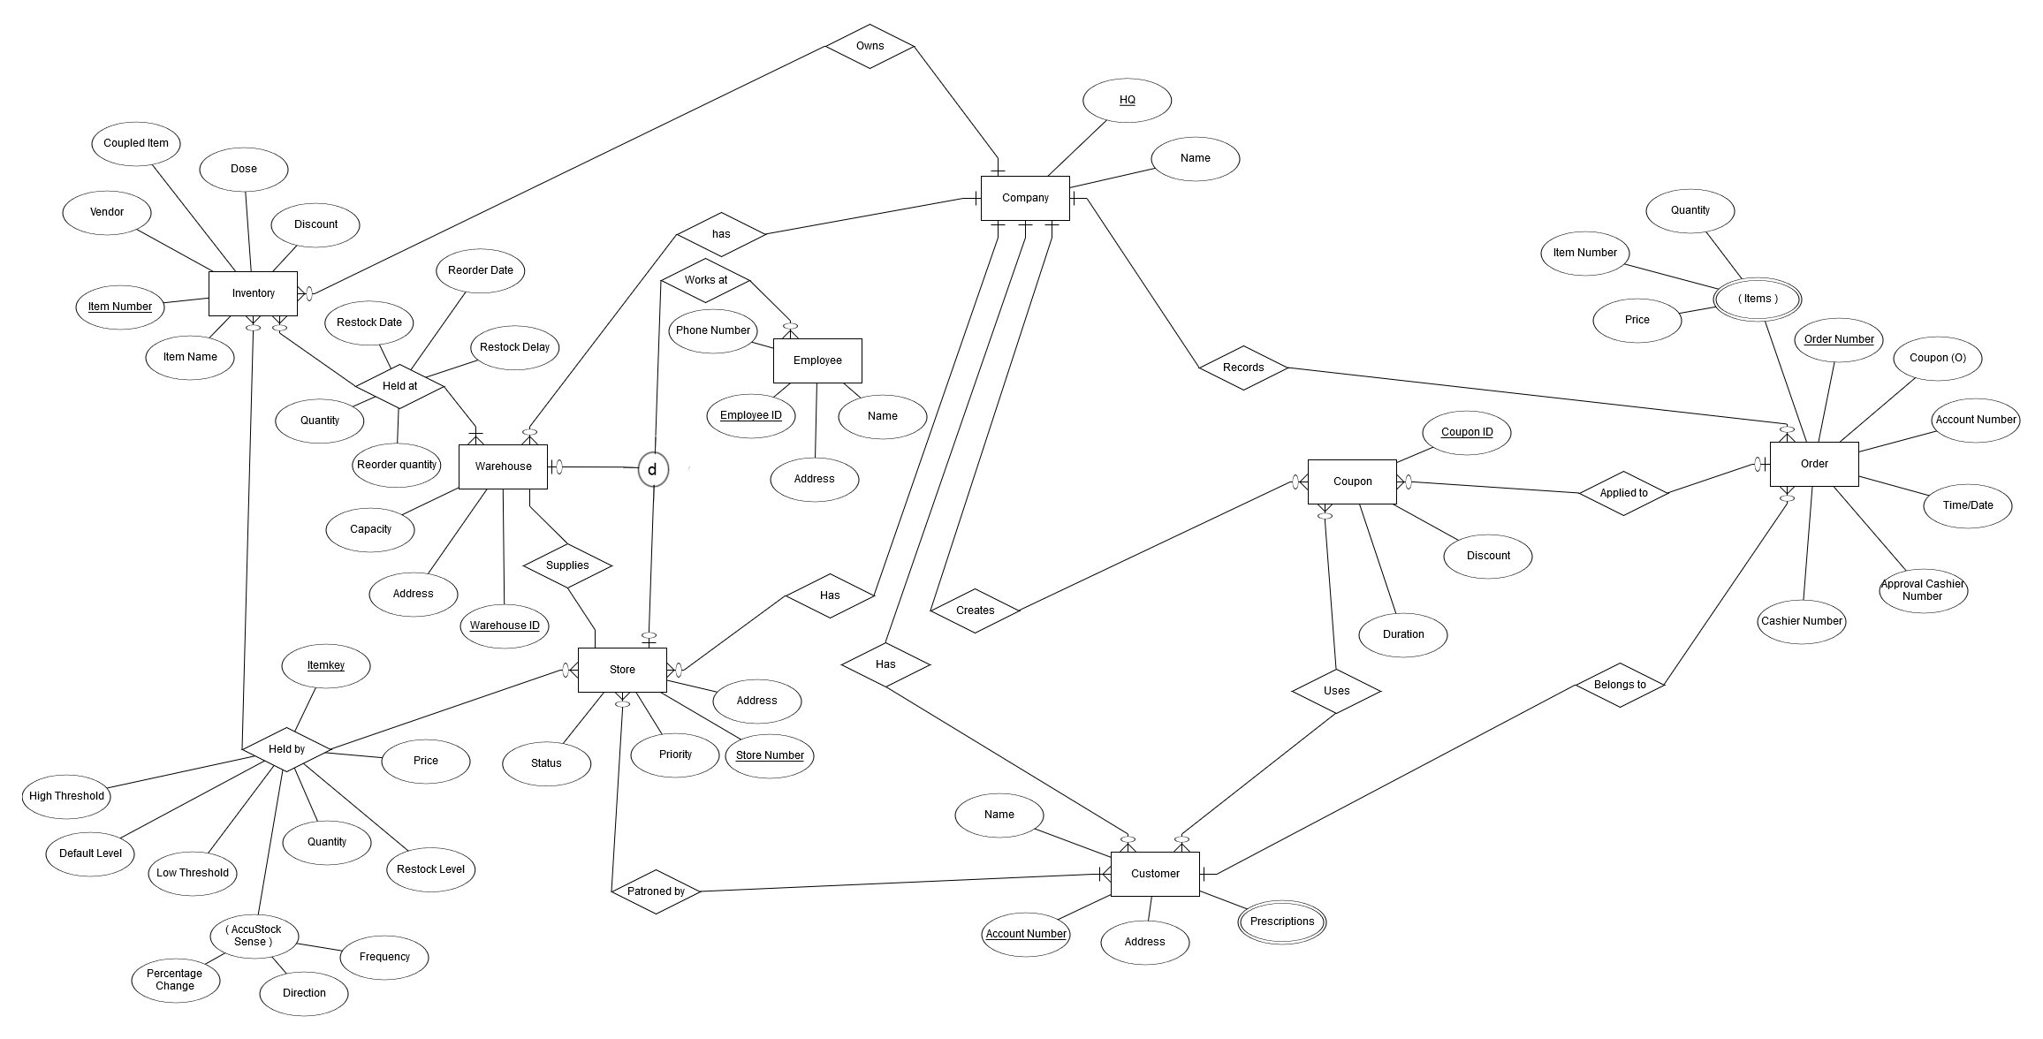

**Build ERD:** 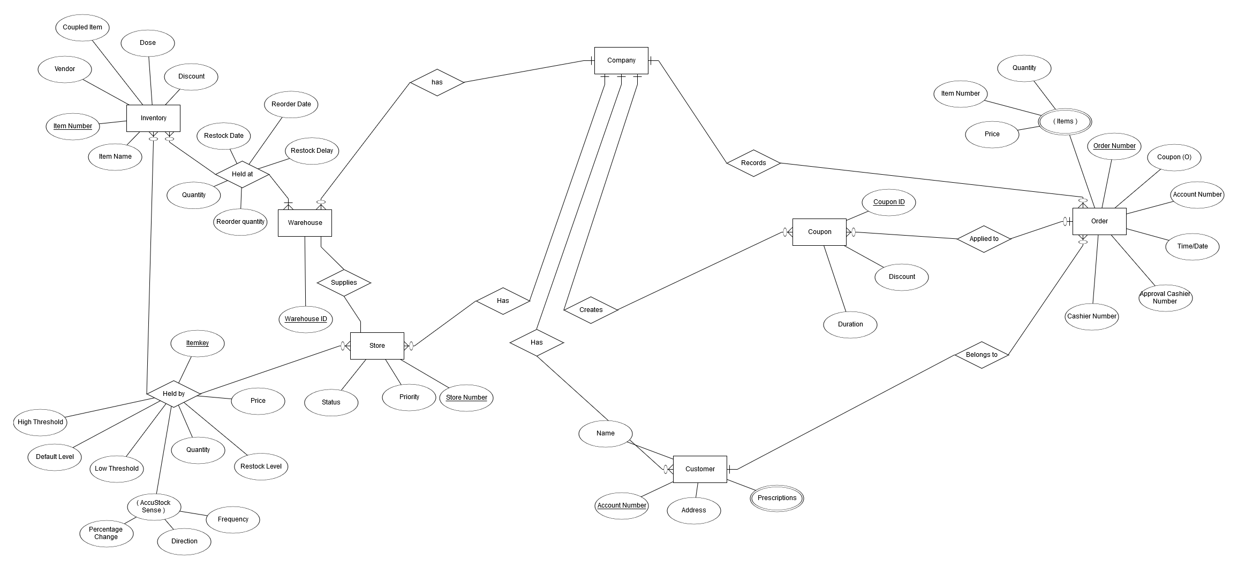

**3.1.2 Data Flow Diagram**

**Describe flow of data into/out of application – processes match to use-cases**

**Legend:**



**Context:**

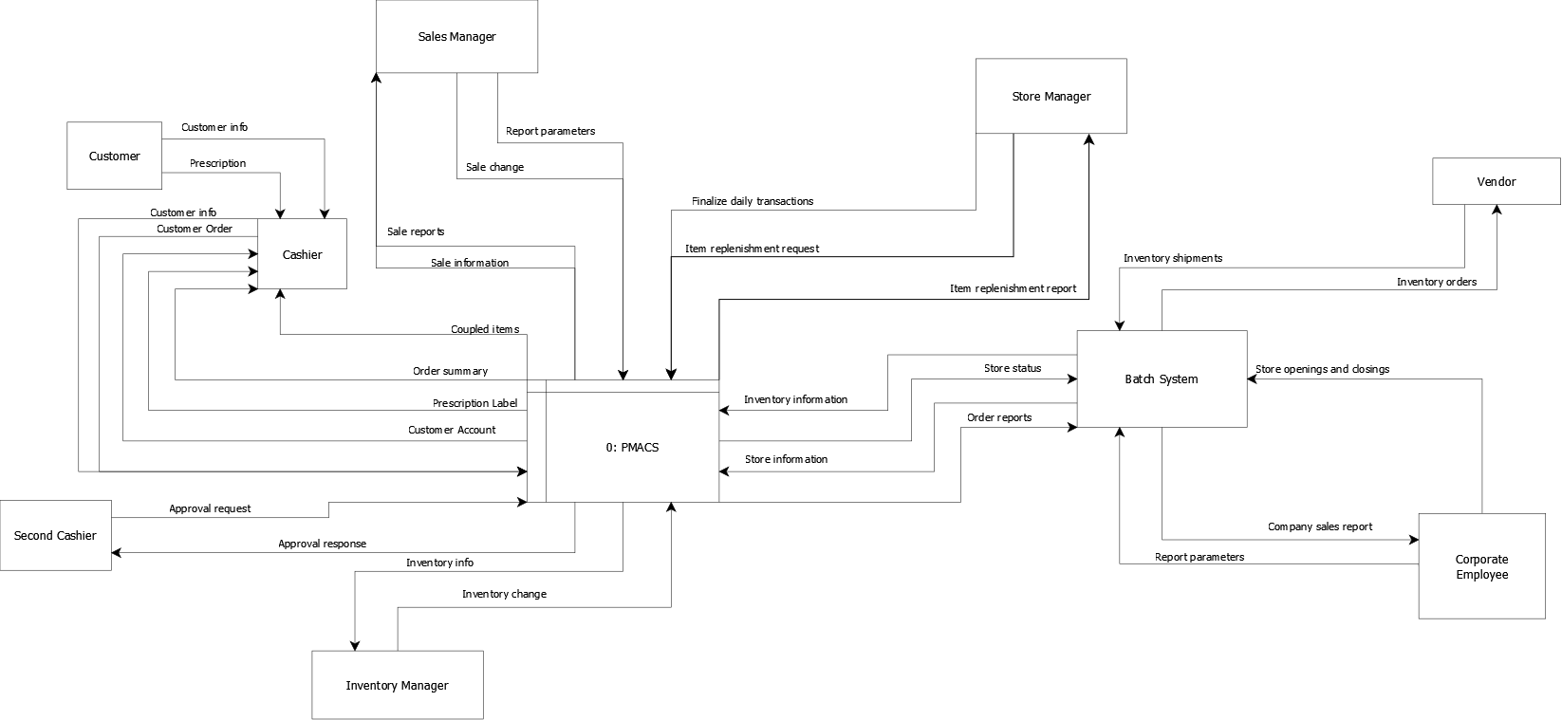

**DFD 0:** 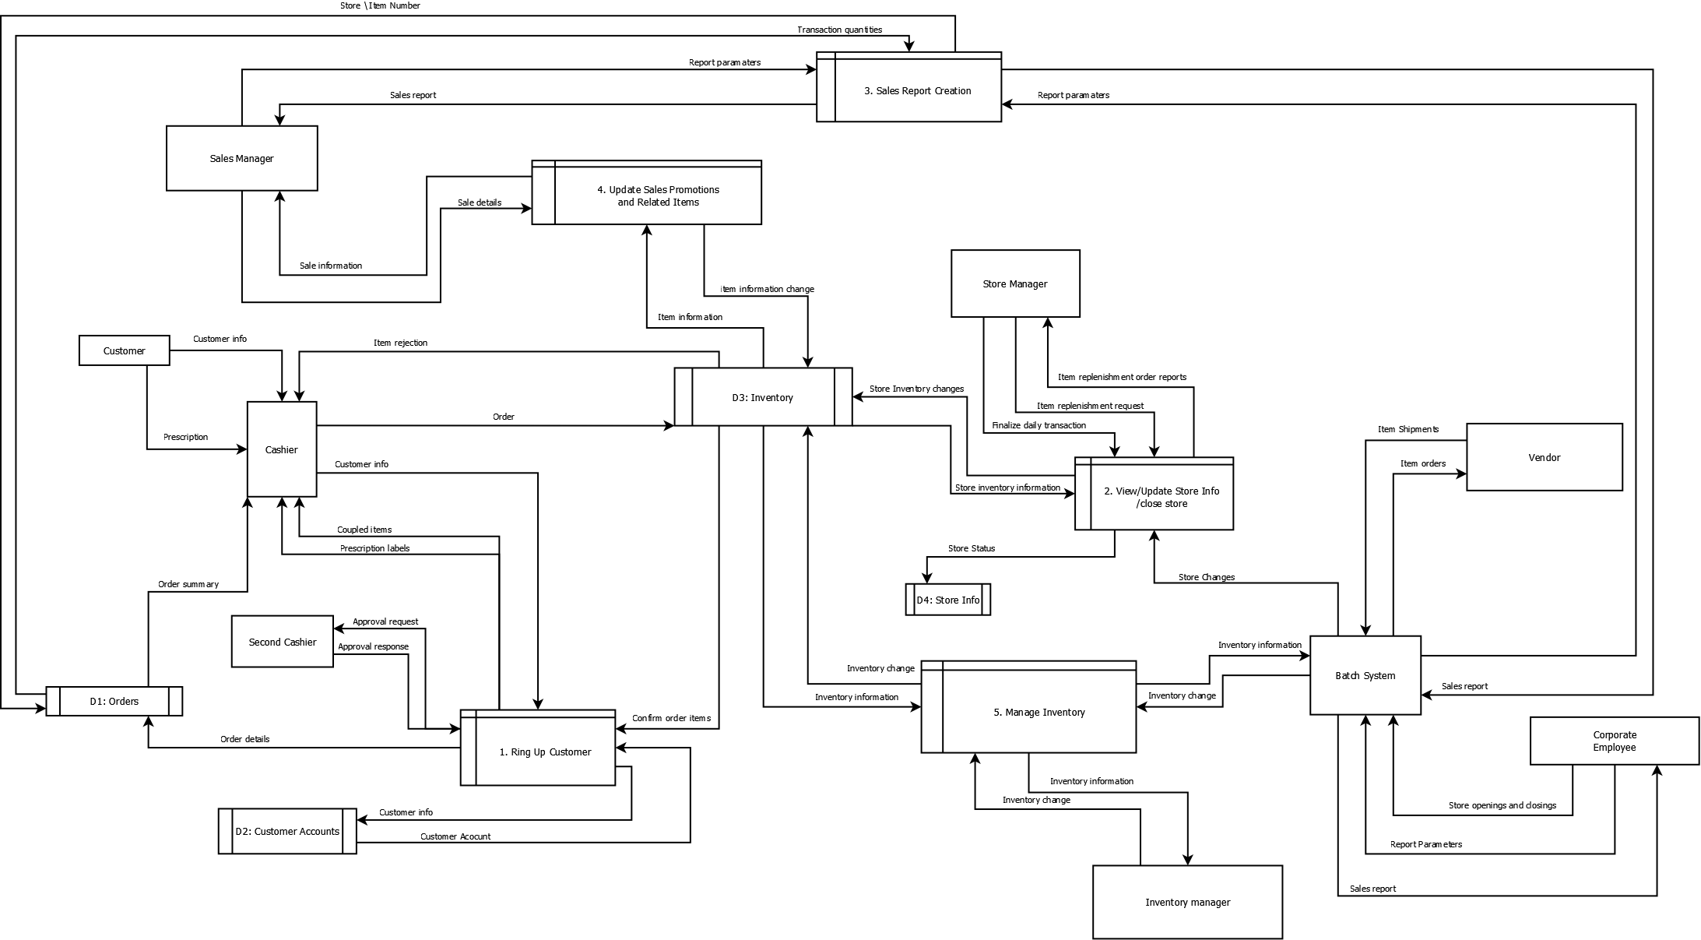

**3.1.3 Object Relationships**

**Relationships among data objects are described using CRC cards. No attempt is made to provide detail at this stage.**

**CRC:**  
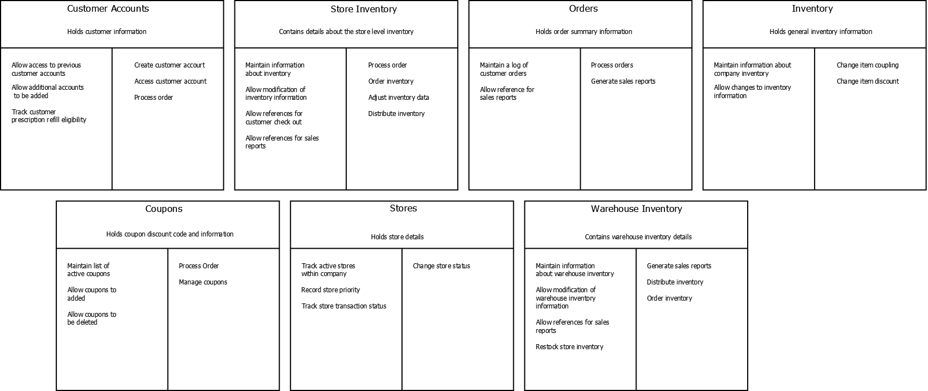

**3.1.4 Complete data model**

**An UML Class model (class diagram) for the software is developed**

1. **Ring Up Customer:**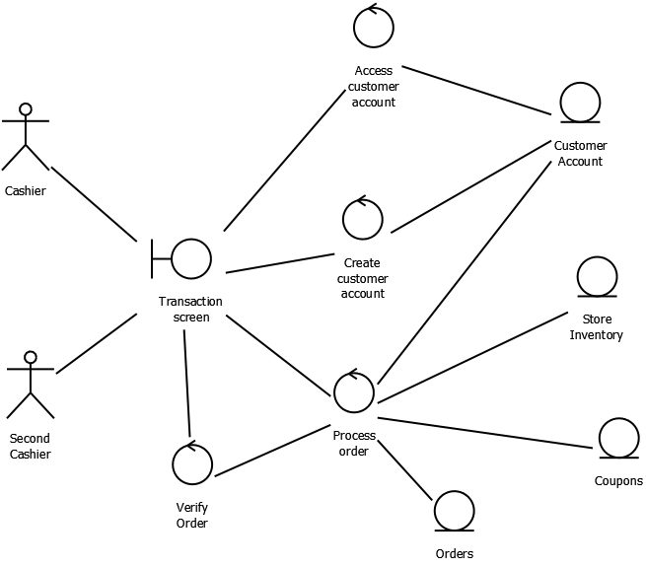
2. **View/Update Store Info/ Close Store:**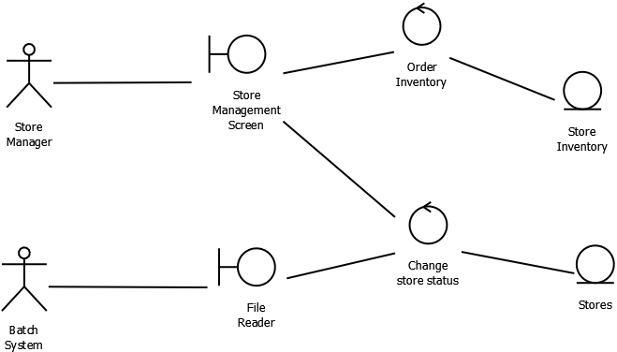
3. **Sales Report Creation:**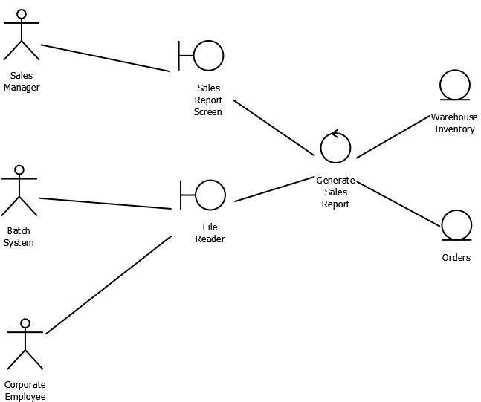
4. **Update Sales Promotions and Related Items:**
5. **Manage Inventory:**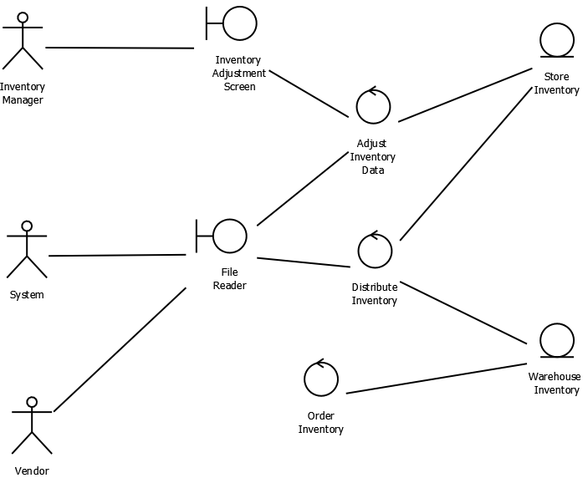

**3.1.5 Data dictionary**

**<Please reference external document Data Dictionary.xlsx>**

**4.0 Functional Model and Description**

**Description of major software functions along with UML Use Case, sequence, and communication diagrams.**

**4.1 Use cases**

* **Use Case Summary:**
  + **File Name: Use_Case_Summary.doc**
* **Use Case 1: Cashier – Ring Up Customer**
  + **File Name: Use_Case_Ring_Up_Customer.doc**
* **Use Case 2: Sales Manager – Run Sales Reports**
  + **File Name: Use_Case_Sales_Report_Creation.doc**
* **Use Case 3: Sales Manager – Update Sales Promotions and Related Items**
  + **File Name: Use_Case_Update_Promotions_Related_Items.doc**
* **Use Case 4: Store Manager – View/Update Store Info**
  + **File Name: Use_Case_Store_Manager.doc**
* **Use Case 5: Inventory Manager – View/Update Store Info**
  + **File Name: Use_Case_Manage_Inventory.doc**

**4.2 Software Interface Description**

Our software will be presented using command line prompts. The menu will consist of a list of options or selections that the user will select by inputting a specified value. The user may be prompted for an employee number at some log-in screens to verify identity. There will also be screens that prompt for another cashier’s credentials to approve prescription orders.

**4.2.1 External machine interfaces**

**N/A**

**4.2.2 External system interfaces**

This system will interact with other systems and networks by producing outputs in the form of flat files. The files will be formatted using guidelines given by the customer. External systems will use the flat files. Data will also go in to the system using the flat file format. The formats of these files will also be determined by specifications given by the customer.

**4.2.3 Human interface**

The software will be navigated by the user using a command line system. The screen will show a list of options or menus the user can access. The user will navigate these by submitting specified values corresponding with the menu item they wish to access. Users may also be prompted for a log-in on some screens. This will be done in the same format asking for the user to input their employee number.

**4.2.3.1 User screen interface layouts**

The screen layout for users will consist of a list of menu options displayed to the user that can be selected by entering certain values. Each option on screen will have a unique value associated with it that the user can enter in order to access that option. All of this will be done in command line format.

**4.2.3.2 Report layouts**

Reports will be stored in flat file formats. The user will define how they would like the reports calculated. They can be created using multiple time segments for the reports. These include by day, week, month, and year. The reports may also be created to display information for one store or for all stores. This option is also determined by user preference. Reports can also be created for specific items. Reports will also be generated by AccuStock if the order threshold for an item is changed automatically. This report will specify the change made by AccuStock. An inventory report will be generated to show items ordered by vendors and their estimated arrival time to the location. Company-wide sale reports can also be generated for the entire company or by specific stores. Lastly, a final report for summary totals can be generated.

**4.3 Sequence Diagrams**

**See external documentation:**

* + **SeqFlow1Main.pdf**
  + **SeqFlow2NoAccount.pdf**
  + **SeqFlow3AccountNumber.pdf**
  + **SeqFlow4AvailableRefill.pdf**
  + **SeqFlow5NoStock.pdf**
  + **SeqFlow6NoStockNoAdd.pdf**
  + **SeqFlow7CoupledItem.pdf**
  + **SeqFlow8CoupledItemWithLimit.pdf**
  + **SeqFlow9Coupon.pdf**
  + **SeqFlow10InvalidCoupon.pdf**

**4.4 Communication Diagrams**

**See external documentation:**

* + **CommDiagram.png**

**5.0 Behavioral Model and Description**

**A description of the behavior of the software is presented.**

**5.1 Description for software behavior**

**A detailed description of major events and states is presented in this section.**

**The main menu is accessed**

**5.1.1 Events**

* + - **Main Menu:**
      * **Customer ready for ring-up**
      * **Store data needs update, inventory needs replenishment**
      * **Sales promotions need updates or sales reports need outputting**
      * **Inventory Needs assigning/reclaiming Or item details need changing**
    - **Manage Inventory:**
      * **Inventory Manager Selects Inventory Management From Main Menu**
    - **Offline Batch Process**
      * **System time hits 12:00 AM, overnight batch process is launched automatically**
      * **Create/Delete Stores Process Fails**
      * **Create/Delete Stores Process Completes Successfully**
      * **Mass Item Updates Process Fails**
      * **Mass item updates process completes successfully**
      * **Inbound vendor shipment processing process completed successfully**
      * **Inbound vendor shipment processing process fails**
      * **Store Inventory Replenishment process fails**
      * **Store inventory replenishment process completed successfully**
      * **AccuStock threshold updates process fails**
      * **AccuStock threshold updates process completed successfully**
      * **Vendor replenishment request transmission and report generation process fails**
      * **Vendor replenishment transmission and report generation process completed successfully**
      * **Company Sales report generation fails**
      * **Company sales report generation process completed successfully.**
    - **Ring Up Customer**
      * **Customer ready for order entry**
      * **Customer account does not exists**
      * **Customer account exists**
      * **Customer wants more items**
      * **Order finalized**
      * **Order rejected**
    - **Sales report creation**
      * **Sales manager selects sales reports from sales management menu**
      * **Sales manager chooses by-store**
      * **Sales manager chooses by-item**
      * **Sales manger selects daily**
      * **Sales manager selects weekly**
      * **Sales manager selects Monthly**
      * **Sales manager selects yearly**
    - **Update Sales Promotions Related Items**
      * **Sales manager selects "manage promotions" from sales management menu**
      * **Sales manager selects "coupled items" from "manage promotions" menu**
      * **Sales manager selects "manage item discount" from "manage promotions" menu**
      * **Sales manager selects "manage coupons" from "manage promotions" menu**
    - **View Update Store Info Close Store**
      * **Store manager selects "store management" from main menu**
      * **Store manager selects "request inventory replenishment**
      * **Store manager selects "finalize daily sales"**
      * **Store manager selects "exit menu" from store management menu**

**5.1.2 States**

* + - **Main Menu:**
      * **PMACS Main Menu**
      * **POS Login**
      * **Store Management**
      * **Sales Management**
      * **Inventory Management**
    - **Manage Inventory**
      * **Inventory Management**
    - **Offline Batch Process**
      * **Create/Delete stores**
      * **Mass item updates**
      * **Inbound Vendor Shipment Processing**
      * **Store Inventory Replenishment**
      * **AccuStock Threshold Updates**
      * **Vendor Replenishment Request Transmission and Report Generation**
      * **Company Sales Report Generation**
    - **Ring Up Customer**
      * **Customer Account Handling**
      * **Customer Item Entry**
      * **Secondary Cashier Validation**
    - **Sales Report Creation**
      * **Choose Report Type**
      * **Select Time Period**
    - **Update Sales Promotions**
      * **Select Promotions to Manage**
      * **Manage Coupled items**
      * **Manage Item Discount**
      * **Manage Coupons**
    - **View Update Store Info**
      * **Display Store Management Menu**
      * **Request Inventory Replenishment**
      * **Finalize Daily Sales**

**5.2 State Transition Diagrams**

**Depict the manner in which the software reacts to external events.**

**Ring Up Customer:**

**Please see external file**

**State_Transition_Diagram_Ring_Up_Customer.pdf**

**Sales Reports:**

**Please see external file:**

**State_Transition_Diagram_Sales_Report_Creation.pdf**

**Update Sales Promotions:**

**Please see external file**

**State_Transition_Diagram_Update_Sales_Promotions_Related_Items.pdf**

**View/Update Store Info/Close Store:**

**Please see external file**

**State_Transition_Diagram_View_Update_Store_Info_Close_Store.pdf**

**All Users – Main Menu:**

**Please see external file**

**State_Transition_Diagram_Main_Menu.pdf**

**Offline Batch Process:**

**Please see external file**

**State_Transition_Diagram_Offline_Batch_Process.pdf**

**6.0 Restrictions, Limitations, and Constraints**

**Special issues which impact the specification, design, or implementation of the software are noted here.**

1. **The online and offline portions of the software cannot run concurrently.**
2. **Files will be used for internal storage due to database inexperience.**
3. **Software deadline limits implementation to minimum requirements.**
4. **Software deadline limits gui to command line interface.**

**7.0 Validation Criteria**

**The approach to software validation is described.**

**7.1 Classes of tests/Test Strategy**

* 1. **Valid and Invalid Data**
     1. **Inputs will be tested using both valid and invalid data. Simple examples of tests to perform could include menu testing. We can also test the validity of security clearances. Some menus will require input from an additional cashier to complete the transaction. At this point in the transaction, the system will ask for an additional cashier’s approval. If they approve, they will enter their employee number.**
  2. **Reports**
     1. **This software generates many kinds of reports. It is important to test that these reports are accurate. Tests with different kinds of data will be used to ensure the accuracy of these reports. Additionally, there will be tests for each time segment that reports can be produced through (day, week, month, etc).**
  3. **Output Files**
     1. **Much like the reports, it is critical that the output files have correct information. These files are going to vendors and other machines where accuracy is critical. These tests will be very similar to the report testing and will ensure accuracy in outputs.**
  4. **Batch File Sequence**
     1. **All batch files will have consecutive numbers to ensure that they are reading and writing into the correct files. Tests will create multiple batch files and ensure that the files all have the correct consecutive batch file sequence numbers. There will also be tests where a file is purposely embedded with an incorrect sequence number. It should also halt all inventory processes until the issue is resolved. This will be done to prevent further errors with inventory.**

**7.2 Expected software response**

* 1. **Valid and Invalid Data**
     1. **Menu testing will be done by using multiple different values. An example would be a menu that has options 1-5. User inputs between 1 and 5 should produce the corresponding menu or action. An input that is out of range (IE: 6) should produce an error message to the screen informing the user of the error. Testing the security clearance will be done in a similar manner. Tests will be done with a valid and invalid employee number. The valid number should continue the transaction and the invalid one will print an error message to the screen.**
  2. **Reports**
     1. **Tests will use many different inputs with known answers to ensure the accuracy of reports produced by the system. These reports will be run for each time segment that can reported. This includes reports by day, week, month, etc.**
  3. **Output Files**
     1. **The output file tests should produce identical results to the reports testing. We will use data with expected results to ensure the accuracy of the outputted data.**
  4. **Batch File Sequence**
     1. **Multiple tests will be run for the batch files. The first round of testing will should produce batch files with consecutive numbering. If the batch files do not produce consecutive numbers, the system should catch this error and halt all inventory processes until the issue is resolved. Tests using incorrect batch numbering will also be run to make sure the system can accurately catch these errors.**

**7.3 Performance bounds**

**The systems batch process must finish before 5 am the following day. The process will begin at midnight. Additionally, any feedback or message must be displayed to the user within 5 seconds of the users input.**

**8.0 Appendices**

**Presents information that supplements the Requirements Specification**

**8.1 System traceability matrix**

**See external documentation:**

* + **TraceabilityMatrix.xlsx**

**8.2 Product Strategies**

**N/A**

**8.3 Analysis metrics to be used**

**A description of all analysis metrics to be used during the**

**analysis activity is noted here.**

**Descriptive non-hierarchical artifacts - 1.1, 1.3, 1.4, 2.3, 5.1, 6.0, and 8.2. The progress on these is not measured (aside from the pertinent team member reporting the estimated status), since they are mostly descriptive text, which is not quantifiable easily.**

**Diagrams - Based on a predetermined list of items agreed upon at team meetings, the following documents' progress were measured by comparing the number of items in the list to the number of items entered/covered and Project Manager's agreement.**

**Itemized Lists – Also based on a predetermined list of items agreed upon at team meetings, the following documents' progress were measured by comparing the number of items in the list to the number of items entered/covered and Project Manager's agreement.**