HyperChat Design Doc
s/chat

Date: 03/29/2020
Status: In Progress

Objective
Build a generic real-time chat infrastructure that is scalable to billions of users.

Background
Currently, there are 4 major large scale chat systems in the market:

- Facebook messenger
- Whatsapp
- Slack
- WeChat
- Telegram

However, none of them provides easy to use APIs or libraries for small businesses to create their own custom service chat system or internal chat app.

Requirements

Functional Requirements

Authentication
- single sign on

Users
- find an user ( replaced with a better way of sharing unique ID )
- save an user to favorites
- block user
- user status & timezone

Chat
- 1 vs 1 chat with any users ( Passively receive message, offline delivery[transaction], device registry, connection hub, database, read and received message feedback)
- push notification
- Editing / Delete / Reply to message

Group Chat
- create group chat
- add friend into group chat
- remove friends from group chat
- end the group chat

Non-functional Requirements
- Very low latency
- Consistency(everyone should see the messages in same order)
- High availability
- Very secure & encrypted messages
- Support 1 billion users

Extended requirements

Messaging
- send a picture
- send a video
- send emoji

Extra
- offline message support
- see friend tweets
- video call
- discover nearby people (Bluetooth)
- secret chat ( timeout message )
- survey & vote
- send chat history as a email
- admin for group chat and his roles and responsibilities?
- Broadcast a message to multiple friends
- Share business card with other users

Questions
- Do we want to show the status of the users?
- Do we want to track the timezone of the users?
- Do we want to track user's devices?

UI Mockup

Icon

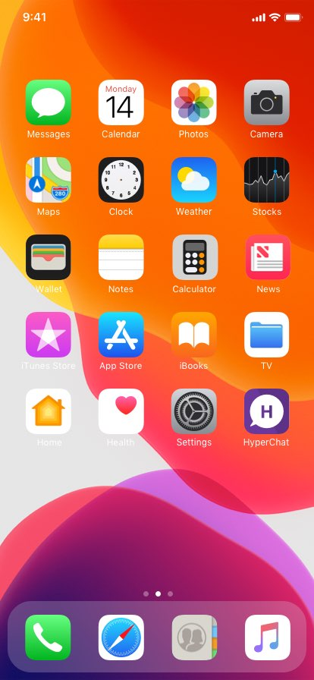

Launch Screen



Sign In

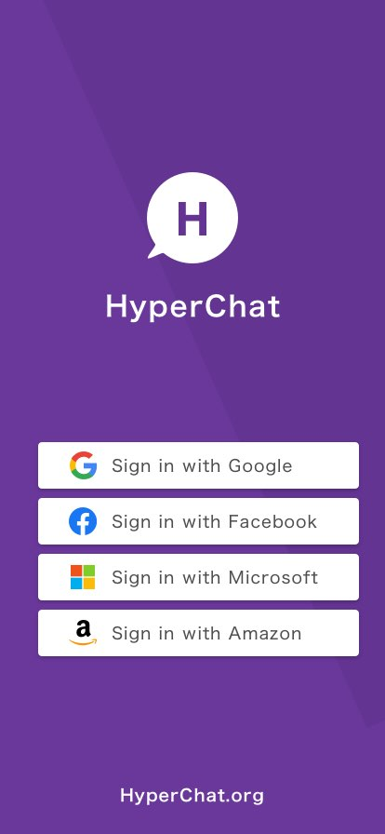

Home Screen & Create Group Screens:

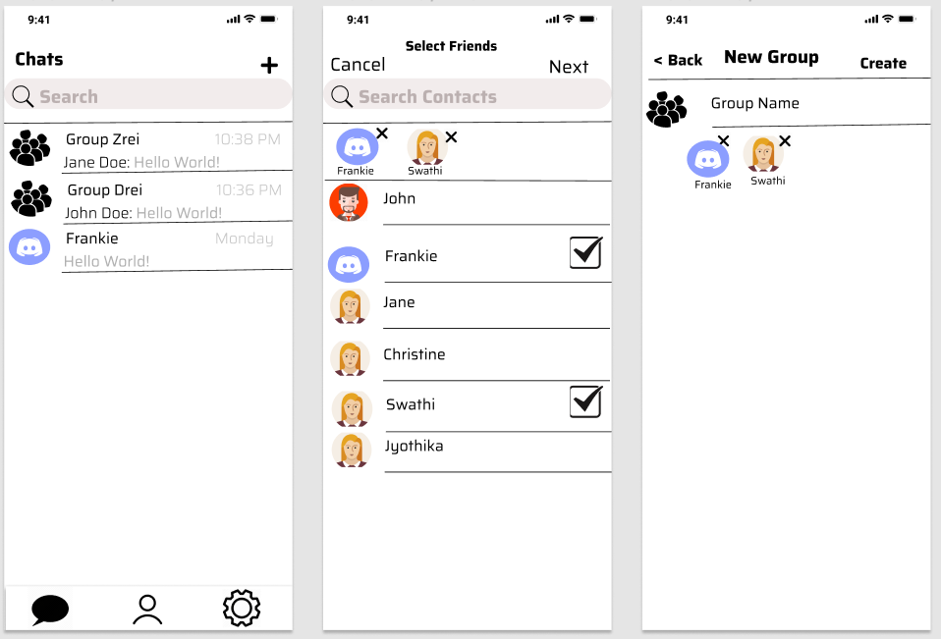

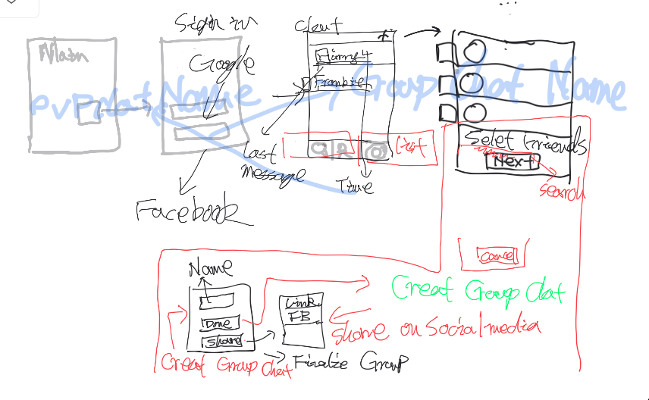

Person to person chat
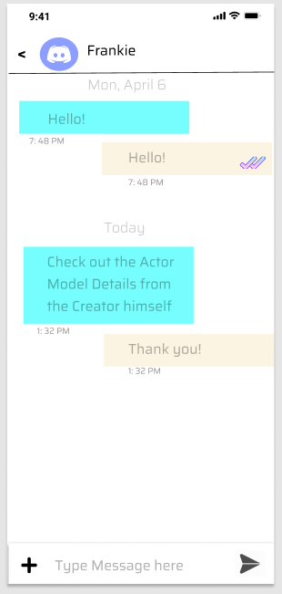
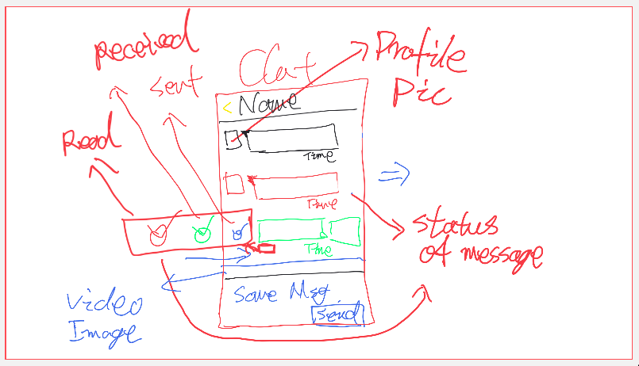

Edit chat message
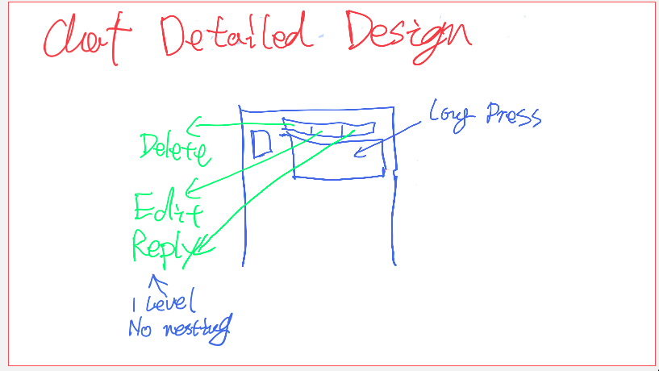

Delete & reply to chat message
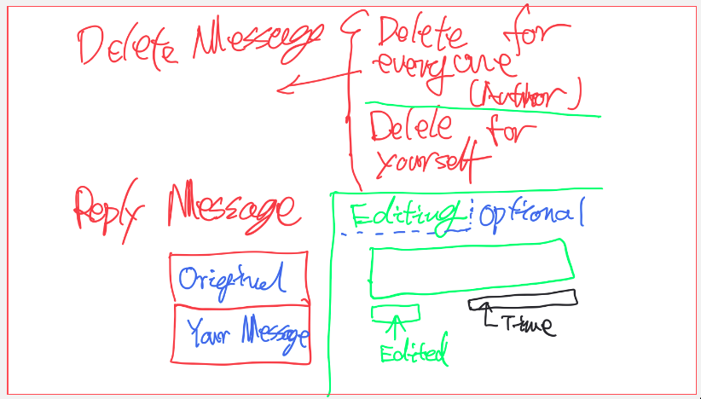

Add friend
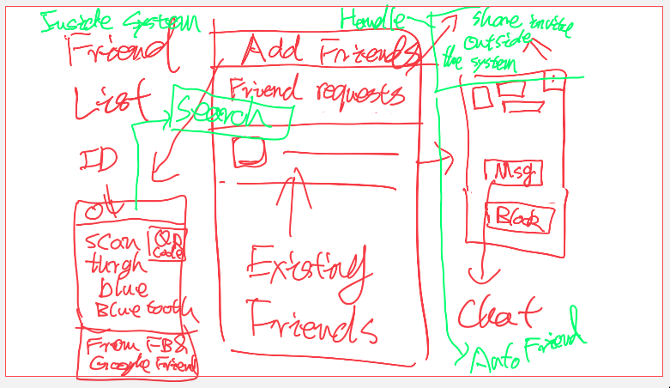

Group management
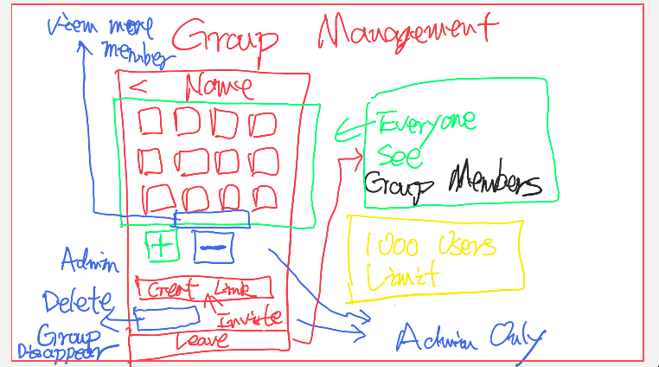

Deleted group chat
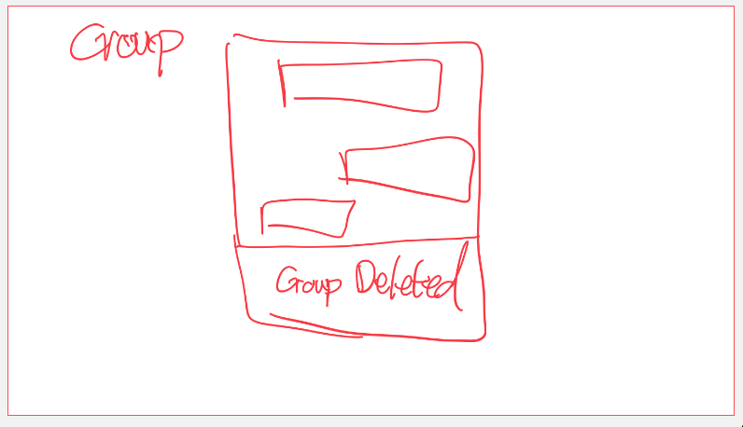

User profile
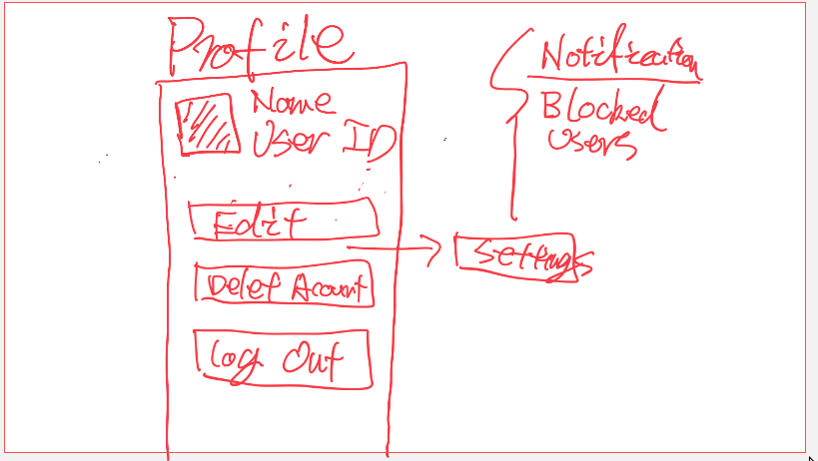

Notification

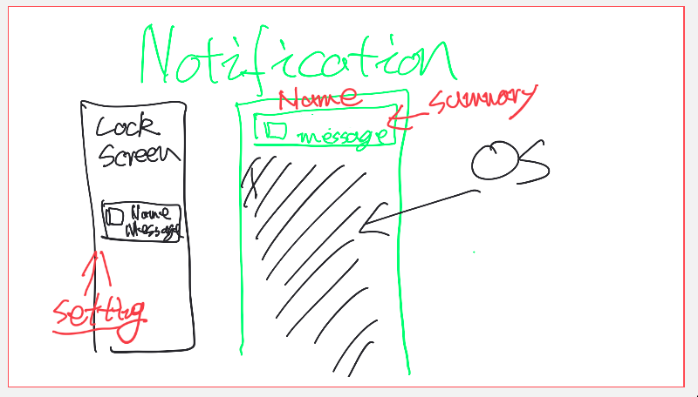

Public APIs

Sign in
getChatUserID() chatUserID:String
We can uniquely identify a chat user with chatUserID in our system

Chat list
ListChats(userID: string, pageIdx: int, pageSize: int): List<ChatThumbnail>
ChatThumbnail {
chatID string
iconURL string
mostRecentMessage ThumbnailMessage
}
ThumbnailMessage {
senderName string
body string
receivedAt time
}

Create a peer to peer chat
Chat is created when becoming favorites
createPeerToPeerChat(initiatorID string, receiverUserID string): chatID string
Comment: consider creating a chatID from directly sending on the first time.

Create a group chat
createGroupChat(ownerID string, groupName string, friendIDs List<String>): chatID string
userID: This user is the admin of the group chat by default
Comment: combining peer into a group of one

Sending a message
sendMessage(senderID string, chatID string, messageBody string): messageID string
Comment: should we add a time from client

System event
receiveMessageCallback(chatID string, message Message)
This functional is invoked by eventbus when the client received a message from the server

receiveAckCallback(chatID string, ackMessage AckMessage)

Message {
messageID string
senderID string
sentAt string
body string
// Part of proactively retrieving message
repliedTo *string
isEdited boolean
isDelete boolean
editedAt datetime
}
AckMessage {
messageID string
isRead boolean
isReceived boolean
isSent boolean
}
// Include all the people who read the message

Editing and deleting a message
editMessage(senderID string, chatID string, messageID string, messageBody string)
deleteMessage(senderID string, chatID string, messageID string)
// viewDeleteMessage might need to persist
Update {
messageID: String
type: String
updatedMessage: *String
}

Type: Delete, Edit

Reply to a message
replyMessage(senderID string, chatID string, messageID string, messageBody string): messageID string

// Message being replied will show up right on top of the response for it.

// If the sender tries to edit a message already being replied by others, the old message body will be kept on top of the reply. However, when the user clicks on the old message, then it directs the user to the edited message. If the message is deleted, we don’t perform any redirects.

Social network discovery
// Everyone can chat with others if they can discover the receiver and they are not blocked by receiver
Optional: discoverPeopleNearBy() userIDs List<String> // Bluetooth

Favorites
getFavorites(userID string): favoriteIDs List<String>
addAsFavorite(userID string, favoriteI.D string)

Invitation to new users
getInvitationLink(userID string): invitationLink string
retrieveUserIDFromInvitation(invitationLink string): userID string

Group management
getMembers(userID string, groupID string): userIDs List<String>
// ChatID is associated with a groupID
addUserToGroup(adminID string, groupID string, userID string)
removeUser(adminID string, groupID string, userID string)
deleteGroup(adminID string, groudID string)
updateGroupInfo(adminID string, groupID string, groupInfo GroupInfo)
// adminID is retrieved from authentication token
GroupInfo {
name string
icon Array<Byte>
}

Profile
getUserInfo(userID string): userInfo UserInfo
updateUserInfo(userID string, userInfo UserInfo)
deleteAccount(userID string)
blockUser(userID string, blockID string)
UserInfo {
name string
icon Array<Byte>
}

Notification settings
// app local setting
// Receive message. Users determine whether they are notified

Request missed updates / messages during offline

getLatestTransctionID(chatID: string): String
Response {
snapshot: Snapshot
transactions: Array<Transaction>
}
fetchSnapshotAndTransactions(chatID: String, clientTransactionID: String?, latestTransactionID: String): Response
---------------------------------------------------------------------------
// Minor optimization
// Delta = Missed transactions + snapshots
// Snapshot aggregates changes between start & end transactions
Delta {
// Missed new messages that may potentially be edited. Deleted new
// messages won’t show up
newMessages: Array<Message>
// Read, received, edited or deleted old messages on the client.
updates: Array<Update>
}
fetchDelta(chatID: String, clientTransactionID: String?, latestTransactionID: String): Delta

Database Schema

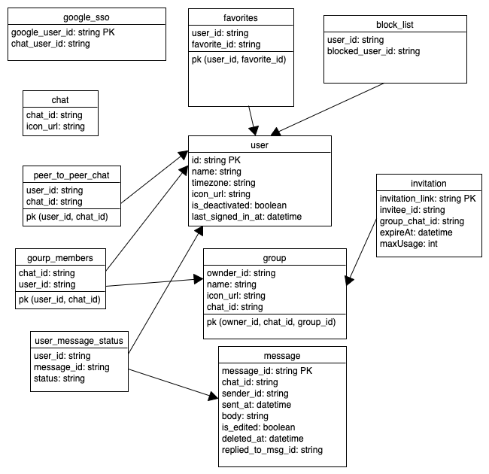
Note:
user_message_status: Status can be one of [Read, Received, Sent]

Capacity Estimation & Constraint

Assumptions
- 500 millions daily active users
- Peer to peer 50 msg/day
- 10 msg/day/group
- average group size: 50
- 5 groups/user
- 100 bytes/msg

Storage
5e+8 (50 + 5 . 10) 100 = 5 TB/day = 3.65 PB / 2 yr

Bandwidth
5e8 (50 . 2 + 5 . 10 . 50) 100 / (60 . 60 . 24) = 1.5 GB/s

Cache Memory

High Level Architecture

Real-time messaging delivery

Peer to peer messaging

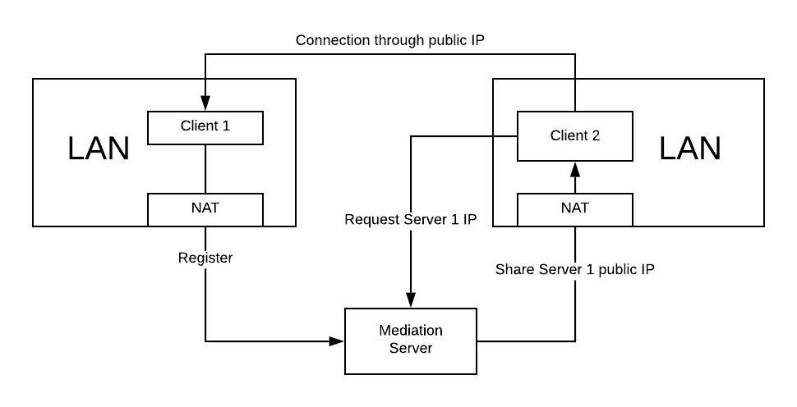

NAT Penetration

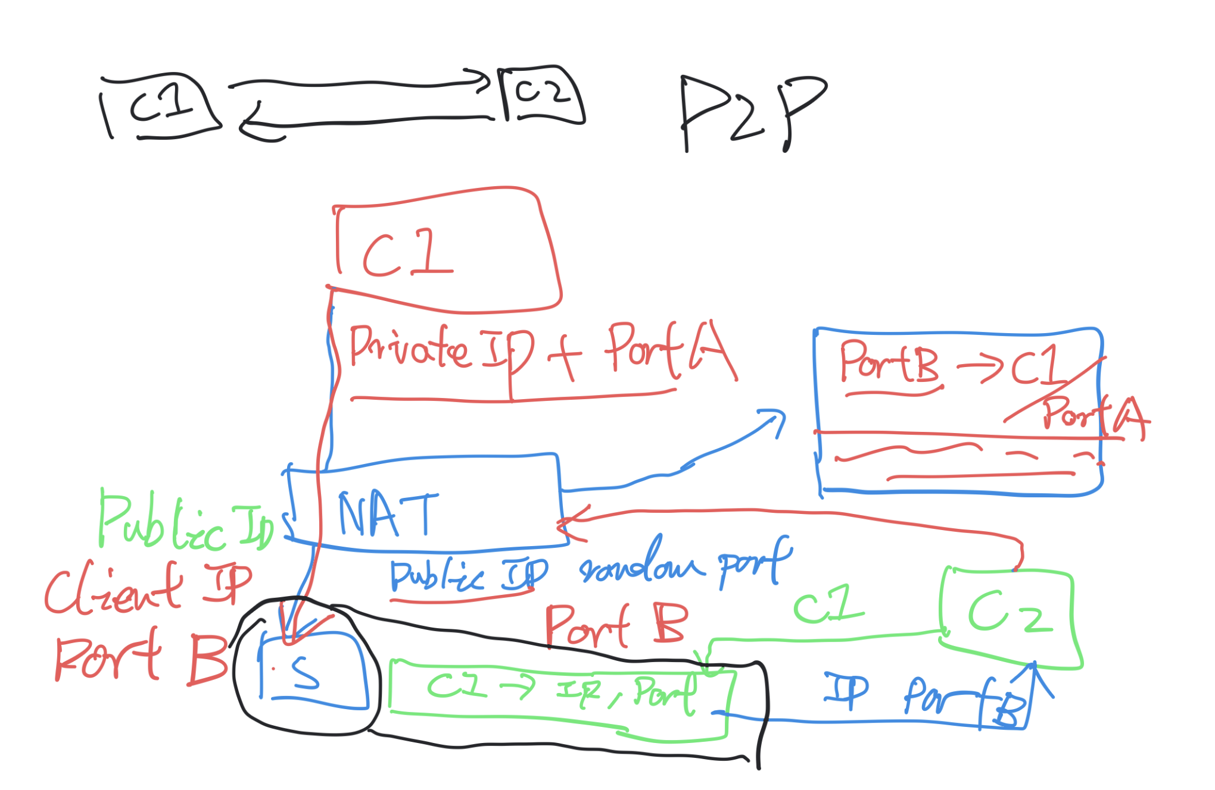

Client/Server Architecture

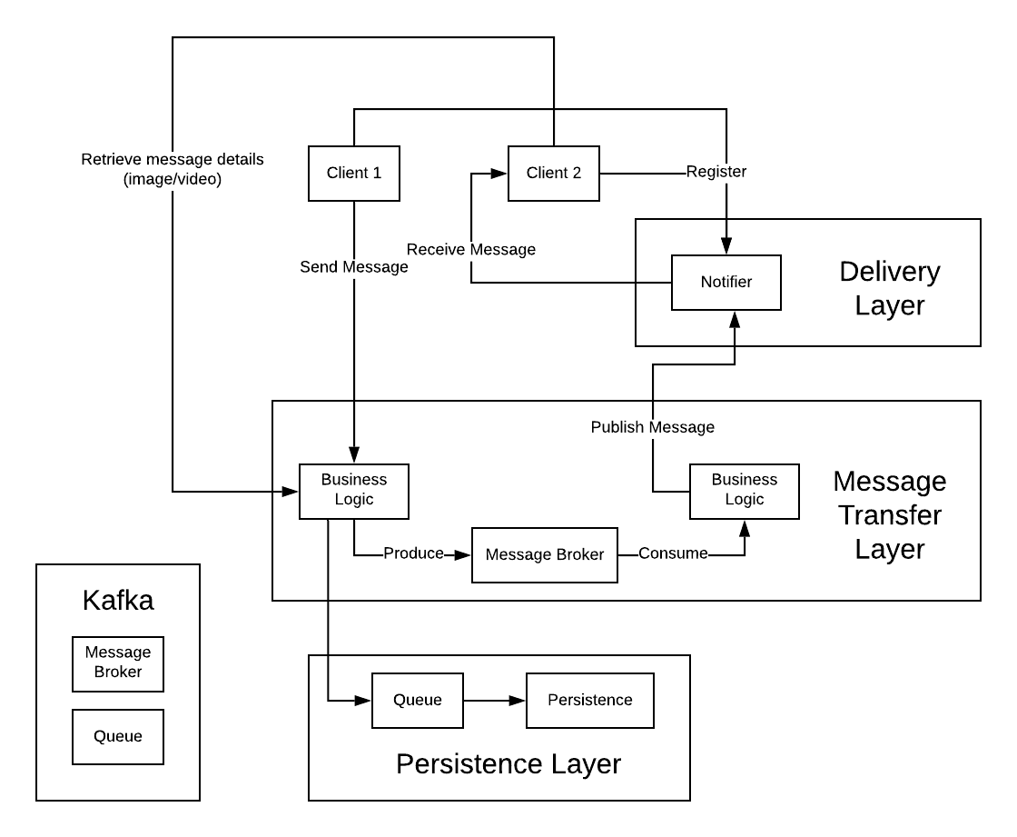

The system has 3 layers:

- Message transfer layer: receive and route message inside the chat cluster
- Persistence layer: save messages for future retrieval
- Delivery layer: deliver the message to the receiving clients

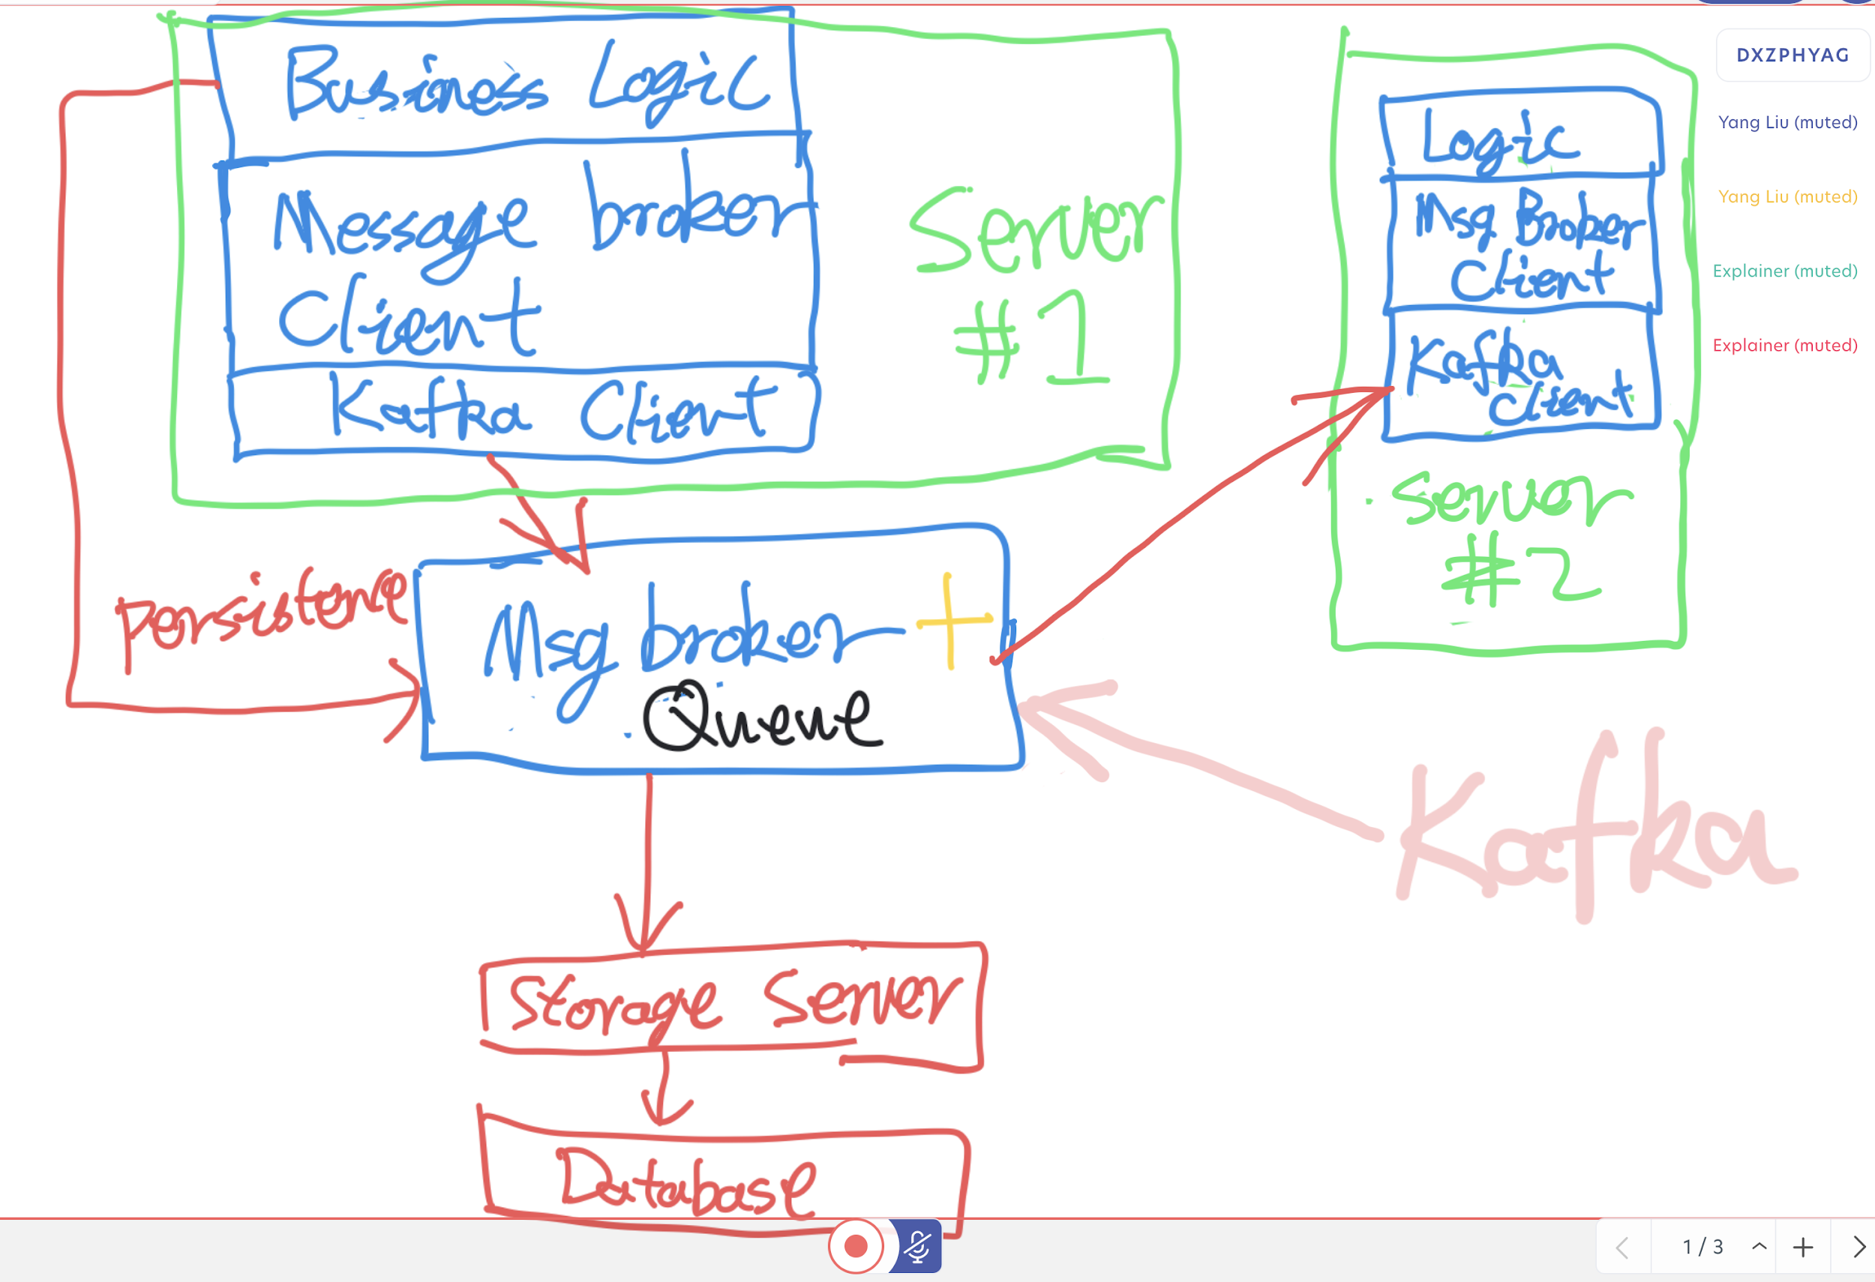

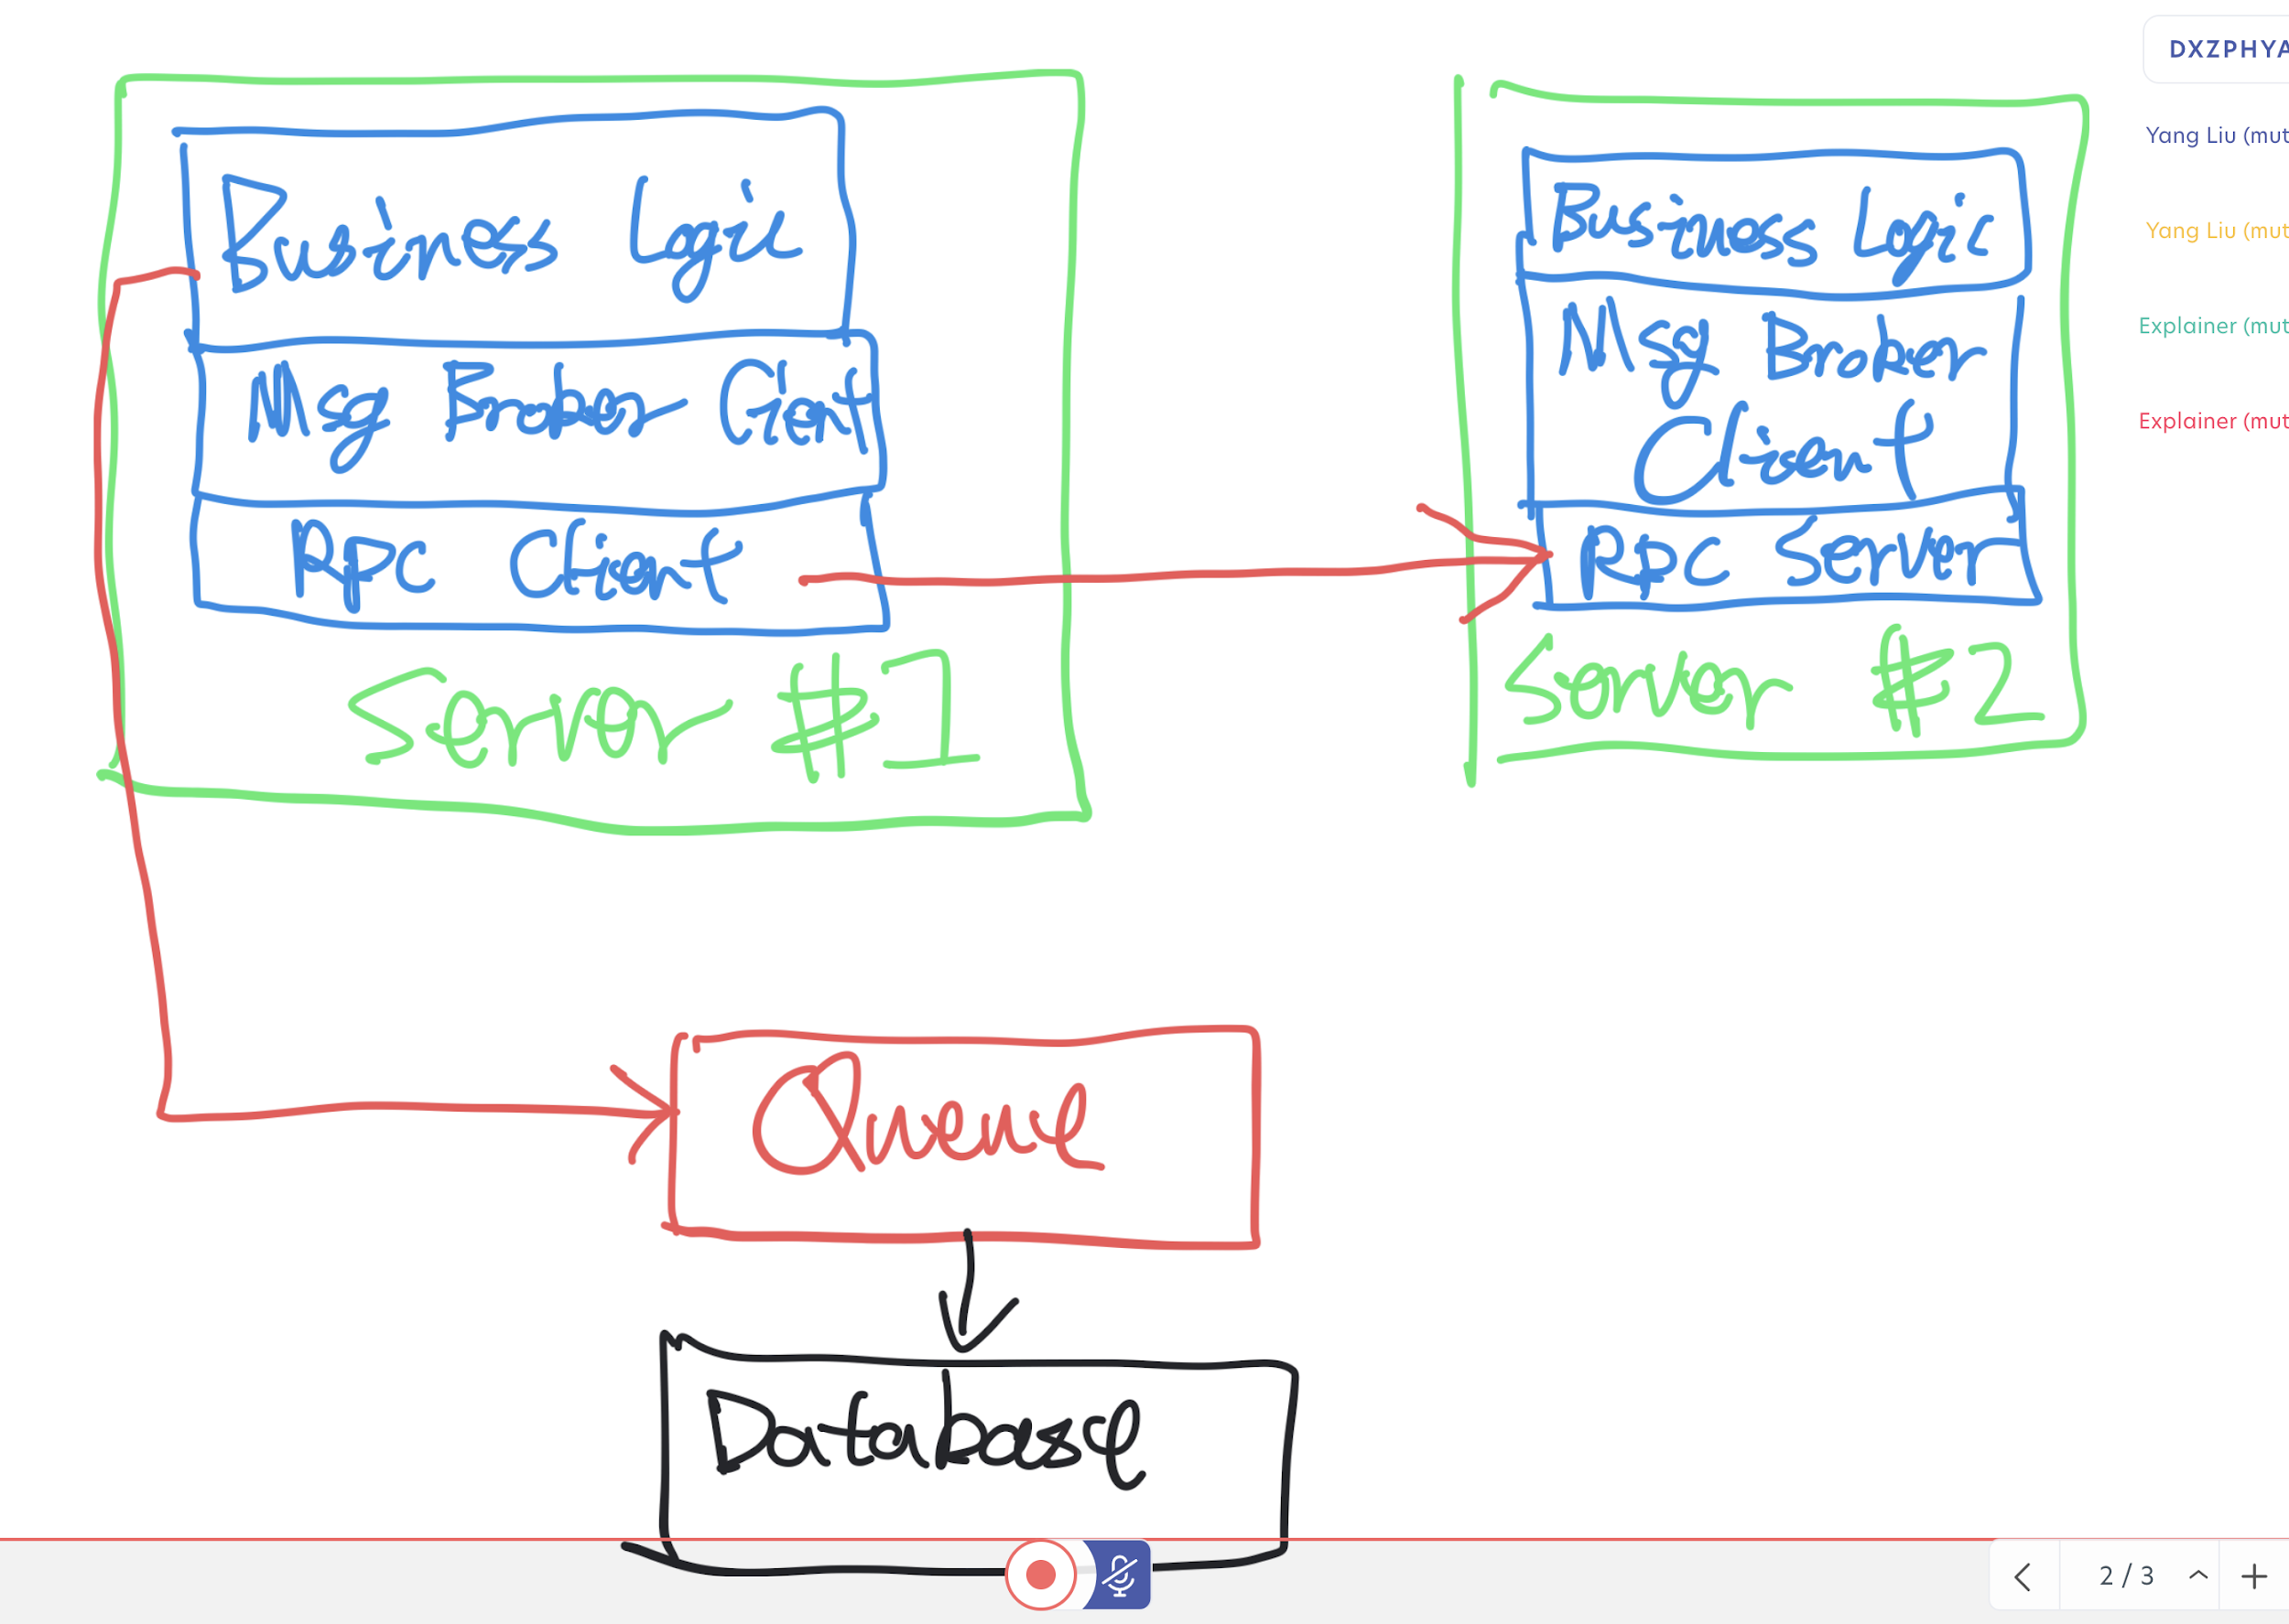

3 layers
- Delivery layer
- Message transfer layer: Route message between servers
- Persistence layer

0 => Background notification: APNS, FCM

1 => Long live socket, WebSocket, MQTT, Long-poll, polling
2 => Direct RPC between server / Kafka
3 => HBase ( Column based NoSQL ) / Cassandra ( NoSQL ) / MongoDB ( NoSQL ) / Postgres ( SQL ) / MySQL ( SQL ) [DynamoDB ( NoSQL ), Aurora (SQL), BigTable (NoSQL), Spanner ( SQL )
1 + 2 => Ejabberd
2 + 3 => Firebase ( NoSQL )

Multiple client delivery & ACK priorities?
Assume 1 user only has 1 device for v1.

Recommendation
- Use client/server architecture for V1
- Define the interface of 3 layers
- Message Transfer Layer: Use Kafka as the global message queue for V1 ( Voted with 7 Kafka and 2 RPC)
- Use WebSocket as real-time delivery protocol for V1 because it’s easier to implement ( Voted with Raw Socket: 1, WebSocket: 4, MQTT: 4, Long-pull: 2)
- Use NoSQL as backend data store ( Vote NoSQL:7 SQL: 3 )

Message status update?

Detailed Component Design

Real-time messaging delivery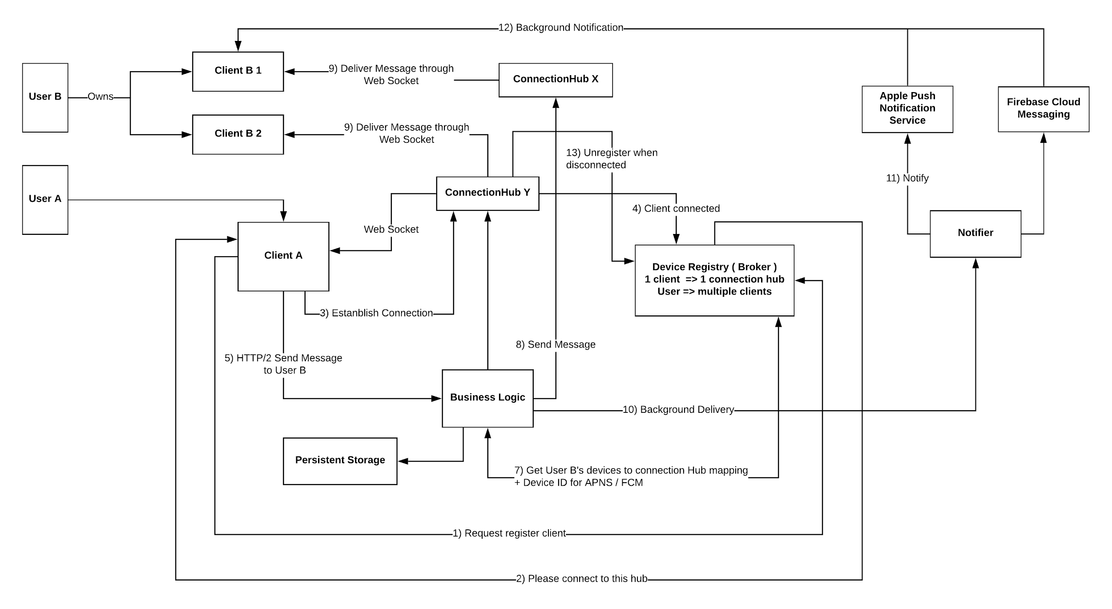
Connection Hub
Input
- Business logic
{
message:
clientID:
}
- Device registry
Health check ( 100 ms )
- Client
Request for connection
Output
- Connect with client

Notification when app is not running
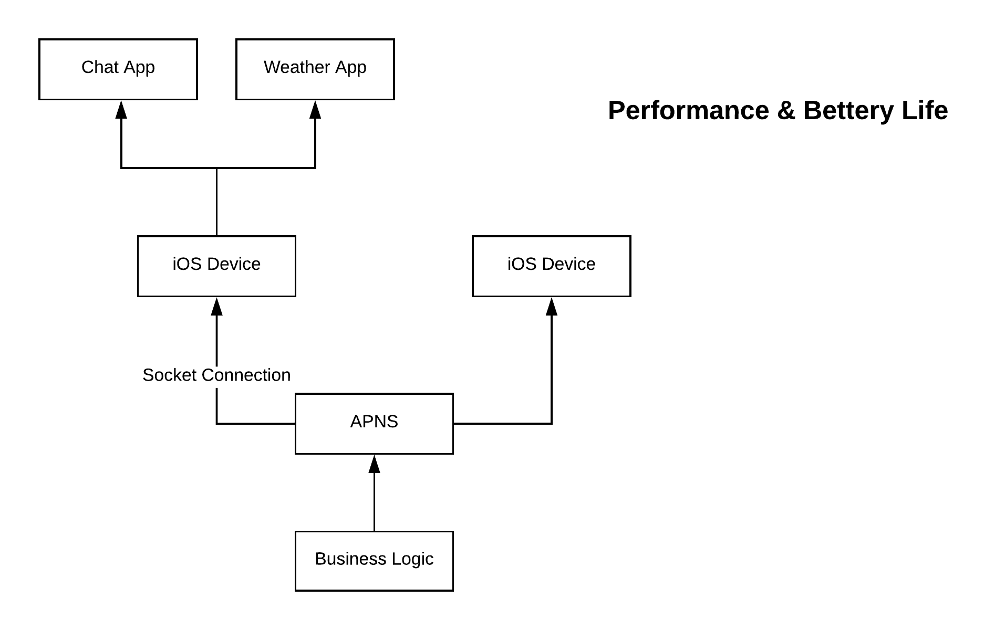

Message transport
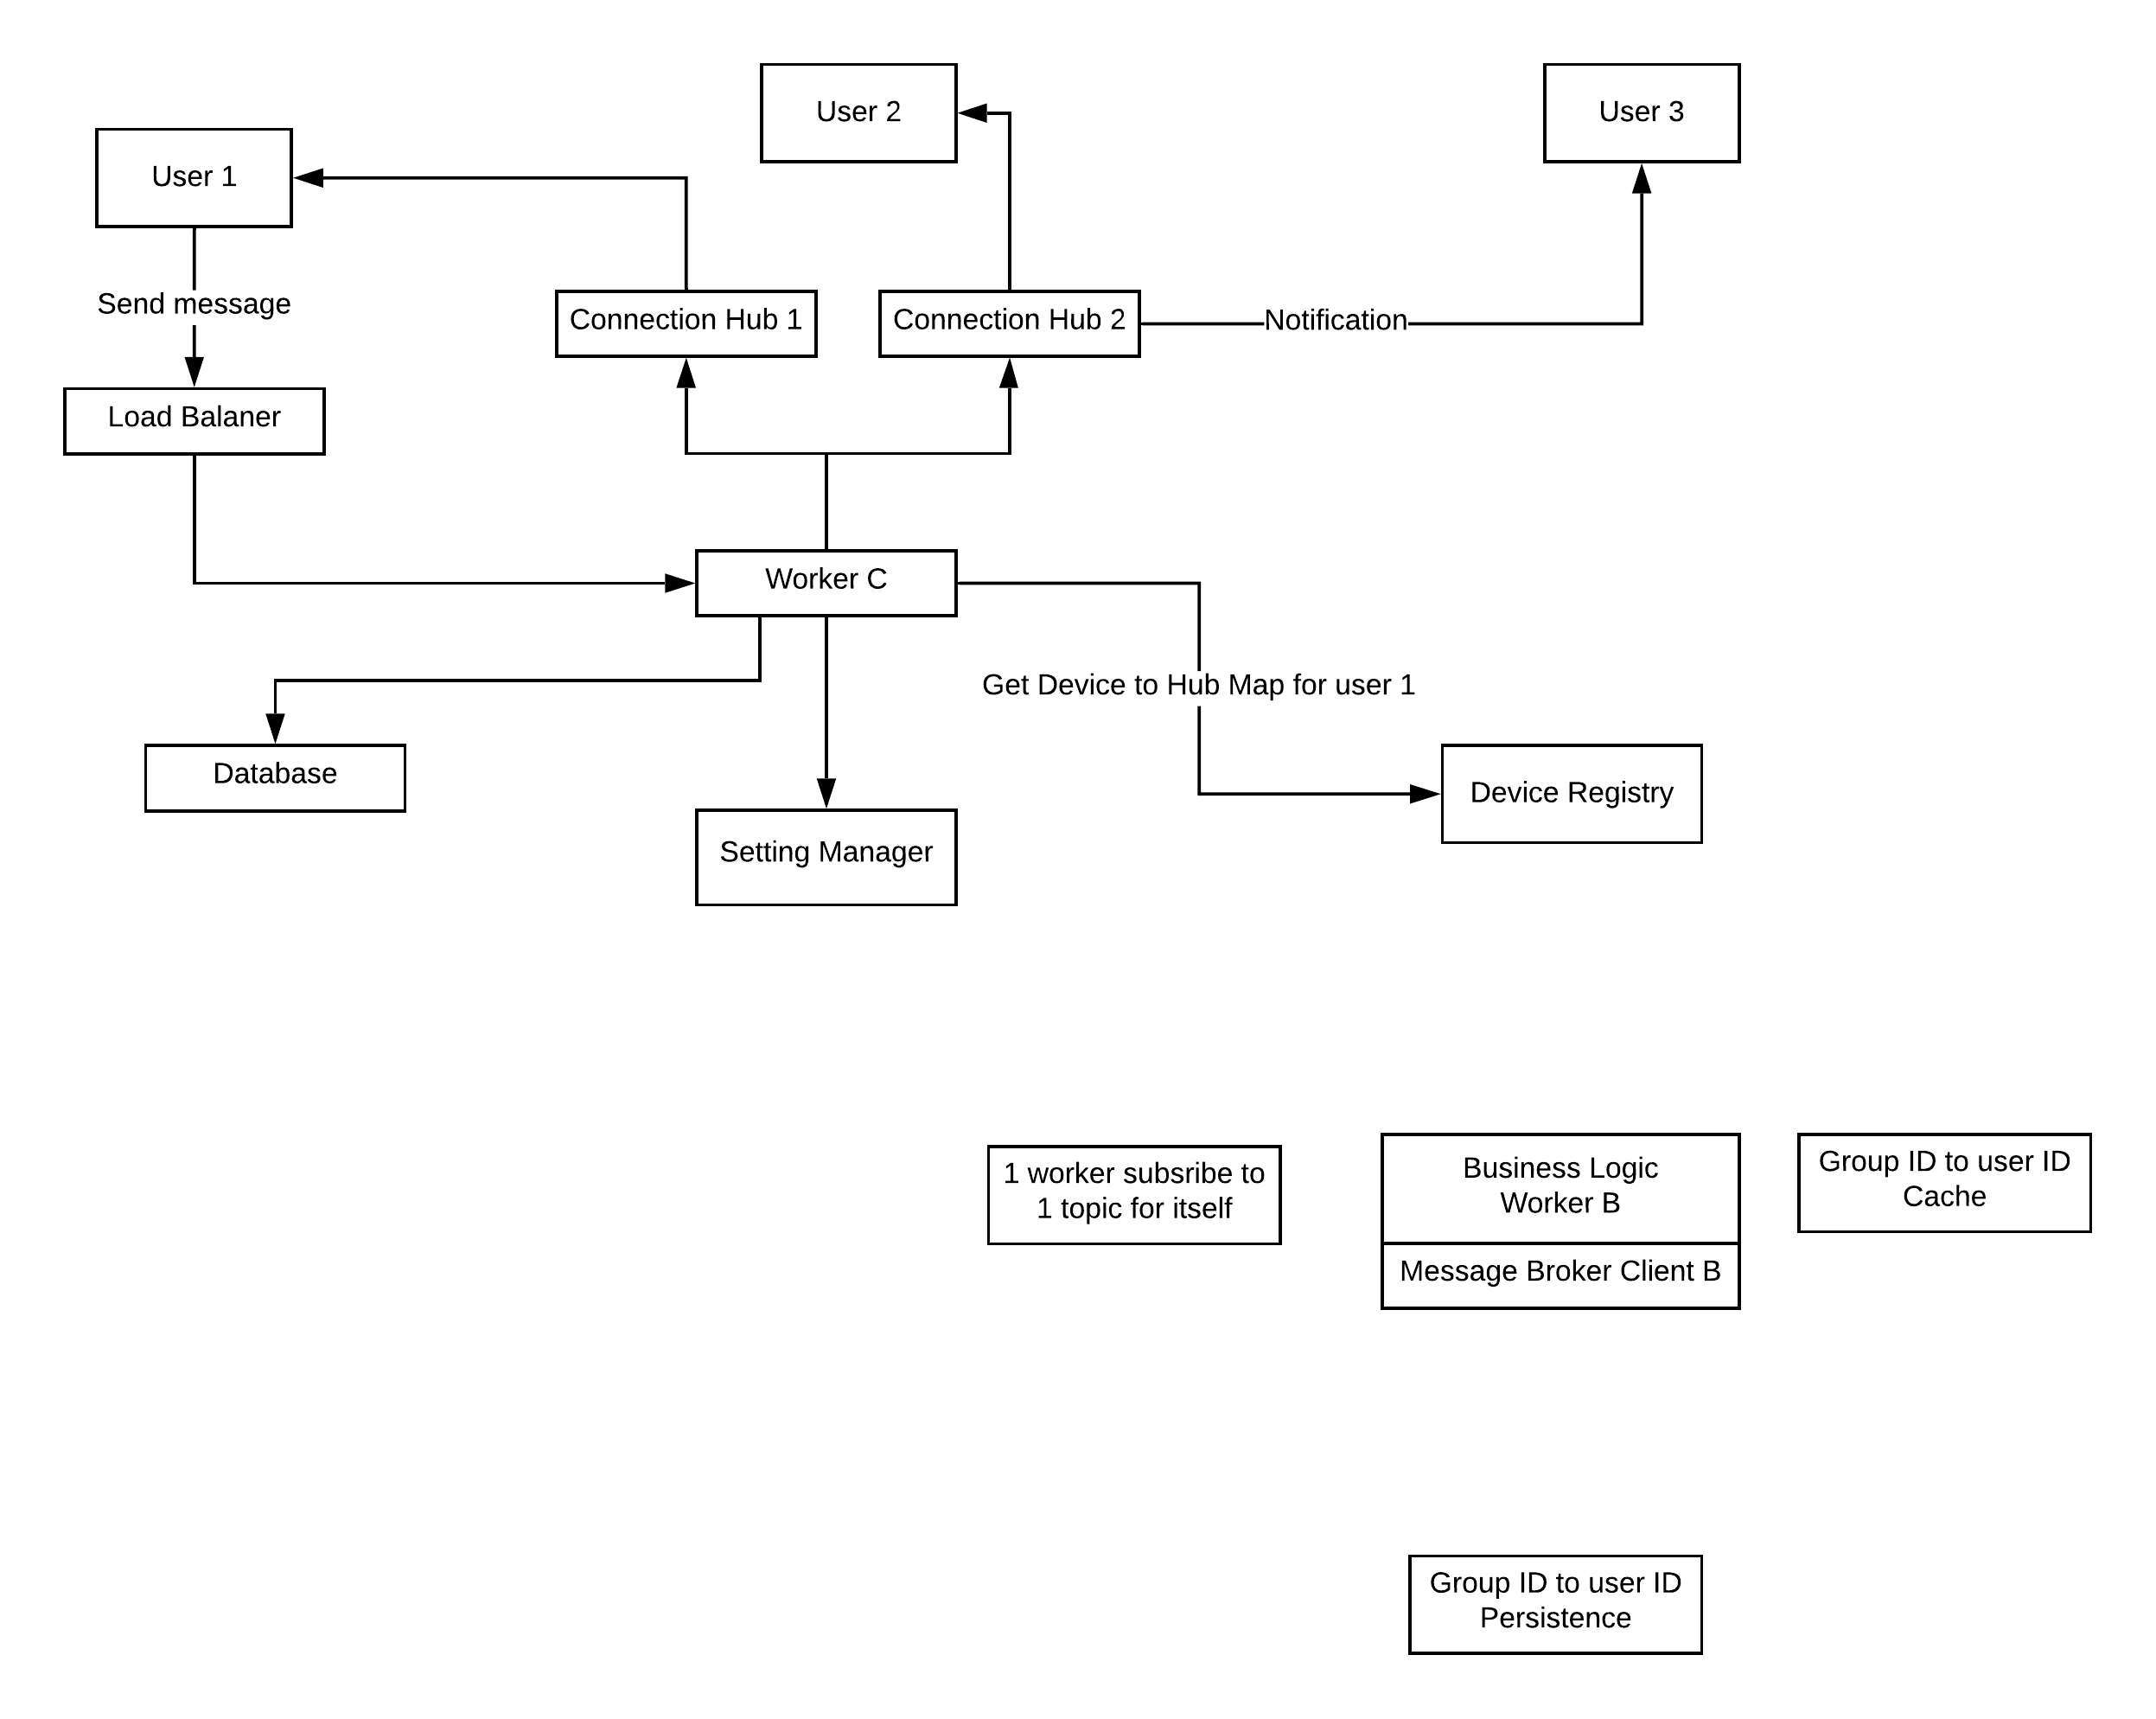

Receive & read message feedback
Online
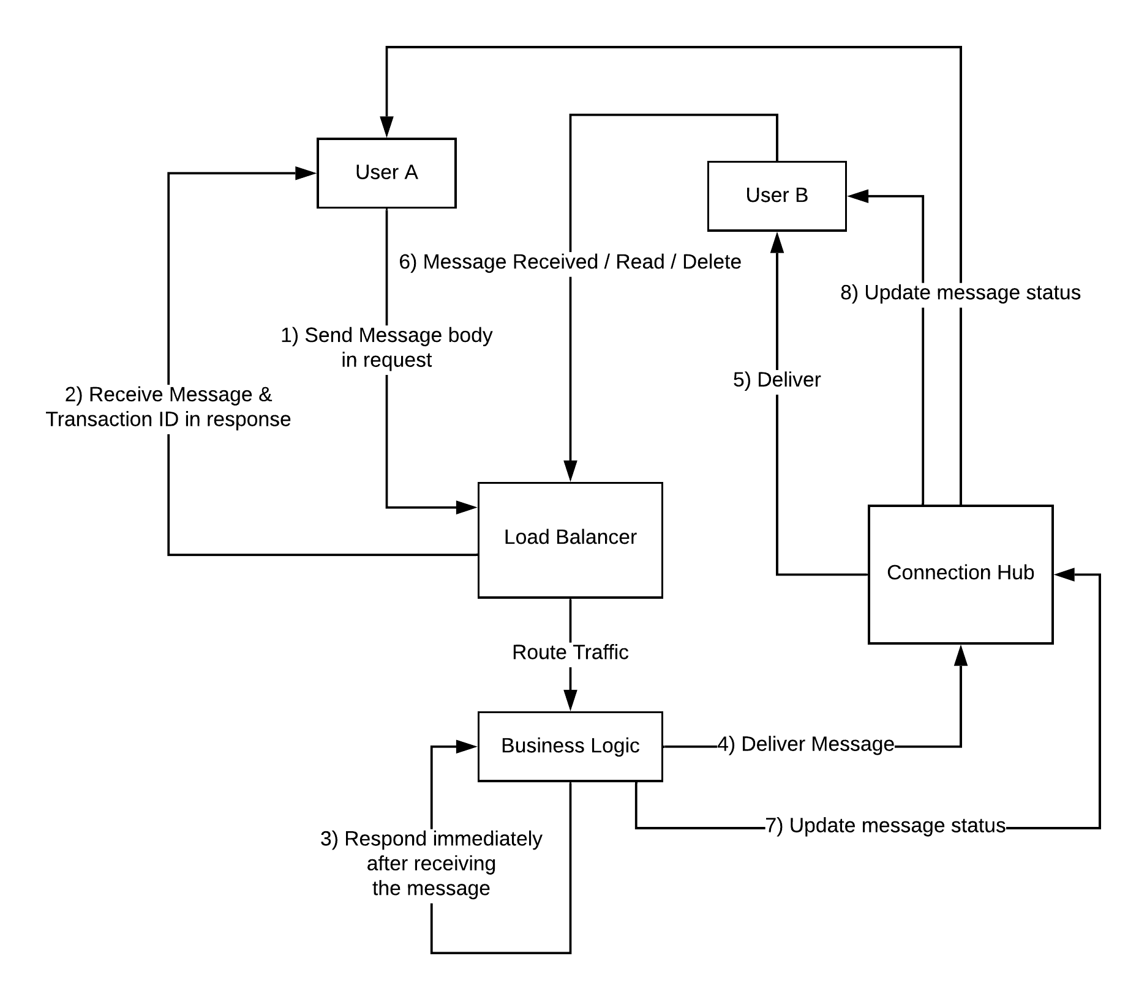
Offline
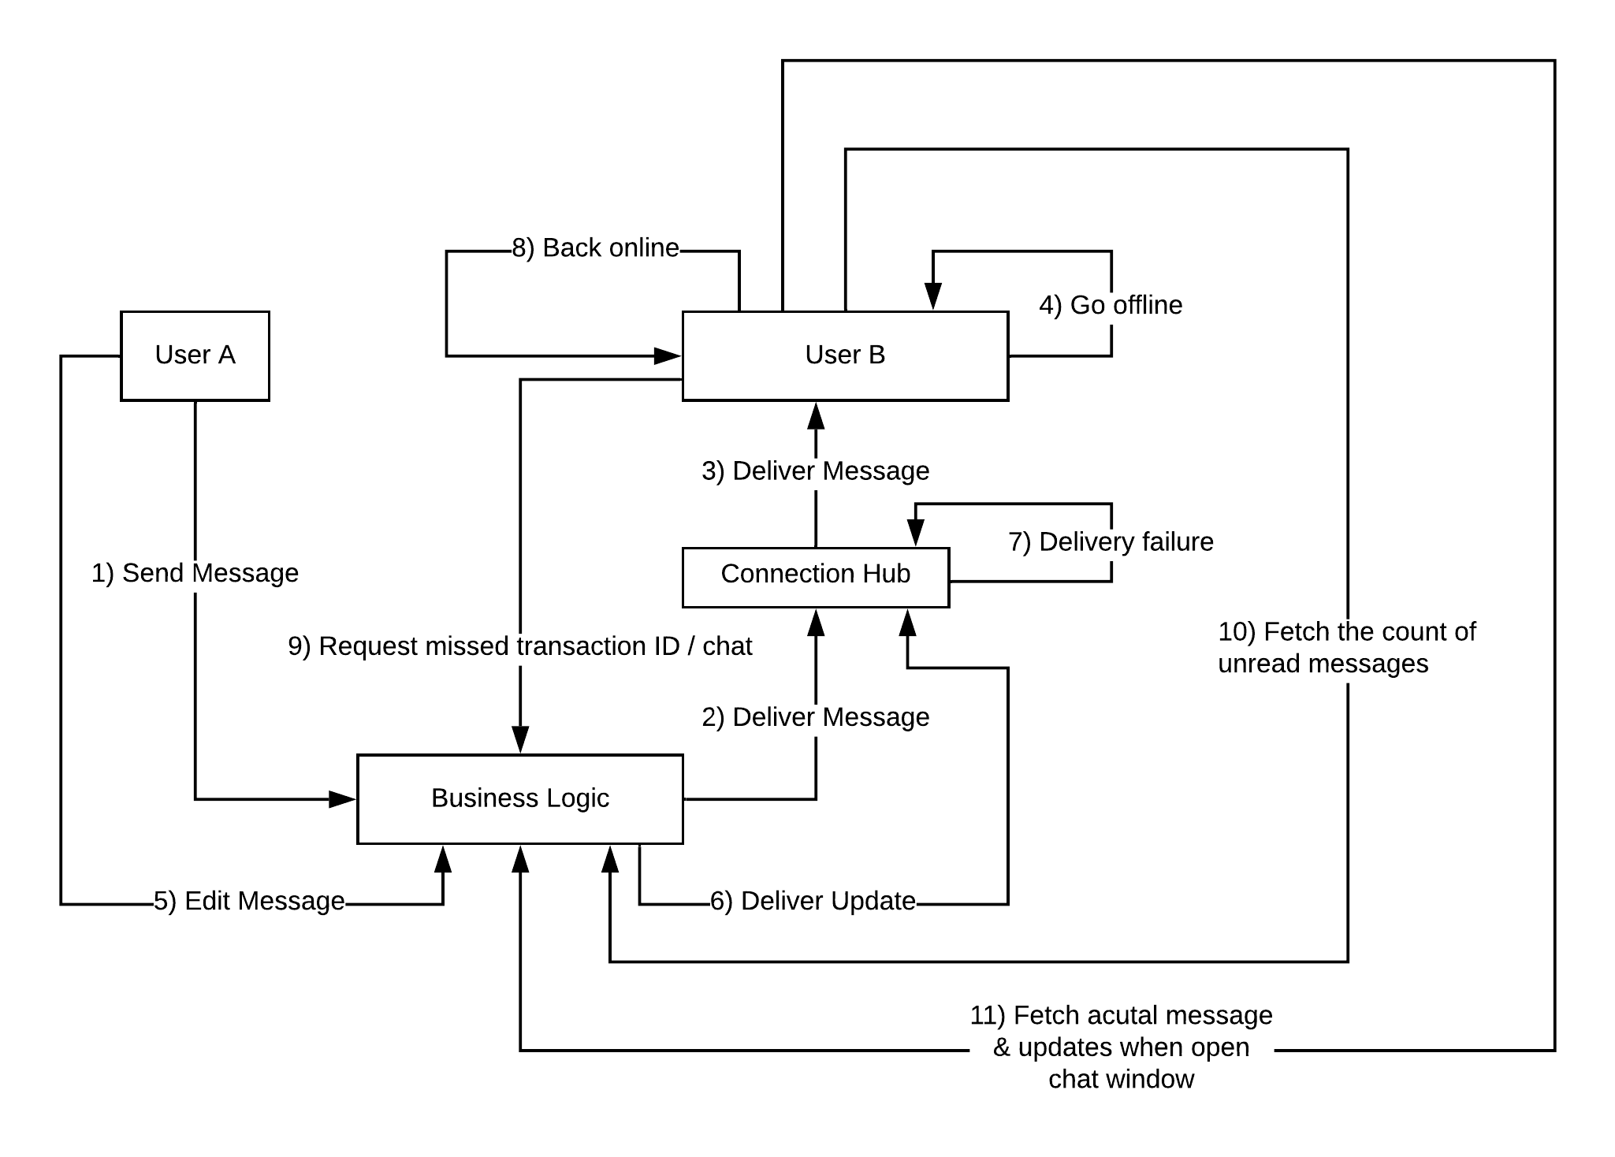

Unique ID generation
- user
- chat
- messages in each chat ( counter service )

Message update
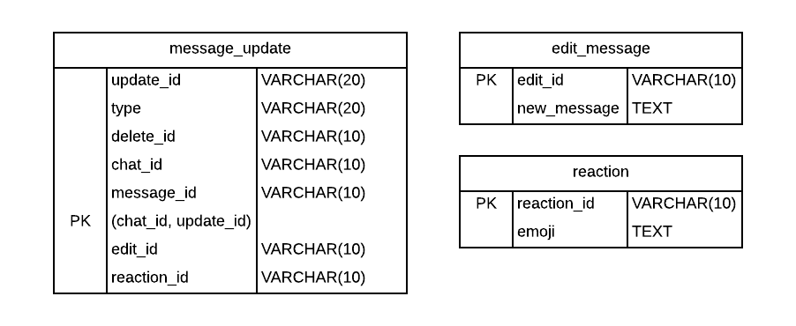
Mutable State vs Transaction

Edit message
Modify the previous message

Delete message

Reply to message
Create a new message

Persistence

Protocol negotiation

Send message detail
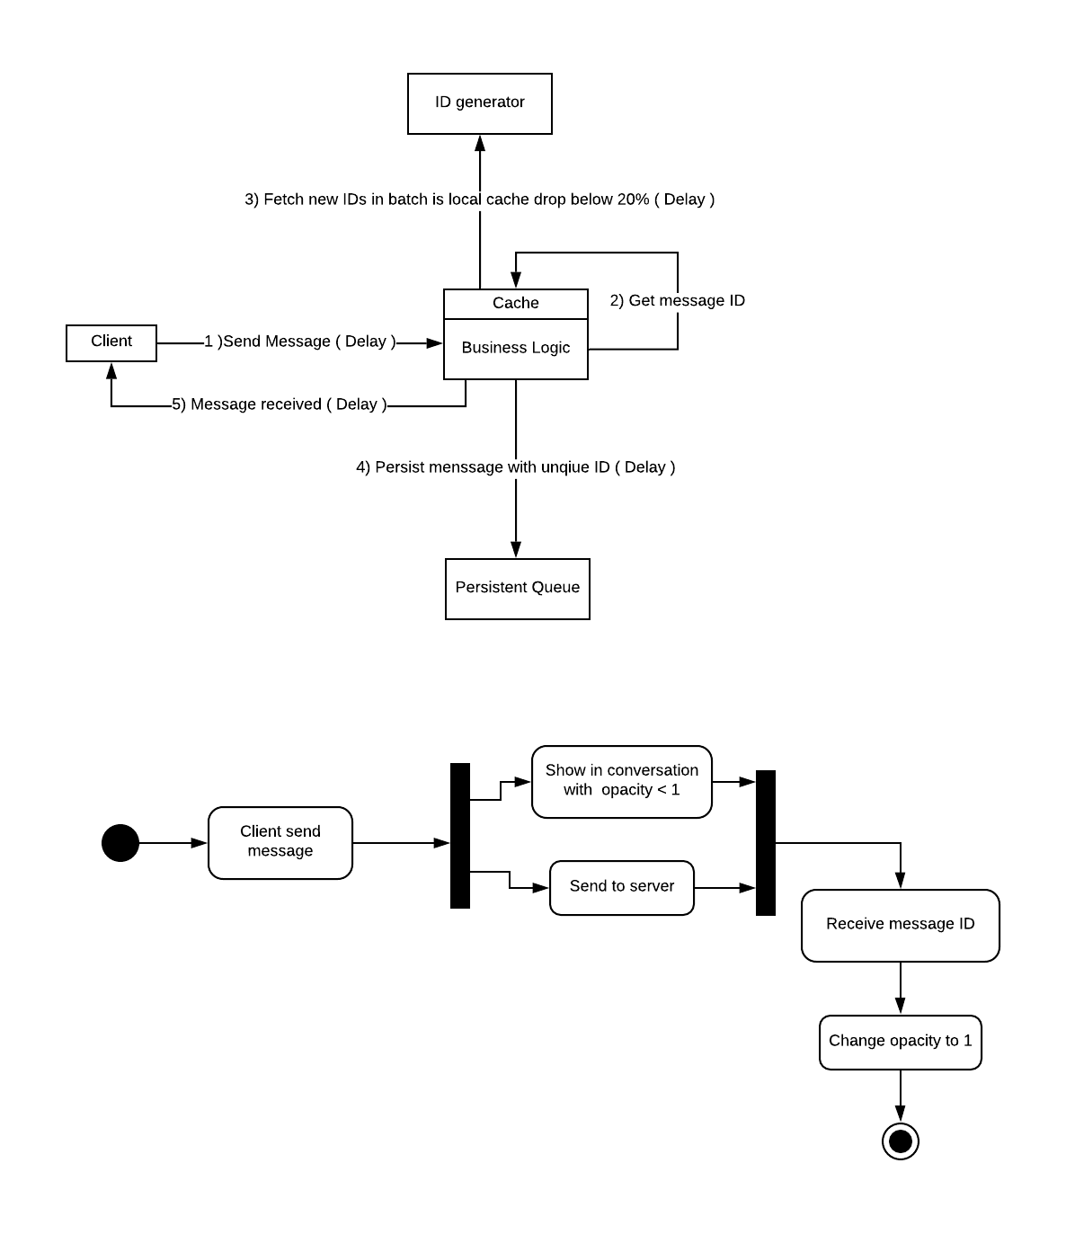

System Behavior Priority
- Audio & video chat connection initiation
- Real time message delivery
- Fetch missed messages & updates when going back online
- Download file, audio, video from static media server

Message Delivery Priority
Allow only one active device at time
- Web notification preferred
- Mobile notification preferred
- Smart watch notification preferred

Or based on user settings

Data Storage
- User data in DB
- Uploaded image, audio & video (file server)
- Client cache
  - Authentication token
  - chatID => lastTransactionID (key-value pair)
  - peer status
  - chatHistory
  - downloaded media

Data Partitioning

Fault Tolerance

Point of failures
- Network congested
- Network temporarily disconnected
- Network permanently disconnected
- Server crashes
- Server restart
- Disk out of storage
- Disk failures
- Service pauses
  - Garbage collector stops the world
  - Memory swapping to disk
  - Different process hogging the CPU
- Lose of logs due to crashes ( acceptable because it’s only for internal debugging & monitoring )

Security

Caching

Testing

Appendix
System Diagrams

References

Contributions
Please add your name if you have already contributed in the following section. If you are planning to contribute, please mark [TODO] beside your name.

P2P Architecture

C/S Architecture
Yang Liu
Ajay Tanikonda
Sejal Shinde
Frankie Liu
Rohith Nedunuri[TODO]

API Design
Yang Liu
Anil Kumar Nandamuri
Rohith Nedunuri
Sejal Shinde
Frankie Liu
Vinod Krishnan [TODO]

Database Schema
Yang Liu
Anil Kumar Nandamuri
Rohith Nedunuri
Sejal Shinde
Frankie Liu
Vinod Krishnan [TODO]

Message Queue ( Kafka )
Rohith Nedunuri[TODO]
Sejal Shinde [TODO]
Abhijit kajranjkar [TODO]
Vinod Krishnan [TODO]

Fault Tolerance
Yang Liu
Rohith Nedunuri[TODO]
Sejal Shinde [TODO]

Transaction System
Yang Liu
Frankie Liu
Sejal Shinde [TODO]
Vinod Krishnan [TODO]
Rohith Nedunuri[TODO]

UI Mockup
Yang Liu
Ajay Tanikonda
Sejal Shinde
Frankie Liu

Documentation
Anil Kumar Nandamuri
Frankie Liu

Coding

Project/Product Management

