Method 1:

1. Configure config/database.yml

Put in your new database: for example:

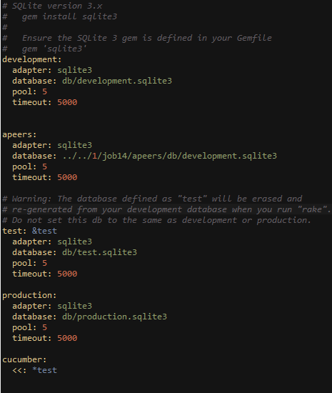

Apeers is the old rails application, I want to use the database from “apeers” in my new rails application.

After you configure the old database, you can create a model without migration:

For example, in old application there is model named: “product”

Then in my new application, you have to create a model with exactly the same name, and you cannot migrate, as migrate is for add/ delete/change something in the database.

In new app: rails g model product –migration=false

In the new product model:

Class Product < ActiveRecord::Base

establish_connnection: products

end

Then all have done, you could use the old database of “apeers” now in the new rails application.

If you want to use lots of model from old application, I highly recommended you to difine a parent class for all tables , for example:





Method 2: using ActiveResourses

The old rails app located in localhost:3000 web port.



Firstly you have to change the new rails app in a new web port:

For example: in config/boot.rb file: add the codes(you can change 3003 to the new port you want)

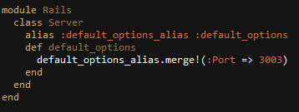

Then in your model :



Then you can also access the database from odd application now.

These two methods could help you access the database, but if you want to share the uploaded images or pdf, then you could use symbolic link, to share the folder which keeps the uploaded files.

For example, share the products folder between these two apps.

