**hyperlyse** manual

Version 1.3.3

**hyperlyse** is a software tool developed within the project “Digital Transformation of the Austrian Humanities” (<https://www.ditah.at/>). It aims at providing an intuitive user interface for viewing and analyzing hyperspectral images, thereby lowering the threshold for using this kind of data in humanist research.

# Getting started

If you have received **hyperlyse** as a .zip archive, unpack it somewhere on your computer.

The program is started by executing hyperlyse.exe. You can create a shortcut (right-click hyperlyse.exe -> create shortcut) and move it somewhere convenient (e.g., the Desktop).

After starting the program, two windows will open:

* Console window: here you see textual output of the software. If something does not work as expected, you might get some clues from the console output.
* Main window: the graphical user interface, where you can do all the things explained in the rest of this manual.

To get started, you need to load a hyperspectral image (a.k.a. hyperspectral cube). This software supports the ENVI format. ENVI data cubes are often accompanied by header files (.hdr) that contain metadata. For opening a file in **hyperlyse**, you should always open the data file itself – it can have different endings, e.g. “.envi” or “.raw” – if in doubt, the largest file should be the right one.

Open such a file by clicking “*File->Load Hyperspectral Image…*”, or by simply dragging it to the image display on the left side of the main window.

# Overview

Figure 1 shows the main parts of the user interface:

* The **image display** shows a visualization of the currently loaded spectral cube and allows the selection of points or rectangular areas, by clicking or dragging with the left mouse button, respectively. The selected point/area is marked on the image.
* The **spectrum display** shows the spectrum of the point or area selected in the image display (if an area is selected, the spectra within this area are averaged). Additionally, spectra stored in a database can be shown.
* The **image controls** influence only the visualization of the spectral cube. The currently displayed visualization can be exported using the “Save Image” button (in the menu,   
  “*File->Save current image…*” does the same).
* The **spectra controls** contain functionalities for selecting and searching database spectra for comparison with the currently selected one, and also provide options for comparison operations.

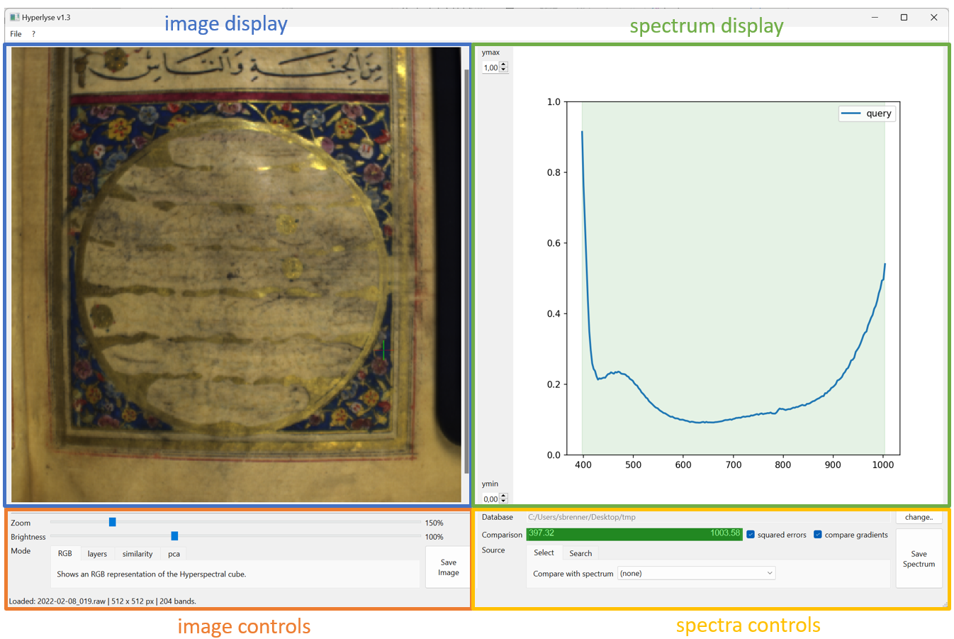

Figure 1: User interface overview

# Modes of Visualization

The **image controls** provide a choice between 4 different modes of visualization (see Figure 2), that can be activated by choosing one of the tabs:

* *RGB*: An approximate “natural color” view of the object. The image is generated by selecting three wavelengths from the cube that best correspond to red, green and blue, and displaying them as an RGB image.
* *layers:* allows viewing single spectral layers. The wavelengths can be chosen with the slider.
* *similarity:* For each point of the spectral cube, the similarity to a reference spectrum is computed and visualized as a color map (blue: dissimilar, yellow: similar). As a reference spectrum, either the currently selected point or a database spectrum can be used. The choice of the database spectrum and mode of comparison (including the range of wavelengths considered and the comparison function) is controlled in the **spectra controls** (see below). The computation of the similarity map can take a while, depending on image size.
* *pca:* here, the results of a Principal Component Analysis (PCA) are shown. The range of wavelengths used for computing the PCA can be adjusted in the **spectra controls** - this is useful if the upper or lower end of the spectrum is very noisy, leading to noisy PCA results.   
  A slider lets you choose between the first 10 components. Simply speaking, if two pixels have the same color in a principal component, they have something in common. Components are ordered by decreasing variance.

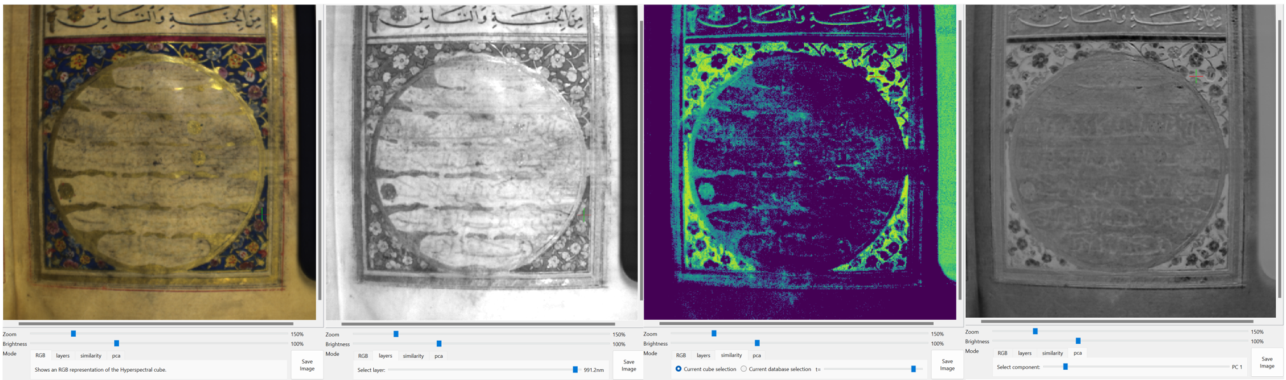

Figure 2: Modes of Visualization

# About the Database

When talking about the “database” in this document, we are really talking about a folder in the local file system, in which a bunch of spectra files in JCAMP-DX format are located. This makes managing databases and their spectra very easy and flexible:

* A new database spectrum is created simply by exporting a spectrum from **hyperlyse**.
* Spectra can be moved and copied between different folders, deleted, etc., just as any other file on your computer.
* As the spectra come in a standardized format, they can then also be imported to other analysis software (e.g., *Opus*).
* To load a database with **hyperlyse**, simply provide a folder path. The software will search the folder and all its subfolders for compatible JCAMP-DX files. Currently, only files produced by **hyperlyse** can be guaranteed to be compatible.

For exporting a spectrum from **hyperlyse**, select a point or rectangle in the **image display** – the corresponding spectrum will be displayed in the **spectrum display** in blue.

Clicking the “*Save Spectrum*” button in the **spectrum controls** (or “*File->Save selected spectrum..*” in the menu) will open a dialog asking for metadata information:

* *Sample ID*: some short name that makes you easily recognize the sample, e.g.: “32r mp5 red”
* *Description*: short free text, e.g.: “brownish red in the flower ornaments”
* *Intensity*: Choose between “light”, “medium” and “dark” (or leave undefined)
* *Source object*: a name of the object from which the spectrum was sampled, such as the name of the pigment collection or the name of an analyzed painting/manuscript.

After pressing “Ok”, a file name and location must be specified. The default filename is composed as:

{original hyperspectral image}_{selection coordinates}_{source object)_{sample id}.jdx

…but you can name the file just as you like, this has no influence on anything.

The thus created JCAMP-DX file can be opened with any text editor. The manually entered metadata are found in the fields “##TITLE” and “##SAMPLE DESCRIPTION“ at the top section of the file, and can be edited if required (at own risk). Just be sure to preserve the blank space after the “=” and the “|” symbols separating pieces of metadata. Otherwise, **hyperlyse** has trouble reading back the metadata.

Together with the JCAMP-DX file, a .png image with the same base name will be exported, on which the selected point or area is shown.

Within **hyperlyse**, the currently loaded database folder is displayed at the top of the **spectra controls**. To load a database from a different folder, click the “*change..*” button and load a different one. In the menu, “*File->Set database..*” does the same.

# Spectra Comparison

The **spectra controls** provide options for comparing the spectrum of a selected point in the cube (the “query” spectrum) with a database spectrum. You have two basic options, depending on which tab is selected:

* “*Select*”: you can choose a database spectrum from the dropdown menu. This spectrum is then displayed in the spectrum display on top of the query spectrum, and the mean error between the two is shown in the legend.
* “*Search*”: the query spectrum is compared to all other spectra in the database, and the *k* most similar spectra are shown, together with their mean errors. The number *k* of shown spectra can be specified in the spin box.

Furthermore, the way in which the errors between spectra are calculated can be specified:

* With the green range slider, you can specify a specific part of the spectrum that is used for comparisons. For example, this can be used to ignore the noisy lower and upper ends of spectra. The transparent green area in the **spectrum view** visualizes the selected range.
* If the “squared errors” checkbox is checked, squared differences are computed; otherwise, absolute differences are computed.
* If the “compare gradients” checkbox is checked, the gradients (i.e., first derivatives) of the spectra are compared; otherwise, the absolute intensities are compared. Usually, comparing gradients makes more sense, as this eliminates shifts along the y-axis.

The settings made in the **spectra controls** (chosen database spectrum, comparison parameters) are also applied in the “similarity” image visualization mode.

# The Config File

In the main directory of the software (where also the hyperlyse.exe is located), you find a file “config.json”. It can be opened with any text editor. Here you can change some settings of the software. For example, in the line

"DEFAULT_DB_PATH": ".",

You can set a standard path for a database directory, which is loaded automatically when the software is started. For example, change the line to:

"DEFAULT_DB_PATH": "C:/the/path/to/your/database",