**ABSTRACT**

The project aims to design a user-friendly social media platform for chefs and food enthusiasts, focusing on creating an intuitive and visually appealing interface using Figma. The design process involved wireframing, prototyping, and user testing to ensure a seamless user experience.

The app's key features include user and other chef profile management, restaurant tracking, community engagement, personalized feeds, event integration, trending recipes, and a marketplace for various recipes. The design emphasizes usability, accessibility, and responsiveness across devices.

The completion of the UI/UX design phase provides a solid foundation for further development and deployment. The project prioritizes user-centric design principles and continuous iteration, aiming to create a feature-rich application that fosters a community for chefs and becomes a central platform for recipe-related interactions

1. **PROJECT DESCRIPTION**

**Title: RESTAURANT INSPIRED RECIPE APP**

**1.1 Objective:**

* The goal of UI/UX design for a restaurant inspired recipe app is to create an engaging, intuitive, and effective digital platform that allows various restaurants and chefs to provide their recipes to all the newbie chefs out there.
* It also provides a chance for the new chefs to create their own recipes and recreate various recipes out there.

**1.2 Scope:**

1. **Research & Discovery**: Understand user needs through research and analyze competitors to identify best practices.
2. **Information Architecture**: Develop a clear site map and content strategy to ensure organized and accessible information.
3. **Design**:

* Wireframes: Create basic layouts to plan functionality.
* Visual Design: Develop appealing and on-brand visual elements.
* Prototypes: Build interactive models for testing design concepts.

1. **UI Design**: Focus on accessibility, responsiveness, and visual consistency to ensure usability across devices and by all users.
2. **UX Design**: Design intuitive navigation, engaging new chef profiles, and recipe creation from restaurants and popular chefs.
3. **Development Collaboration**: Provide detailed design specifications to developers and collborate during the build to ensure accurate implementation.
4. **Usability Testing**: Conduct tests with real users to identify issues and refine the design based on feedback.
5. **Launch & post-launch**:

* Deployment: Oversee the site or app launch and ensure functionality.
* Monitoring: Use analytics to track performance and user engagement.
* Feedback: Continuously gather feedback and update the platform as needed.

1. **Training & Support**: Train new chefs for creating restaurant style recipes and provide ongoing technical support.

**1.3 Summary:**

* Snapchef is your go-to mobile app for connecting with different restaurants and chefs for different recipes. This user-friendly platform streamlines the recipe creation process, allowing users to browse, search, and recreate their favourite recipes.

1. **TOOLS AND TECHNOLOGIES**

For the development of the Animal Shelter project, we utilized the following tool:

**2.1. Figma:**

* Figma is a powerful design tool that allows for the creation of intuitive and visually appealing user interfaces. It provides a collaborative environment where multiple team members can work simultaneously on the design. Figma's features, such as vector graphics editing, prototyping, and user interface design capabilities, were instrumental in developing the UI/UX for our social media app. By using Figma, we ensured a streamlined design process and the creation of a cohesive and user-friendly interface for our application.

1. **SYSTEM STUDY AND SYSTEM DESIGN**

**3.1 System Study:**

The restaurant inspired recipe app is a app-based platform designed to facilitate the recipe creation process, manage restaurants and engage users in interacting with trending recipes and chefs.

1. **User Groups:**

* Admin: Restaurants and chefs who manage new chef profiles and recipe creation.
* Restaurants: Restaurants from across the world which provide recipe for various dishes.
* Chefs: Various experienced chefs that help new chefs to learn the recipe easily.
* Food Enthusiasts: People who want to learn new recipes.

1. **Functional Requirements:**

* User Profile Management: Create, edit, and delete User profiles.
* Recipe Creation Process: Manage recipe creation from restaurants and chefs.
* Search and Filter: Implement a robust search and filter system for new chefs.
* Trending Recipes: Try out world’s top recipes at home with detailed instructions.
* Gain Recognition: Create your own recipes and interact with others.
* Reporting and Analytics: Generate reports on recipe creation and interaction with other users.

1. **Non-Functional Requirements:**

* Usability: Intuitive and user-friendly interface.
* Accessibility: Compliant with accessibility standards.
* Performance: Fast loading times and efficient data retrieval.
* Security: Ensure data protection and secure transactions.

1. **Wireframes and Prototypes:**

Create low-fidelity wireframes and high-fidelity prototypes to visualize and test the system's layout, navigation, and functionality.

1. **Usability Testing**

Conduct usability testing with real users to identify areas for improvement and ensure the system meets user needs.

1. **Design Principles**

* Simple Navigation: Easy-to-use navigation and information architecture.
* Clear Typography: Readable typography and clear content hierarchy.
* High-Quality Images: Showcase high-quality animal photos and videos.
* Responsive Design: Ensure a seamless user experience across devices.

By following this system study, the UI/UX design of the restaurant inspired recipe app can effectively support recipe creation, engage users, and facilitate the recipe learning process.

**3.2 System design**

Since the project scope was limited to UI-UX design, the system Design phase primarily encompassed creating intuitive interface and user flows to enhance the application’s usability and visual appeal. This phase involved:

1. **UI/UX Design Elements:**

* **User Interface Design:** Detailed design of screens and components using Figma, focusing on aesthetics, usability, and consistency.
* **User Experience Design:** Crafting user journeys and interaction flows to ensure seamless navigation and engaging user interactions within the app.
* **Prototyping:** Developing interactive prototypes to simulate user interactions and gather feedback for iterative improvements.

##### UI/UX Design Tools and Techniques:

##### Utilized Figma extensively for creating wireframes, high-fidelity designs, and interactive prototypes.

##### Implemented design principles such as consistency, hierarchy, and accessibility to optimize user experience across different devices and screen sizes.

##### https://miro.medium.com/v2/resize:fit:700/1*CChsgAX5GbuTD6pJoDKiVw.pngData Flow Diagram:

##### Implementation:

##### Splash Screen Create Account 1 Create Account 2

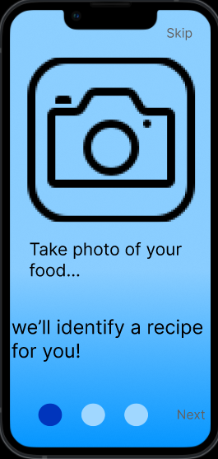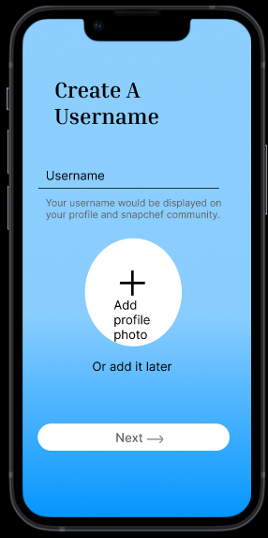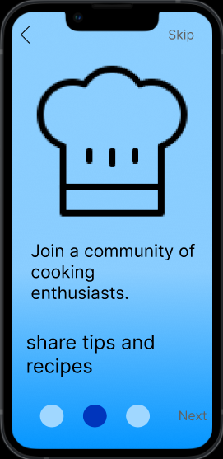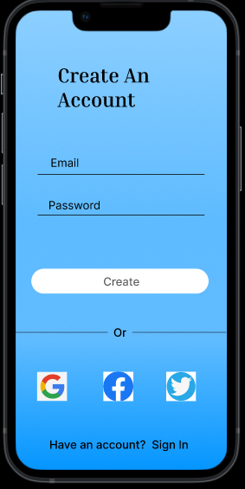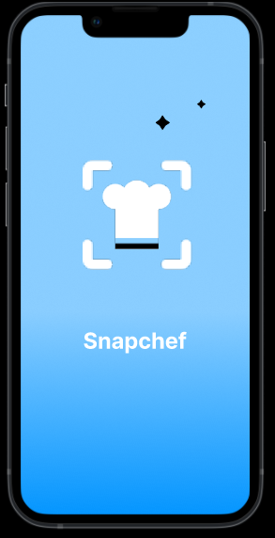Create Account 3 Onboarding 1 Onboarding 2

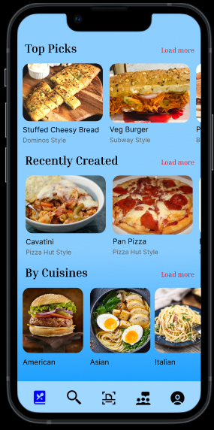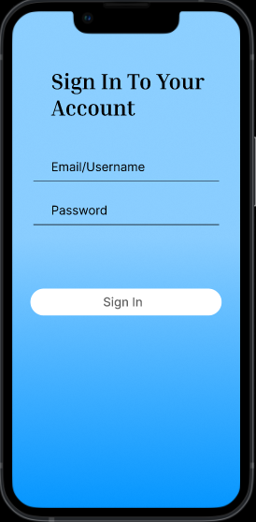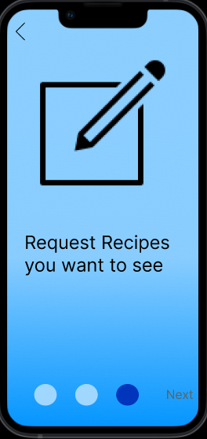 Onboarding 3 Sign In Discover Tab

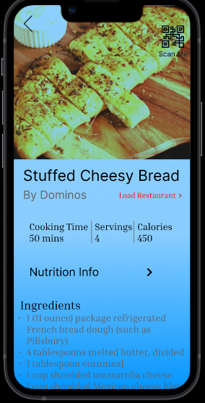

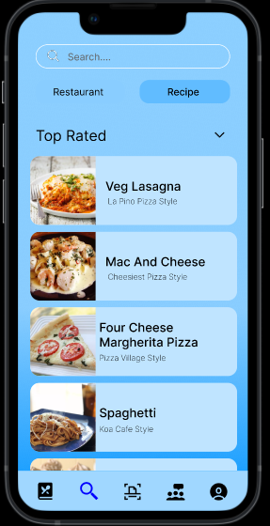 Recipe Info Search-Restaurant Search-Recipe

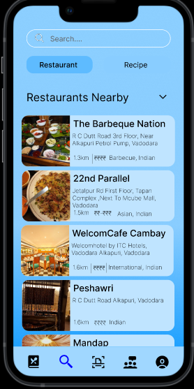

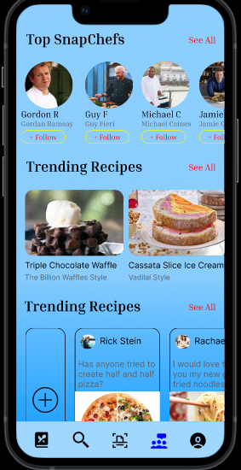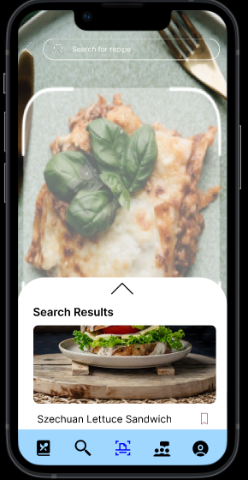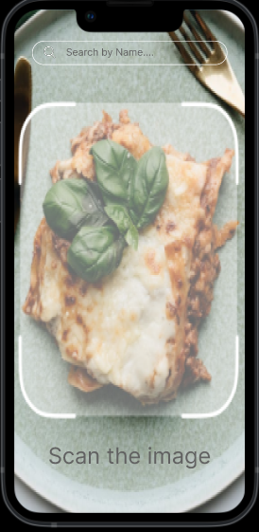 Camera Scan Community

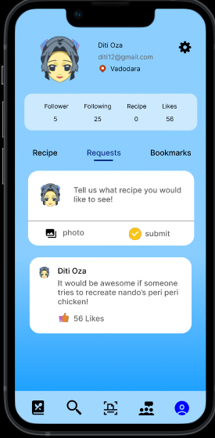 Chef Profile My Profile-Recipe My Profile-Requests

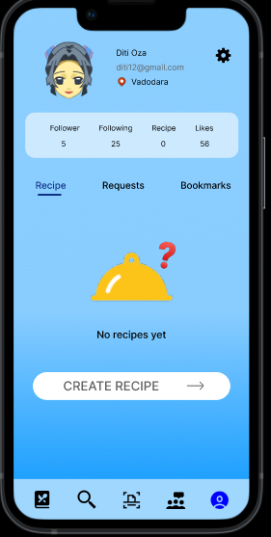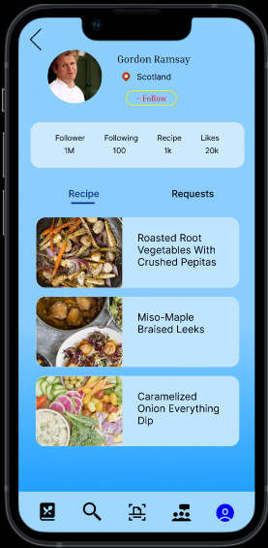

#### CONCLUSION

* The restaurant-inspired recipe app is designed to bridge the gap between dining out and home cooking, allowing users to recreate their favorite restaurant dishes with ease and confidence.
* This app not only aims to simplify the cooking process but also seeks to inspire users to explore their culinary creativity, making home cooking as enjoyable and rewarding as dining out.
* By continuously gathering user feedback and iterating on features, we can ensure the app remains relevant and beloved by its users.

1. **REFRENCES**

* [**https://medium.com/@santosa.jessicaa/designing-a-restaurant-inspired-recipe-app-a-ux-ui-case-study-6e84c5a45391**](https://medium.com/@santosa.jessicaa/designing-a-restaurant-inspired-recipe-app-a-ux-ui-case-study-6e84c5a45391)
* [**https://chat.openai.com/**](https://chat.openai.com/)
* [**https://www.figma.com/**](https://www.figma.com/)