Module:- Public Key Infrastructure Date:- 16/09/2022
Assignment :- 02

CRYPTOOL :-
Practical:- Digital Signature Certificate (DSC)
Step- 1:- Open the Cryptool and it’s show many option. Then we can select Digital Signature/PKI PKI Generate/Import Keys.
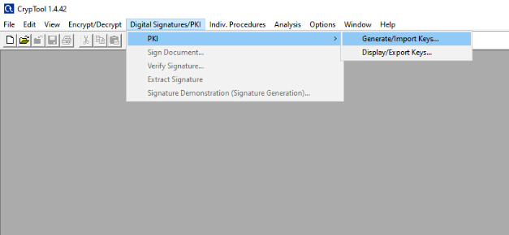
Step-2:- this step show Generation of an Asymmetric Key Pair. In this Key pair show’s three radio button then we can select RSA ,his parallel way user data show’s text box Last Name, First Name, key Identifier(optional) and PIN .we can put all data in text box and Generate New key pair.
Last Name :- NIKAM
First Name:- PRITHVIRAJ
Key Identifier(optional):-
PIN:- ****
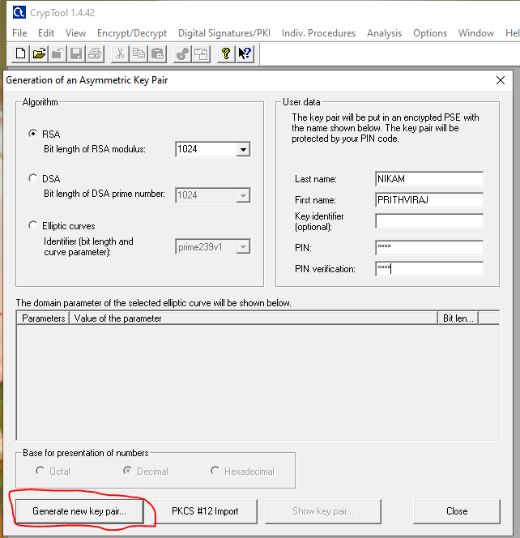
Step-3:- Key Generater opening new popup that show your Key pair successfully created.
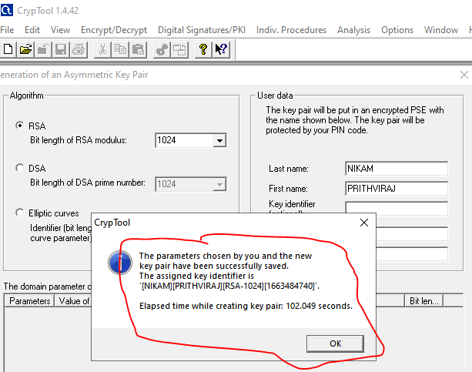
Step-4 :- After key Creation, new window show’s available Asymmetric key pair and we can select show certificate option.
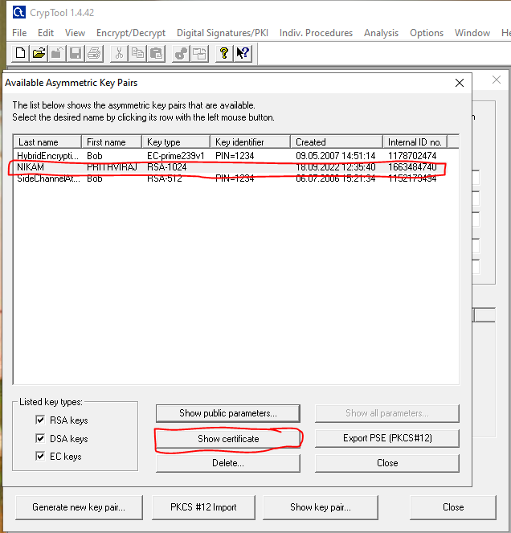
Step- 5 :- The Certificate show all Certificate data .
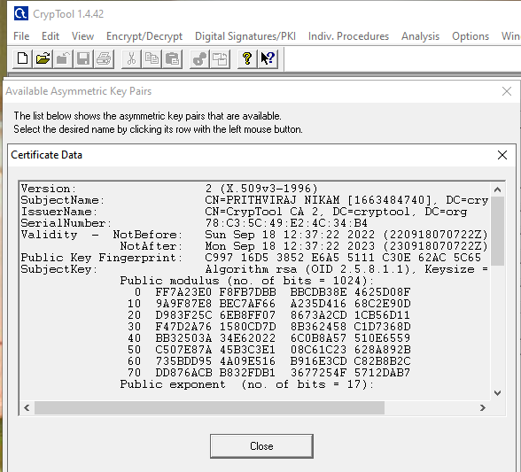
Step-6:- Back to step-4 and select Export PSE(PKCS#12) and tool open new popup that show three text box PSE PIN and PKCS File PIN(***) and it’s verification. Select ok.
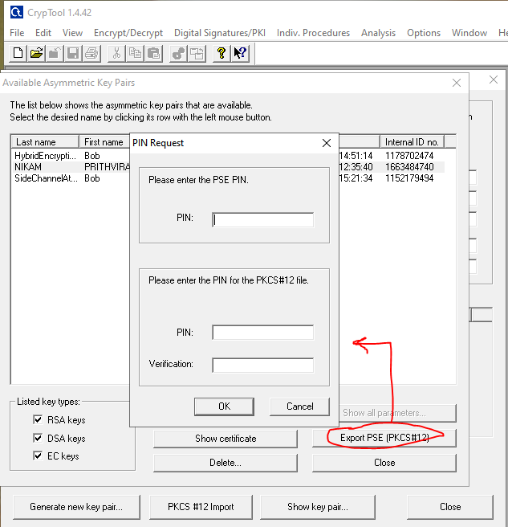
Step- 7:- After clicking ok option opening System Directory. We can Select any folder to store Certificate.
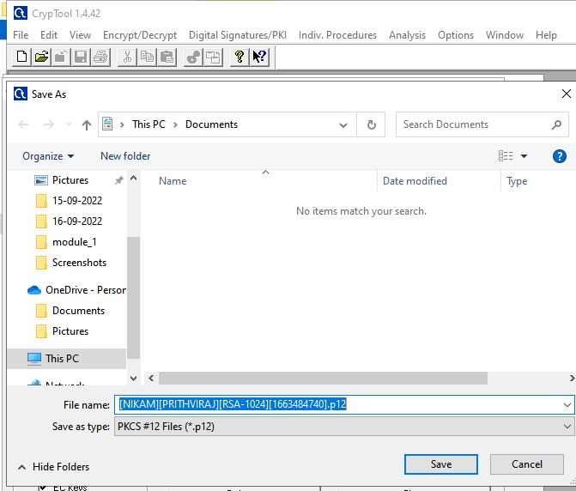
Step- 8:- After saving the certificate. Select the certificate put PSE Password and open new window show’s three PKI items.
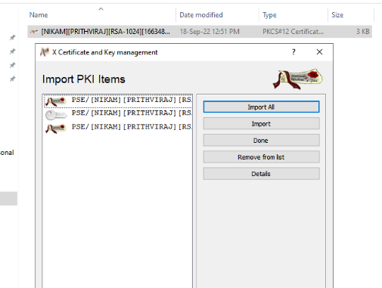
Step-9 :- PKI Item show Key details and Certificate Details.
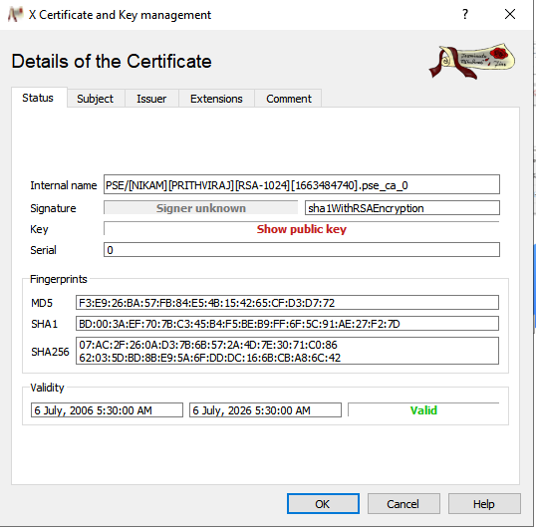
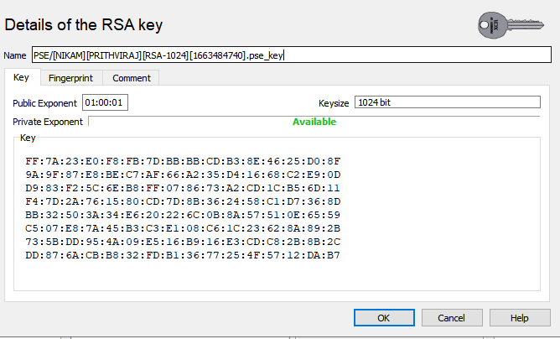

XCA TOOL:-
PRACTICAL:- Digital Signature Certificate (DSC)
Step – 1:- Open XCA tool and select New Database Option.
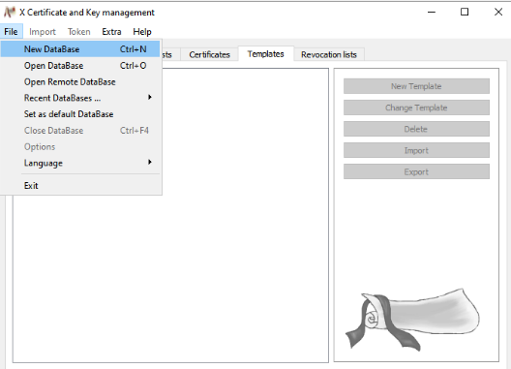
Save New Data Base file into any folder of system.
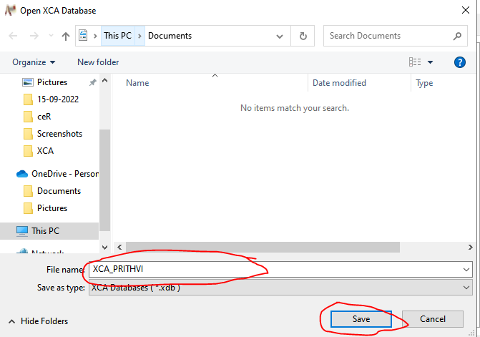
After Saving Set Password.
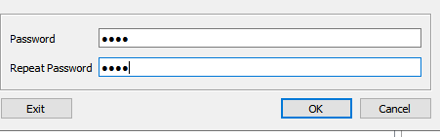
Step -2:-Now select Certificate option and then select New certificate option.
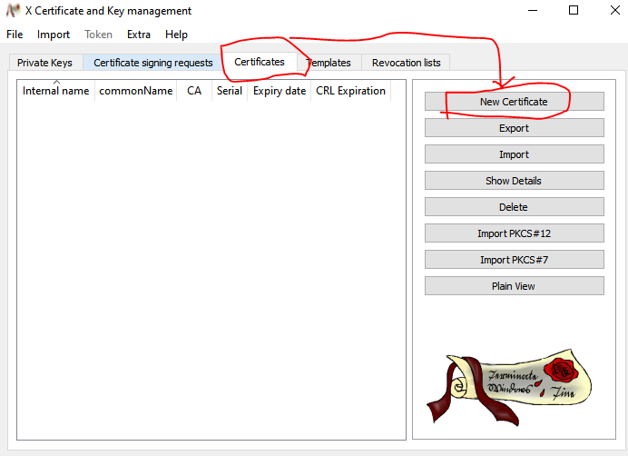
Step -3:- Now , after opening new certificate in XCA tool open new window and Create Certificate that have many text box such as.
Internal name:- PRITHVIRAJ
Country name:- IN
State :- MADHYAPRADESH
Locality :- BURHANPUR
Organization name :- CDAC
Organization Unit Nmae :- CDAC
Common Name:- PRITHVI
Email-ID :- patilnikam813@gmail.com

And then we can select Generate new Key option.
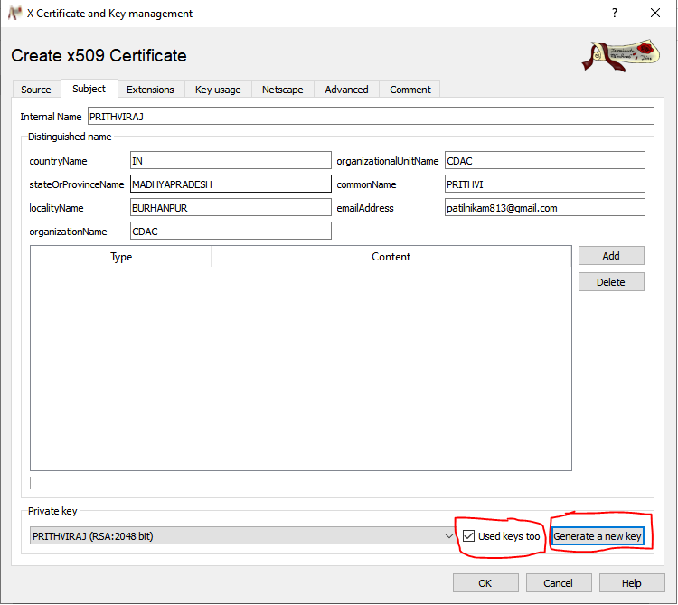

New Key generator generate is following image .
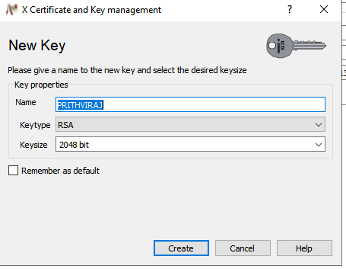
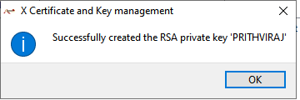
Step -4 :- After we can select Extensions when we can select End Entity and Time Period
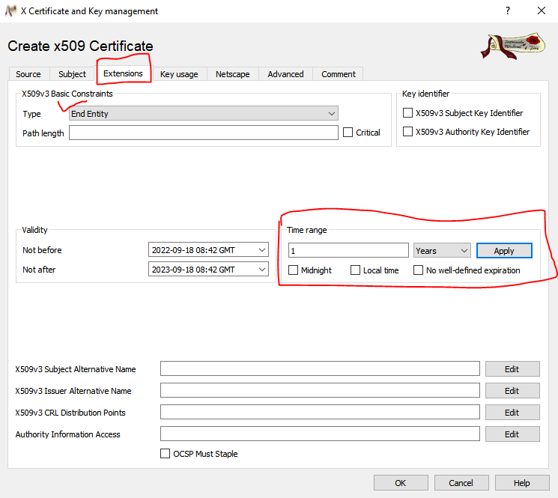
Step- 5:- Now we go to Key usage Option when we select Digital signature ,Non Repudiation and Certificate Sign option and last select ok.
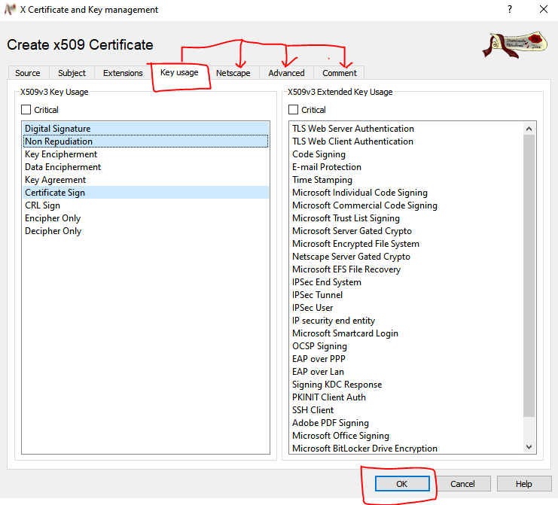
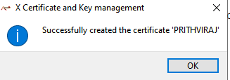
Step -6 :- After certificate creation open new popup that we can set path.

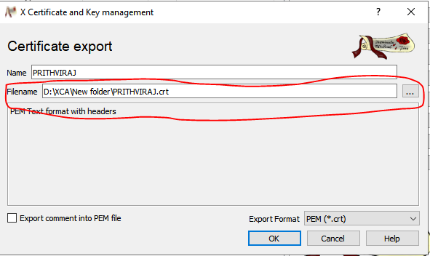
Step -7:- We can go to Directory when store Certificate and select PRITHVIRAJ.crt and show details of Certificate.

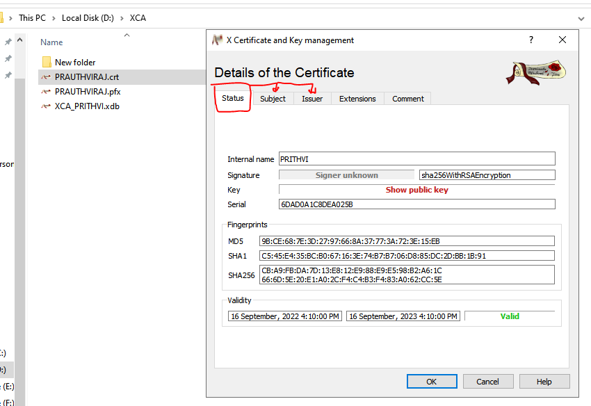
Now we can select Subject that show RSA Key
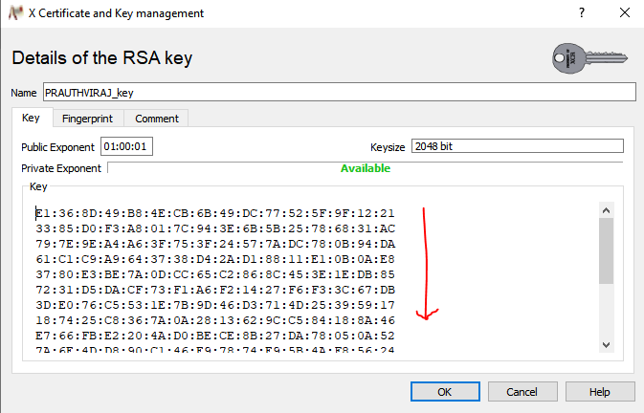
Step -8:- Now we can select PRITHVIRAJ.pfx and Select PRITHVIRAJ_KEY option and Click it.
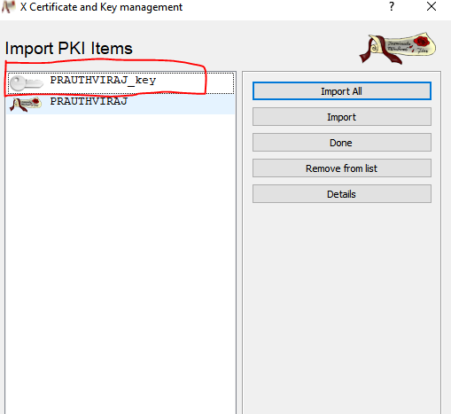
After Clicking on PRITHVIRAJ_key open new popup that show password Enter option and put password on it.
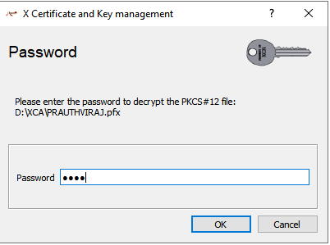

Now Open new window that show Certificate Details.
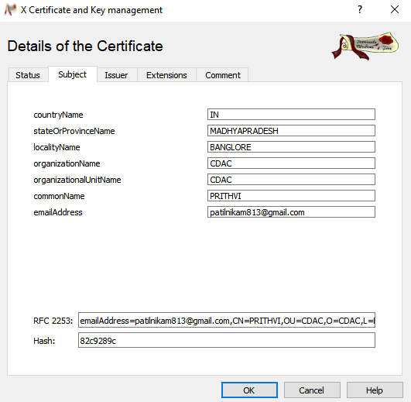

OPEN SSL:-
PRACTICAL :- Digital Signature Certificate (DSC)
Step – 1:- To check the version of openssl
Command:- openssl versio –a
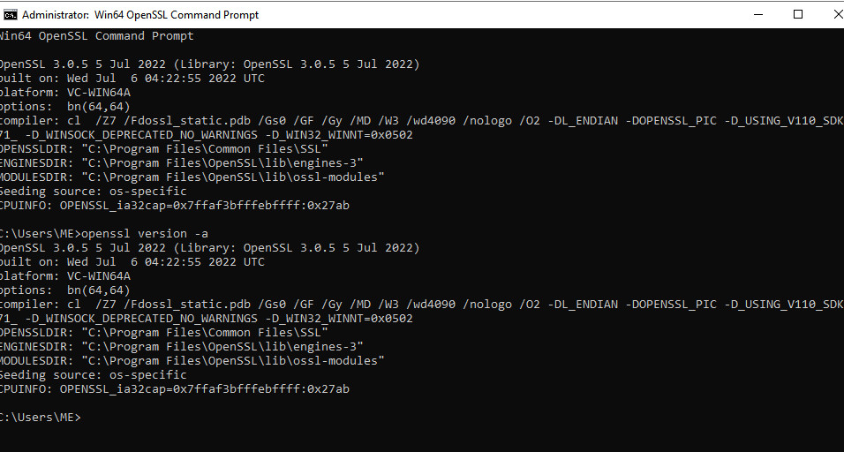
Step- 2 :- To Generate key pair:-
Command:- openssl genrsa -out name_of_your_file_cont_thekeypair.key
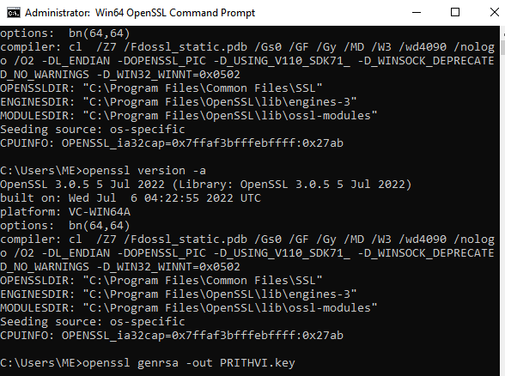
Step- 3:- To Extract the public key form the key pair file:
Command :- openssl rsa -in name_of_your_file_cont_thekeypair.key -pubout -out public_key_file.key
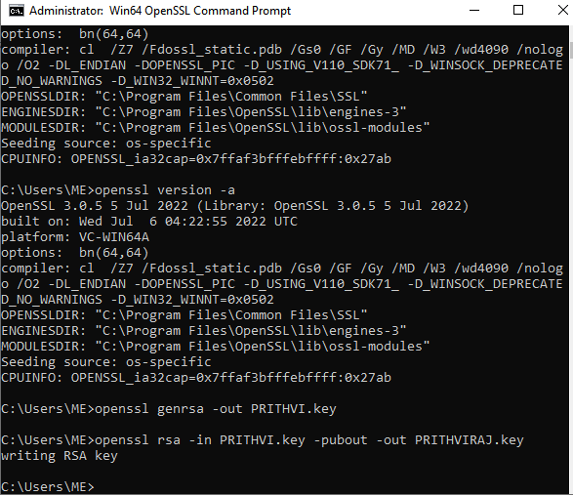
Step- 4:- To Create certificate signing request:-
Command:- openssl req -new -key name_of_your_file_cont_thekeypair.key –out name_of_the_csr_file.csr
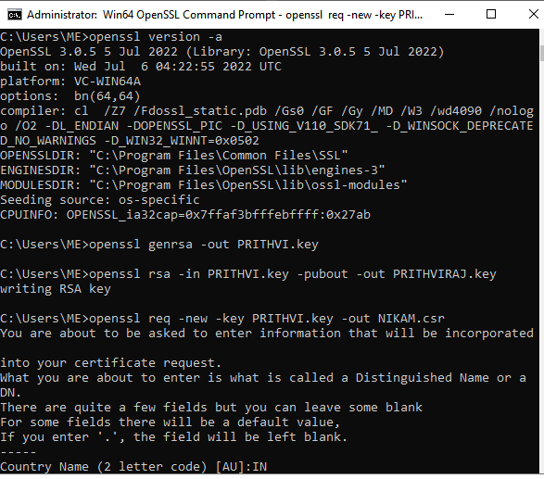

Step- 5:- To verify the details of csr
Command:- openssl req -text -in name_of_the_csr_file.csr -noout –verify
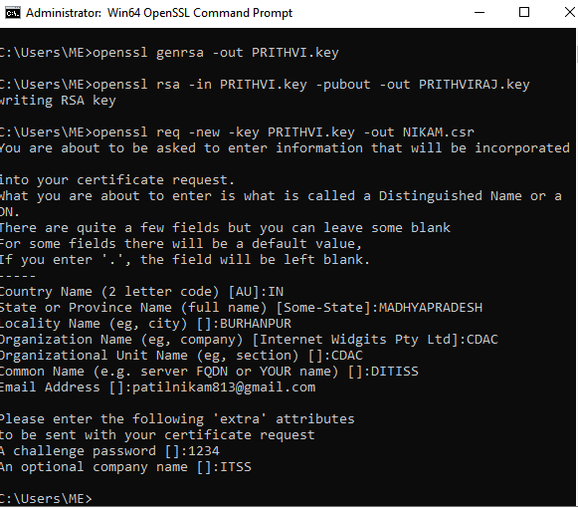
Step – 6:- To Genrate the Self Sign certificate
Command:- openssl x509 -in name_of_the_csr_file.csr -out name_of_the_certificate_file.crt -req -signkey name_of_your_file_cont_thekeypair.key -days 365
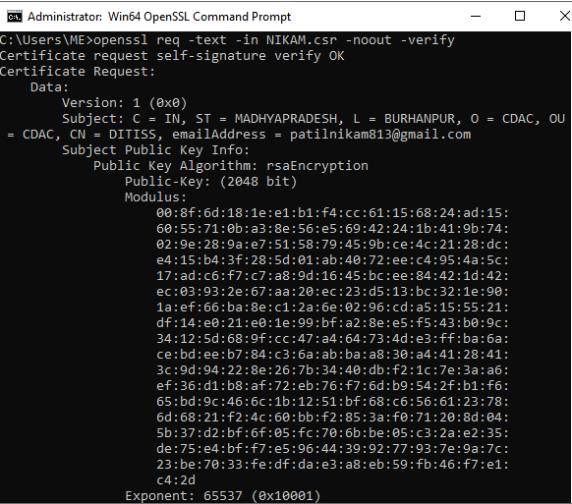

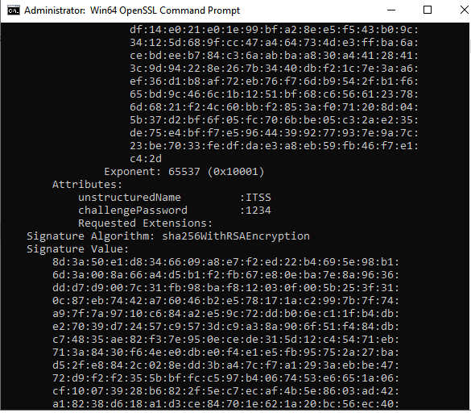

Step- 7:- To Export the crt file into PFX file ( pfx file for windows)
Command:- openssl pkcs12 -export -in akshay.crt -inkey akshay.key -out akshay.pfx

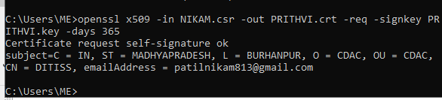
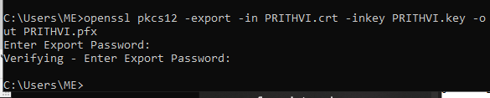

Step-8:- We can go to Directory when store Certificate and select PRITHVIRAJ.crt and show details of Certificate.

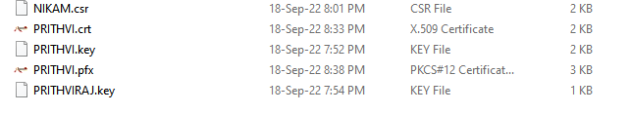
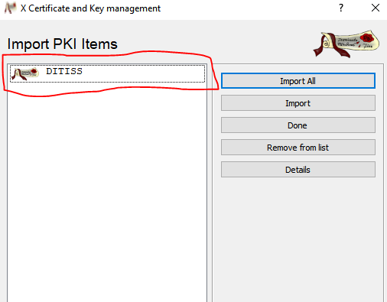
Now we can Show the detail of Certificate
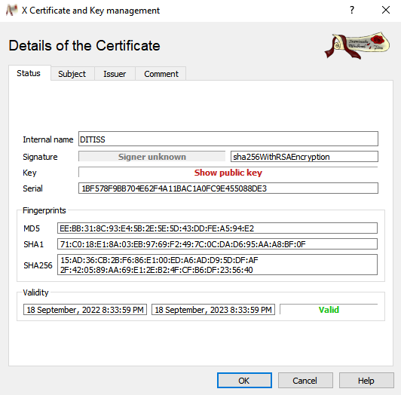

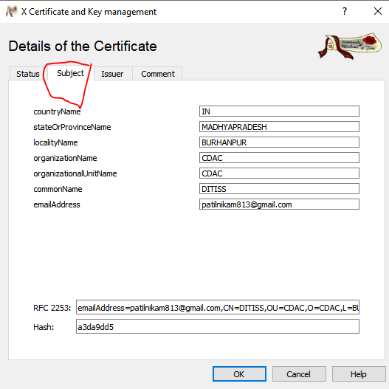

Step -10:- Now we can select PRITHVIRAJ.pfx and Select PRITHVIRAJ_KEY option and Click it.
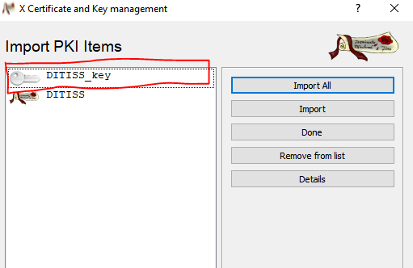
Now Put Password(****)
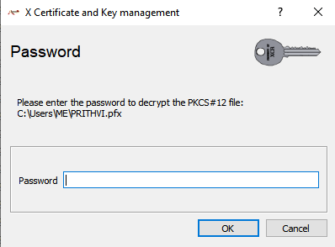
After Clicking on DITISS_key open new popup that show password Enter option and put password on it.

