Module:- Public Key Infrastructure Date:- 19/09/2022
Assignment :- 03

XCA TOOL:-
PRACTICAL:- Digital Signature Certificate (DSC) validity only one day 19/09/2022 to 20/09/2022.
Step – 1:- Open XCA tool and select New Database Option.
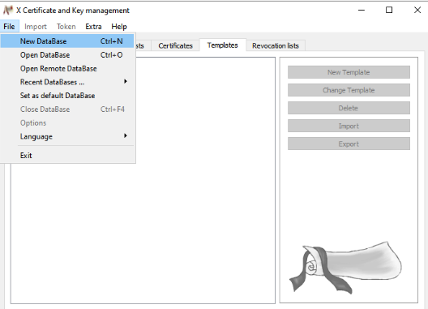
Save New Data Base file into any folder of system.
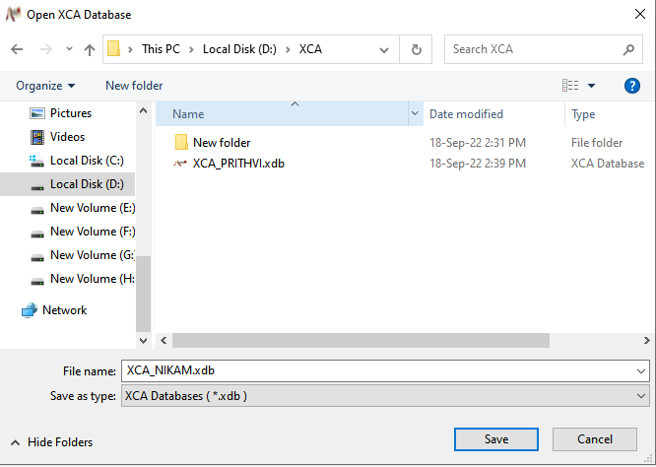
After Saving Set Password.
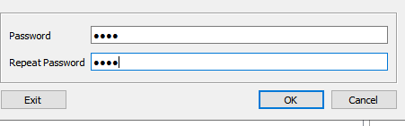
Step -2:- Now select Private key option and then select New key option.
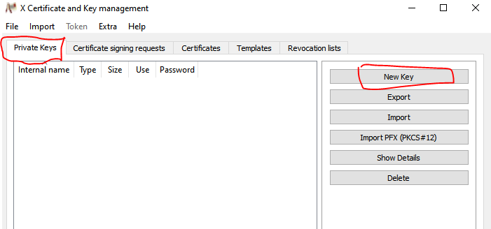

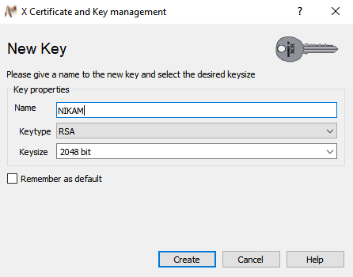
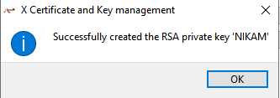
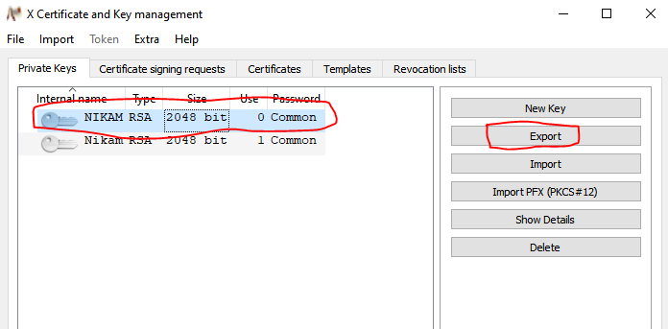

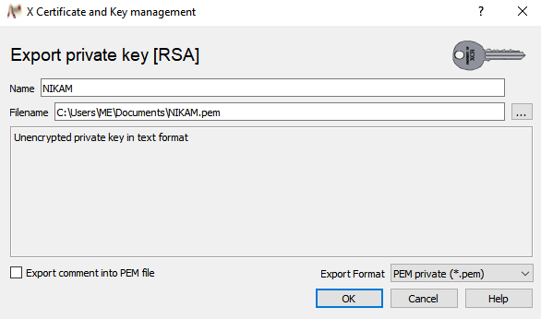
Now select Certificate option and then select New certificate option.
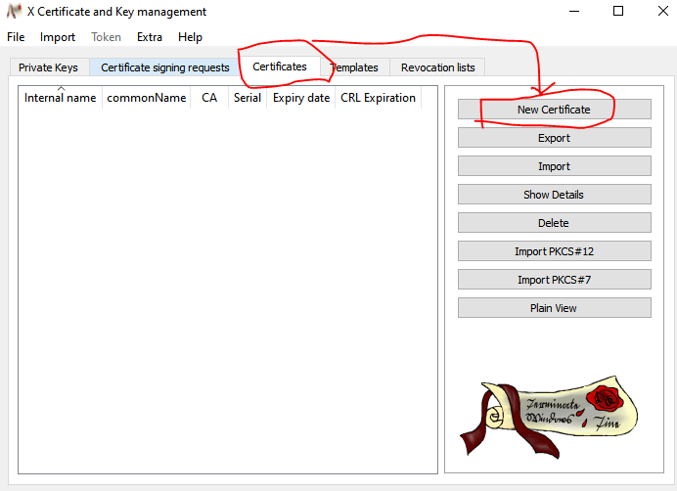
Step -3:- Now , after opening new certificate in XCA tool open new window and Create Certificate that have many text box such as.
Internal name:- NIKAM
Country name:- IN
State :- KARNATAKA
Locality :- BANGALURU
Organization name :- CDAC
Organization Unit Nmae :- CDAC
Common Name:- DITISS
Email-ID :- patilnikam813@gmail.com

And then we can select Generate new Key option.
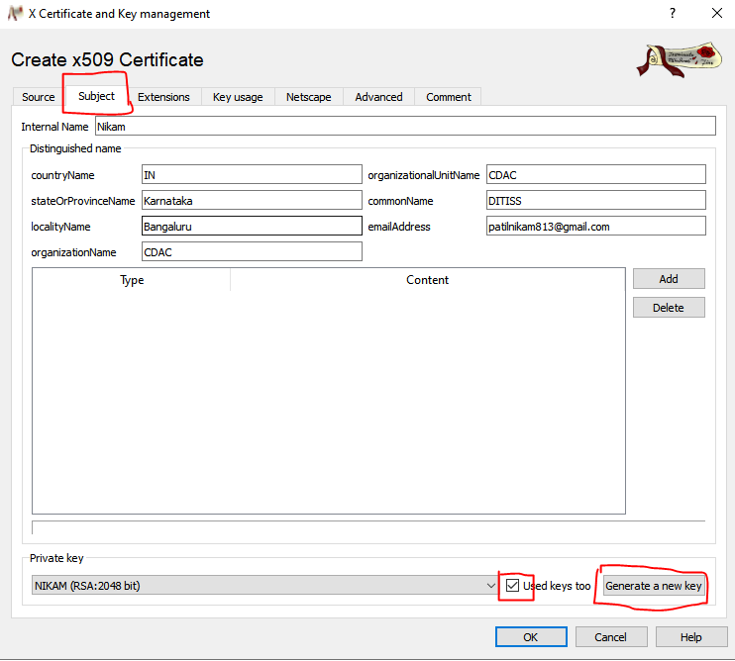

New Key generator generate is following image .

Step -4 :- After we can select Extensions when we can select End Entity and Time Period only one day(19/sep/2022 to 20/sep/2022) .
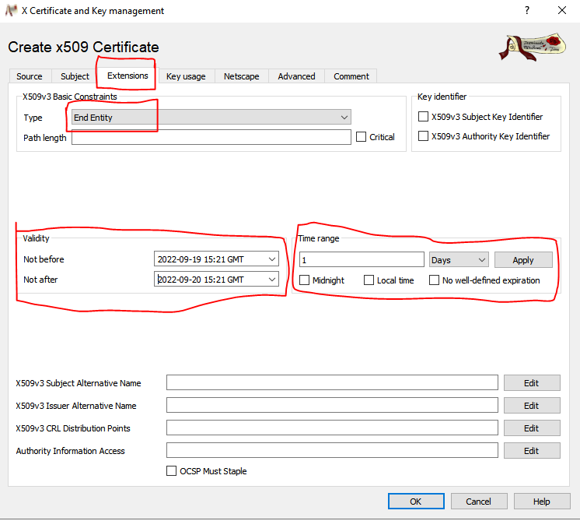
Step- 5:- Now we go to Key usage Option when we select Digital signature ,Non Repudiation and Certificate Sign option and last select ok.
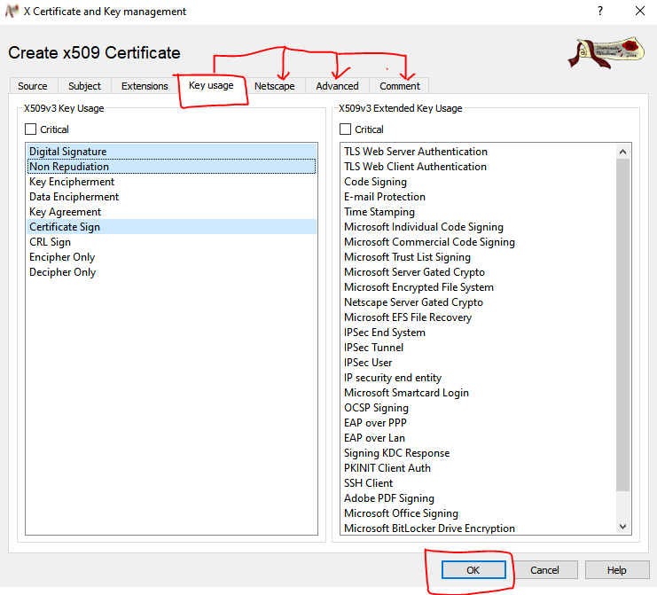

Step -6 :- Click Certificate and Export it.
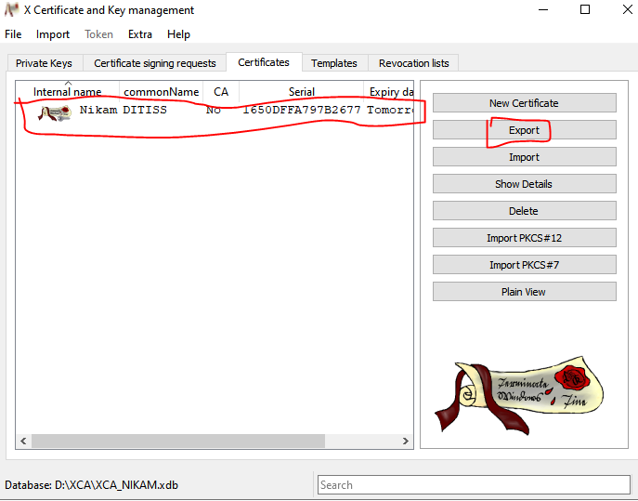
Export certificate in directory
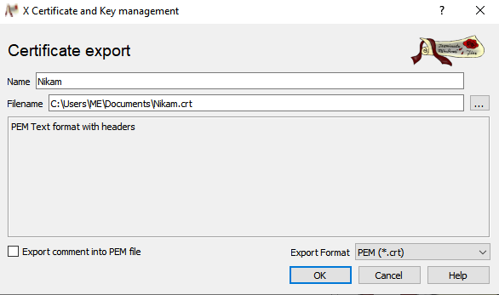

Export pfx file in Directory.
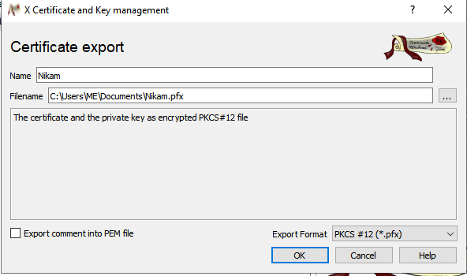

Step -7:- We can go to and search, Manage user certificate when store Certificate and select personal All task Import Nikam.crt and Nikam.pfx .
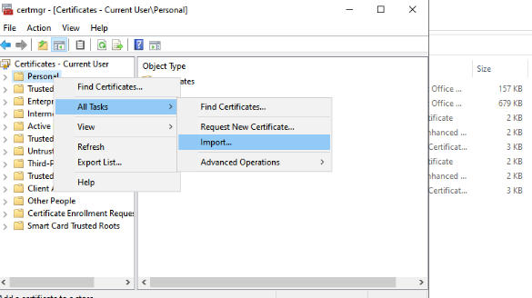

Now Popup Open it is Certificate vizard
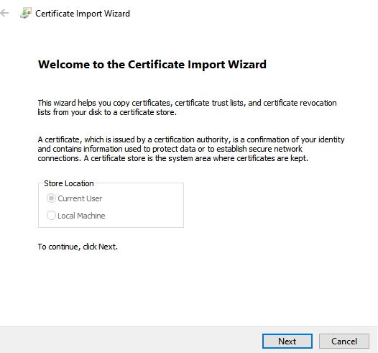

Now Import PFx File from Directory
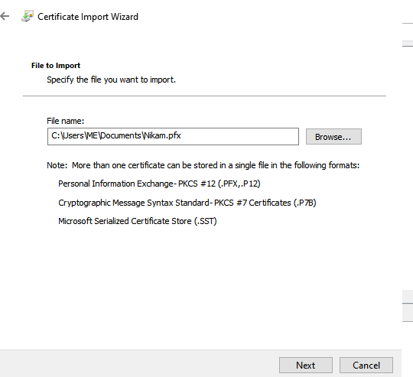

Put password and click to next
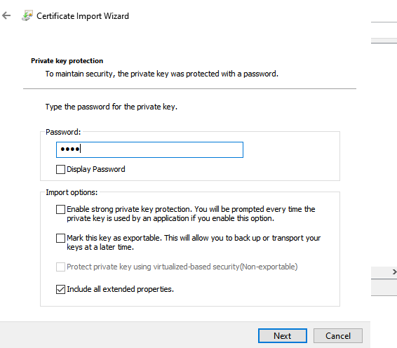
Select Personal
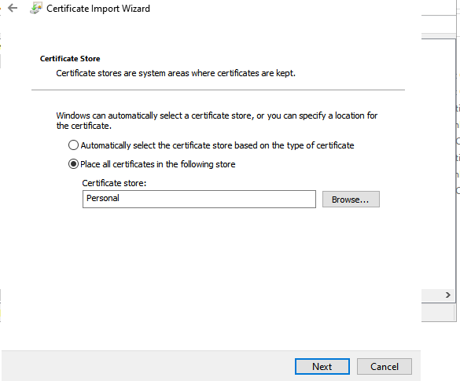

Completing the import Wizard
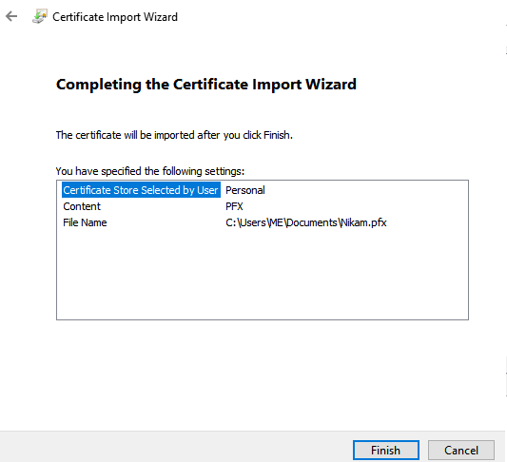

Select the certificate and open it.
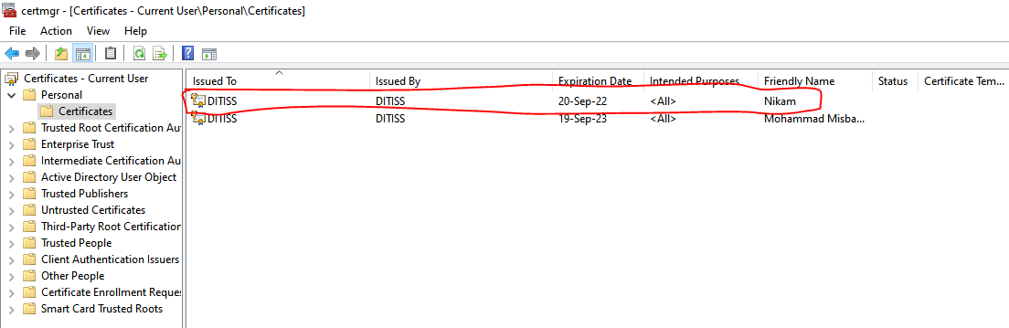
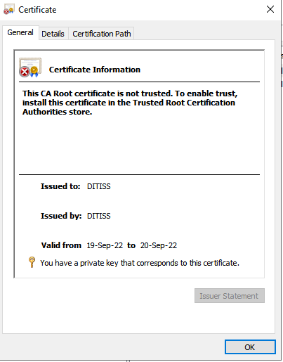

SIGN A DOCUMENT DIGITALY
- PDF:-
PRACTIAL :-
Step-1:- Open the new word file and fill some information save it.

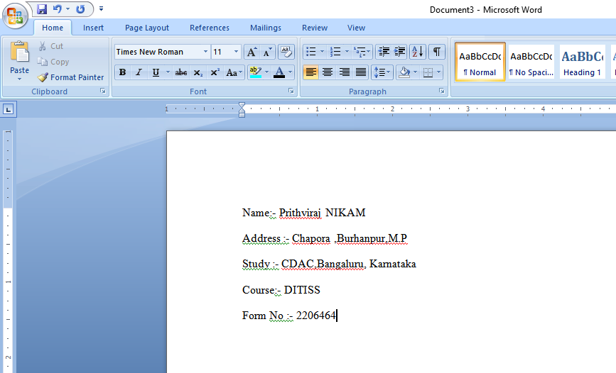

Step – 2:- Now open the new popup and select ok.
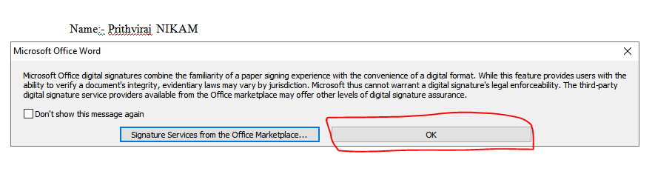
Step- 3:-opening the new window that can be show the purpose of document.

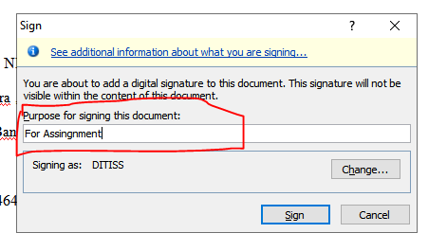
Step- 4:- Then word file right side showing the certificate DITISS.Now we can select
DITISS Signature Detail

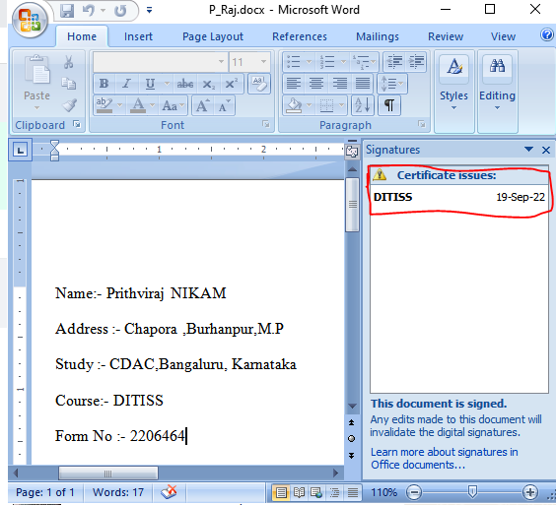

Step-5 :- Now we can view the certificate.
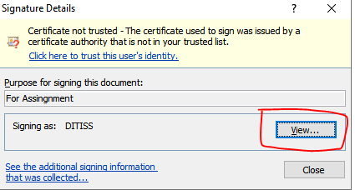

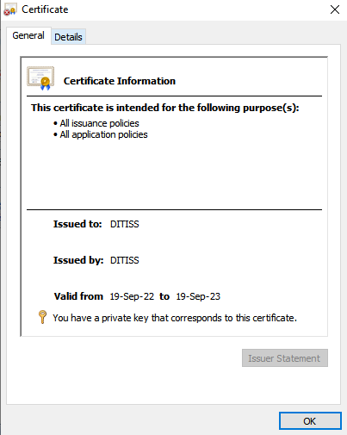

- PDF :-
PRACTICAL :-
Step-1:- Open the new PDF file.
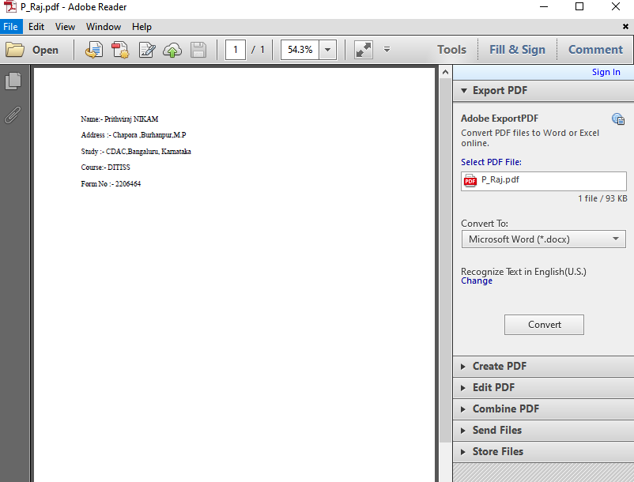

Step-2:- Now we can select Fill & Sign Work with certificate Sign with certificate.
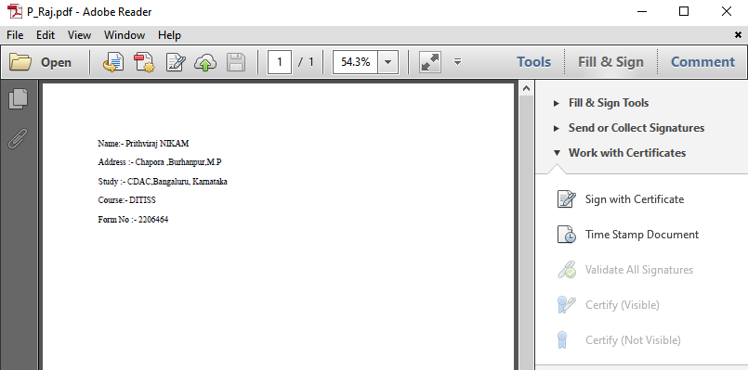

Now open the new popup that can be shown by drag and create a space on pdf page .
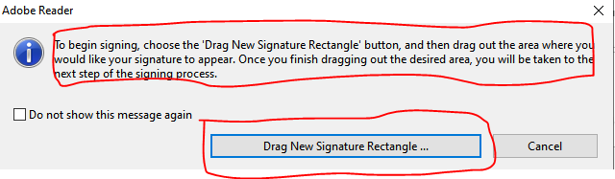

After Selection Drag New Signature Rectangle then click sign option.
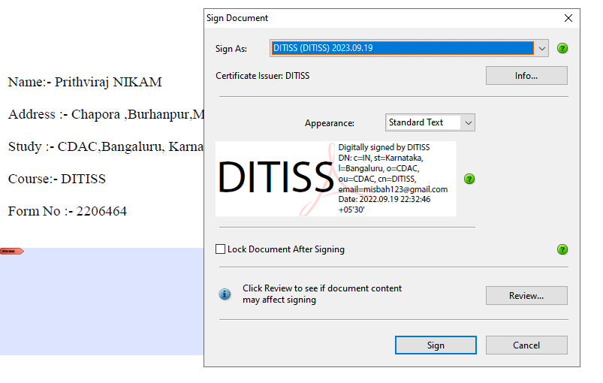
Step – 3:- Now The signature is created.

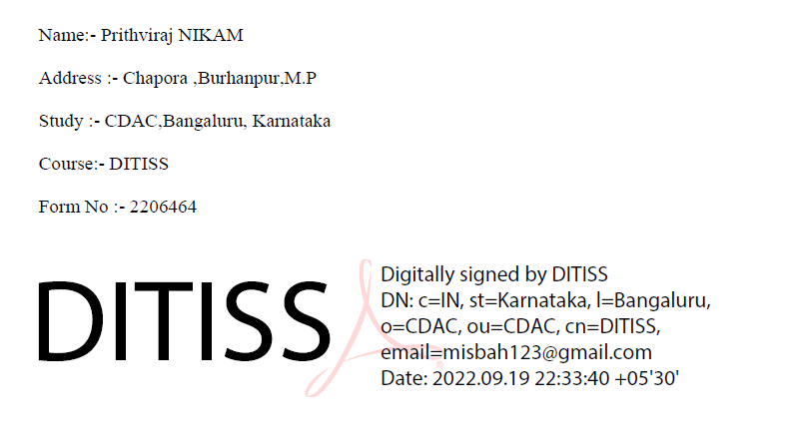

- XCEL :-
PRACTICAL:-
Step-1:- Open the new Xcel file and fill some information save it.

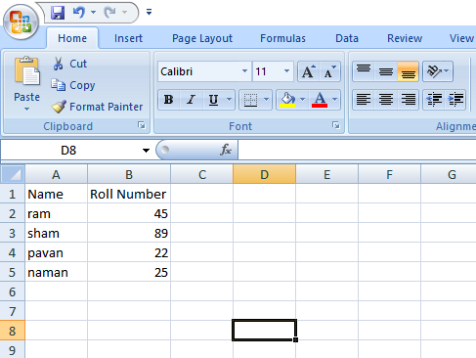

Step – 2:- Now open the new popup and select ok.
Step- 3:-opening the new window that can be show the purpose of document.

Step- 4:- Then word file right side showing the certificate DITISS.Now we can select
DITISS Signature Detail

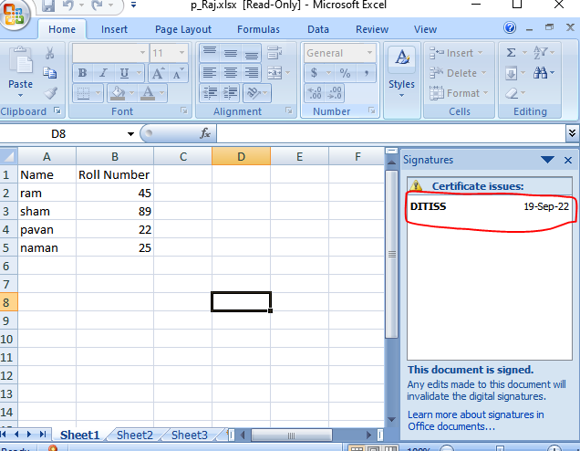

Step-5 :- Now we can view the certificate.

- OPEN OFFICE :-
PRACTICAL :- Using Apache Open Office
Step-1:- Now we can open the Apache Open Office and select text document.
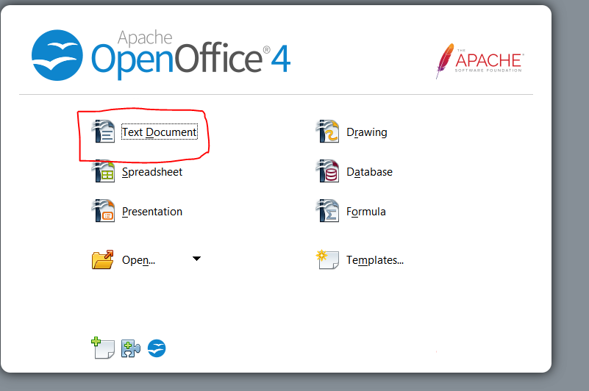

Step- 2:- Fill some information and save the file with .odt extention. Then go to File Dital signature and Click it.

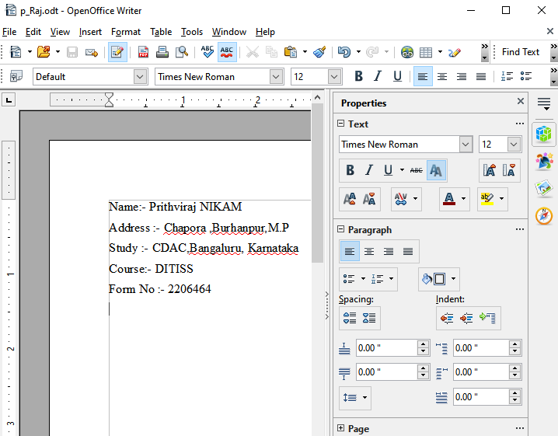

Step -3:- Then show the new window option Sign Certificate and click it
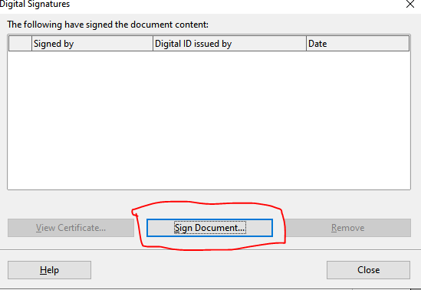
After clicking again new window will be open and select any one certificate and view it.

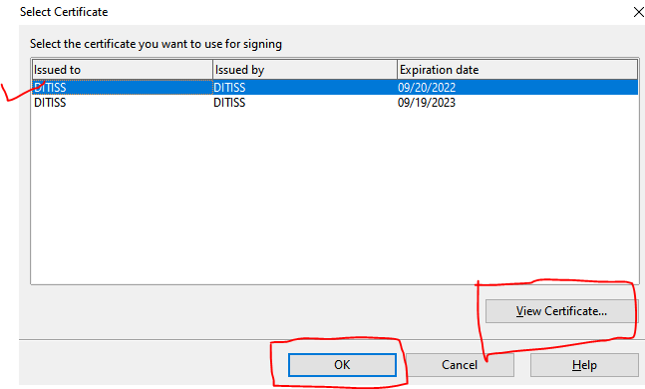

New scree will be open that can be show the certificate detail.

