Module:-COSA(Concept Of Operating System And Administration) Date:- 20/10/2022
Assignment :- 01(Basic Cent OS Command) Name:- Prauthviraj Nikam

1.ls
Content present working directory. “ls” command is used to see the folders and files of the folder.
Cmd:-
ls
ls -l
ls -l -t
ls -a
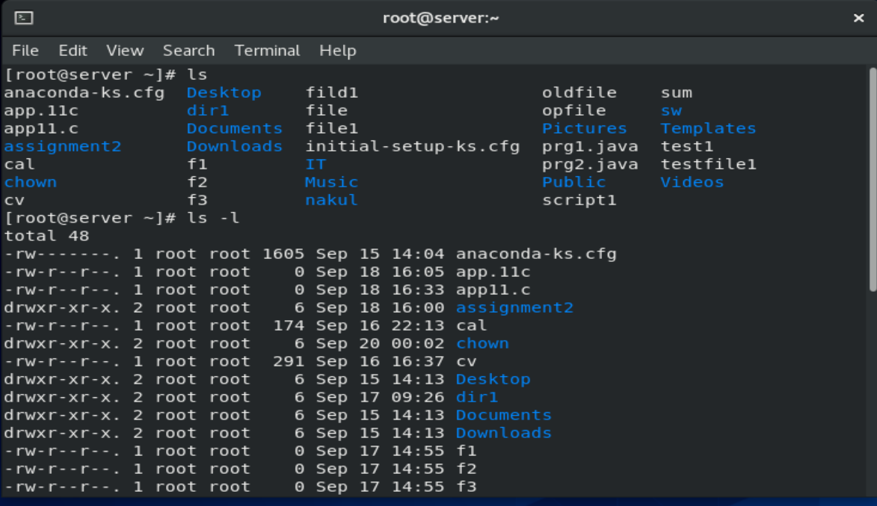
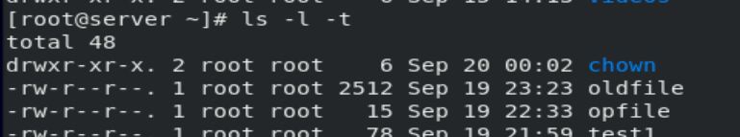
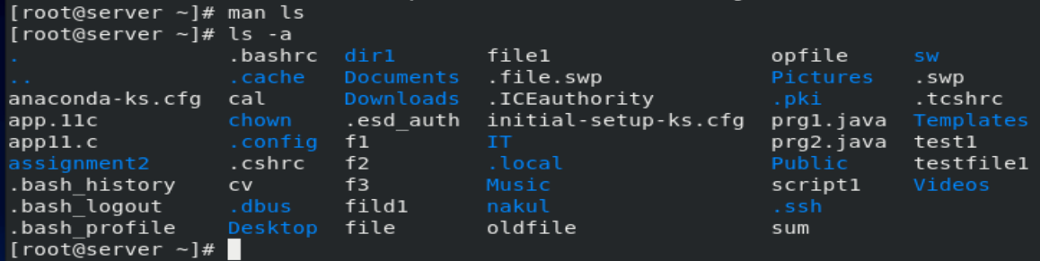
2. CP:-
Copy one folder to another folder
Cmd:-
cp s.f d.f
cp -r s.f / d.f/
cd file_name
cd .. (go to previous directory)
mv s.f d.f
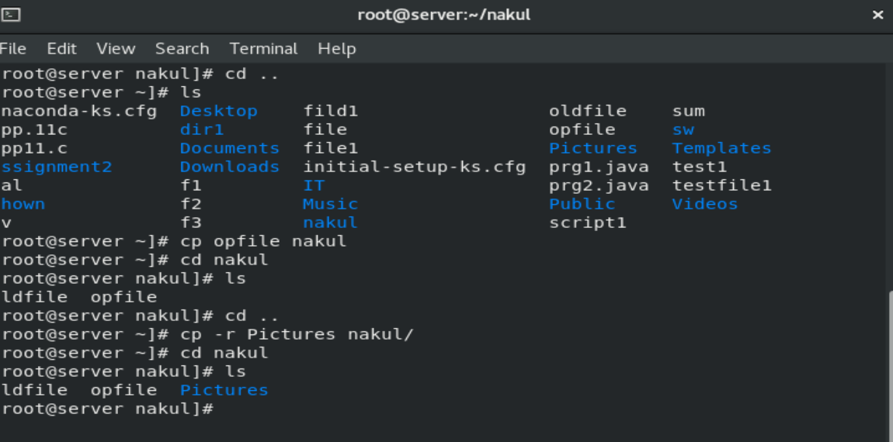
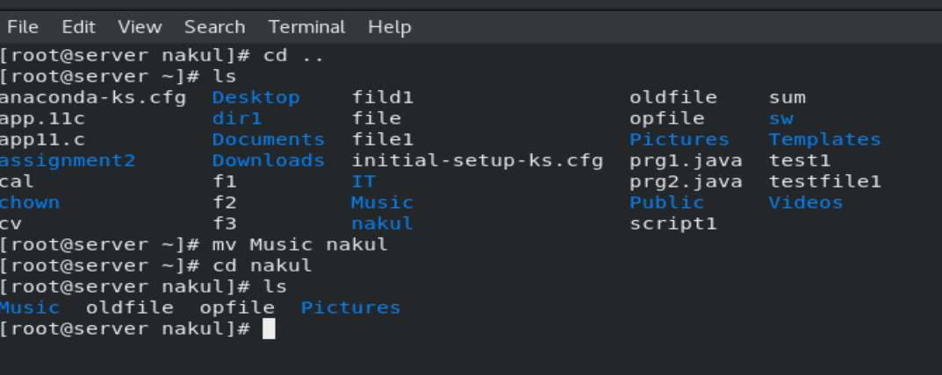

3.lpr
It is used for printing purpose
4.gedit
Editor in linux
Cmd:-
gedit file_name

5.sort
To sort the content of file
Cmd:-
sort file_name (ascending order)
sort -r file_name (descending order)

6.grep
It is used for pattern searching (matching content)
Cmd:-
grep -i file_content file_name

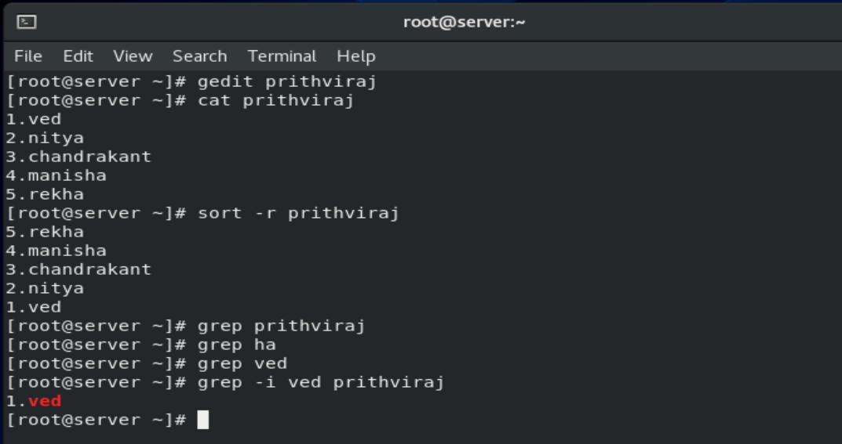

7. cat
Show the content of file
Cmd :-
cat file_name

8.tac
To show content of file in reverse order
Cmd:-
tac file_name
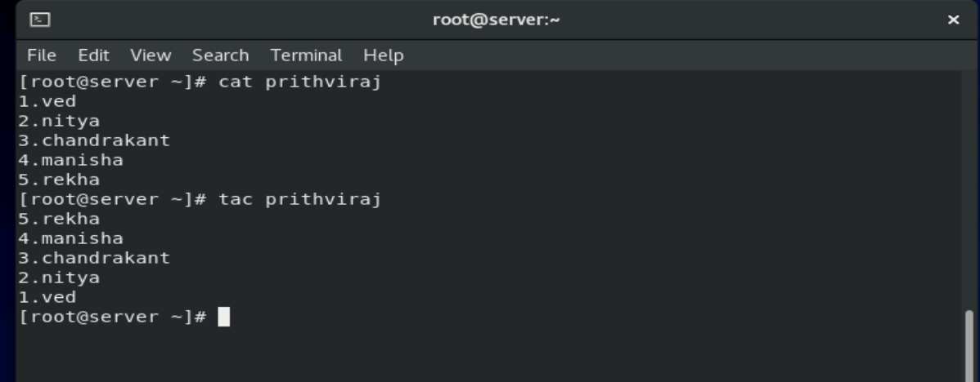

9.more
Show content file but page by page
Cmd:-
more file_name
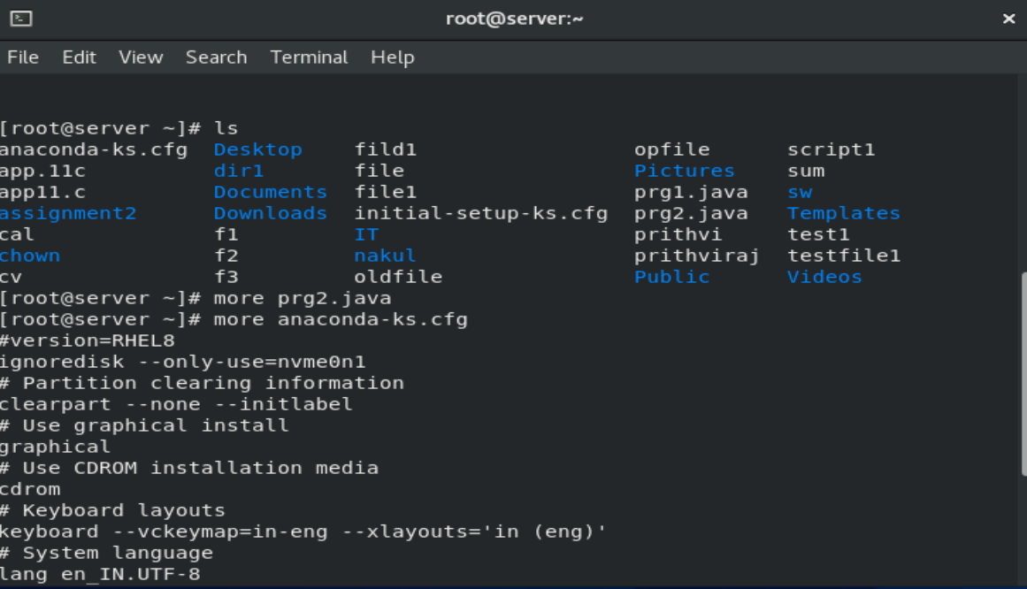

10.ps
It show current running process on shell
Cmd:-
Ps -e -a -f
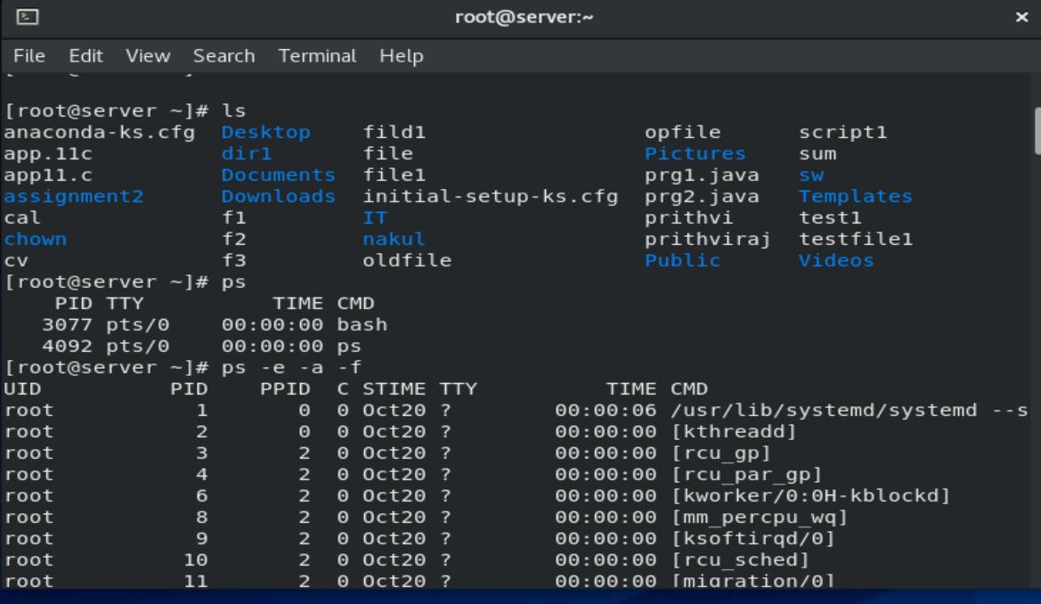

11.head
Show me the heading of file(10 line)
Cmd:-
head file_name (first 10 line)
tail file_name (last 10 line)
head -n 3 file_name
tail -n 2 file_name

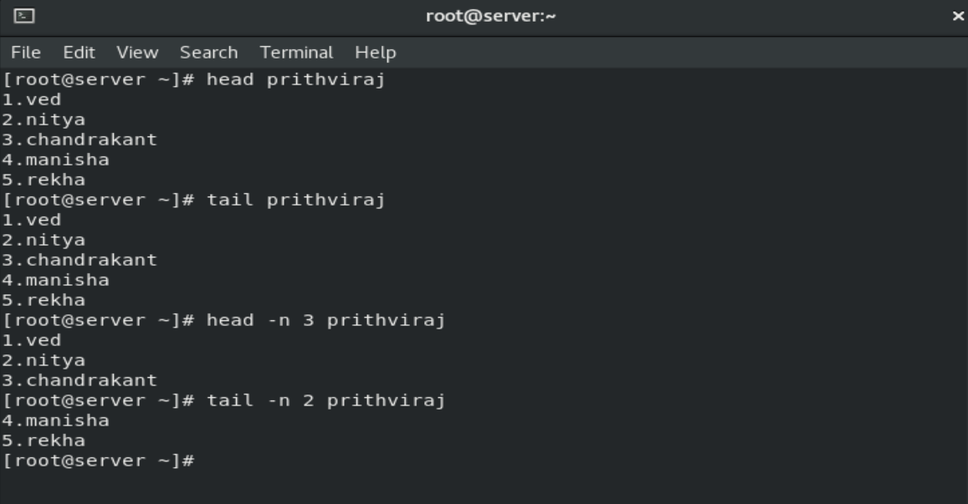

12.man
Show the manual of any command
Cmd:-
man type_any_cmd
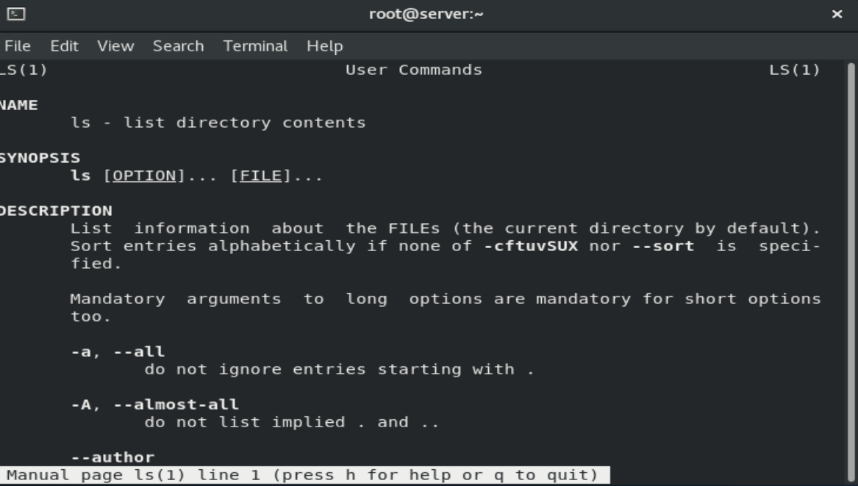

13.whatis
Give the sort discription of command
Cmd:-
whatis type_any _cmd

14. whereis
Where is the location of command
Cmd:-
whereis type_any _cmd

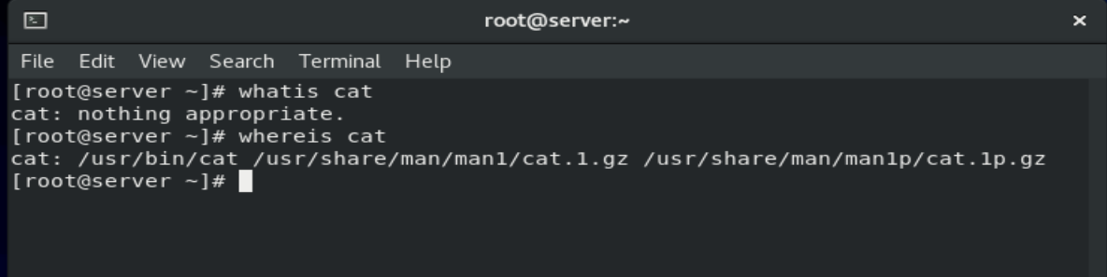

15. find
Find file or folder
Cmd:-
find / -name file_name

16.locate
Try to find out inside the file name locate the pattern matching
Cmd:-
locate file_name

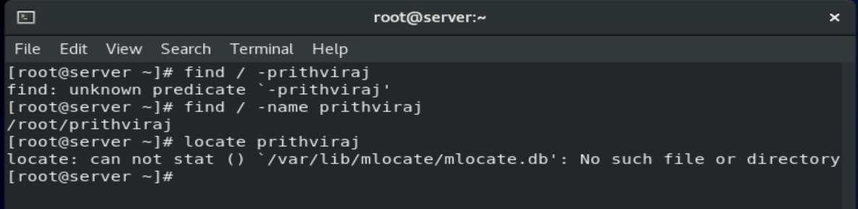

17. diff
It is used to find difference between two files
Cmd:-
diff file_name1 file_name2
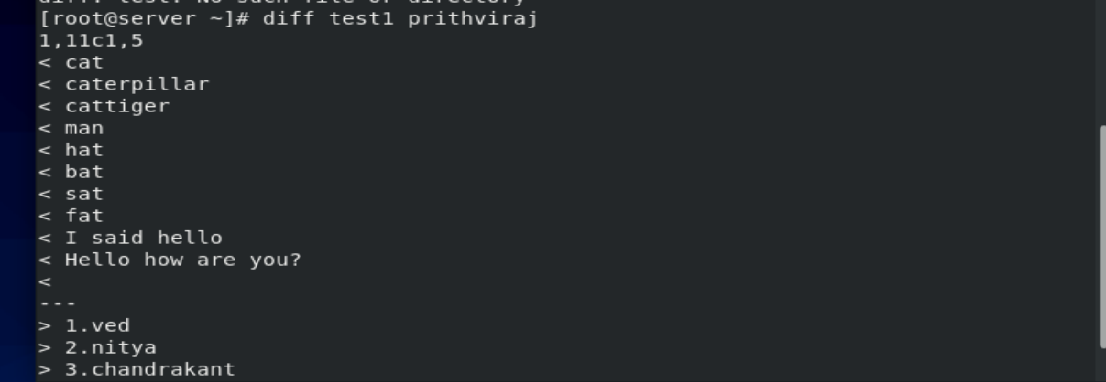

18.file
Cmd:-
file type_of_file_name

19. jobs
How many jobs are running in current shell
Cmd:-
jobs

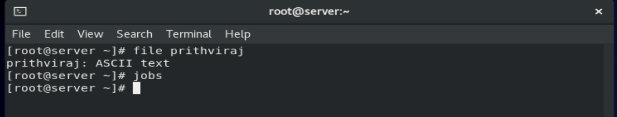

20.rm
Delete something
Cmd :-
rm file_name (choose yes or no)
rm -r folder_name/
rm -r -f folder_name/ (force fully)
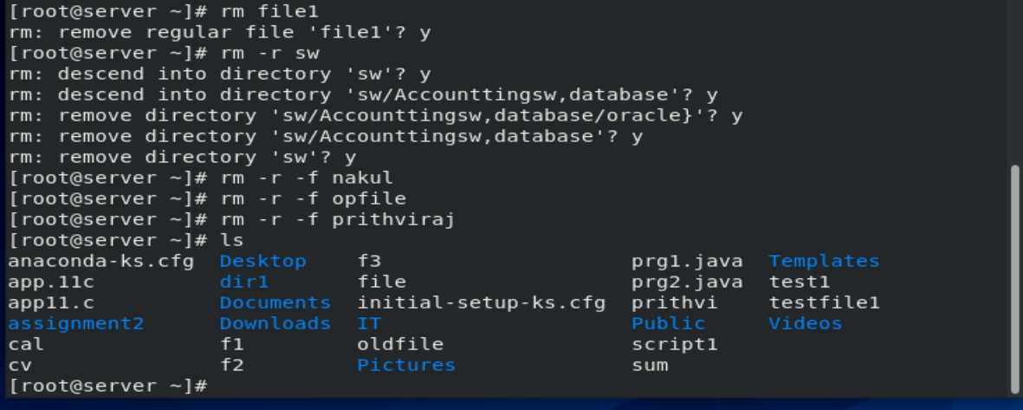

21. mkdir
To create empty directory
Cmd:-
mkdir file_name

22.touch
To create empty file
Cmd:-
touch file_name

23.rmdir
Remove directory
Cmd:-
rmdir file_name

24.cd
Changed directory
Cmd:-
cd file_name

25.pwd
Show me present working directory
Cmd:-
pwd

26. ln
To create links
Cmd :-
ln actual_file_name_of_the_link

27.gzip
To create zip file and compress it
Cmd:-
gzip file_name
gzip -d file_name (uncompress file)
gunzip file_name (decompress file)

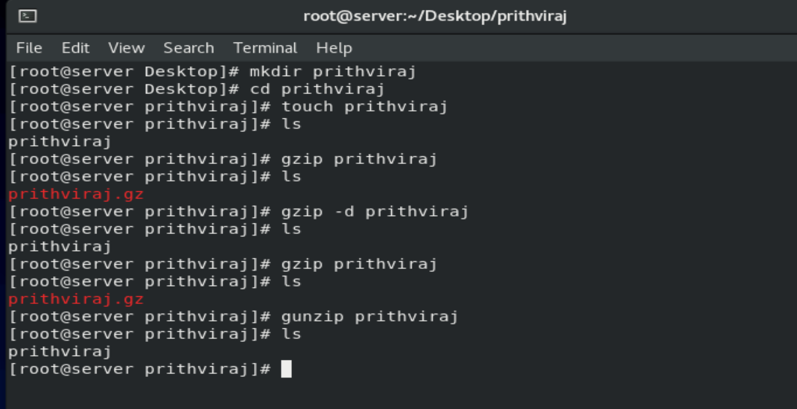
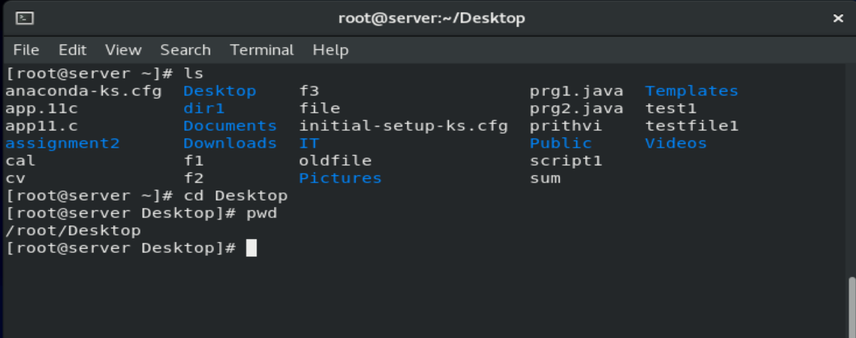

28. tar
It is used for archile file(many file keep into the single file)
Cmd:-

tar -cf file_name.tar f1 f2 f3…..

*how to see content of archile file
tar -tf file_name.tar

*extract the archile file content
tar -xf file_name.tar

*create archile file as zip
tar -czf file_name.tar .zip f1 f2 f3 …….

*how to see content of archile zip file
tar -tzf file_name.tar .gz

* extract the archile zip file content
tar -xzf file_name.tar .gz

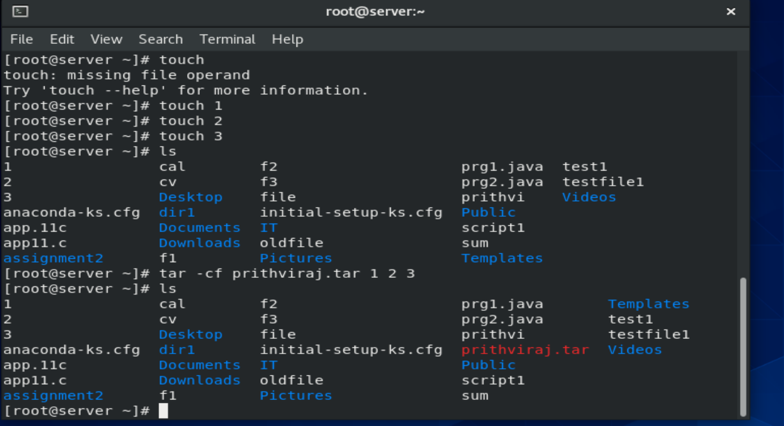
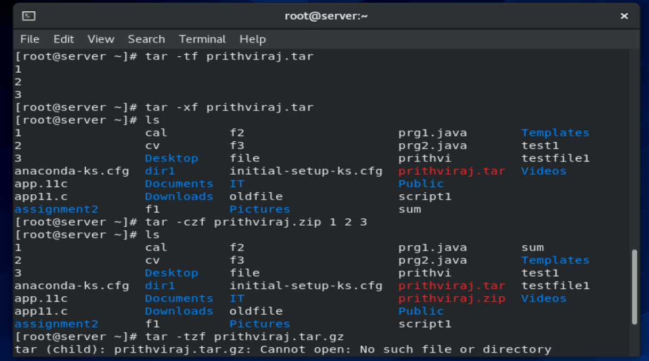

29.whoami:-
Show current login username on to the shell
Cmd:-
whoami

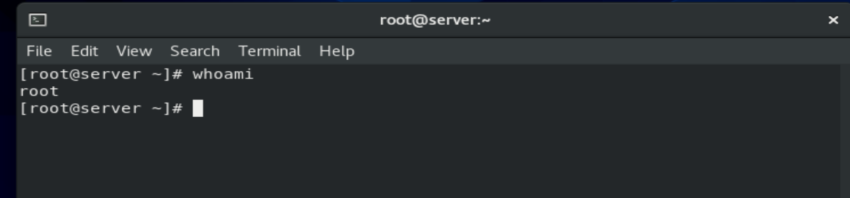

30.zcat
It show the zip file actual content
Cmd:-
zcat file_name.gz

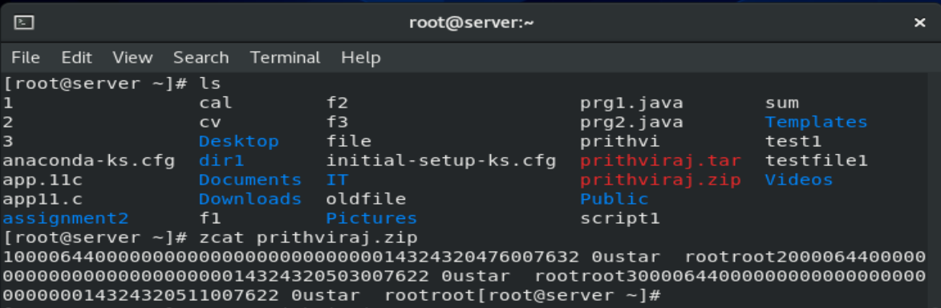

31.cal
It show the calendar
Cmd:-
cal
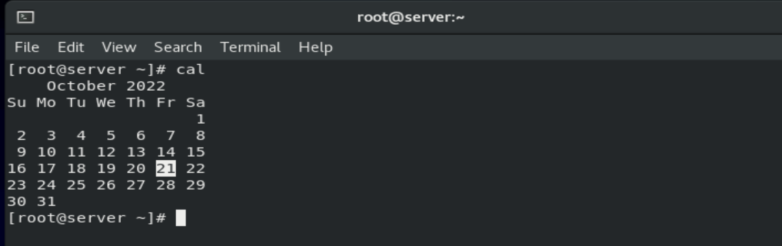

32.bc
For calculation
Cmd:-
bc
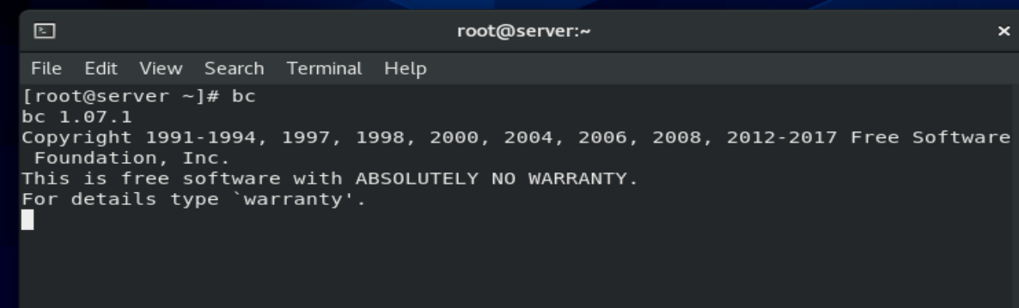
33.date
Show current date and time of system
Cmd:-
date
date -s “date_and_time”
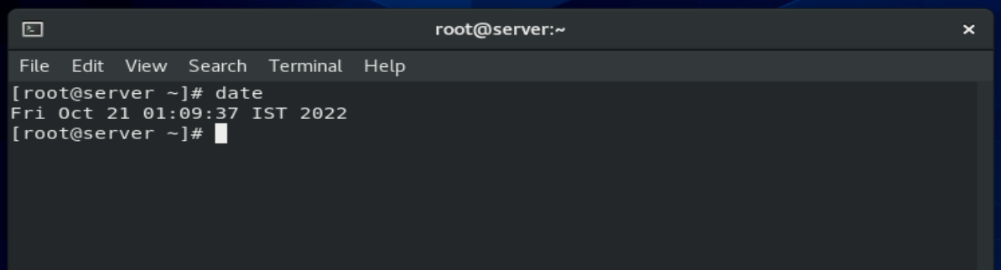

34.wc
(Word count) how many word and character in file
Cmd:-
wc file_name
wc -l file_name (I want to know only files)
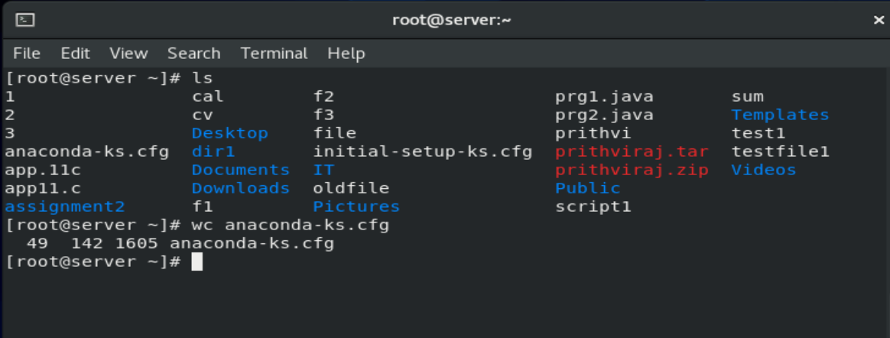

35.touch:-
To create empty file
Cmd:-
touch file_name
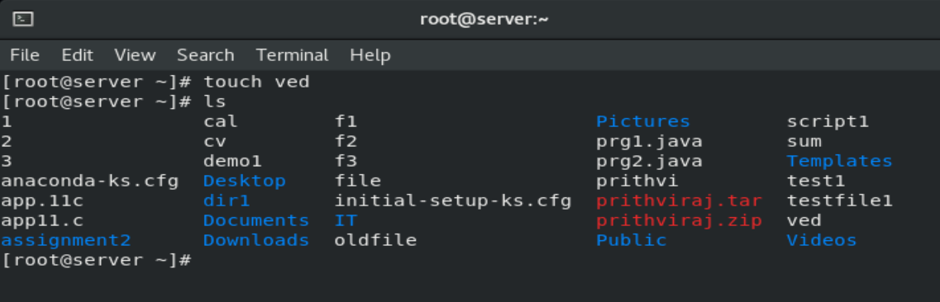

36.echo
Print something in command line
Cmd:-
echo “message”
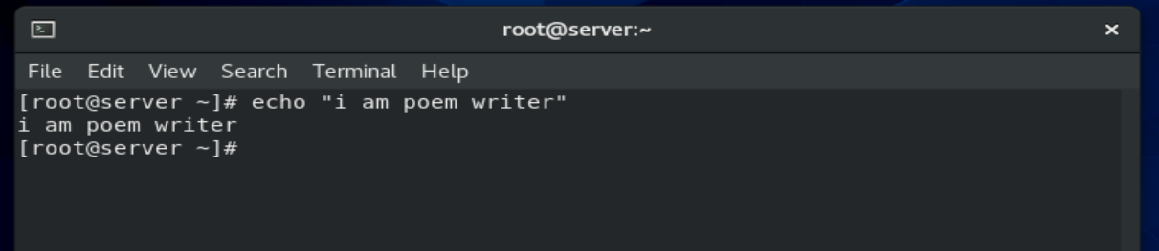
37.who
Show is user login to terminal
Cmd:-
who
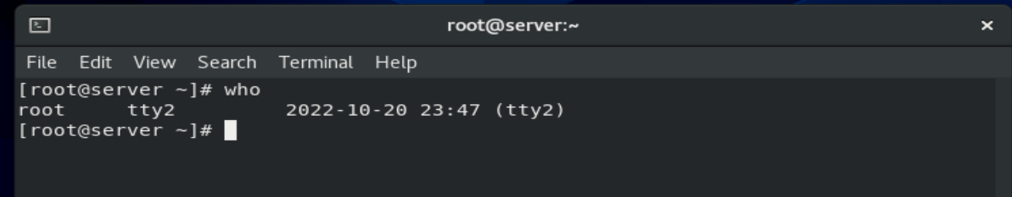

38.w
Show resources of the system
Cmd:-
w

