Module:-COSA(Concept Of Operating System And Administration) Date:- 21/10/2022
Assignment :- 02(Installation of Fedora OS) Name:- Prauthviraj Nikam
Step 1:- Firt of all download Fedora OS from following website and select Fedora 37:x86_64 Live ISO.
https://getfedora.org/en/workstation/download/
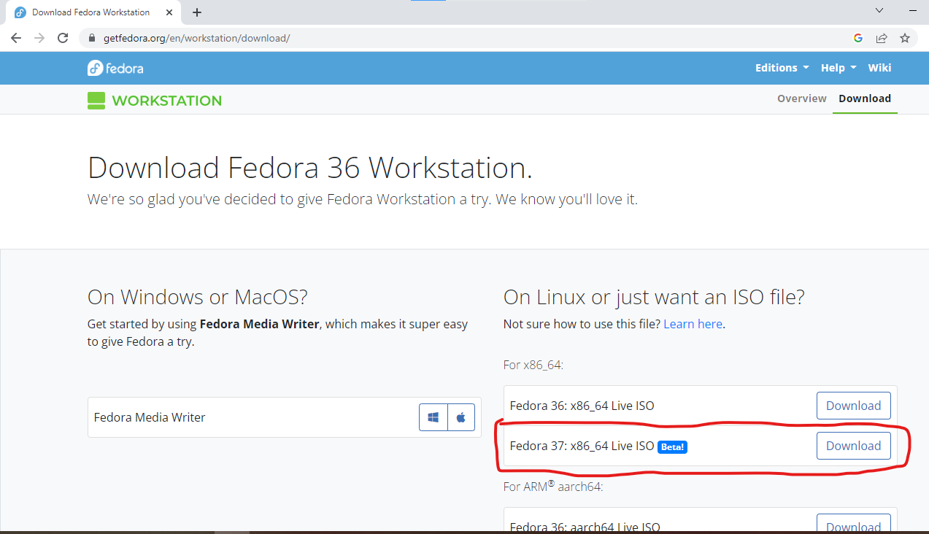

Step 2:-Open virtual box and Create New Virtual Machine Using Name Fedora_Prithviraj

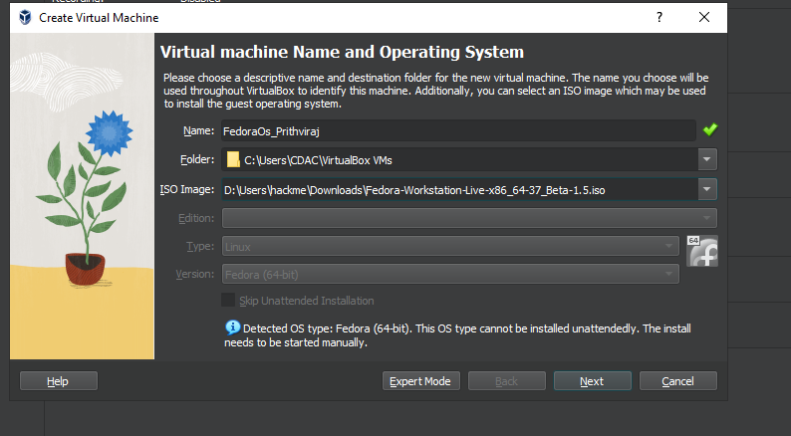

Step 3:- Now put Base Memory(RAM) = 2048 MB and Processors = 1CPU
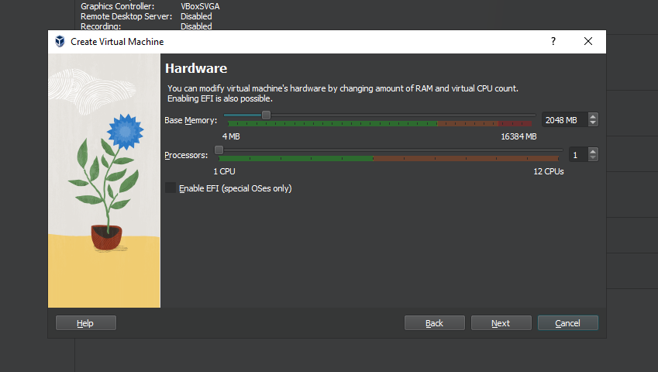

Step 4:- Now Put Storage = 30.29 GB
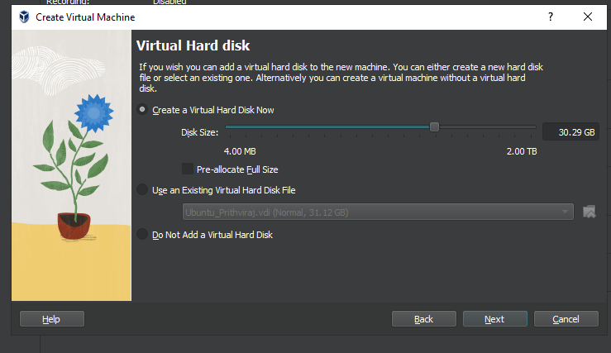

Step 5:- This Step show FedoraOS (Virtual Machine) Summery
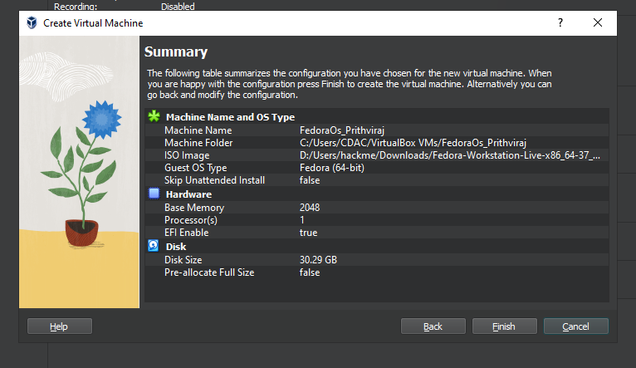

Step 6:-Click the run symbol and opening Fedora GUI then install fedora to Hard Drive

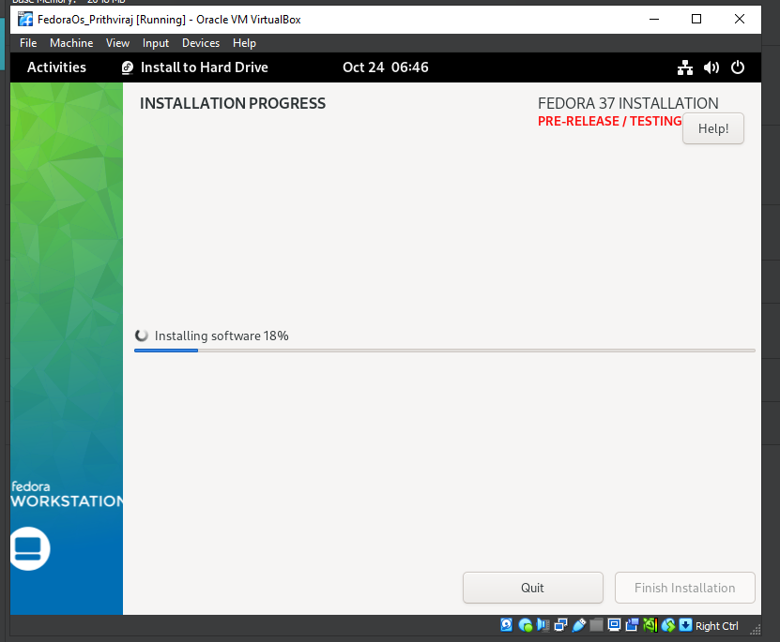

Step 7:- Now Open New Window.

