Module:-COSA(Concept Of Operating System And Administration) Date:- 21/10/2022
Assignment :- 02(Installation of Parrot OS) Name:- Prauthviraj Nikam
Step1:-Firt of all download ParrotOS from following website and select Download option.
https://www.parrotsec.org/download
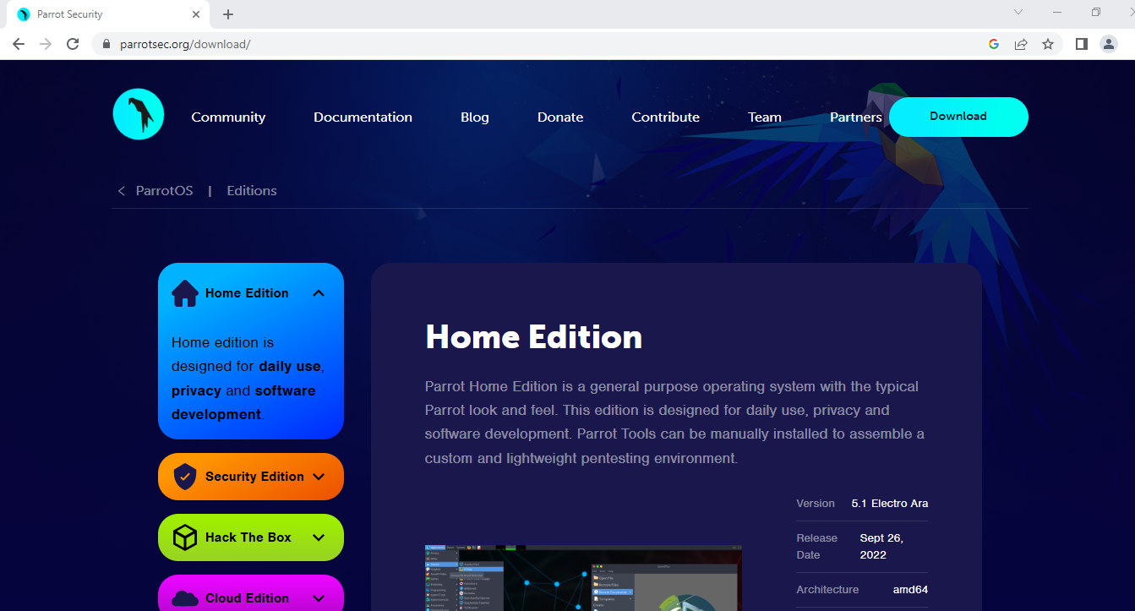

Step 2:-Open virtual box and Create New Virtual Machine Using Name Parrot_Prithviraj

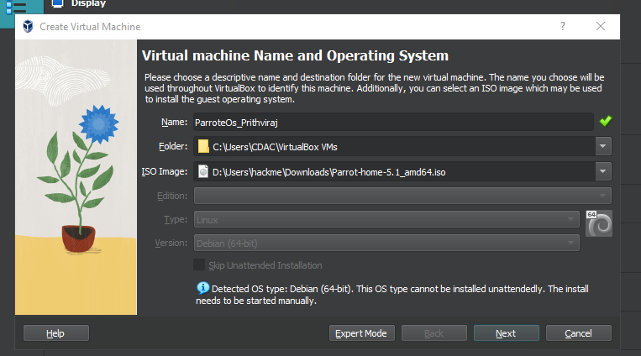

Step 3:- Now put Base Memory(RAM) = 2048 MB and Processors = 1CPU
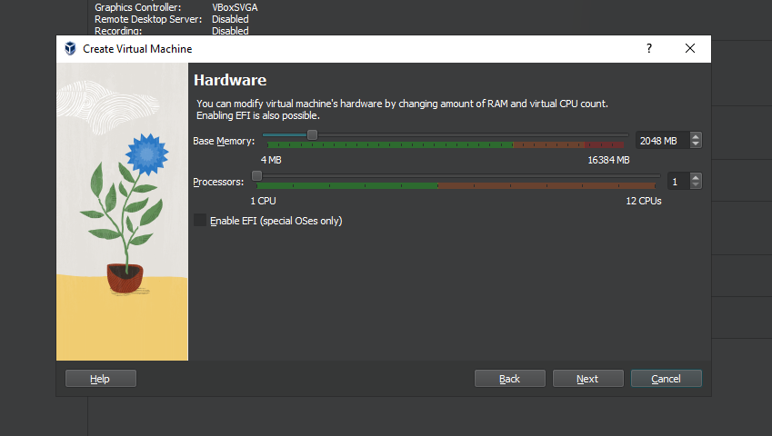

Step 4:- Now Put Storage = 31.12 GB
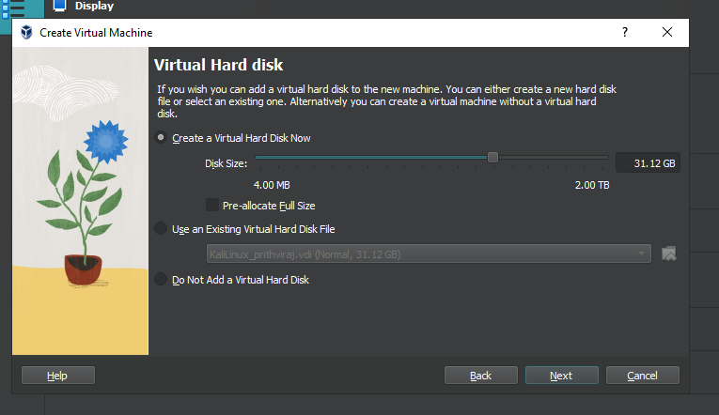

Step 5:-Click the run symbol and opening Parrot GUI then select option try/install.

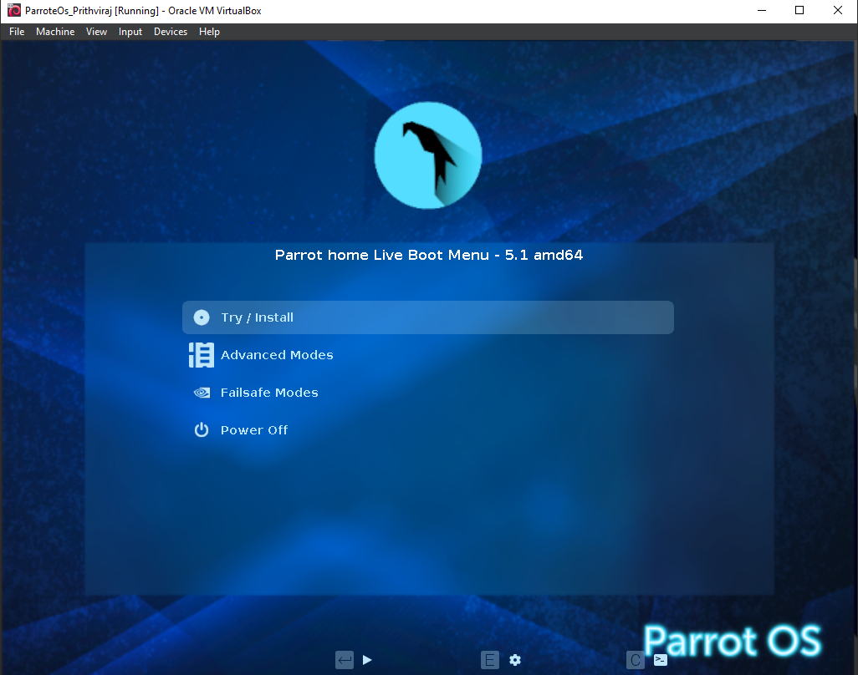

Step 7:- Now Open New Window.
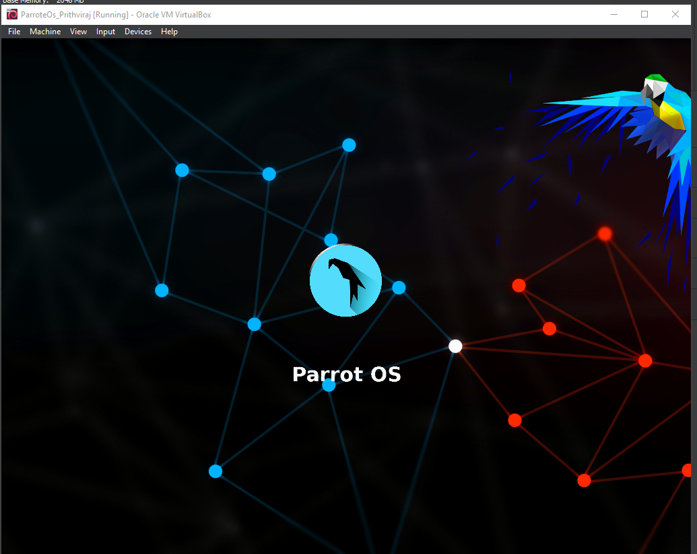

Step 8:- Installation time you set location Kolkata,India.
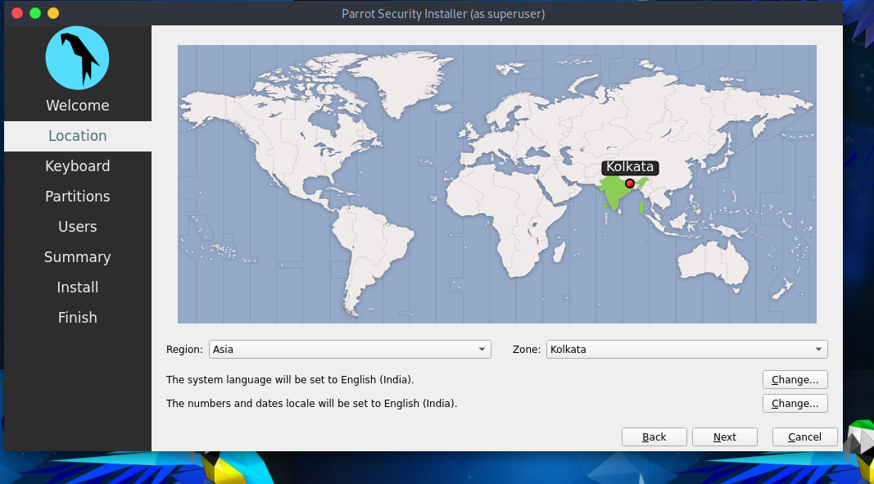

Step 9:- Now you can select Keyboard languge English (US).

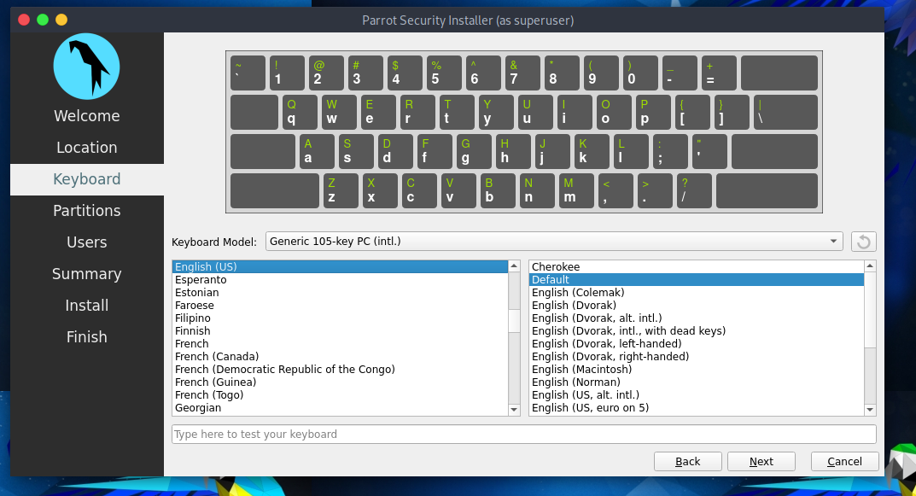

Step 10:- Now current Step show installation working of ParrotOS
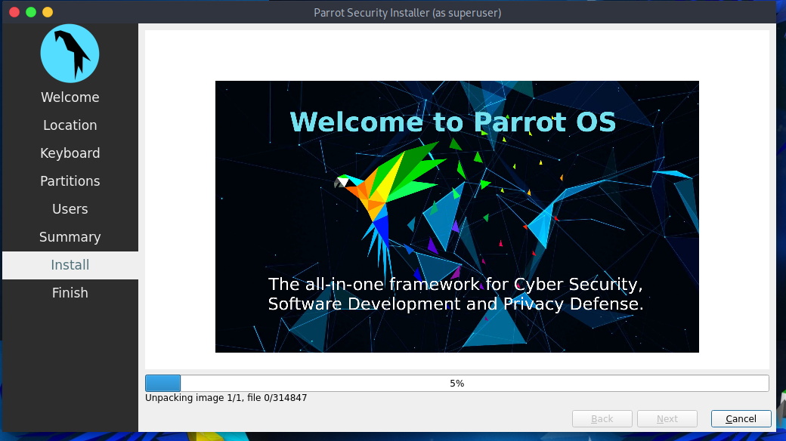

Step 11:- After installation Opening Parrote OS GUI.
