Module:-COSA(Concept Of Operating System And Administration) Date:- 21/10/2022
Assignment :- 02(Installation of Ubuntu) Name:- Prauthviraj Nikam

Step 1:- Firt of all download Ubuntu from following website and select 22.04LTS version
https://ubuntu.com/download/desktop#download.

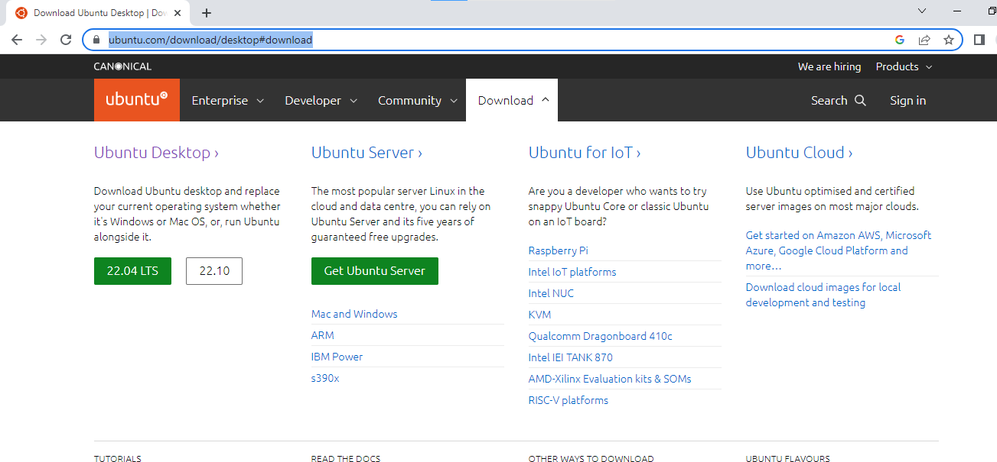

Step 2:-Open virtual box and Create New Virtual Machine Using Name Ubuntu_Prithviraj

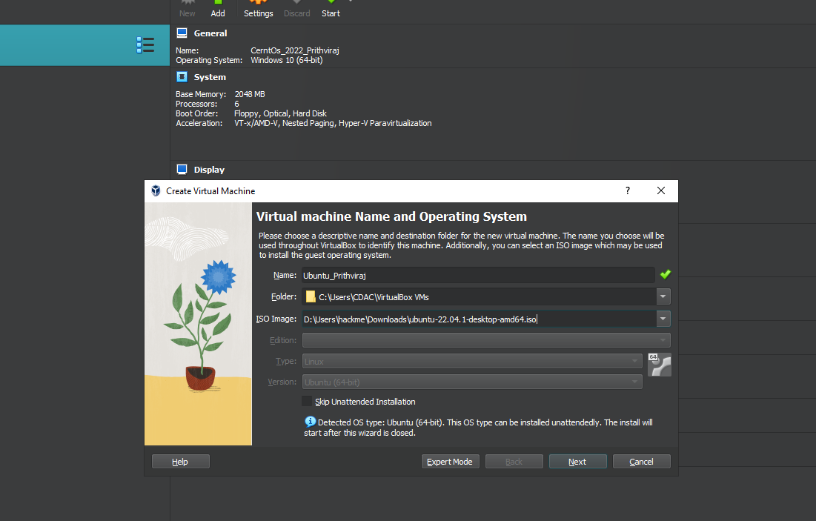
Step 3:- Now put Base Memory(RAM) = 2048 MB and Processors = 1CPU
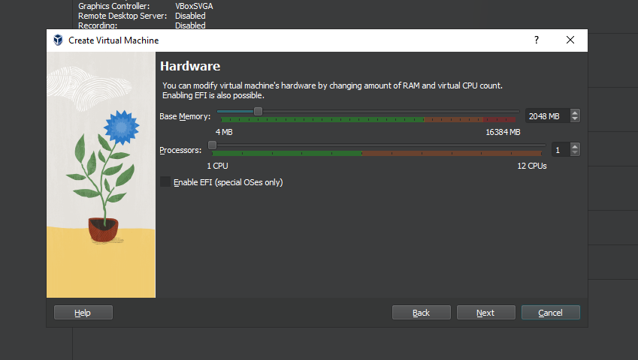

Step 4:- Now Put Storage = 25 GB
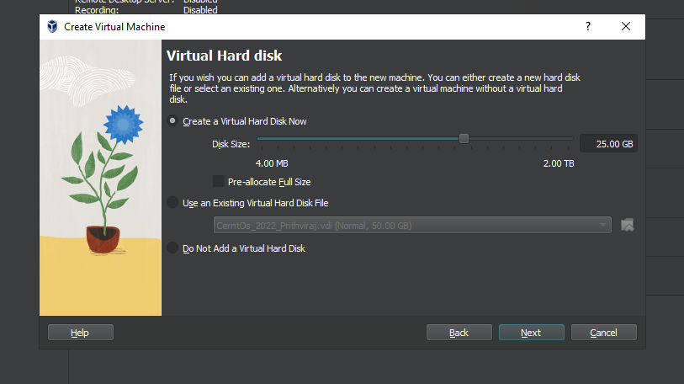

Step 5:- This Step show Ubuntu (Virtual Machine) Summery
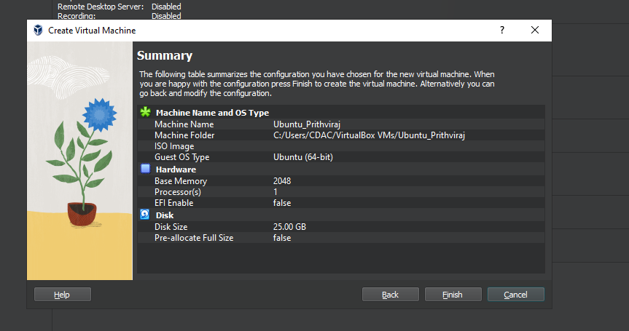

Step 6:-Now go to setting Select Network Bridge Adapter

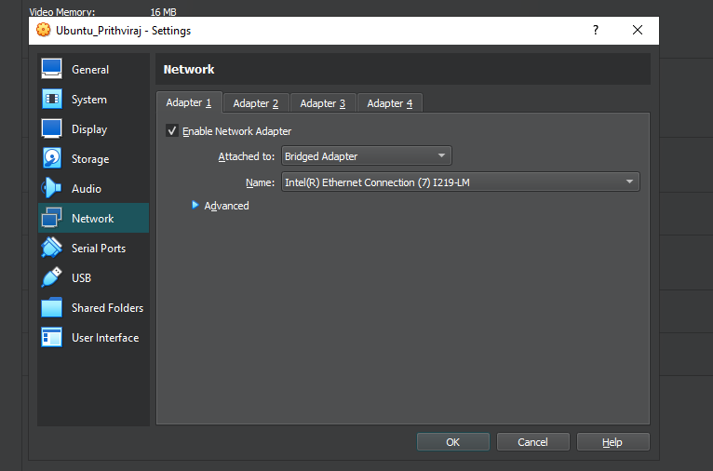

Step 7:-Click the run symbol and opening Ubuntu GUI.
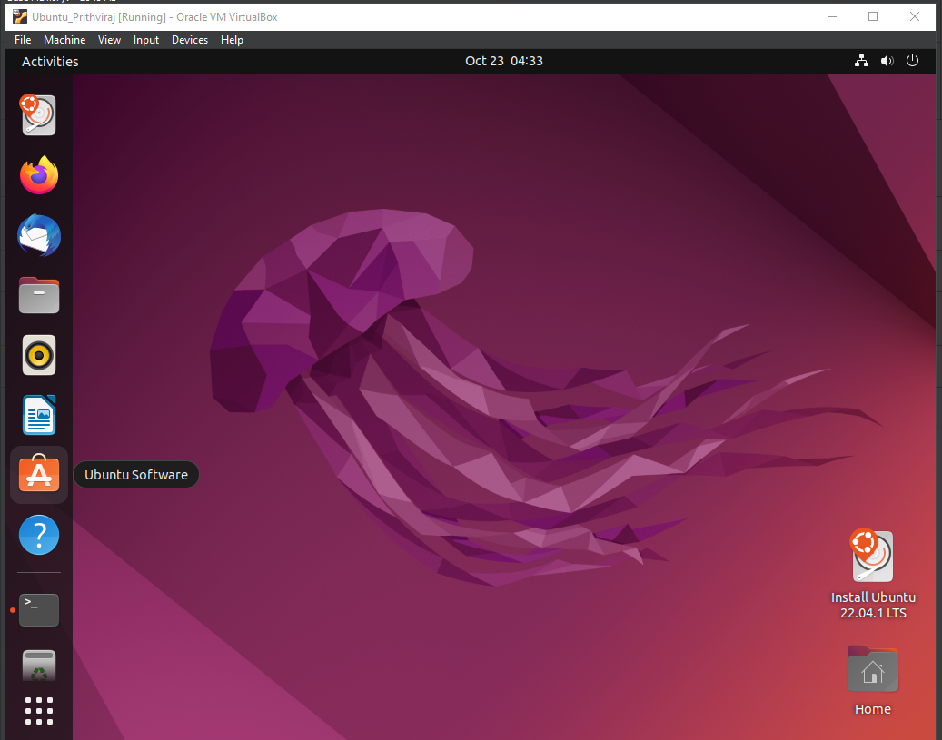

Step 8:- Now install Ubuntu package

