Module:-COSA(Concept Of Operating System And Administration) Date:- 31/10/2022
Assignment :- 05 Name:- Prauthviraj Nikam

- /proc :- It is filesystem acts as an interface to internal data structures in the kernel. It can be used to obtain information about the system and to change certain kernel parameters at runtime(sysctl). or we can say It is a temporary file system which stores the CPU or processor data. Below data what we shown in pic. is volatile as the system shutdown it lost. When the system running proc file system generated and use the data.

How to Check load on CPU and I/O overtime

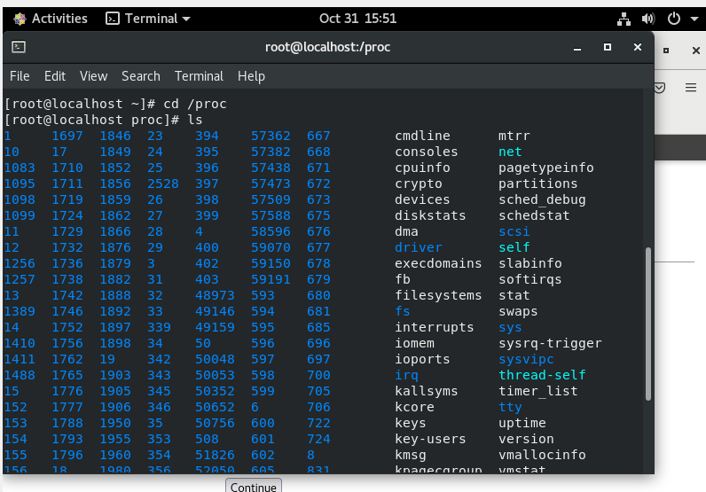

- systemctl :- “systemctl” cmd is used to run, execute and find error .
- How many System Run
- How many system active
- How many system show error

It’s possible to display services’ status like follows:-
CMD:-
#systemctl -t service
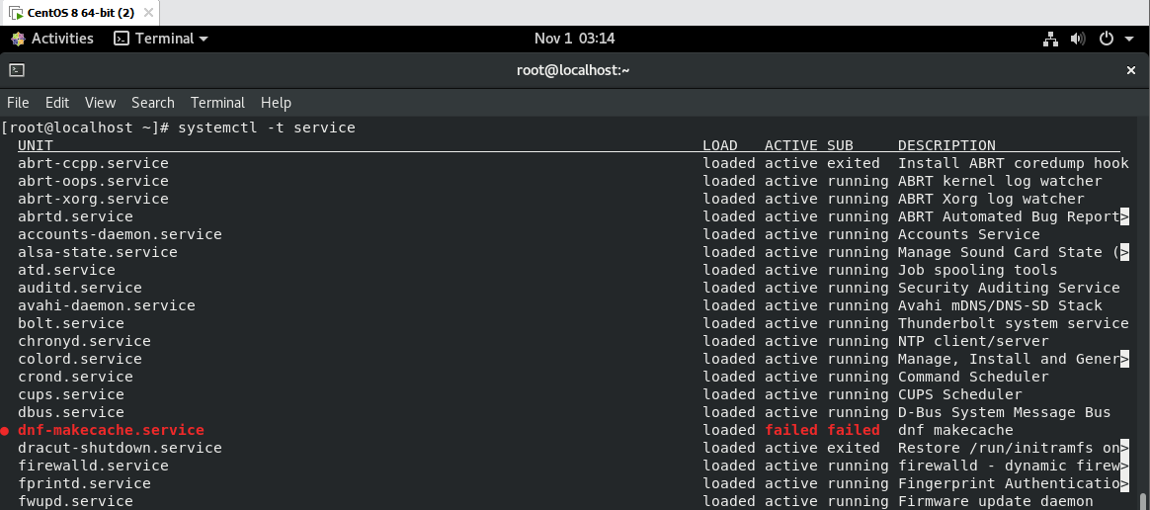

List of all services
CMD:-
systemctl list-unit-files -t service
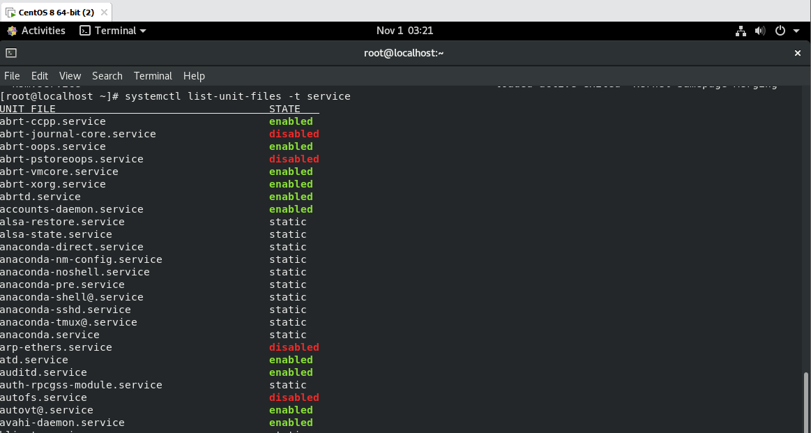

Stop and turn OFF auto-start setting a service if you donot need it
CMD:-
systemctl stop Service_Name
systemctl disable Service_Name
systemctl enable Service_Name

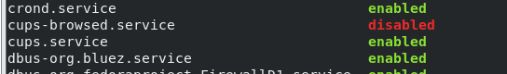

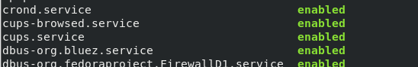

3.vmstat :- It show status of virtual memory.
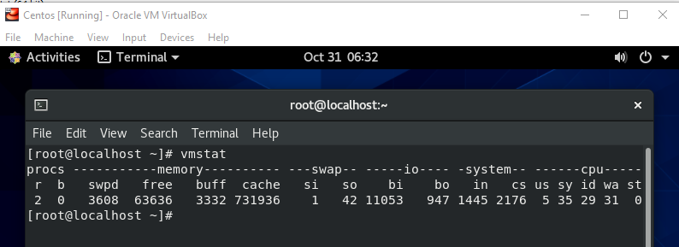
4.sysstat:- System Activity Report (sar) The sysstat utilities are a collection of performance monitoring tools for Linux. It also include sar, sadf, mpstat, iostat, tapestat, pidstat, cifsiostat and sa tools.
CMD:-System Activity Report (sar)
dnf install systat
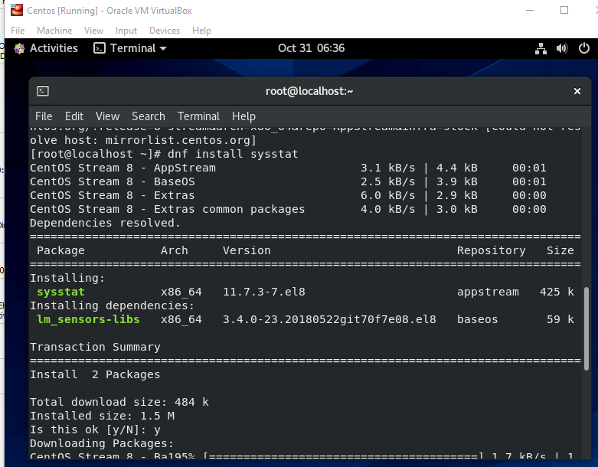
To show the version of sysstat utility
CMD :-
mpstat –V
mpstat command without using any flags or options will display the global average activites by All CPUs.
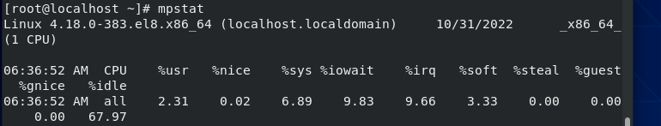
Using mpstat with option ‘-P’ (Indicate Processor Number) and ‘ALL’, will display statistics about all CPUs one by one starting from 0
CMD:-
mpstat –P ALL
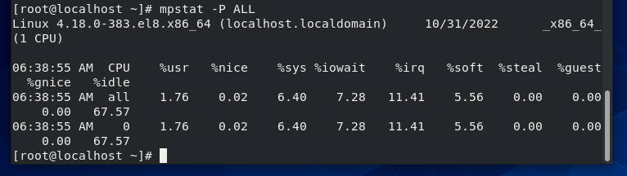

5.sar(System Activity Reporter):- “sar” helps to get the reports about whole system’s
To check run queue length, total number of processes and load average
CMD :-
sar -q 2 5

Load Avg. total no of Process

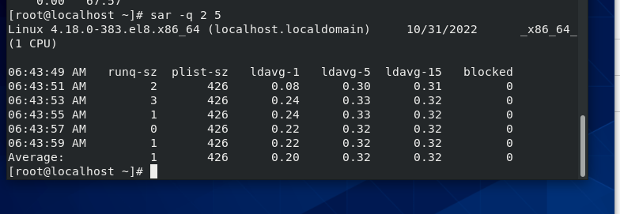

To check statistics about the mounted file systems using –F
CMD:-
sar -F 1 3 | egrep -v lo
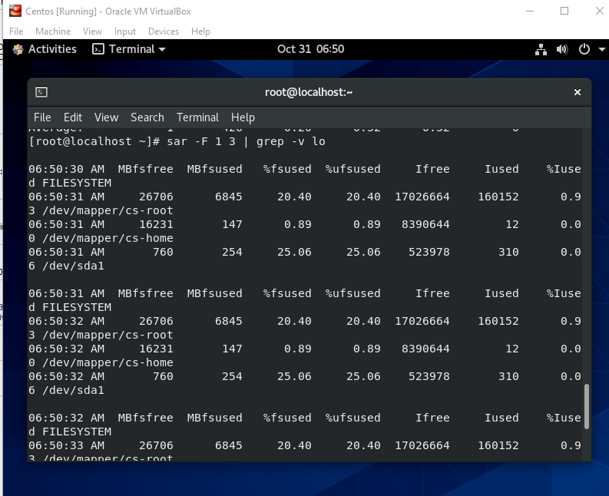

To print memory statistics use -r option
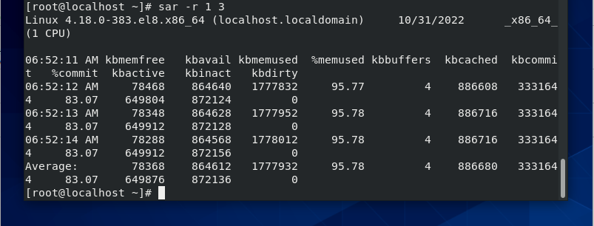

6.pidstat:- It is used for process monitoring and current threads, which are being managed by kernel. pidstat can also check the status about child processes and threads.
To print all active and non-active tasks use the option ‘-p’ (processes).
CMD:-
pidstat –p ALL

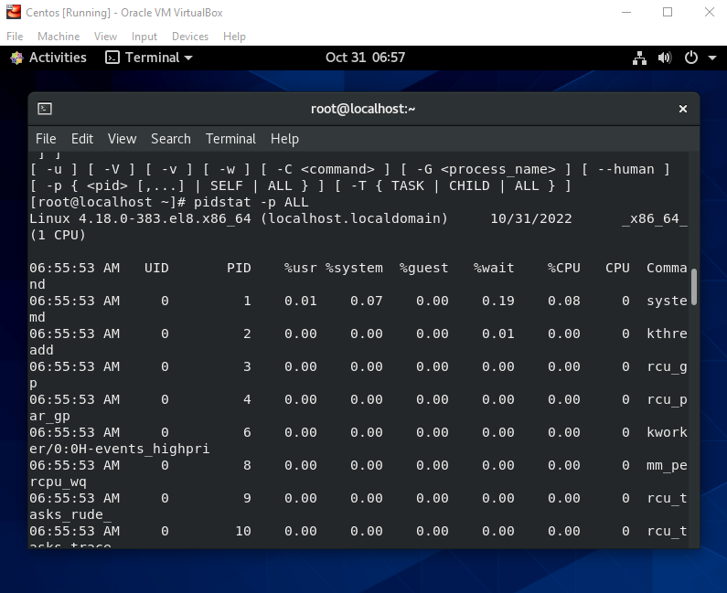

Using pidstat command with ‘-d 2’ option, we can get I/O statistics within 2 seconds interval to get refreshed statistics. This option can be handy in situation, where your system is undergoing heavy I/O and you want to get clues about the processes consuming high resources.
CMD :-
pidstat -d 2 n z

7.perf:- Performance monitoring for the Linux Kernel. It gives report which parameters passed or failed or skipped those parameters which is not applicable for the systems.
CMD:-
dnf install perf
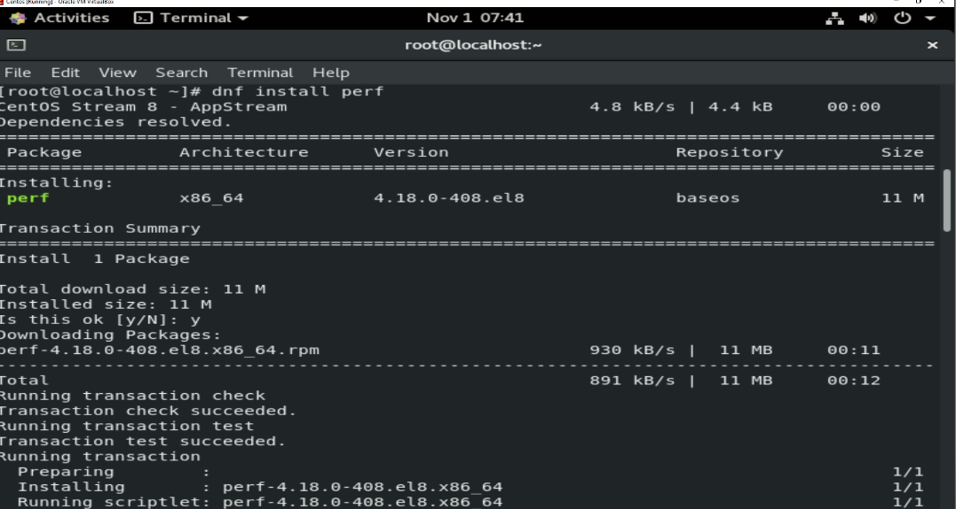

To perform sanity test in the system
CMD :-
perf test
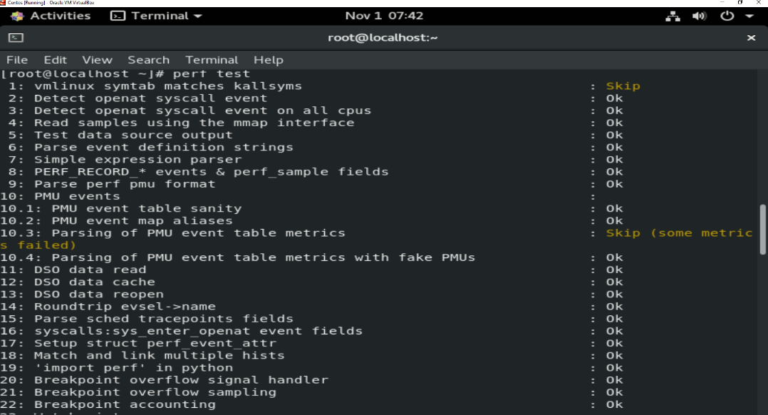

8. turbostat:- Report processor frequency and idle statistics. It gives the report about the processor performance.
CMD :-
turbostat
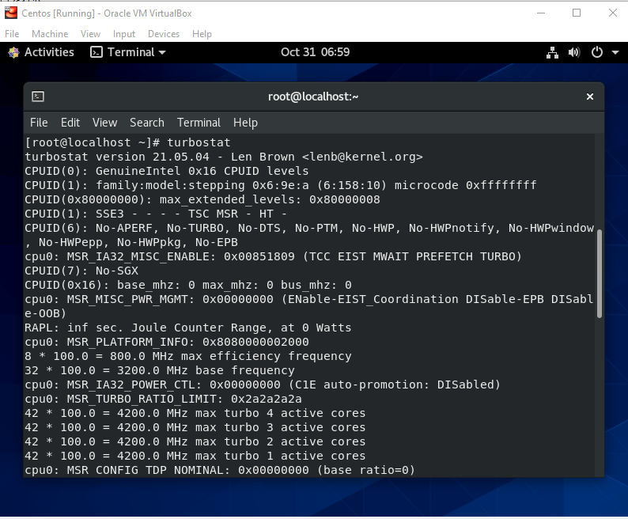

9. iostat:- Report central processing unit (CPU) statistics and input/output statistics for devices and partitions.-
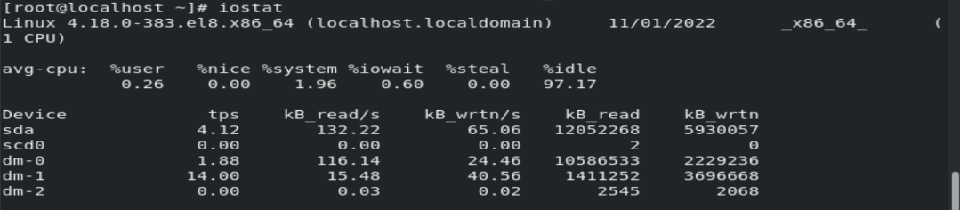

10. irqbalance:- It distribute hardware interrupts across processors on multiprocessor system in order to increase performance. It will find a balance between power savings and optimal performance. It work is invisible to us. The daemon balances savings in power consumption with performance. The irqbalance configuration file is /etc/sysconfig/irqbalance allows the selection of which CPU’s which may be assigned which interrupts.

11. ss:- It is a Network tool which is used for displaying network socket related information on a Linux system. The tool displays more detailed information that the “netstat” command which is used for displaying active socket connections
CMD :-
ss
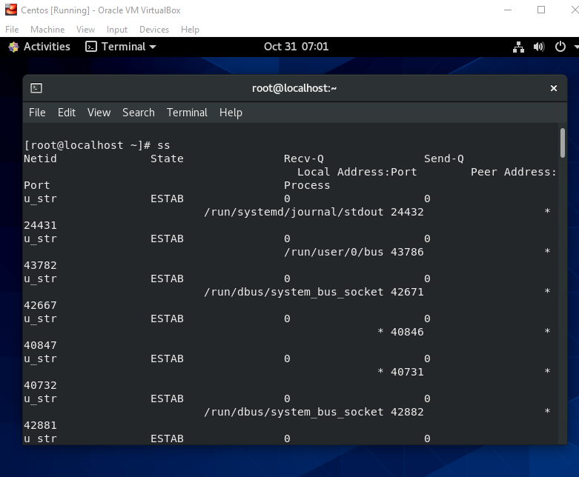

To retrieve a list of both listening and non-listening ports using the –a
CMD:-
ss –a
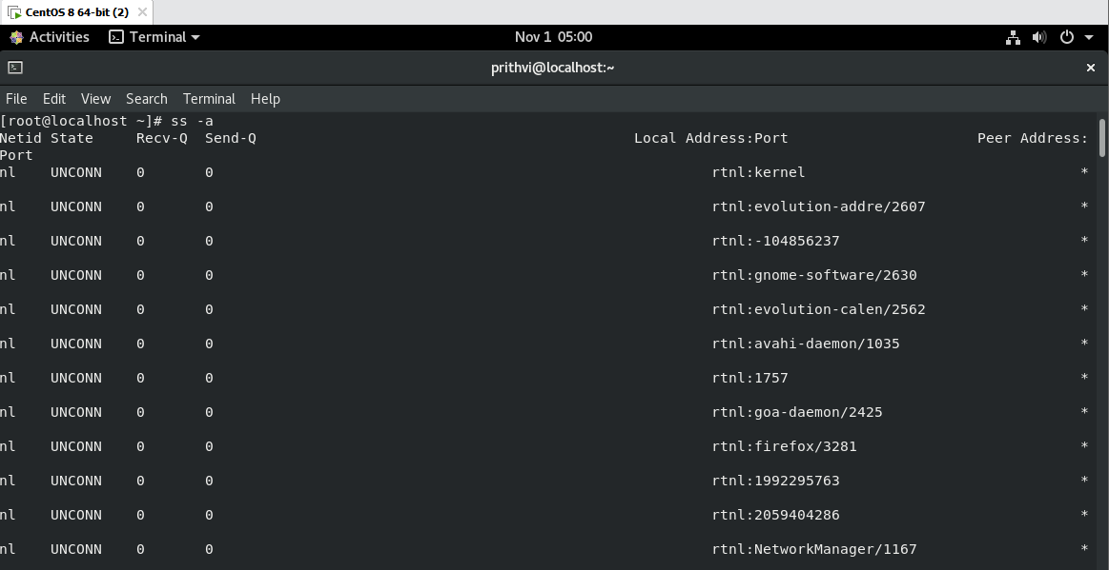

To display listening sockets only, use the “-l” flag
CMD:-
ss –l
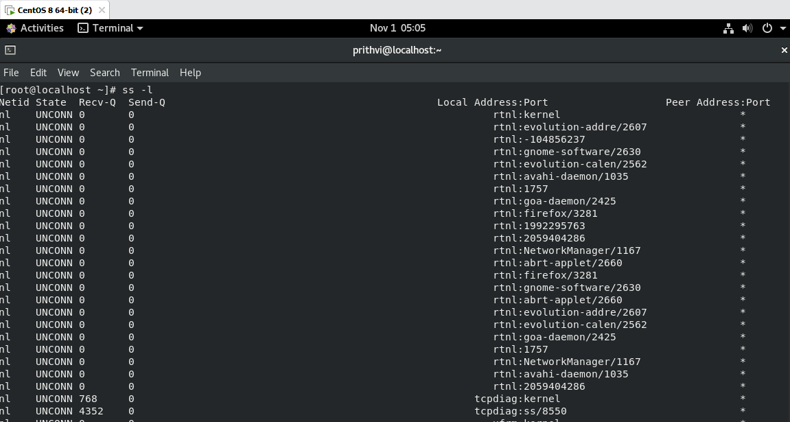

To display all TCP connection, use the –t
CMD :-
ss –t
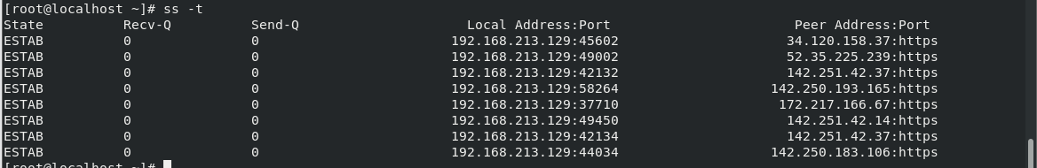

To view all the listening TCP socket connection use the “-lt”
CMD:-
ss -lt
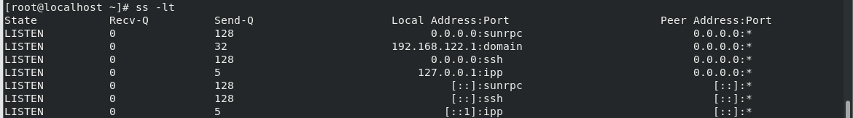

To list listening UDP connection use “-lu” option.
CMD:-
ss –lu
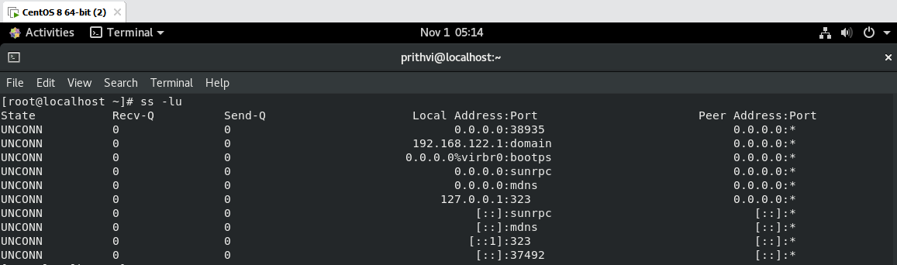

To display the process IDs related to socket connections, use the -p flag as shown
CMD:-
ss –p
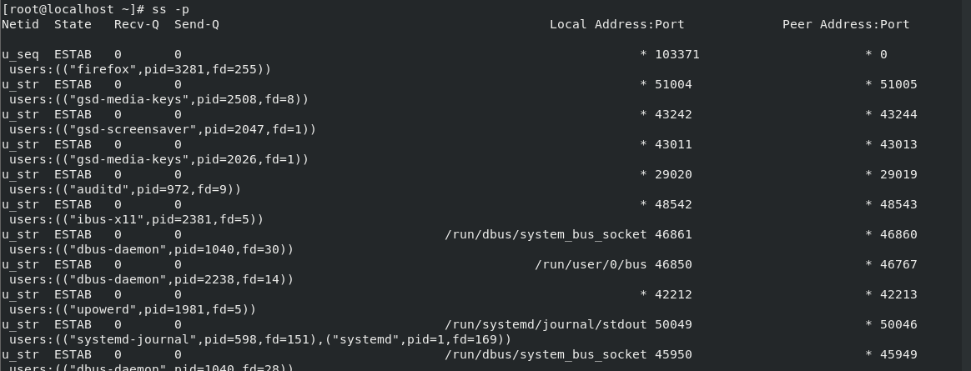

To display summary statistics, using the “-s” option.
CMD:-
ss –s
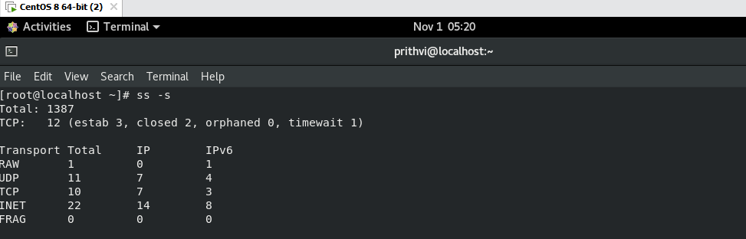

12.numastat:- The “numastat” tool is used to display node memory statistics of processes and operating systems from the kernel memory allocator. Eache NUMA has different memory policies.
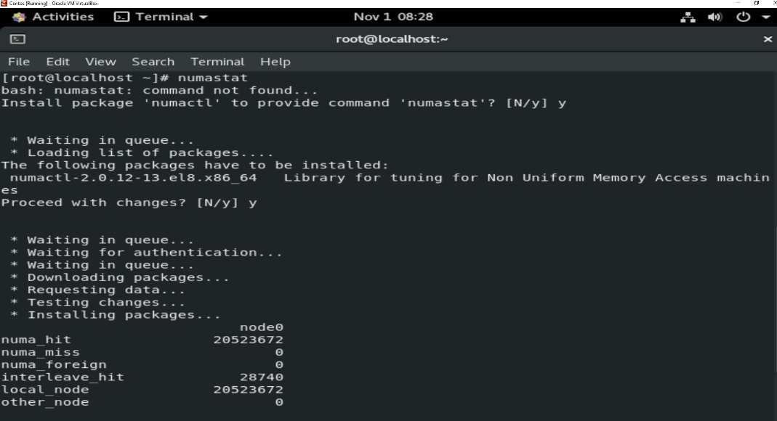

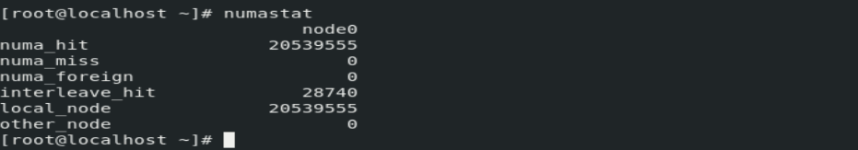

13.tuna:- It is a tool that can be used to adjust scheduler tunables such as such as schedulaer policy, RT priority and CPU affinity. It also allows the user to see the results of these changes. Most Tuna operations can be performed on either the command line or in the GUI.

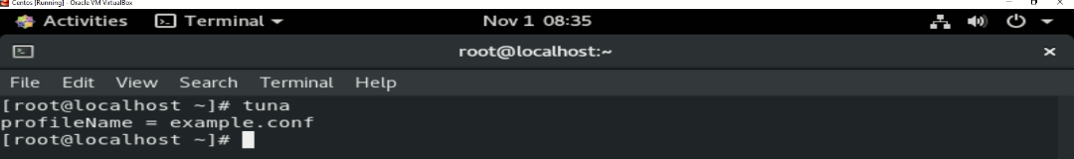
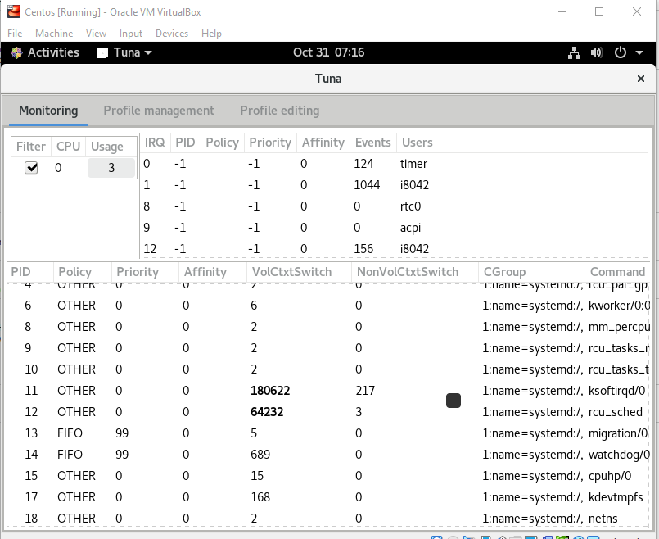

14.ethtool:- It is a networking utility on Linux. It is used to configure Ethernet devices on Linux. ethtool can also be used to find a lot of information about connected Ethernet devices on your Linux computer.
To show the version of ethtool
CMD :-
ethtool –version
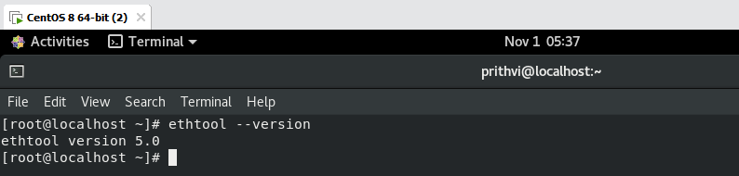

To display the information about a NIC ( Network Interface Card)
CMD :-
ethtool enp0s3
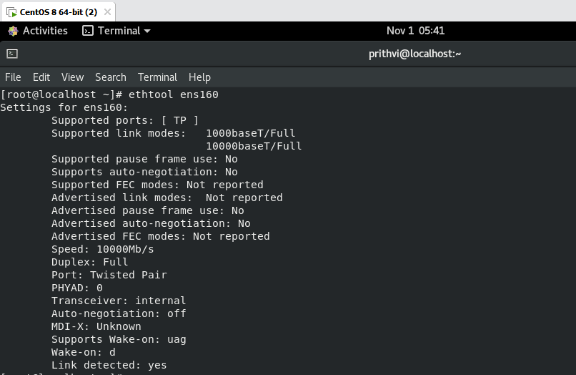

To check for the driver used
CMD :-
ethtool -i enp0s3
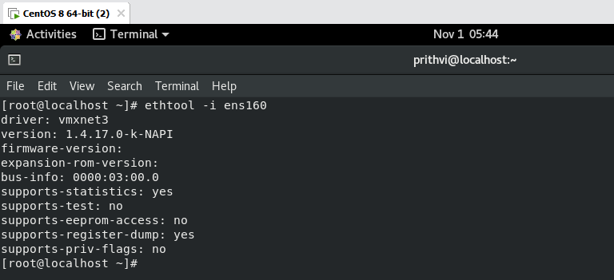

15.ip :- This commands is used to show or manipulate routing, devices and tunnels. It is similar to ifconfig command.
To find the assigned names of all the available network interfaces of your computer
CMD:-
ip link show
