Module:-COSA(Concept Of Operating System And Administration) Date:- 31/10/2022
Assignment :- 05 Name:- Prauthviraj Nikam

16.ifconfig :- Ifconfig is used to configure the kernel-resident network interfaces.It is used at boot time to set up interfacesas necessary.After that, it is usually only needed when debugging or when system tuning is needed.If no arguments are given, ifconfig displays the status of the currently active interfaces.If a single interface argument is given, it displays the status of the given interface only; if a single -a argument is given, it displays .the status of all interfaces, even those that are down. Otherwise, it configures an interface.
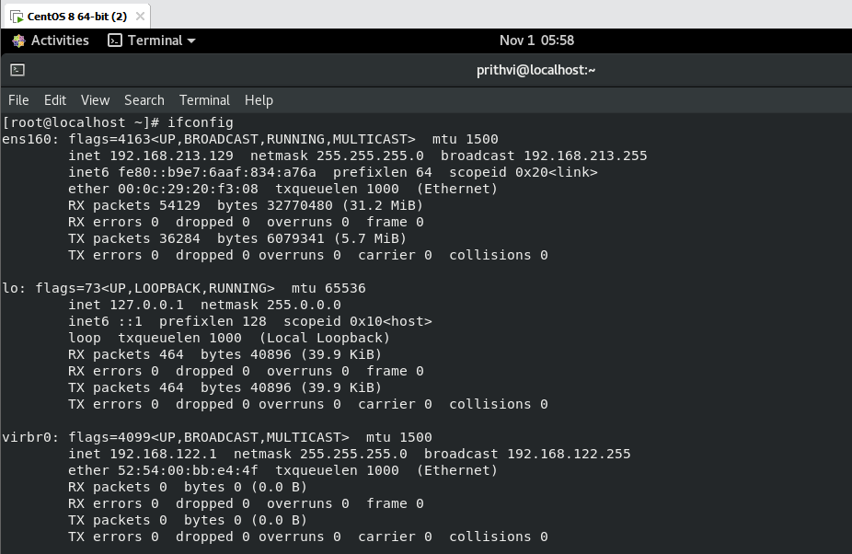
17.pqos:-
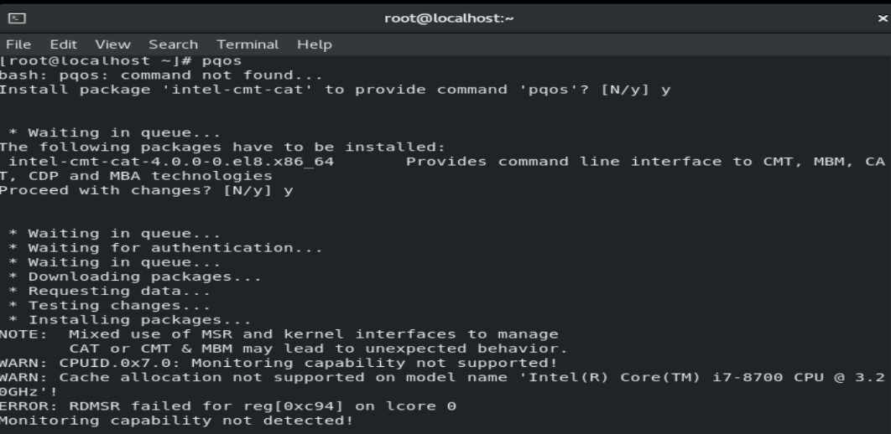
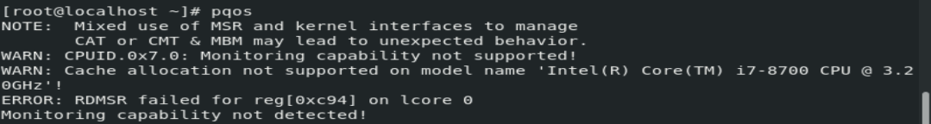

18. tune:- tuned is a dynamic adaptive system tuning daemon that tunes system settings dynamically depending on usage.
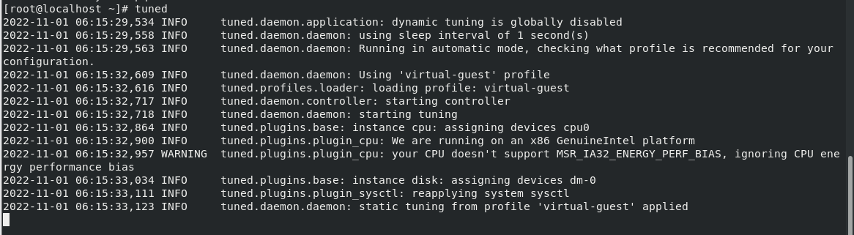
19. /proc/net/snmp:-
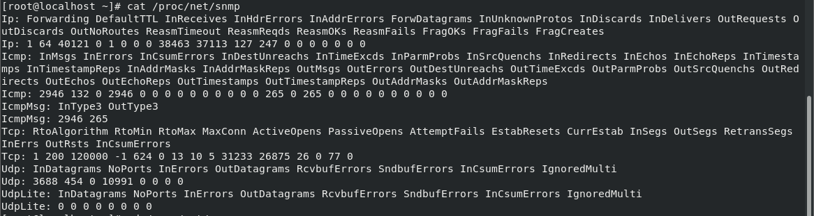
20.watch:-watch runs command repeatedly, displaying its output and errors (the first screenfull). This allows you to watch the program output change over time. By default, command is run every 2 seconds and watch will run until inter - rupted.
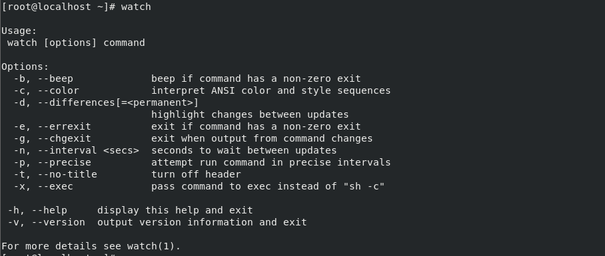
21.lvscan:-lvscan scans all VGs or all supported LVM block devices in the system for LVs. The output consists of one line for each LV indicating whether or not it is active, a snapshot or origin, the size of the device and its allocation policy.Use lvs(8) or lvdisplay(8) to obtain more comprehensive information about LVs.
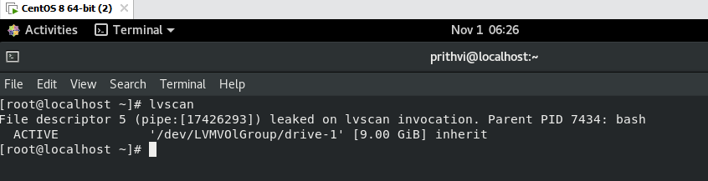
22.nmcli:- nmcli is a command-line tool for controlling NetworkManager and reporting network status. It can be utilized as a replacement for nm-applet or other graphical clients. nmcli is used to create, display, edit, delete, activate, and deactivate network connections, as well as control and display network device status.
Typical uses include:
- Scripts: Utilize NetworkManager via nmcli instead of managing network connections manually. nmcli supports a terse output format which is better suited for script processing. Note that NetworkManager can also execute scripts, called "dispatcher scripts", in response to network events.
- Servers, headless machines, and terminals: nmcli can be used to control NetworkManager without a GUI, including creating, editing, starting and stopping network connections and viewing network status.
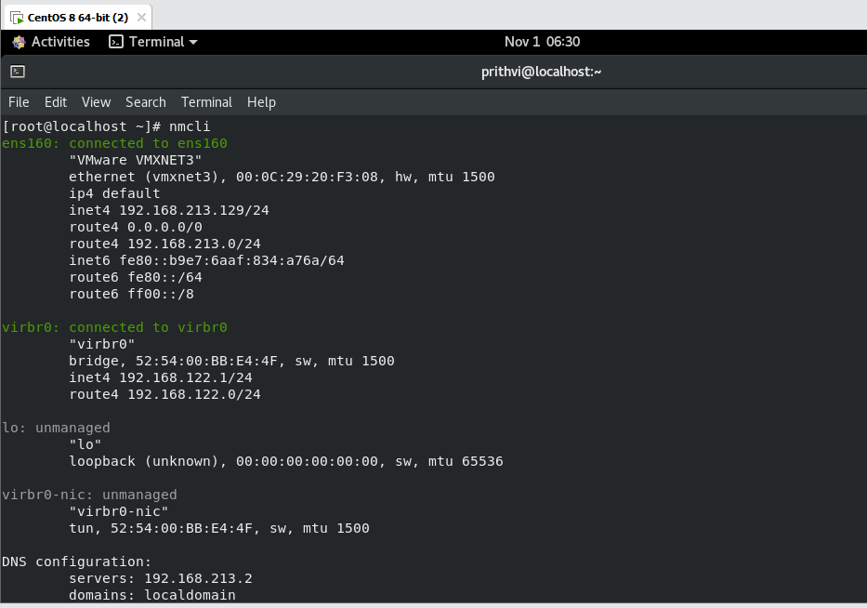
23.du:- Summarize disk usage of the set of FILEs, recursively for directories.
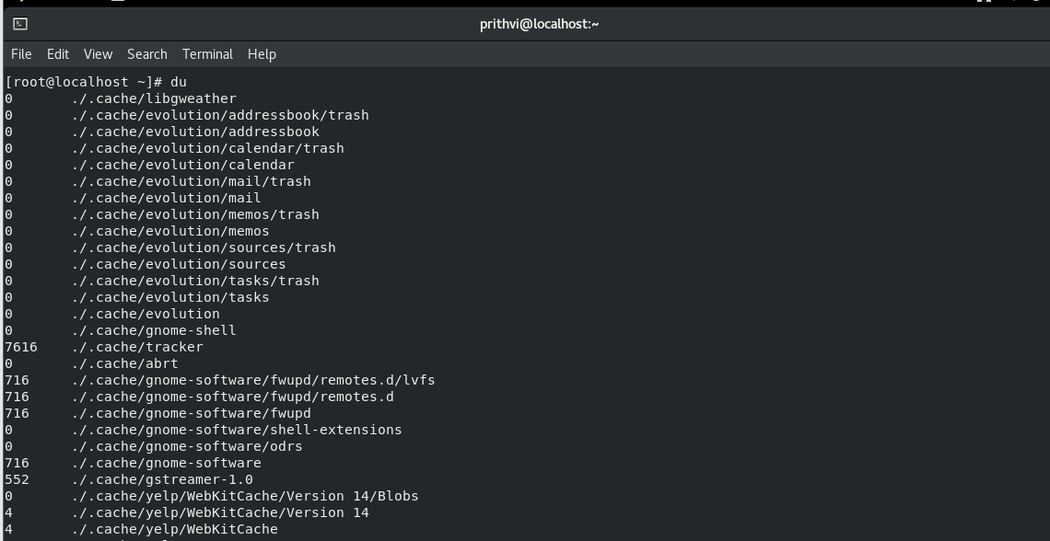
24.lspci:- lspci is a utility for displaying information about PCI buses in the system and devices connected to them. By default, it shows a brief list of devices. Use the options described below to request either a more verbose out‐ put or output intended for parsing by other programs.
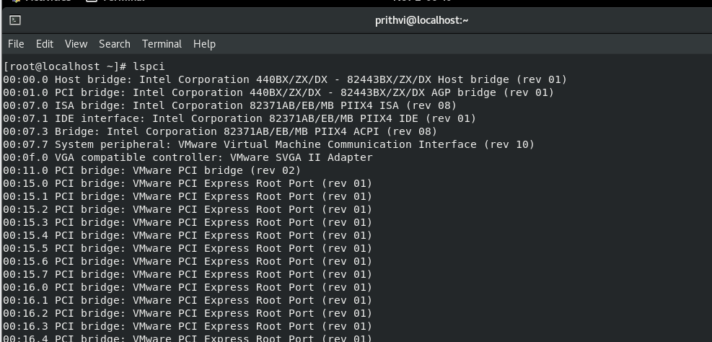
25.findmnt:-
findmnt will list all mounted filesystems or search for a filesystem. The findmnt command is able to search in /etc/fstab, /etc/mtab or /proc/self/mountinfo.If device or mountpoint is not given, all filesystems are shown.The device may be specified by device name, major:minor numbers, filesystem label or UUID,or partition label or UUID.The command prints all mounted filesystems in the tree-like format by default.
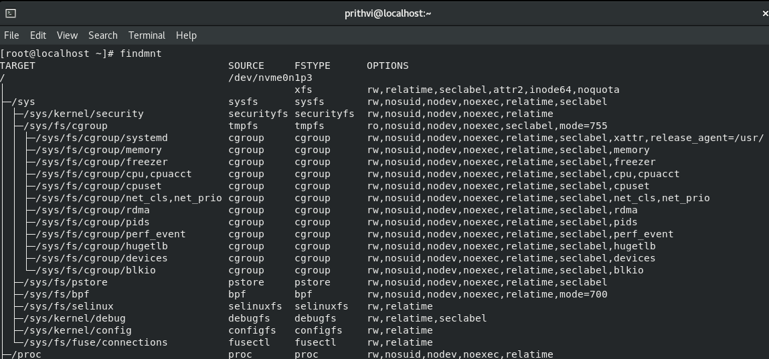
26.blkid:- The blkid program is the command-line interface to working with the libblkid(3) library.It can determine the type of content (e.g. filesystem or swap) that a block device holds, and also the attributes (tokens, NAME=value pairs)from the content metadata (e.g. LABEL or UUID fields).
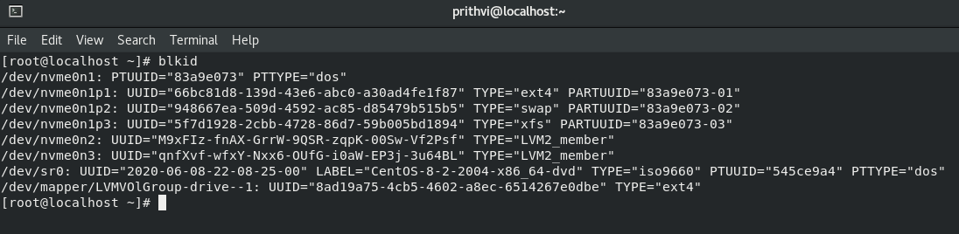
27.lsblk:- lsblk lists information about all available or the specified block devices.The lsblk command reads the sysfs filesystem and udev db to gather information. If the udev db is not available or lsblk is compiled without udev support than it tries to read LABELs, UUIDs and filesystem types from the block device. In this case root permission are necessary.The command prints all block devices (except RAM disks) in a tree-like format by default.
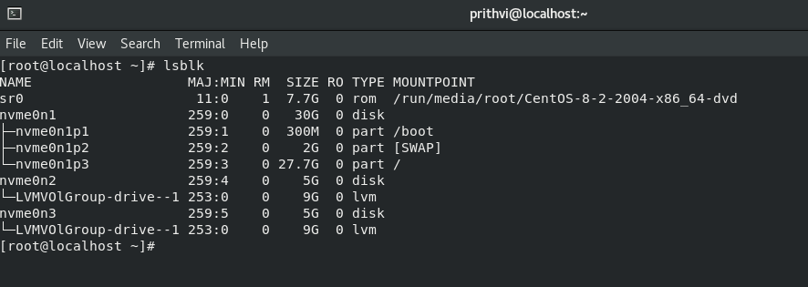
28.lsusb:-lsusb is a utility for displaying information about USB buses in the system and the devices connected to them.
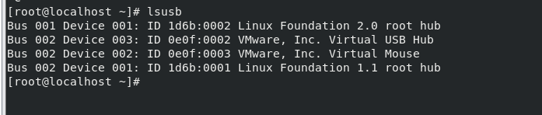
29.lscpu:-scpu gathers CPU architecture information from sysfs, /proc/cpuinfo and any applicable architecture-specificlibraries (e.g. librtas on Powerpc).The command output can be optimized for parsing or for easy readability by humans.The information includes, for example, the number of CPUs, threads, cores, sockets, and Non-Uniform Memory Access (NUMA) nodes.There is also information about the CPU caches and cache sharing, family, model, bogoMIPS, byte order, and stepping.
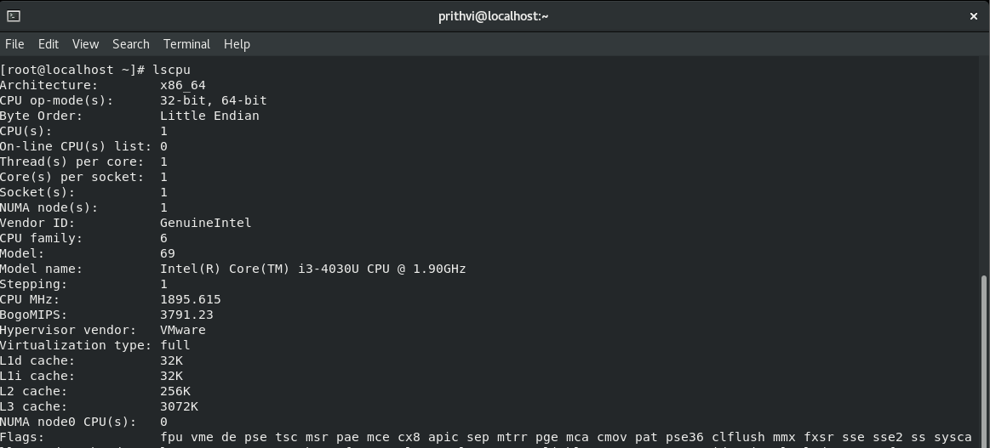
30.lsof:-Lsof revision 4.91 lists on its standard output file information about files opened by processes for the following
UNIX dialects:
Apple Darwin 9 and Mac OS X 10.[567]
FreeBSD 8.[234], 9.0 and 1[012].0 for AMD64-based systems
Linux 2.1.72 and above for x86-based systems
Solaris 9, 10 and 1
(See the DISTRIBUTION section of this manual page for information on how to obtain the latest lsof revision.)
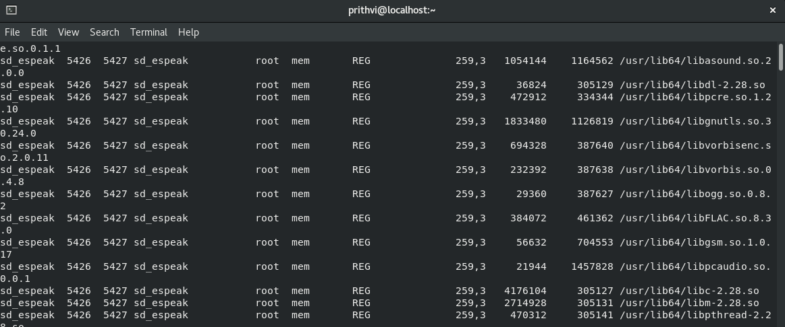

31.fuser:-fuser displays the PIDs of processes using the specified files or file systems. In the default display mode, each file name is followed by a letter denoting the type of access:

c current directory.
e executable being run.
f open file. f is omitted in default display mode.
F open file for writing. F is omitted in default display mode.
r root directory.
m mmap'ed file or shared library.
. Placeholder, omitted in default display mode.
fuser returns a non-zero return code if none of the specified files is accessed or in case of a fatal error. If at least one access has been found, fuser returns zero.

32. chroot :- Run COMMAND with root directory set to NEWROOT.
33.kill:- The command kill sends the specified signal to the specified processes or process groups.
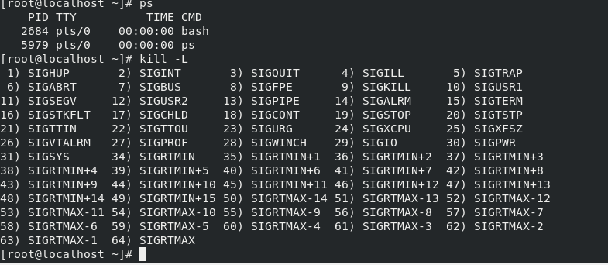
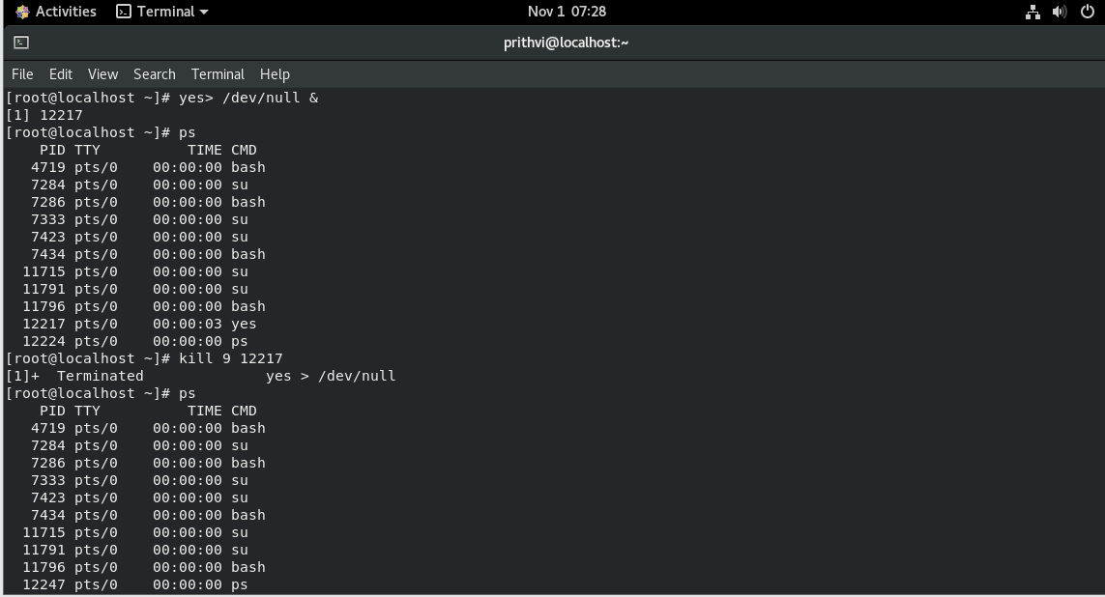

34.df :-This manual page documents the GNU version of df.df displays the amount of disk space available on the file system containing each file name argument.If no file name is given, the space available on all currently mounted file systems is shown.Disk space is shown in 1K blocks by default, unless the environment variable POSIXLY_CORRECT is set, in which case 512-byte blocks are used.
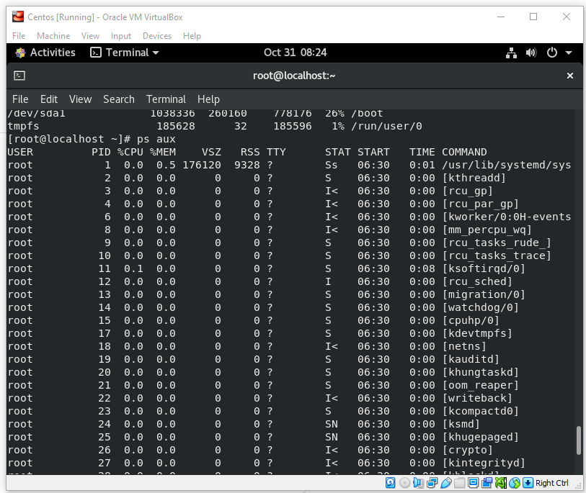
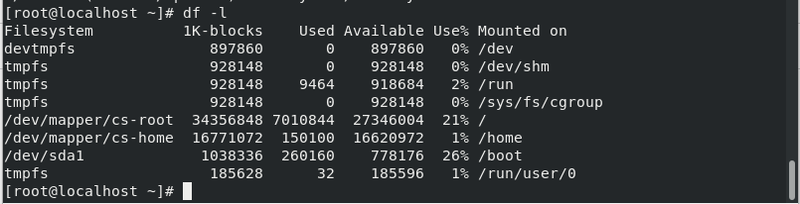

35.cockpit:- Cockpit is a web accessible interactive admin interface for Linux machines. Cockpit can usually be accessed on port 9090 of the machine it's installed on. Cockpit starts on demand. Use your system credentials to log in.
