Module:-COSA(Concept Of Operating System And Administration) Date:- 31/10/2022
Assignment :- 05 Name:- Prauthviraj Nikam

36. check-update:-
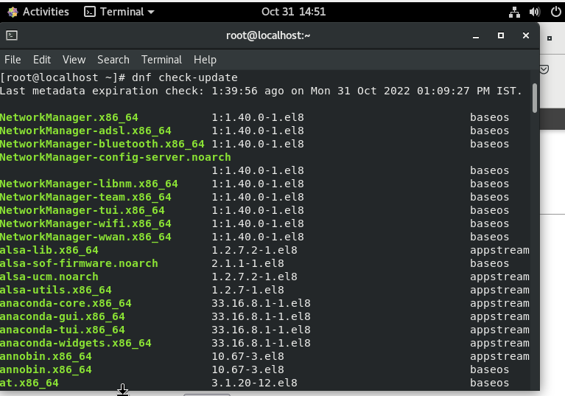
37.epel *:-
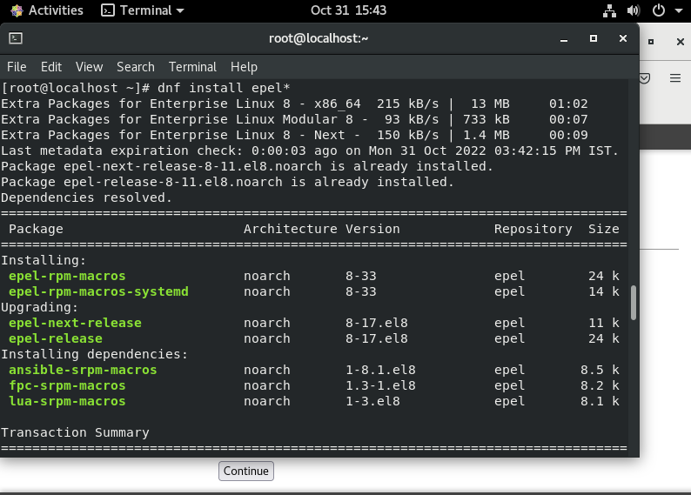
38.top:- The top program provides a dynamic real-time view of a running system. It can display system summary information as well as a list of processes or threads currently being managed by the Linux kernel. The types of system summary information shown and the types, order and size of information displayed for processes are all user configurable and that configuration can be made persistent across restarts.
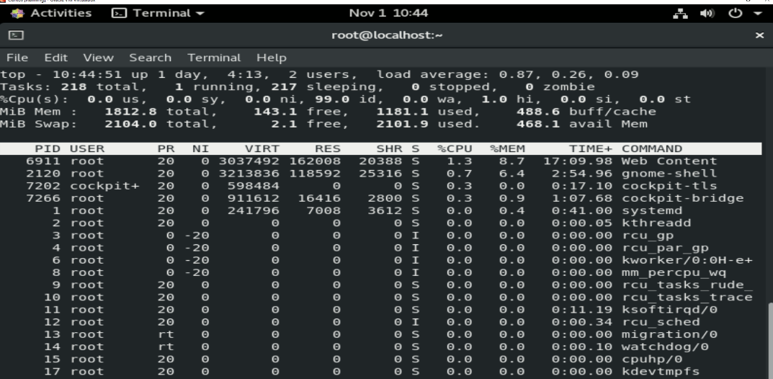
39.atop
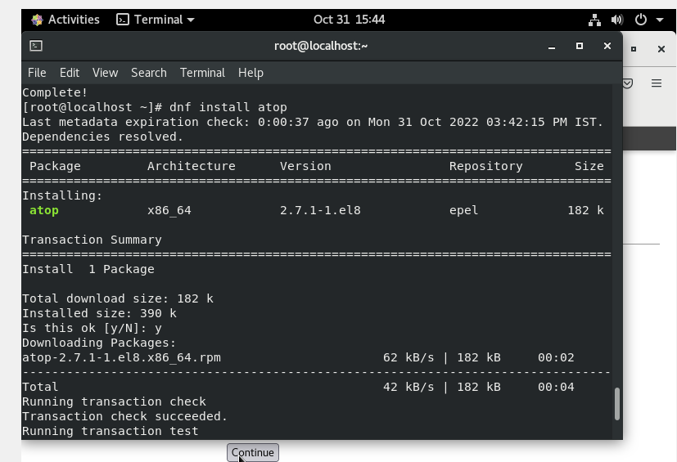
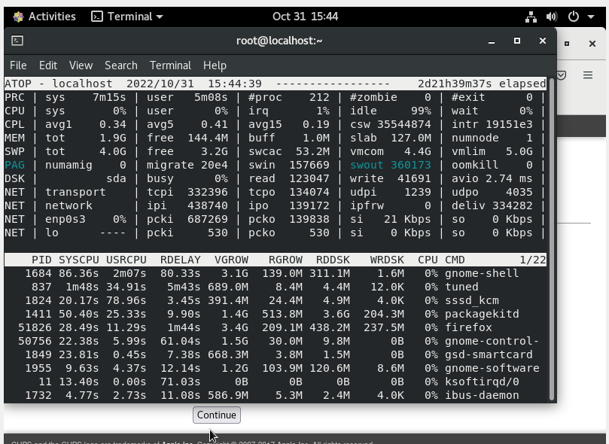
40.htop:-
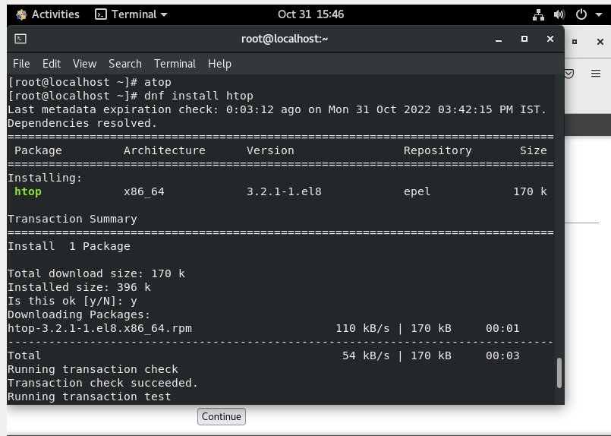
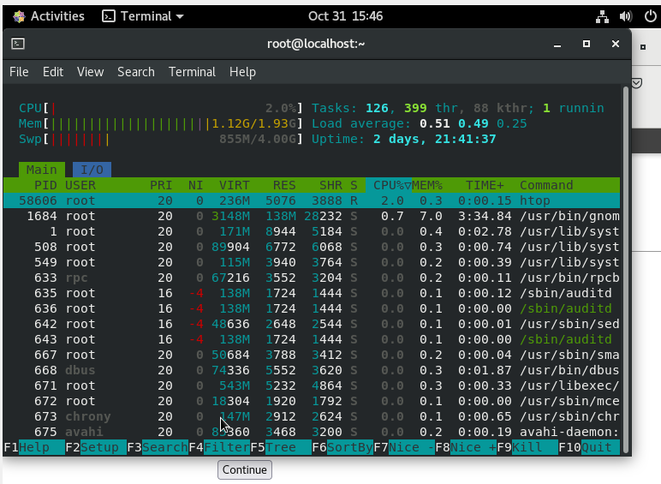
41. glances:-
