Annotation.

We added some meta-tags for facebooks OGP.

To do so we first located the head tag (we had to format the html a little bit to make the OGP-tags easy to see) and put the required tags inside of it.
We don’t have access to the url of this article other than the internal one in mitt.uib, so we used a placeholde for uib as well as picture.
We added a short description as well as a site name for the owner of the article.
The type of the object is article.
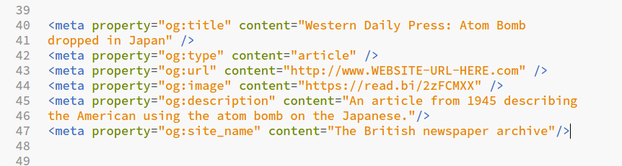

Here we can see the tags as Facebook would see them, using OGP check.
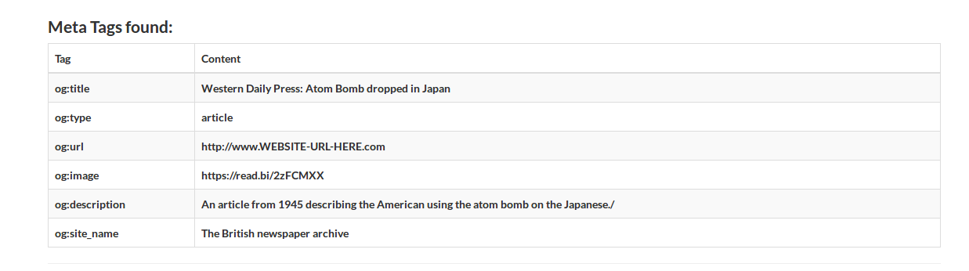
JSON-LD:

Annotating in JSON-LD gave us a challenge because we weren’t sure if we should describe the web page as an article or as the historical event it is describing. We eventually decided to use the JSON-LD to describe the article, and fill in the relevant historical data in the “about tag”.
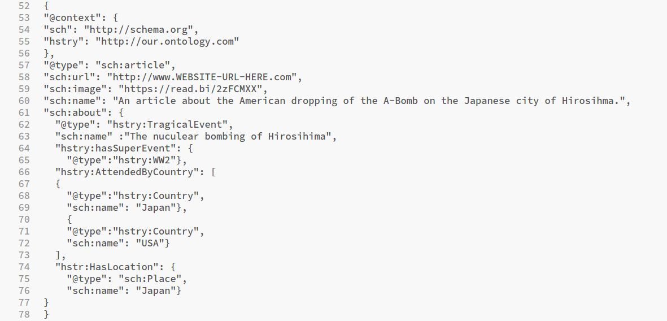

We gave our ontology a faux URL, with the prefix “hstry”. This prefix will be used later with the RDFa lite annotation as well.

Here is what Googles test tool sees:
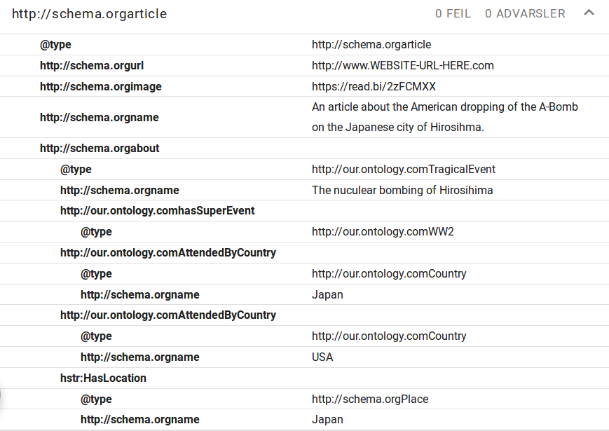

As we can see the page is annotated as an article, an the article is annotated to be about a “TragicalEvent” Hiroshima bombing, and relevant historical information is added.
From this is it easy to see that the article is about a tragical event that happened in Japan, where Japan and USA were the two participating parties.

RDFa Lite.
This was the hardest annotation to do, both because the syntax was slightly more complicated, but mostly because it was difficult to decide what to annotate and in what way.
The web page we are working on is mostly filled with irrelevant non-historical data, with a small snippet of text about a very important historical event. But how should we describe this with RDFa?
Should we bunch all the text together, annotate it as one event, add some data like who was participating and call it night?
No, because we had already done that with the JSON-LD. The RDFa Lite needed to be more specifice, target certain words and phrases.
So we added annotation to describe what “our enemies” meant (surprise, it was Japan), what location “far east” references and what “the weapon race” is. This way, we can give machines contextual information that previously was reserved only for humans.
Here it is in graph form.

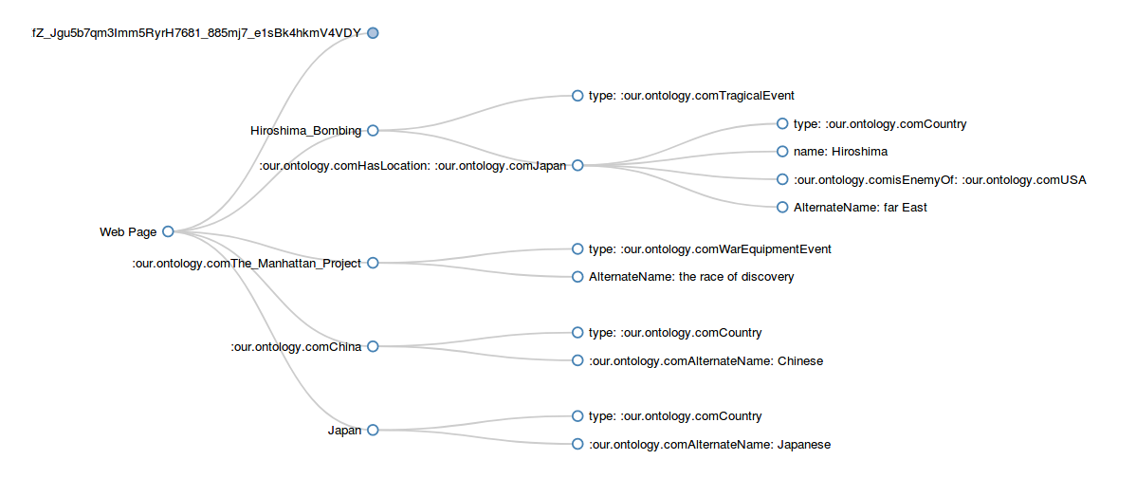
The top node is OGP information, it can be ignored for now.
The rest of the graph shows that the data behaves the way we wanted it, it shows us that Japanese is another word for Japan in this context, and that Japan was the enemy of USA in the context of the bombing of Hiroshima.
Our annotation also showed neatly in Googles test tool, with the exception of the node Country being a part of the Hiroshima_Bombing node. For some reason the testing tool gave an error (type country is not recognized), but because it came out neatly in the graph, we decided that it was probably a difference in how the two tools picked up the data. The TA also didn’t know what the problem could be.

