**Participant Information Sheet**

**Software Architecture for Human-Robot Collaboration User Study**

**Introduction**

Thank you for the interest in this study. Before you decide to participate, it is important for you to understand why the research is being done and what it will involve. Please take time to read the following information carefully and ask if there is anything that is not clear or if you would like more information. Please take time to decide whether or not you wish to take part.

**What is the purpose of the study?**

In the era of the fourth industrial revolution, robots are required to cooperate side by side with humans in an unstructured and dynamic environment. To achieve that goal, robots need to have technical skills such as the ability to monitor the environment conditions and dynamically allocate collaborative tasks to themselves or humans. On top of that, robots need to possess social skills such as multimodal communication capability, awareness of human attention and intention, and make appropriate reactions to unprecedented situations. This study aims to identify and analyse multimodal social signals that people use during Human-Robot Collaboration. The result of this study will be utilised to develop an integrated software architecture for collaborative robots, especially the situation monitoring module and the planning module.

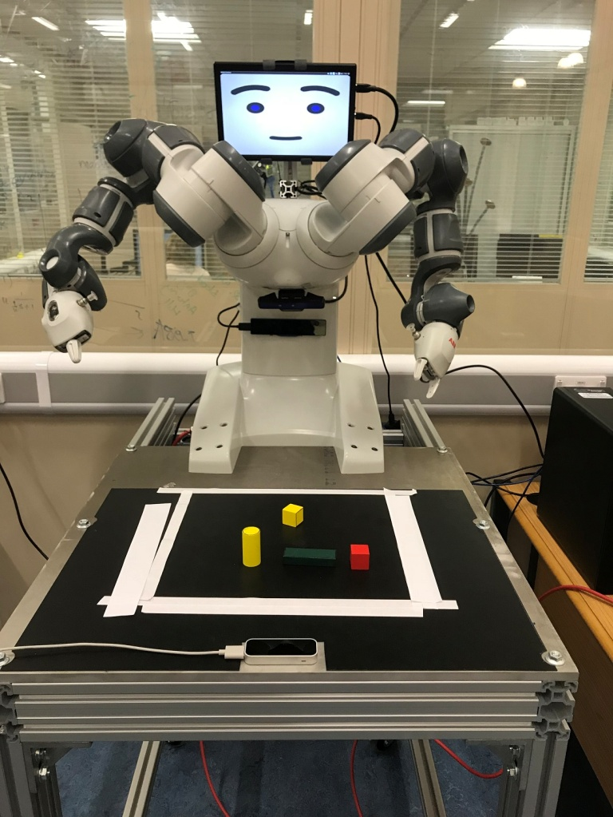

Fig 1. ABB Yumi Collaborative Robot

**Do I have to take part?**

It is your choice whether or not to participate. There are no known risks associated with this study. If you do decide to take part, you will be given this information sheet to keep and be asked to sign a consent form. You are free to withdraw at any time before/during the study and without giving a reason. After your participation in the study, you have **5 days** to request the withdrawal of your data. This cut-off allows us to minimise the possible impact of the removal of your data on the ongoing data analysis and write-up of the project. After this point (5 days), it may not be possible to withdraw your data from the study.

**What happens in the study?**

At the beginning of this study, you will be asked to fill in demographic and personality questionnaires. After that, you will be asked to interact with a collaborative robot called Yumi (Fig. 1) and complete twenty simple assembly tasks using wooden blocks. The robot will know the plan of the first ten tasks, while you will know the plan of last ten tasks. With this arrangement, you are encouraged to communicate the plan and work together with the robot in order to complete the task.

At the end of the study, you will be asked some follow-up questions about your interactions with Yumi. Your interactions with Yumi will be video-recorded for analysis. The whole study will take around 30 minutes to complete.

**What will happen with the data collected in this study?**

The personal information collected in this research project will be processed by the University in accordance with the terms and conditions of the 1998 Data Protection Act. We will hold your data securely and not make it available to any third party unless permitted or required to do so by law.

All the data will be stored under an anonymous identifier and used on a confidential basis. The recorded task data and the resulting analysed data will be held for as long as it retains research value although this is unlikely to exceed 10-years. The anonymised data may be made available for further appropriately approved research at the University.

The findings from this research may be used in publications, academic journals and also presentations at academic conferences or teaching purposes by the researchers of this study and other researchers in the related field. The audio and video recording of this user study will be archived as a dataset and disseminated publicly for future research. As a consequence, the audio and video recording of this user study can be accessed, downloaded and seen by any interested researcher throughout the world. All published data will be completely anonymised with no identifying information about individual participants.

**Who do I contact for further information?**

Should you have any questions about this research, please contact the researcher conducting this research below.

Dito Cahya (researcher): [dito.cahya@bristol.ac.uk](mailto:dito.cahya@bristol.ac.uk)

FARSCOPE Centre for Doctoral Training  
Bristol Robotics Laboratory  
University of the West of England  
T Block, Frenchay Campus  
Coldharbour Lane  
Bristol, BS16 1QY