Partition Functions and Recursive Relations

Partition of numbers forms and important area in number theory [1,2]. The theoretical developments invariably make use of the properties of generating functions. The recurrence relations for the development of partition theory can be developed independently. The theme of this paper is to explore the application of recursive relations for the additive partition of numbers.

Partition of Numbers

We define p(m,n) as partition of n using the largest number equal to m. Then the partition p(n) is given by

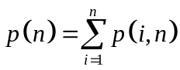

Theorem 1: The recurrence relation for p(m,n) is given by

with p (k, k) = 1.

Proof: If partitions p(m, n − m), p(m −1,n − m)…, p(1,n − m) are obtained, p(m, n) is obtained by prefixing m to each of these. Thus

We also have

The recurrence relation follows from these two relations.

Theorem 2: Let π (m, n) denote the partition of n into m parts. Then π (m, n) = p (m, n).

Proof: Let us separate m units from n to represent the m parts. Then π (m, n) is precisely the sum of the number of ways of dividing the remaining n – m into m – 1, m – 2,…, 1 parts. This leads to the same recurrence as defined in Theorem 1, with π (1, k) = 1.

Theorem 3: Let p′(m, n) denote the partition of n using numbers no greater than m then

Proof: We have

From the argument of Theorem 1, we have

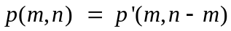

Theorem 4: Let h(m,n) denote the partition of n with the least number equal to m, then the following recurrence relation holds

with h(1, k) = p(k − 1), h(k, k) = 1.

Proof: If partitions h(m, n − m), h(m + 1,n − m), … are obtained, h(m, n) is obtained by prefixing m to each of these. Thus

Using this relation, we can write

The result follows.

Theorem 5: Let h′ (m,n) denote the partition of n with the least number m or larger, then the following recurrence relation holds

with h′ (k, k) = 1.

Proof: Using the definition of the partition in Theorem 4, we write

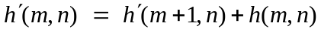
As noted in the theorem 4,

In the development of the partition table, we proceed from h′ (n, n) and move upward.
Theorem 6: Let p_{k}(m,n) denote the partition of n with the largest number equal to m using numbers differing from m by a multiple of k, then the following recurrence relation holds

Proof: If partitions p_{k} (m , n − m), p_{k} (m − k, n − m), … are obtained, p_{k} (m, n) is obtained by prefixing m to each of these. Thus

Using this relation, we can write

The result follows.

This recurrence relation can be used for developing tables for partition using odd numbers or even numbers. For partition into odd numbers with the largest odd number equal to m, k = 2. For partition into even numbers with largest even number m, we choose k = 2.

Distinct Partitions

We define the distinct partition d(m,n) as partition of n using distinct numbers, with the largest number equal to m. Then the distinct partition 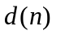is given by

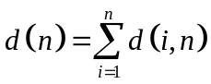

Note that 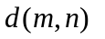= 0 if ( m(m + 1 )/2 < n), and 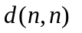 = 1

Theorem 7: The recurrence relation for d(m,n) is given by

Proof: If partitions d(m − 1, n − m), d(m −2,n − m)…, d(1,n − m) are obtained, d(m, n) is obtained by prefixing m to each of these. Thus

We also have

The recurrence relation follows from these two relations.

Theorem 8: Let d′ (m, n) denote the partition of n using numbers no greater than m then the following recurrence relation holds

Distinct partition d(n) is given by 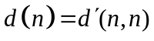.

Proof: We have

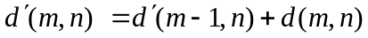

From the argument of Theorem 7, we have

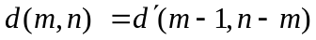

Theorem 9: Let θ (m, n) denote the partition of n into m distinct parts. Then the following recurrence relation holds for θ (m, n).

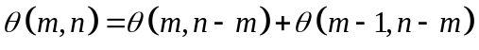

Proof: We first identify the m parts by assigning one to each part. Then adding on distinct partitions into m parts and m − 1 to this will define all the distinct partitions.

The maximum number of parts k for a given number n is the largest k such that

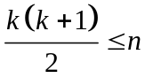.

Theorem 10: Let θ (m, n) denote the partition of n into m distinct parts. Then the following relation holds for θ (m, n).
[Ref: http://www.unc.edu/~rowlett/combin/notes/NumberPartitions.PDF]

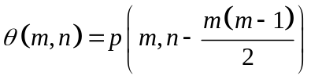
Proof: We arrange number m−1, m−2,…, 1, a total of m(m − 1)/2 into the first m−1 locations. The distinct partition is the partition of the remaining numbers into m parts.

Theorem 11: Let u(m,n) denote the partition of n with the least number equal to m, then the following recurrence relation holds

with u(0, k) = u(k − 1), u(k, k) = 1.

Proof: If partitions u(m + 1, n − m), u(m + 2,n − m), … are obtained, u(m, n) is obtained by prefixing m to each of these. Thus

Similarly, we can write

The result follows. From the expression for u(m, n) above, the expression for u(0, n) is easy to see.

Distinct odd partitions of a number correspond to its self conjugate partitions.

Theorem 12: Let u′ (m,n) denote the partition of n with the least number m or larger, then the following recurrence relation holds

with u′ (k, k) = 1.

Proof: Using the definition of the partition in Theorem 11, we write

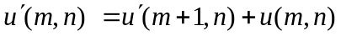
As noted in the Theorem 11,

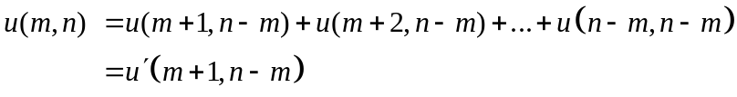

In the development of the partition table, we proceed from u′ (n, n) and move upward.

Theorem 13: Let C(m, n) denote the difference between the number of distinct partitions of n starting with the largest number m and with odd number of parts, and the number of distinct partitions of n with the largest number m and with even number of parts, then the following recurrence relation holds.

with C(1, 1) = 1.

Proof: We have the following relationship for distinct partitions

In our derivation, the second term in the above relation is the partition of n – m to which m is added to get the partition of n. Thus a new part is added to the second term. The first term is distinct partition of n – 1 and 1 is added to the first term. Thus the number of parts does not change. If we identify the number of odd partitions as positive numbers, starting with C(1, 1) = 1, and the number of even partitions as negative numbers, the left side may be replaced by C(m, n) and the right two terms are replaced by C(m – 1, n – 1) , and −C(m –1, n – m).

Theorem 14: With C(m, n) defined as in Theorem 13, we have

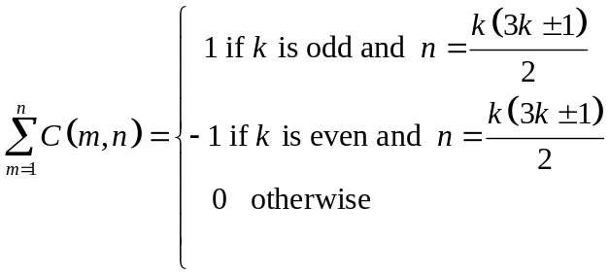

Proof: 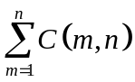 represents the difference between the number of distinct partitions of n with odd number of parts and the distinct partitions with even number of parts. We make use of Franklin’s argument using Ferrar’s diagrams to establish the relationship. Fig.1 illustrates one distinct partition of 17 = 6 + 5 + 4 + 2, with four parts (k = 4)

N_{S} = 3

N_{B} = 2

Figure 1: An even partition of 17 k = 4

We connect the dots in the bottom row with N_{B} = 2, and the dots on the at a slant on the right in the Northwest direction from the extreme right corner, with N_{S} = 3. We look for the possibility of the bottom dots to be placed on the right or the right dots to be placed at the bottom to get a valid distinct partition. In this case the bottom two dots can be placed on the right as shown in Fig. 2, to get 17 = 7 + 6 + 4.

N_{S} = 2

N_{B} = 4

Figure 2: Odd partition of 17 corresponding to Fig. 1, k = 3

The odd partition of 17 corresponding to 6 + 5 + 4 + 2 is 7 + 6 + 4, and the even partition corresponding to 7 + 6 + 4 is 6 + 5 + 4 + 2. The correspondence is unique. This correspondence does not exist for two cases for every k. Consider k = 3.

N_{B} = 4
N_{S} = 3

N_{S} = 3

N_{B} = 3

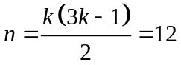
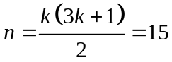

Figure 3: Two cases with no odd-even correspondence

The odd-even correspondence does not exist for n = k(3k ±1)/2. One odd partition is in excess when k is odd, and an even partition is in excess when k is even.

Theorem 15: Let d_{k}(m, n) denote the distinct partition of n with the largest number equal to m using numbers differing from m by a multiple of k, then the following recurrence relations holds.

Proof: The steps follow the proof of Theorem 6.

Extraction of Recurrence Relations and the Partition Function Theorem

Theorem 16: The partition p(n) of n is given by

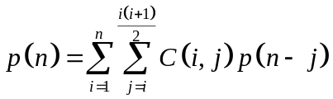
with p(0) = 1.

Proof: We make use of the relation

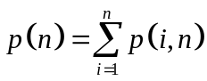

Using the recurrence relation given in Theorem 1,

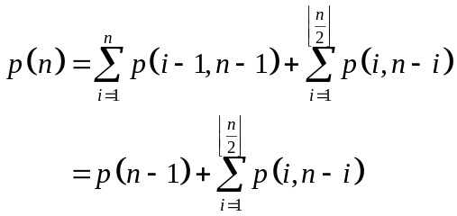

where 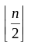 is the floor function, which equals the integer part of n/2.

This gives

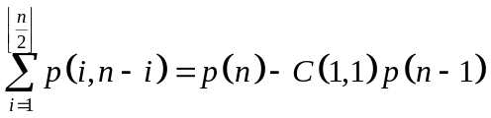 (1)
with C(1,1) = 1.

On expanding the left side and using the above relation, we get

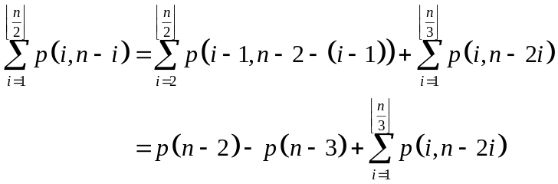

This gives

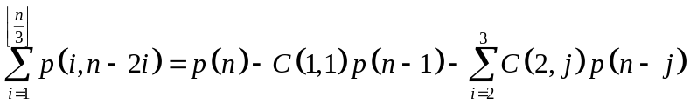 (2)

We have C(2,2) = C(1,1) − C(1,0) , and C(2,3) = C(1,2)− C(1,1), where C(1,0) = 0 and C(1,2) = 0.

The next expansion gives

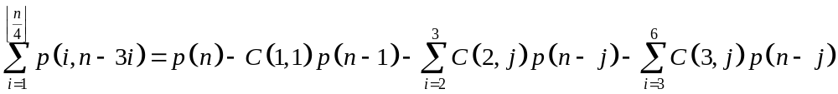

Finally we get

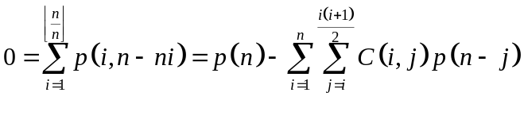

The result follows.

Theorem 17 (Partition Function Theorem): The partition of n is given by

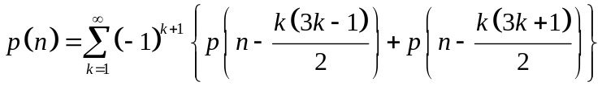
with p(0) = 1, and p(j) = 0 if j < 0.

Proof: From the Theorem 16, we have

Noting that C(i, j) is zero when j < i, and when j > n, we can put the above equation in the form

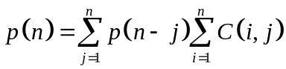
The result then follows from Theorem 14.

Theorem 18: The distinct partition d(n) of n is given by

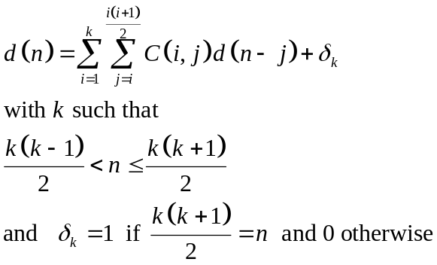

Proof: We make use of the relation

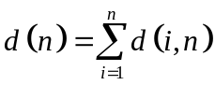
For n = 1, d(1) = 1.

Using the recurrence relation given in Theorem 7,

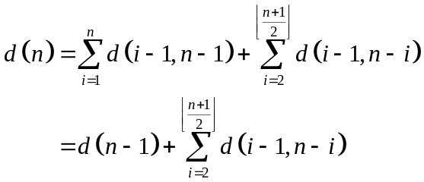
The second term vanishes when n = 2, and is equal to 1 (or d(1)) when n = 3.

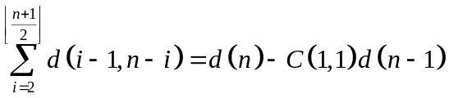 (3)

On expanding, we get

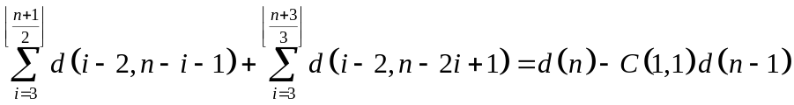

On substituting from (3),

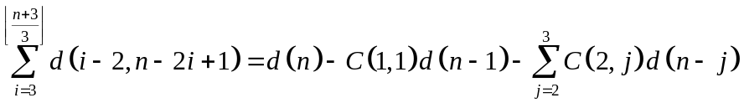 (4)

At step k, we get

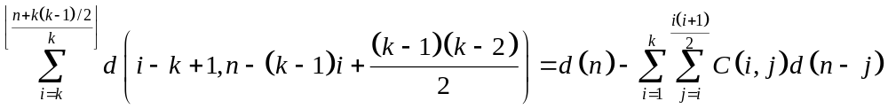

The left side has a value of 1 when the upper limit is exactly k. The result follows.

Theorem 19: Distinct partition function d(n) is given by.

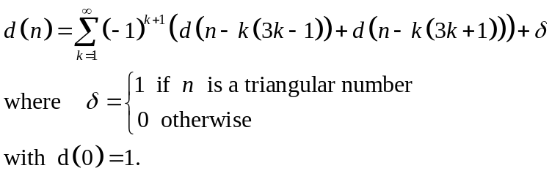

n is a triangular number if there is an integer j such that n = j ( j + 1)/2.

Proof: Proof follows steps from the proof of Theorem 17.

References

[1] Andrews, G.E., Number Theory, Dover Publications, New York, 1971.

[2] Andrews, G.E., The Theory of Partitions, Addison-Wesley, 1976 (reprinted Cambridge University Press, 1998).

[3] Hardy, G.H., and E.M.Wright, An Introduction to the Theory of Numbers (5th Edition), Oxford University Press, 1979.

[4] Franklin, F., “Sur le dèveloppement du produit infini (1 – x) (1 – x²) (1 – x³) (1 – x⁴)…”, C.R. Acad. Sci. Paris, 92 (1881), 448-450.

[5] Osler, T.J., “Playing with Partitions on the Computer,” Mathematics and Computer Education,

