Results:
Schrödinger’s Chess, overall, was a complete success. All major goals that were detailed in the requirements specification were implemented and tested according to the design specification except for one, which was omitted for technical reasons to improve the quality of the game. The omitted goal was to allow the artificial intelligence to “forget” which concealed piece was which. This feature was abandoned simply because the artificial intelligence rarely reveals concealed pieces, even without this feature. If this feature was included, I believe that the players would not enjoy competing against the artificial intelligence as much as if it was not implemented. According to this interpretation, the overall project is much better without the ability for the artificial intelligence to “forget” what its concealed pieces hide.
The Schrödinger’s Chess artificial intelligence is very hesitant to reveal its concealed pieces. There are two major reasons why the artificial intelligence hesitates to reveal pieces. The first reason is that concealed pieces are almost always more flexible than the standard chess pieces, since they can move two spaces in any direction. Since the SharpChess artificial intelligence that the Schrödinger’s Chess artificial intelligence was based on tends to play a very defensive game, it rarely needs the range afforded to rooks and bishops. Instead, the concealed piece becomes very powerful because they can defend large blocks of territory in a way that most other pieces cannot. The second reason for hesitating to reveal pieces, including the much more powerful queen, is that the artificial intelligence is loathe to waste a turn to make the reveal move. Oftentimes, it prioritizes fortifying its defenses rather than revealing any kind of piece. In other words, the artificial intelligence only reveals pieces if it is biding its time. The feature that made it possible for the artificial intelligence to forget which concealed piece mapped to the standard pieces was removed because it would make it almost certain that the artificial intelligence would never reveal a piece. It would have taken some of the enjoyment away from playing against the artificial intelligence if it refused to use one of the main features of the game outright.
Screenshot Examples:
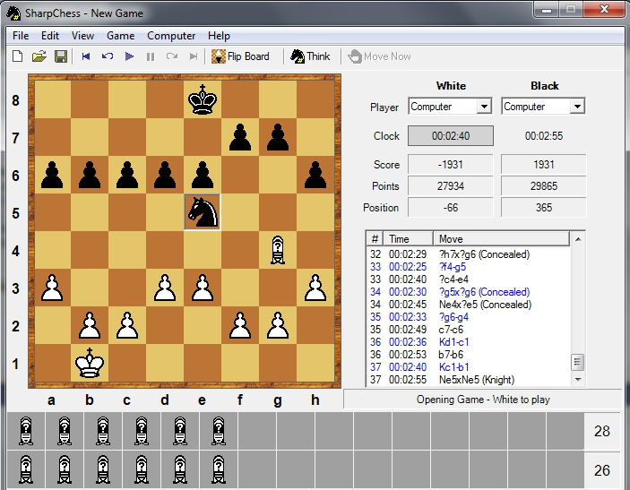

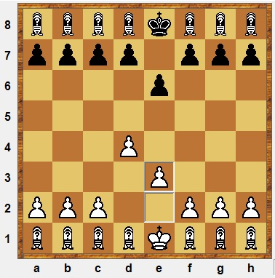
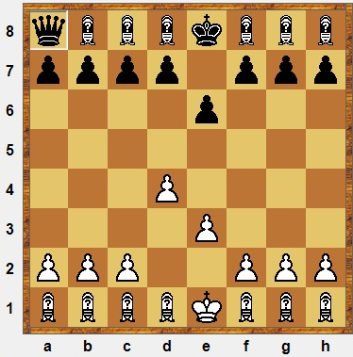
The black knight was revealed by the artificial intelligence to put pressure on the last white concealed piece.

The player controlling black pieces decided to reveal the queen from its concealed state. This was done because the player controlling black pieces is not under any pressure, and a queen is always better to have than a concealed piece.
References Links:
- Inspiration for project from Professor Provine’s webpage:
  - http://elvis.rowan.edu/~kilroy/other/?chess
- Homepage for SharpChess:
  - http://sharpchess.com/?page=01%20Home
- GitHub for Schrödinger’s Chess:
  - https://github.com/dittma75

