PrintTicket and PrintCapabilities Support in Windows Print Drivers
February 6, 2006
Abstract
This paper provides information about supporting the PrintTicket and PrintCapabilities objects in Microsoft® Windows® print drivers for the Microsoft Windows Vista™ operating system. It provides print driver developers with guidelines for including this technology in new print drivers.
This information applies for the following operating systems:
Microsoft Windows Vista
Microsoft Windows Server™ 2003
Microsoft Windows XP
Future versions of this preview information will be provided in the Windows Driver Kit.
The current version of this paper is maintained on the Web at:
http://www.microsoft.com/whdc/device/print/XPSDrv_PrintTicket.mspx
References and resources discussed here are listed at the end of this paper.
Contents
Introduction 4
PrintTicket and PrintCapabilities Features 4
Print Schema 5
The Life of a PrintTicket 5
PrintTicket Hierarchy 5
PrintTicket Creation 7
Processing the XML PrintTicket 7
Merging and Validating an XML PrintTicket 7
PrintTickets in an XPS Document 8
Printer Configuration with PrintTicket and PrintCapabilities 9
PrintCapabilities Overview 10
PrintTicket and PrintCapabilities Support through GPD and PPD 11
PrintCapabilities Support in Print Driver Plug-ins 12
PrintCapabilities Support in GDI-based, Monolithic Print Drivers 12
PrintTicket Use in the Print Driver 12
XPSDrv Print Driver Components 12
GDI-based Print Driver Components 14
Print Driver Interfaces 14
Interface Overview 14
XPSDrv and GDI-based, Monolithic Print Driver Support 15
Print Driver Plug-in Support 15
Interface Integration 16
OpenPrinter 16
ConvertDevModeToPrintTicket 17
ConvertPrintTicketToDevMode 17
ValidatePrintTicket 17
Interface Descriptions 17
IPrintTicketProvider Interface 17
IPrintOemPrintTicketProvider Interface 20
Resources 23

Disclaimer

This is a preliminary document and may be changed substantially prior to final commercial release of the software described herein.

The information contained in this document represents the current view of Microsoft Corporation on the issues discussed as of the date of publication. Because Microsoft must respond to changing market conditions, it should not be interpreted to be a commitment on the part of Microsoft, and Microsoft cannot guarantee the accuracy of any information presented after the date of publication.

This White Paper is for informational purposes only. MICROSOFT MAKES NO WARRANTIES, EXPRESS, IMPLIED OR STATUTORY, AS TO THE INFORMATION IN THIS DOCUMENT.

Complying with all applicable copyright laws is the responsibility of the user. Without limiting the rights under copyright, no part of this document may be reproduced, stored in or introduced into a retrieval system, or transmitted in any form or by any means (electronic, mechanical, photocopying, recording, or otherwise), or for any purpose, without the express written permission of Microsoft Corporation.

Microsoft may have patents, patent applications, trademarks, copyrights, or other intellectual property rights covering subject matter in this document. Except as expressly provided in any written license agreement from Microsoft, the furnishing of this document does not give you any license to these patents, trademarks, copyrights, or other intellectual property.

Unless otherwise noted, the example companies, organizations, products, domain names, e-mail addresses, logos, people, places and events depicted herein are fictitious, and no association with any real company, organization, product, domain name, email address, logo, person, place or event is intended or should be inferred.

© 2005 Microsoft Corporation. All rights reserved.

Microsoft, Win32, Windows, and Windows Vista are either registered trademarks or trademarks of Microsoft Corporation in the United States and/or other countries.

The names of actual companies and products mentioned herein may be the trademarks of their respective owners.

Introduction
The print support in Microsoft® Windows Vista™ introduces the PrintCapabilities and PrintTicket objects. Together, these objects provide more flexible and extensible printer configuration and more consistent printed document appearance than before. These objects can be used by both managed and unmanaged applications, as well as both XPSDrv print drivers and print drivers based on the graphics device interface (GDI).This paper describes these new features for print driver developers so that they can support this technology in their print drivers.

PrintTicket and PrintCapabilities Features
Print drivers in earlier versions of Microsoft Windows® operating systems used device capabilities functions to communicate printer capabilities to an application and the DEVMODE structure to configure printer settings. The limited extensibility and portability of these methods, however, restrict printer innovation and feature support in applications. For example, custom feature information that appears only in the private portion of the DEVMODE structure is understood only by applications that are aware of that information in advance. The PrintTicket and PrintCapabilities features in Windows Vista, however, support new printer features and innovation by providing a more flexible and extensible framework in which to communicate printer configuration information. Using a common feature schema with the self-describing nature of extensible markup language (XML) makes it much easier for applications to understand new and custom printer features without requiring custom application code.
The PrintCapabilities feature returns an XML document that contains information about the printer’s features and capabilities. Unlike the Microsoft Win32® functions, which return information about only one printer feature per call, an XML PrintCapabilities document returns information about all features that the printer supports in a single call.
XPSDrv print drivers must support the PrintCapabilities feature. To provide more robust printer feature support in Windows Vista, PrintCapabilities support can also be added to drivers that are GDI based. The Windows Vista print subsystem automatically creates a PrintCapabilities document for GDI-based print drivers that do not support the PrintCapabilities feature, but this support is limited.
A PrintTicket is an XML-based description of printer settings and configuration information that can be passed as an object to a print driver or stored as a part in an XPS Document. PrintTickets can be applied in two different contexts:
- Specific
A specific PrintTicket is based on an actual printer’s features and settings as described in the printer’s PrintCapabilities document. The specific PrintTicket is used in the same way in which a DEVMODE structure is used.
- Generic
A generic PrintTicket describes the user’s intent. It is based on the generic printer features and settings that are described in the public Print Schema and does not reference the features of a specific printer. When no printer is referenced, generic PrintTickets describe the printer's intent.

Because generic PrintTickets can be added to XPS Documents, the user’s intent for how a document should be printed can now accompany the document. The PrintTicket that is embedded in the document provides a more consistent document appearance when subsequent readers print the document. PrintTickets can be associated with an entire document or with any of the individual parts of an XPS Document.

Print Schema
The Print Schema document defines the organization and content of the PrintTicket and the PrintCapabilities documents. The Print Schema design supports private extensions to enable innovation by independent hardware vendors (IHVs).The PrintTicket framework and the PrintCapabilities framework are subsets of the overall Print Schema.
Using a common schema for features and properties makes it possible for applications to access print features and capabilities without connecting to a specific print driver or application. A common schema also reduces the ambiguity of names and features by providing a consistent set of names and definitions for printer features and attributes. A prerelease version of the Print Schema is documented in the Windows Vista SDK.

The Life of a PrintTicket
A PrintTicket is an XML object that describes how a document or document part is to be printed. A PrintTicket can be associated with a print job, a document, or a page in a document. It can be added to an XPS Document as a PrintTicket part and saved with document contents in a file or spooled for printing. Conversion functions also allow PrintTickets to be used in Win32 applications. Functions are available to convert PrintTickets to DEVMODE structures and DEVMODE structures back to PrintTickets.
Although this paper focuses on the print driver, this section of the paper describes the application context for the PrintTicket and PrintCapabilities features and how the print driver supports those features.

PrintTicket Hierarchy
A PrintTicket can be divided into three content levels that represent the high-level job (job-level PrintTicket), the documents in the job (document-level PrintTicket), and the pages in the document (page-level PrintTicket). These levels are ranked according to their specificity. The job-level PrintTicket is most general, followed by the document-level PrintTicket, and finally the page-level PrintTicket, which is the most specific. The elements of the Print Schema Framework that apply to these levels are prefixed with Job, Document, or Page accordingly. The PrintTicket hierarchy corresponds to the hierarchy of XPS Document parts that are described later in this paper.
The hierarchical nature of PrintTickets enables elements in lower-level PrintTickets to override corresponding elements of higher-level PrintTickets. PrintTickets must be merged to obtain the effective PrintTicket for a specific document part that results from the PrintTickets at each of the different levels. This merge is performed before the effective PrintTicket is required for processing, such as in a print driver. Figure 1 shows the relationships among the different levels of PrintTicket and how this merge is performed.
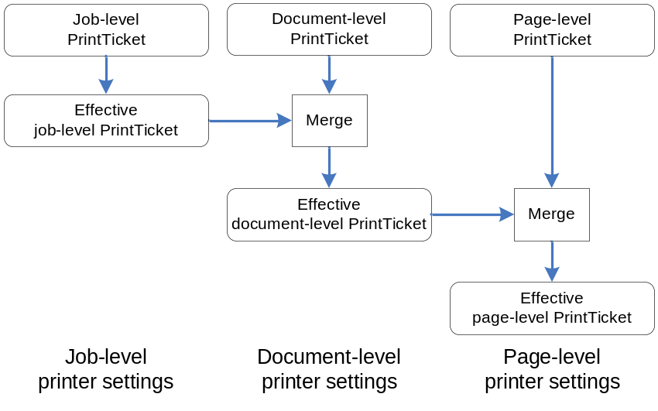
Figure 1. PrintTicket hierarchy and merge sequence
The element names in a PrintTicket are prefixed to indicate their scope. Elements with a job-level scope are prefixed with Job, a document-level scope with Document, and a page-level scope with Page. A job-level PrintTicket contains all job formatting settings that apply to an entire job and can contain elements with scope prefixes of Job, Document, or Page. A document-level PrintTicket incorporates the printer settings that apply to a document in a job and can contain only elements that have a scope prefix of Document or Page. A page-level PrintTicket contains printer settings that apply to a page in a document and can contain only elements with the Page scope prefix. Figure 2 illustrates this relationship.
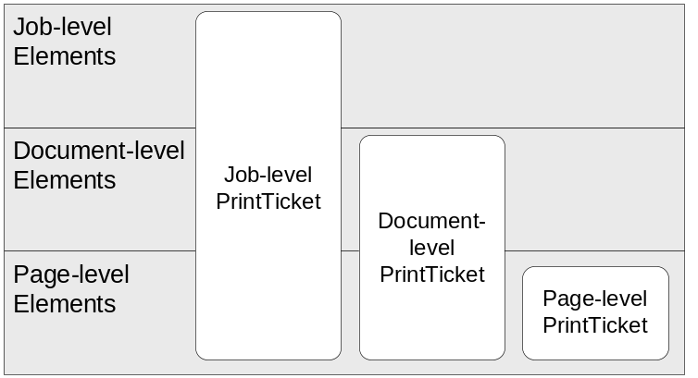
Figure 2. Relationship between PrintTicket level and element scopes

PrintTicket Creation
PrintTickets are generally created by the application that creates or prints a document. The print driver can help the application create a PrintTicket by providing the PrintCapabilities document to the application, and the Print dialog box can provide a PrintTicket that contains the results of the user’s interaction with the printer’s configuration user interface (UI). With this information, the application can then create a specific PrintTicket that includes the features that the user wanted and the printer supported.

Processing the XML PrintTicket
The validated settings of a PrintTicket object are used to configure the print processing that the XPSDrv print driver performs. The components of the print driver, therefore, must read the settings of the PrintTickets so that the driver can process the document according to these settings.
XPSDrv drivers perform this processing in the print processing filters of the print driver. GDI-based print drivers continue to use the DEVMODE structure for this information. When Windows Presentation Foundation (WPF) applications print to print queues with GDI-based print drivers, the print support converts the PrintTicket settings to the appropriate DEVMODE values for the graphics processing functions of the GDI-based print driver to use. When a Win32 application that is not PrintTicket aware prints to a print queue with an XPSDrv print driver, the GDI-to-XPS conversion module creates a PrintTicket for the print job that is based on the DEVMODE structures that are associated with the job.

Merging and Validating an XML PrintTicket
Applications might be required to merge PrintTickets, for example, when a generic PrintTicket that is read from a document must be merged with the PrintTicket that was returned by the Print dialog box. The methods that were provided to merge and validate the PrintTicket facilitate this process for the application.
The merge and validate process correctly merges the elements and properties of the two PrintTickets so that the resulting PrintTicket contains the correct elements for the PrintTicket scope. Errors and conflicts that result from the merge are identified and returned to the application for resolution.
PrintTickets also must be merged in the processing filters of the XPSDrv print driver. As the XPSDrv print driver processing filters process the document parts for printing, the PrintTickets must be cached from the document parts that apply to the current document part so that they can be merged and the filter can apply the correct settings. This process is described in greater detail later in this paper.

PrintTickets in an XPS Document
Figure 3 shows the hierarchical layout of the parts in an XPS Document and how PrintTickets can be added to these individual parts. The PrintTicket parts have the same hierarchical relationship as the XPS Document parts.
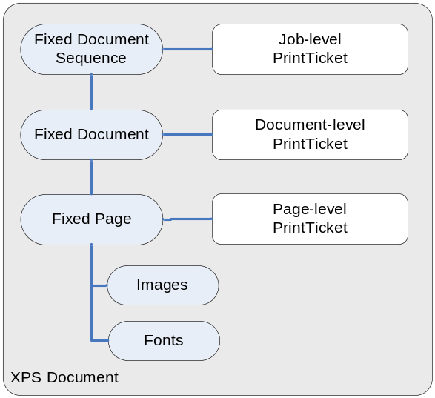
Figure 3. Document parts in an XPS Document
PrintTickets in an XPS Document are merged in the same hierarchical fashion that was shown in Figure 1. Figure 4 shows a more complex XPS Document to illustrate how PrintTickets might be added to specific parts and then merged for processing.
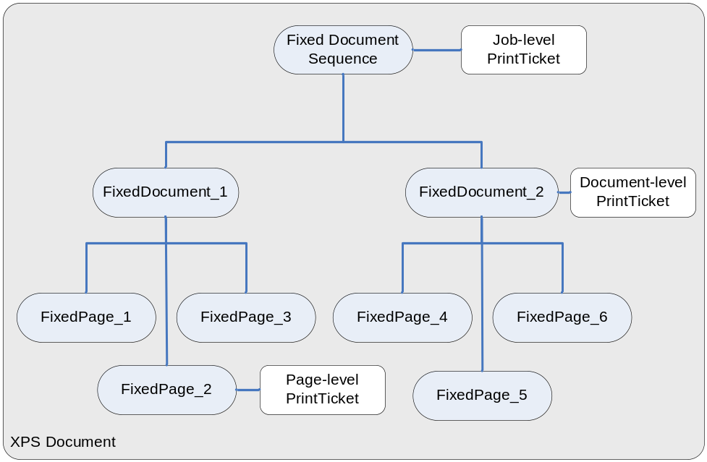
Figure 4. XPS Document with PrintTickets
In this example, a job-level PrintTicket has been added to the FixedDocumentSequence part of the document and includes the following feature elements:
<psf:Feature name="psk:DocumentDuplex">
<psf:Option name="psk:TwoSidedLongEdge" />
</psf:Feature>
<psf:Feature name="psk:PageOutputQuality">
<psf:Option name="psk:Normal" />
</psf:Feature>

This job-level PrintTicket applies to all FixedDocuments in this XPS Document. The DocumentDuplex element indicates the desired DuplexMode, and the PageOutputQuality element indicates the desired print quality.
In FixedDocument_1, FixedPage_2 has a page-level PrintTicket that contains the following element to indicate that the print quality should be of photographic quality for that page:
<psf:Feature name="psk:PageOutputQuality">
<psf:Option name="psk:Photographic" />
</psf:Feature>

When the page-level PrintTicket of this FixedPage is merged with the job-level PrintTicket of the FixedDocumentSequence, the page-level option value replaces the job-level value, but only for FixedPage_2.
FixedDocument_2 in the same document includes a document-level PrintTicket to override the duplex setting. This PrintTicket applies to only the pages in FixedDocument_2 and includes the following document-level feature element:
<psf:Feature name="psk:DocumentDuplex">
<psf:Option name="psk:OneSided" />
</psf:Feature>

When the document-level PrintTicket of FixedDocument_2 is merged with the job-level PrintTicket of the FixedDocumentSequence, the job-level setting to print the document on both sides of the paper is replaced by the document-level setting of one-sided printing. The new PrintTicket applies only to the pages that belong to this FixedDocument: FixedPage_4, FixedPage_5, and FixedPage_6.
The print driver must correctly merge and apply the PrintTickets to the document. This process is described later in this paper.

Printer Configuration with PrintTicket and PrintCapabilities
The PrintTicket and PrintCapabilities features of Windows Vista provide a standardized, yet extensible interface to query and set printer capabilities, settings, and preferences. Windows Vista, however, retains support for the DEVMODE structures that were used in earlier versions of Windows for existing print drivers and applications.
Print drivers, whether GDI based or XPSDrv, must support the printer configuration dynamic link library (DLL) entry points that earlier GDI-based, Version-3 print drivers require. XPSDrv print drivers must also support the IPrintTicketProvider interface. These interfaces are described completely in the Windows Driver Kit, and a summary of them is provided later in this paper. This section describes these interfaces at a high level and introduces several different ways to provide this support in a print driver. For more detailed information, see the Windows Driver Kit. For more information on XPSDrv print driver configuration interface support, see the white paper titled XPSDrv Configuration Module Implementation.

PrintCapabilities Overview
The PrintCapabilities feature returns a printer’s capabilities and features as a set of XML elements in an XML document. Earlier versions of print drivers returned this information in response to calls to the DeviceCapabilities or the GetDeviceCaps function. However, these Win32 functions to get printer capabilities can return information only about a fixed set of printer features and settings and can return information only about one feature or setting per function call. The XML PrintCapabilities document, on the other hand, is much more flexible and is designed to support new printer features. The PrintCapabilities method also returns the entire XML PrintCapabilities document in one function call.
Figure 5 illustrates, at a high level, the different paths that the PrintCapabilities documents and DeviceCapabilities data follow when an application queries the print support for this information.
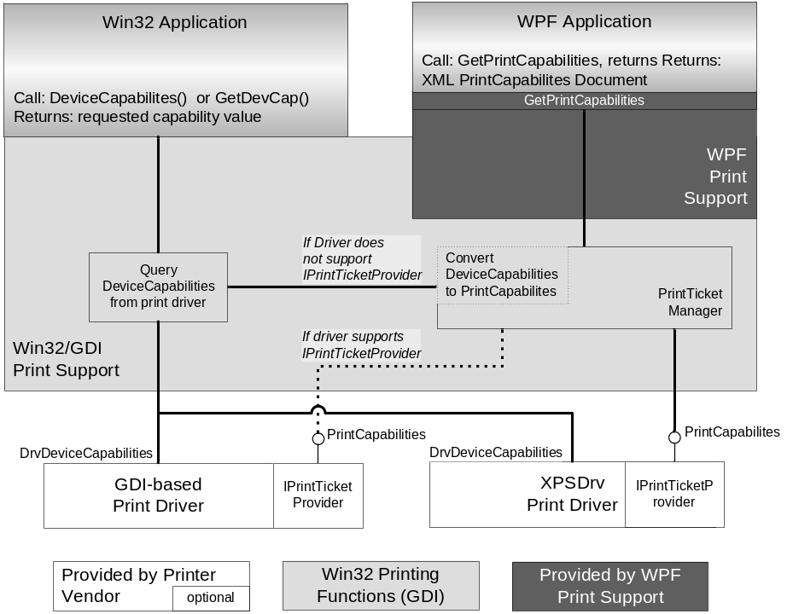
Figure 5. PrintCapabilities data flows
XPSDrv print drivers must support the PrintCapabilities functions directly by supporting the IPrintTicketProvider interface that includes the GetPrintCapabilities method. Older, GDI-based print drivers can also be modified to provide a PrintCapabilities document directly; however, the print subsystem creates an XML PrintCapabilities document for GDI-based drivers that do not add the ability to return one. The PrintCapabilities document that is created in this way includes only the limited set of parameters that the DeviceCapabilities function supports.
To provide a complete list of printer features and capabilities, the IPrintTicketProvider interface must be added to a GDI-based driver. Support for the IPrintTicketProvider interface has been added to Universal (Unidrv) and PostScript (PScript5) print drivers in Windows Vista. To return a complete PrintCapabilities document, plug-ins to provide custom features to Unidrv or PScript5 print drivers must support the IPrintOemPrintTicketProvider interface, whereas GDI-based, monolithic print drivers must add support for the IPrintTicketProvider interface.
Figure 6 shows how a GDI-based print driver can offer PrintCapabilities support to provide a richer set of printer feature information to an application. Figure 6 also shows how two types of GDI-based print drivers can supply XML PrintCapabilities documents.
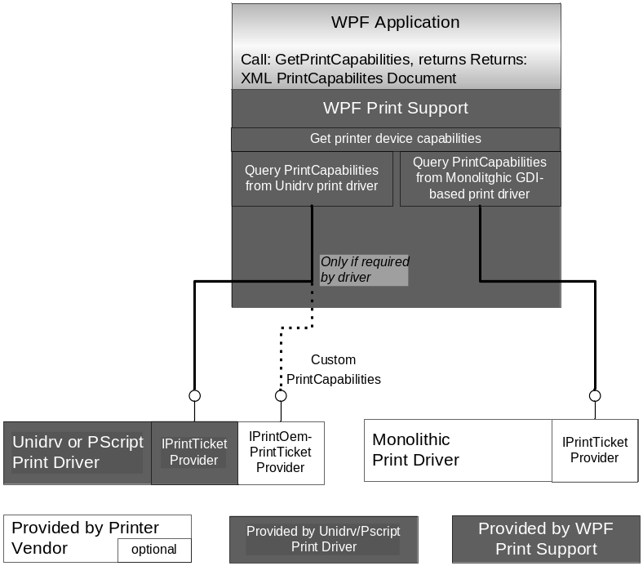
Figure 6. PrintCapabilities support in GDI-based print drivers

PrintTicket and PrintCapabilities Support through GPD and PPD
In drivers that are based on Unidrv or PScript5 print drivers, the minidriver provides the required PrintTicket and PrintCapabilities interfaces, as illustrated in Figure 6. These print drivers provide PrintTicket and PrintCapabilities support for the features that are described in the generic printer description (GPD) file or the PostScript printer description (PPD) file, as appropriate, whether the feature information is in the public or the private portion of the DEVMODE structure.
XPSDrv print drivers can also use the Unidrv printer configuration DLL to provide the required support for both the GDI-based printer configuration interface and the IPrintTicketProvider interface. This option can expedite print driver development for basic-functionality printers or pass-through print drivers.
For the complete description of using the Unidrv or PScript5 print driver for the configuration module, see the white paper titled XPSDrv Configuration Module Implementation.

PrintCapabilities Support in Print Driver Plug-ins
To provide complete PrintTicket and PrintCapabilities support, print driver plug-ins that provide additional or modified functionality to minidriver-based print drivers must support the IPrintOemPrintTicketProvider interface. Supporting this interface provides many features, such as the ability to edit the PrintTicket and modify the configuration UI, but also requires considerably more development effort than just editing a GPD or PPD file. Plug-ins that do not support this interface are limited to their existing DEVMODE support, which might mean that some functions that the plug-in provides are not included in PrintTicket or PrintCapabilities.
The IPrintOemPrintTicketProvider interface is described later in this paper, and the Windows Driver Kit contains the complete instructions and sample code for this interface.

PrintCapabilities Support in GDI-based, Monolithic Print Drivers
To provide complete PrintTicket and PrintCapabilities support, GDI-based, monolithic print drivers and XPSDrv print drivers that cannot use the GPD printer interface DLL must implement the IPrintTicketProvider interface. GDI-based, monolithic print drivers are not required to support this interface although this could limit the printer’s features that are exposed in the PrintCapabilities document and supported by the PrintTicket. XPSDrv print drivers, however, must implement this interface.
The IPrintTicketProvider interface is described later in this paper, and the Windows Driver Kit contains the complete instructions and sample code for this interface.

PrintTicket Use in the Print Driver
To completely support the PrintTicket and PrintCapabilities features, print drivers must:
- Support the IPrintTicketProvider interface as appropriate to provide the PrintCapabilities document for the printer.
- Use the PrintTicket information when processing a print job.

Supporting the IPrintTicketProvider interface accomplishes the first task, but does not address the second task.
The print driver must read and process the settings of the PrintTickets in an XPS Document so that these settings affect the printed document. This section describes how a print driver can read and process PrintTickets in a document that is spooled for printing, and the following section describes how a print driver can support the IPrintTicketProvider interfaces.

XPSDrv Print Driver Components
Documents that are being printed on printers with XPSDrv print drivers are spooled in the XPS Spool File format. These documents are processed for printing by the filters that make up the print driver’s filter pipeline. In the filter pipeline, the document parts of the XPS Spool File are passed sequentially to each filter for processing. The interface to each document part contains a GetPrintTicket method. To read the PrintTicket for that part, each processing filter calls the GetPrintTicket method of the document part interface that was passed to the filter.
Each filter must cache the PrintTicket objects of the relevant document parts higher in the XPS Document part hierarchy to create a complete PrintTicket object for the current document part. In other words, when processing a page-level PrintTicket, the filter must be able to merge that PrintTicket with the PrintTickets of the FixedDocument and FixedDocumentSequence parts to create the correct, merged PrintTicket for that part. To do this, the filter must save these higher-level PrintTickets as the filter reads their document parts. Figure 7 illustrates this merging process.
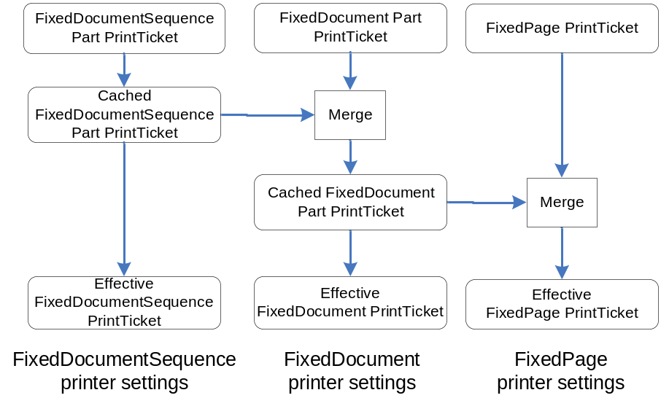
Figure 7. PrintTicket hierarchy and merge sequence for XPS Spool File
The following pseudocode illustrates how a filter might cache the PrintTickets that were read from an XPS Document in the manner shown in Figure 7. After the PrintTicket for that part has been evaluated, the filter can use the information from the final, merged PrintTicket for that part to process the document part.
The PrintTicket from each document part is read, merged with its parent if necessary, and cached for use by the document parts below it in the document-part hierarchy. PrintTickets of one level apply to that document part and those document parts directly below it in the hierarchy. For example the PrintTicket of one FixedDocument part applies only to that FixedDocument part and the FixedPages in that FixedDocument and not to other sibling FixedDocuments in the FixedDocumentSequence.
If a part does not have a PrintTicket, then the PrintTicket of the next higher level (the parent PrintTicket) is cached for that part. The following code shows the result of merging a parent PrintTicket with a null part PrintTicket:
class Filter
{
PrintTicket Saved_FDS_PT;
PrintTicket Saved_FD_PT;

ProcessFDS(pIFixedDocumentSequence)
{
Saved_FDS_PT = pIFixedDocumentSequence->GetPrintTicket();

// continue processing the FixedDocumentSequence part
}

ProcessFDS(pIFixedDocument)
{
Saved_FD_PT->Release();

temp = pIFixedDocument->GetPrintTicket();

Saved_FD_PT = PrintTicketMergeAndValidate(
Saved_FDS_PT, temp);

// continue processing the FixedDocument part
}

ProcessPage(IFixedPage)
{
temp = pIFixedPage->GetPrintTicket();

PagePT = PrintTicketMergeAndValidate(Saved_FD_PT, temp);

// continue processing the FixedPage part
}

PrintTicket PrintTicketMergeAndValidate(
ParentPT,
PartPT)
{
// Entries in the Part PrintTicket
// take precedence over the corresponding entries
// in the Parent PrintTicket
}
};

GDI-based Print Driver Components
GDI-based print drivers are not required to process PrintTickets. At job submission time, the PrintTicket information of documents with PrintTickets that are spooled to print queues with GDI-based print drivers is converted to DEVMODEs.

Print Driver Interfaces
The following is an overview of the configuration interfaces and their application in print drivers. Unidrv and PScript5 print drivers automatically include support for these interfaces; however, they can also be added to GDI-based, monolithic print drivers.

Interface Overview
This section reviews the required and available configuration interfaces that are available for print drivers to support. XPSDrv print drivers must provide support for the IPrintTicketProvider interface and the Version-3 print driver configuration interfaces. Unidrv and PScript5 drivers are not required to add this support because the driver provides it; however, GDI-based print driver plug-ins that support custom printer features must add support for the IPrintOemPrintTicketProvider interface to make their features visible in the PrintTicket and PrintCapabilities documents. Custom printer features that appear in private DEVMODE values are not supported by the standard print driver data conversion routines.

XPSDrv and GDI-based, Monolithic Print Driver Support
XPSDrv print drivers must also support the IPrintTicketProvider interface. Existing GDI-based, monolithic print drivers can also add support for this interface, whereas Unidrv and PScript5 drivers support this interface by default.
XPSDrv print drivers can use the printer interface functions of the Unidrv print driver that implement these methods as described for Unidrv print drivers, or they can implement their own version of the IPrintTicketProvider interface.
Table 1. Methods of the IPrintTicketProvider interface
BindPrinter | Binds a printer or print queue to a specific version of the PrintTicket schema
ConvertDevModeToPrintTicket | Converts a DEVMODE structure to a PrintTicket
ConvertPrintTicketToDevMode | Converts a PrintTicket to a DEVMODE structure
GetPrintCapabilities | Queries the provider for a complete print capabilities document that describes the printer's features and parameters
GetSupportedVersions | Retrieves major version numbers of the Print Schemas that the plug-in provider supports
QueryDeviceNamespace | Queries the device for its default namespace uniform resource identifier (URI)
ValidatePrintTicket | Validates a PrintTicket

Print Driver Plug-in Support
Plug-ins to Unidrv or PScript5 print drivers can support the IPrintOemPrintTicketProvider interface if they want to provide complete PrintTicket support for the plug-in’s features. To provide PrintTicket support, the plug-in must support the methods that are listed in Table 2.
Print driver plug-ins are subordinate to the print driver. Figure 8 shows the relationship between two plug-ins and the print driver that is hosting them.
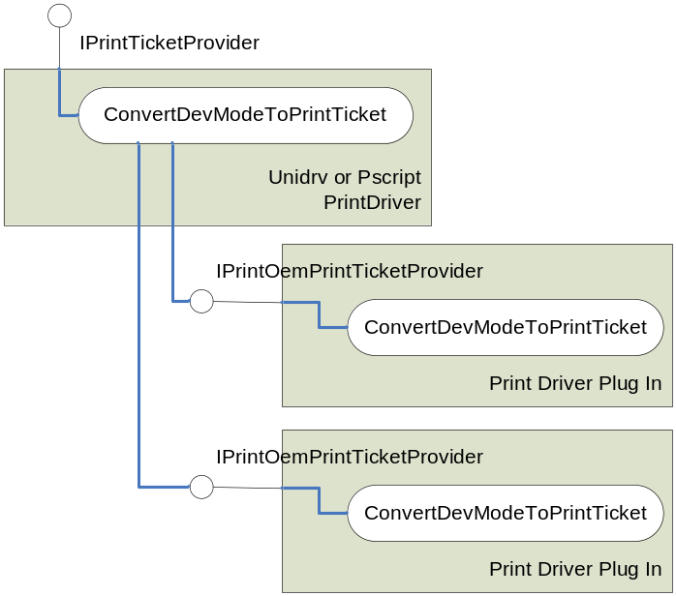
Figure 8. Print driver plug-in relationship
As shown in Figure 8, the methods of the IPrintOemPrintTicketProvider interface are called only by the corresponding functions in the IPrintTicketProvider interface of the hosting print driver. This relationship is described in more detail in the following section of this paper.
Table 2. Methods of the IPrintOemPrintTicketProvider interface
BindPrinter | Binds a printer or print queue to a specific version of the PrintTicket schema
CompletePrintCapabilities | Fills in the private entries of the specified print capabilities document that were not filled in by the main driver
ConvertDevModeToPrintTicket | Converts a DEVMODE structure to a PrintTicket
ConvertPrintTicketToDevMode | Converts a PrintTicket to a DEVMODE structure
ExpandIntentOptions | Enables the plug-in to expand printer options (such as photo printing) into individual feature settings in the PrintTicket
GetSupportedVersions | Retrieves major versions of the Print Schemas that the plug-in provider supports
PublishPrintTicketHelperInterface | Publishes the PrintTicket helper interface for either Unidrv or PScript5 UI plug-ins
QueryDeviceDefaultNamespace | Queries the device for its default namespace URI
ValidatePrintTicket | Validates a PrintTicket

Interface Integration
This section provides an overview of the methods of the IPrintTicketProvider and IPrintOemPrintTicketProvider interfaces and their context in the print subsystem. The information applies to XPSDrv and GDI-based print drivers that have implemented the IPrintTicketProvider interface and print driver plug-ins that have implemented the IPrintOemPrintTicketProvider interface.
Descriptions of the Unidrv and PScript5 implementations apply to Unidrv and PScript5 print drivers and XPSDrv print drivers that use the printer interface features of the Unidrv or PScript5 print driver.

OpenPrinter
When a print queue is opened, the print driver is loaded and the following methods of the IPrintTicketProvider interface are called in the sequence shown below:
- GetSupportedVersions
- BindPrinter
- QueryDeviceDefaultNamespace
- GetPrintCapabilities

The methods of the IPrintTicketProvider interface of a Unidrv or PScript5 print driver that hosts print driver plug-ins calls the IPrintOemPrintTicketProvider methods of the installed plug-ins. The following list show how these calls are made in the OpenPrinter case:
- GetSupportedVersions
For each plug-in, call IPrintOemPrintTicketProvider::GetSupportedVersions.
- BindPrinter
For each plug-in, call IPrintOemPrintTicketProvider::BindPrinter.
- QueryDeviceDefaultNamespace
For each plug-in, call
IPrintOemPrintTicketProvider::QueryDeviceDefaultNamespace.
- GetPrintCapabilities
For each plug-in, call
IPrintOemPrintTicketProvider::CompletePrintCapabilities.

ConvertDevModeToPrintTicket
Unidrv and PScript5 print drivers create the PrintTicket by using the elements from the public and private parts of the DEVMODE that they support. The IPrintOemPrintTicketProvider::ConvertDevModeToPrintTicket method is called for each print driver plug-in that was installed.

ConvertPrintTicketToDevMode
Unidrv and PScript5 print drivers fill in the public and private parts of the DEVMODE that they support by using the information from the PrintTicket that was passed in the call. The IPrintOemPrintTicketProvider::ConvertPrintTicketToDevMode method is called for each print driver plug-in that was installed.

ValidatePrintTicket
Unidrv and PScript5 print drivers validate the PrintTicket by using the following sequence:
- For each plug-in, call the IPrintOemPrintTicketProvider::ExpandIntentOptions.
- Call IPrintTicketProvider::ConvertPrintTicketToDevMode.
- For each plug-in, call IPrintOemPrintTicketProvider::ConvertPrintTicketToDevMode to convert the private portions of the DEVMODE.
- Validate public and private parts of DEVMODE that the Unidrv or PScript5 print driver supports.
- For each plug-in, validate the private parts of the DEVMODE.
- Call IPrintTicketProvider::ConvertDevModeToPrintTicket.
- For each plug-in, call IPrintOemPrintTicketProvider::ConvertDevModeToPrintTicket to convert the private portions of the DEVMODE.
- For each plug-in, call IPrintOemPrintTicketProvider::ValidatePrintTicket to validate the PrintTicket.

Interface Descriptions
This section describes the methods of the interfaces that were mentioned previously in this paper. They are provided only for information and reference. For the complete and current descriptions of these interfaces, refer to the Windows Driver Kit help documentation before adding them to your print driver.

IPrintTicketProvider Interface
This section describes the IPrintTicketProvider interface and its methods. For the detailed description of this interface, see the documentation on this interface in the Windows Driver Kit.

BindPrinter
The IPrintTicketProvider::BindPrinter method binds a printer or print queue to a specific version of the PrintTicket schema. This enables the core driver to associate a set of private namespace URIs with a device.
Binding to a device enables the provider to cache certain objects and handles that it requires for future PrintTicket or device capabilities services on that device. For example, the printer handle in the hPrinter parameter can be cached. The IPrintTicketProvider::BindPrinter method is guaranteed to be called only once for each PrintTicketProvider instance.
STDMETHOD (BindPrinter) (
IN HANDLE hPrinter, // spooler's print handle
IN INT version, // major version of the PrintTicket
OUT PSHIMOPTS pOptions, // options returned by driver
OUT DWORD *pDevModeFlags, // flags for DEVMODE conversion
OUT INT *cNamespaces, // count of namespaces used
OUT BSTR **ppNamespaces // list of namespaces used by plugin
)

ConvertDevModeToPrintTicket
The IPrintTicketProvider::ConvertDevModeToPrintTicket method converts a DEVMODE structure to a PrintTicket.
STDMETHOD (ConvertDevModeToPrintTicket) (
IN ULONG cbDevmode, // size of DEVMODE structure
IN PDEVMODE pDevmode, // pointer to DEVMODE structure
IN OUT IXMLDOMDocument2 *pPrintTicket // PrintTicket
);

The print system converts the contents of a DEVMODE structure to a PrintTicket by calling this function in the print driver. This function converts all of the public DEVMODE fields except those that the plug-in provider indicated should be disabled. For the disabled DEVMODE fields that are not converted, the plug-in provider populates the corresponding PrintTicket elements. If the DEVMODE snapshot was disabled by calling IPrintTicketProvider::BindPrinter and setting the value of pOptions to PTSHIM_NOSNAPSHOT, the PrintTicket that results from the conversion must provide enough information to reconstruct the original DEVMODE structure without a loss of information.
If the PrintTicket cannot accurately support the DEVMODE information, it should use the PTSHIM_DEFAULT value in the pOptions argument so that a snapshot of the DEVMODE data can be returned in a binary large object (BLOB) of data. The DEVMODE snapshot allows support for subtle distinctions in options in the DEVMODE structure for which the PrintTicket might not have representations. For example, DEVMODE might support the LETTER paper size while the PrintTicket supports the LETTERSMALL paper size.

ConvertPrintTicketToDevMode
The IPrintTicketProvider::ConvertPrintTicketToDevMode method converts a PrintTicket to a DEVMODE structure.
STDMETHOD (ConvertPrintTicketToDevMode) (
IN IXMLDOMDocument2 *pPrintTicket, // PrintTicket to convert
IN ULONG cbDevmodeIn, // size of input DEVMODE
IN PDEVMODE pDevmodeIn, // pointer to input DEVMODE
OUT ULONG *pcbDevmodeOut, // size of output buffer
OUT PDEVMODE *ppDevmodeOut, // pointer to output buffer
)

The core driver calls the IPrintTicketProvider::ConvertPrintTicketToDevMode method before it performs its part of the conversion of a PrintTicket to a DEVMODE structure. When the core driver calls this method, it passes an input PrintTicket that is fully populated and a DEVMODE structure that is set to default values.
The conversion must create a properly configured DEVMODE for this printer. In some cases, the conversion from DEVMODE to PrintTicket requires private DEVMODE features to be moved into the public PrintTicket. When a PrintTicket is converted back to a DEVMODE, any such changes must be reversed.

GetPrintCapabilities
The IPrintTicketProvider::GetPrintCapabilities method queries the provider for a complete print capabilities document that describes the printer's features and parameters.
STDMETHOD (GetPrintCapabilities)(
IN IXMLDOMDocument2 *pPrintTicket, // input PrintTicket
OUT IXMLDOMDocument2 **ppCapabilities // output XML document
)

The input PrintTicket describes any constraints on the settings in the output print capabilities document. No features, options, and parameters that are described in the output print capabilities document should change because of the contents of the input PrintTicket. Only the constraint status of the features, options, and parameters are subject to change.

GetSupportedVersions
The IPrintJobTicketProvider::GetSupportedVersions method retrieves major version numbers of the Print Schemas that the plug-in provider supports.
STDMETHOD (GetSupportedVersions) (
IN HANDLE hPrinter, // printer handle to query
OUT INT *ppVersions[], // array of supporte version numbers
OUT INT *cVersions // count of entries in array
)

IPrintJobTicketProvider::GetSupportedVersions returns the major version numbers of the Print Schemas that the provider interface supports. Note that currently there is only one major version.

QueryDeviceNamespace
The IPrintJobTicketProvider::QueryDeviceNamespace method queries the device for its default namespace URI.
STDMETHOD (QueryDeviceNamespace) (
THIS_
OUT BSTR *pDefaultNamespace // URI of namespace
) PURE;

ValidatePrintTicket
The IPrintTicketProvider::ValidatePrintTicket method validates a PrintTicket.
STDMETHOD (ValidatePrintTicket) (
THIS_
IN OUT IXMLDOMDocument2 *pBaseTicket
) PURE;

If the operation succeeds, IPrintTicketProvider::ValidatePrintTicket should return S_NO_CONFLICT or S_CONFLICT_RESOLVED. If necessary, the IPrintTicketProvider::ValidatePrintTicket method should also resolve any conflicting entries in the PrintTicket. Settings made in the public and Unidrv-private parts of the PrintTicket should be inspected to ensure that the resulting PrintTicket is valid and that all of the constraints are resolved.

IPrintOemPrintTicketProvider Interface
The IPrintOemPrintTicketProvider interface should be implemented by developers who are creating plug-ins for PScript5 and Unidrv print drivers and want to provide PrintTicket support.

BindPrinter
The IPrintOemPrintTicketProvider::BindPrinter method binds a printer or print queue to a specific version of the PrintTicket schema. This enables the core driver to associate a set of private namespace URIs with a device.
Binding to a device enables the provider to cache certain objects and handles that it requires for future PrintTicket or print capabilities services on that device. For example, the printer handle in hPrinter can be cached. IPrintOemPrintTicketProvider::BindPrinter is guaranteed to be called only once.
STDMETHOD (BindPrinter) (
IN HANDLE hPrinter, // spooler's print handle
IN INT version, // major version of the PrintTicket
OUT PSHIMOPTS pOptions, // options returned by driver
OUT DWORD *pDevModeFlags, // flags for DEVMODE conversion
OUT INT *cNamespaces, // count of namespaces used
OUT BSTR **ppNamespaces // list of namespaces used by plugin
)

CompletePrintCapabilities
The IPrintOemPrintTicketProvider::CompletePrintCapabilities method fills in the private entries of the specified print capabilities document that the main driver did not fill in.
A Unidrv or PScript5 plug-in should fill in only those capabilities that it explicitly supports, over and above the features and options that the driver supports. The plug-in should at least fill in the capabilities that it lists in its private DEVMODE structure. If the plug-in provider changes the representation of features provided by the core driver in the PrintTicket, the provider must make equivalent changes to the representation here.
STDMETHOD (CompletePrintCapabilities) (
IN IXMLDOMDocument2 *pPrintTicket, // input PrintTicket
IN OUT IXMLDOMDocument2 *pCapabilities // output document
) PURE;

The input PrintTicket describes any constraints on the settings in the output print capabilities document. No features, options, and parameters that are described in the output print capabilities document should change because of the contents of the input PrintTicket. Only the constraint status of the features, options, and parameters are subject to change.

ConvertDevModeToPrintTicket
The IPrintOemPrintTicketProvider::ConvertDevModeToPrintTicket method converts a DEVMODE structure to a PrintTicket.
STDMETHOD (ConvertDevModeToPrintTicket) (
THIS_
IN ULONG cbDevmode, // size of DEVMODE structure
IN PDEVMODE pDevmode, // pointer to DEVMODE structure
IN ULONG cbDrvPrivateSize, // size of private DEVMODE struct.
IN PVOID pPrivateDevmode, // ponter to private DEVMODE struct.
IN OUT IXMLDOMDocument2 *pPrintTicket // PrintTicket
) PURE;

The core driver calls the IPrintOemPrintTicketProvider::ConvertDevModeToPrintTicket method with an input PrintTicket that is populated with public and Unidrv-private or PScript5-private features. The plug-in can set DEVMODE settings in the public part or in the plug-in's private part, based on settings in the input PrintTicket. In addition to setting new DEVMODE items, the plug-in can modify existing settings in the public portion of the DEVMODE structure.
The DEVMODE structure fields that correlate with the part of the DEVMODE structure of interest to the client has already been populated before IPrintOemPrintTicketProvider::ConvertDevModeToPrintTicket is called, including the public portion of the DEVMODE structure and excluding the privately-defined values in the public portion of the DEVMODE structure.

ConvertPrintTicketToDevMode
The IPrintOemPrintTicketProvider::ConvertPrintTicketToDevMode method converts a PrintTicket to a DEVMODE structure.
STDMETHOD (ConvertPrintTicketToDevMode) (
IN IXMLDOMDocument2 *pPrintTicket, // PrintTicket to convert
IN ULONG cbDevmodeIn, // size of input DEVMODE
IN PDEVMODE pDevmodeIn, // pointer to input DEVMODE
OUT ULONG *pcbDevmodeOut, // size of output buffer
OUT PDEVMODE *ppDevmodeOut, // pointer to output buffer
)

The core driver calls the IPrintOemPrintTicketProvider::ConvertPrintTicketToDevMode method before it performs its part of the conversion of a PrintTicket to a DEVMODE structure. When the core driver calls this method, it passes an input PrintTicket that is fully populated and a DEVMODE structure that is set to default values.
The conversion must create a properly configured DEVMODE for this printer. In some cases, the conversion from DEVMODE to PrintTicket requires private DEVMODE features to be moved into the public PrintTicket. Any such changes must be reversed when converting the PrintTicket back to a DEVMODE.

ExpandIntentOptions
The IPrintOemPrintTicketProvider::ExpandIntentOptions method enables the plug-in to expand printer options (such as photo printing) into individual feature settings in the PrintTicket.
STDMETHOD (ExpandIntentOptions) (
IN OUT IXMLDOMDocument2 *pPrintTicket // PrintTicket
) PURE;

IPrintOemPrintTicketProvider::ExpandIntentOptions enables a plug-in to expand options that represent intent. The options are expanded into their individual settings in other features in the PrintTicket before the PrintTicket is validated. Such option expansion has two important effects: it provides the client with information about the results of the intent expansion, and the core driver resolves constraints against the individual features that are affected by the intent.

GetSupportedVersions
The IPrintOemPrintTicketProvider::GetSupportedVersions method retrieves major versions of the Print Schemas that the plug-in provider supports.
STDMETHOD (GetSupportedVersions) (
IN HANDLE hPrinter, // printer handle to query
OUT INT *ppVersions[], // array of supporte version numbers
OUT INT *cVersions // count of entries in array
)

IPrintOemPrintTicketProvider::GetSupportedVersions returns the major version numbers of the Print Schemas that the provider interface supports. Note that currently there is only one major version.

PublishPrintTicketHelperInterface
The IPrintOemPrintTicketProvider::PublishPrintTicketHelperInterface method publishes the PrintTicket helper interface for either Unidrv or PScript5 UI plug-ins.
STDMETHOD (PublishPrintTicketHelperInterface) (
IN IUnknown *pHelper
)

QueryDeviceDefaultNamespace
The IPrintOemPrintTicketProvider::QueryDeviceDefaultNamespace method queries the device for its default namespace URI.
STDMETHOD (QueryDeviceDefaultNamespace) (
OUT BSTR *pbstrNamespaceUri // URI of namespace
)

ValidatePrintTicket
The IPrintOemPrintTicketProvider::ValidatePrintTicket method validates a PrintTicket.
STDMETHOD (ValidatePrintTicket) (
IN OUT IXMLDOMDocument2 *pPrintTicket // PrintTicket
)

IPrintOemPrintTicketProvider::ValidatePrintTicket should return S_NO_CONFLICT or S_CONFLICT_RESOLVED if the operation succeeds. If necessary, the IPrintOemPrintTicketProvider::ValidatePrintTicket method should also resolve any conflicting entries in the PrintTicket. Settings made in the public and Unidrv-private parts of the PrintTicket should be inspected to ensure that the resulting PrintTicket is valid and that all of the constraints are resolved.
Note that this function is called only in the context of the IPrintTicketProvider::ValidatePrintTicket method. As such, it is not required to duplicate any validation that was already performed when the DEVMODE was validated earlier in the validation process.

Resources
WinFX Print Schema User Manual in the
Windows Vista SDK:
http://windowssdk.msdn.microsoft.com/library/
[Navigate to Graphics and Multimedia, and then to Print Schema.]
Windows Driver Kit (WDK):
http://www.microsoft.com/whdc/driver/WDK/aboutWDK.mspx
White Papers:
XPSDrv Filter Pipeline
http://www.microsoft.com/whdc/device/print/XPSDrv_FilterPipe.mspx
XPSDrv Configuration Module Implementation
http://www.microsoft.com/whdc/device/print/XPSDrv_Config.mspx
Microsoft XPS Web site:
http://www.microsoft.com/xps

The GetDeviceCaps and the DeviceCapabilities functions use the Win32 application programming interfaces (APIs) to return printer capabilities, whereas the print driver returns this information to the system through the DrvDeviceCapabilities function.
XPSDrv print drivers that pass the XPS Spool File directly through to an XPS-enabled printer and have no filter modules are called “pass-through” print drivers.

