**Assignment 2 – Quiz**

**1. Can Ordered and unordered lists nested within each other?**

Ordered and unordered lists can be nested within each other but not directly. Only the <li> element can be the direct child of an ordered or unordered list. The ordered/unordered list can be nested within the <li> element inside the main unordered/ordered list.

**2. Is it possible to nest an ordered list within an unordered list or vice versa?**

It is possible to nest an ordered list within an unordered list or vice versa through the <li> element. This is because an ordered or unordered list can only have the <li> element as its direct child.

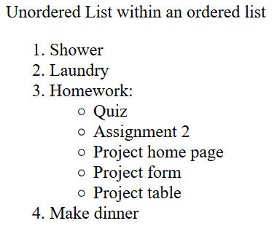Unordered List within an ordered list

<ol>

<li> Shower </li>

<li> Laundry </li>

<li> Homework:

<ul>

<li> Quiz </li>

<li> Assignment 2 </li>

<li> Project home page </li>

<li> Project form </li>

<li> Project table </li>

</ul>

</li>

<li> Make dinner </li>

</ol>

Ordered List within an unordered list

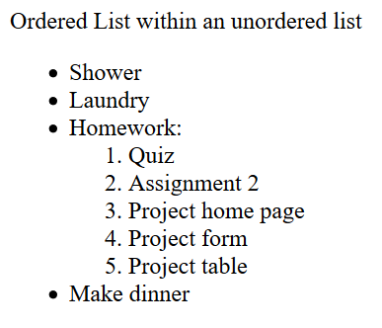 <ul>

<li> Shower </li>

<li> Laundry </li>

<li> Homework:

<ol>

<li> Quiz </li>

<li> Assignment 2 </li>

<li> Project home page </li>

<li> Project form </li>

<li> Project table </li>

</ol>

</li>

<li> Make dinner </li>

</ul>

**3. Give example showing customizing of ordered and unordered list?**

Square bullet points:

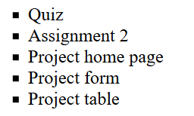 <ul type="square">

<li> Quiz </li>

<li> Assignment 2 </li>

<li> Project home page </li>

<li> Project form </li>

<li> Project table </li>

</ul>

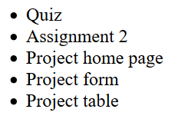Solid round bullet points:

<ul type="disc">

<li> Quiz </li>

<li> Assignment 2 </li>

<li> Project home page </li>

<li> Project form </li>

<li> Project table </li>

</ul>

Circle ring bullet points:

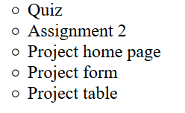 <ul type="circle">

<li> Quiz </li>

<li> Assignment 2 </li>

<li> Project home page </li>

<li> Project form </li>

<li> Project table </li>

</ul>

Ordered List with Numbers:

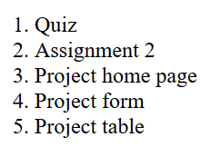<ol type="1">

<li> Quiz </li>

<li> Assignment 2 </li>

<li> Project home page </li>

<li> Project form </li>

<li> Project table </li>

</ol>

Ordered List with lower case letters:

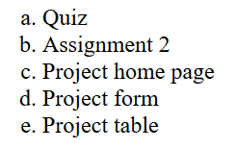<ol type="a">

<li> Quiz </li>

<li> Assignment 2 </li>

<li> Project home page </li>

<li> Project form </li>

<li> Project table </li>

</ol>

Ordered List with lower caser Roman numerals:

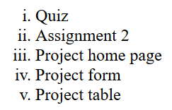<ol type="i">

<li> Quiz </li>

<li> Assignment 2 </li>

<li> Project home page </li>

<li> Project form </li>

<li> Project table </li>

</ol>

**4. Describe basic parts of a table and tags used to identify them?**

The basic parts of a table are the column headers, rows, and row data. First, the table tag <table></table> is used to define a table. Within that, the table row tag <tr> is used to define a row in a table. Within the first <tr> tag, the column headers can be defined by using the table header tag <th>. The data within the rows are identified by the table data tag <td>.

<table>

<tr>

<th> Enter header name </th>

…

</tr>

<tr>

<td> Enter row data </td>

…

</tr>

</table>

**5. How do you create cells that span more than one column or row?**

Using the colspan attribute will allow a cell to span more than one column, and the rowspan attribute will allow a cell to span more than one row.

<th colspan="3">Final Score</th> makes the cell labeled Final Score to span 3 columns.

<th rowspan="2">Cookie Type</th> makes the cell labeled Cookie Type to span 2 rows.

**6. Create a nested table that contains 4 rows and 5 columns. Create a second table that contains 3 rows and 2 columns inside 3rd row and 4th col of parent table.**

Look at the attached file named “DivyaKannan_Assignment2_NestingTables.html” to see the code for this table below.

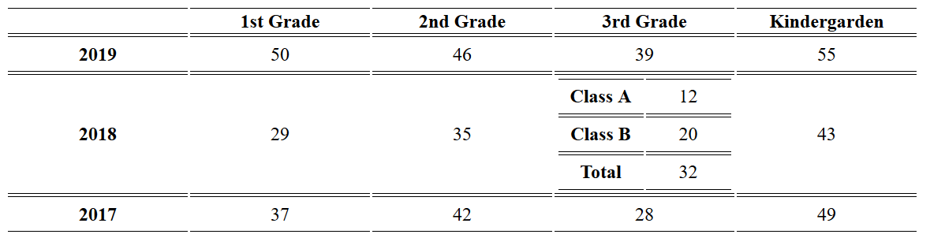

**7. Write down styling attributes you can use while creating table and explain what they do.**

a. You can define a border for the table, the headers, and the row data. The density, line type, and color of the border should be set. The border separates the text in the various columns and rows. Space padding within a cell can also be defined, so that the text does not look cramped. The text alignment can be set to the right, left, or center. The width of the columns can be set either by pixels or by percentage of the page.

Example:

<col width="25%">

<style>

table, th, td {

border: 1px solid blue;

padding: 5px;

text-align: left;

}

</style>