**Module approved by:**

**Name: Hasnat Khan ID: 201249851**

**Name: Charles Wadden ID: 201754280**

**Name: Andrew Stacey ID: 201634581**

**Name: David Ineh ID: 201737582**

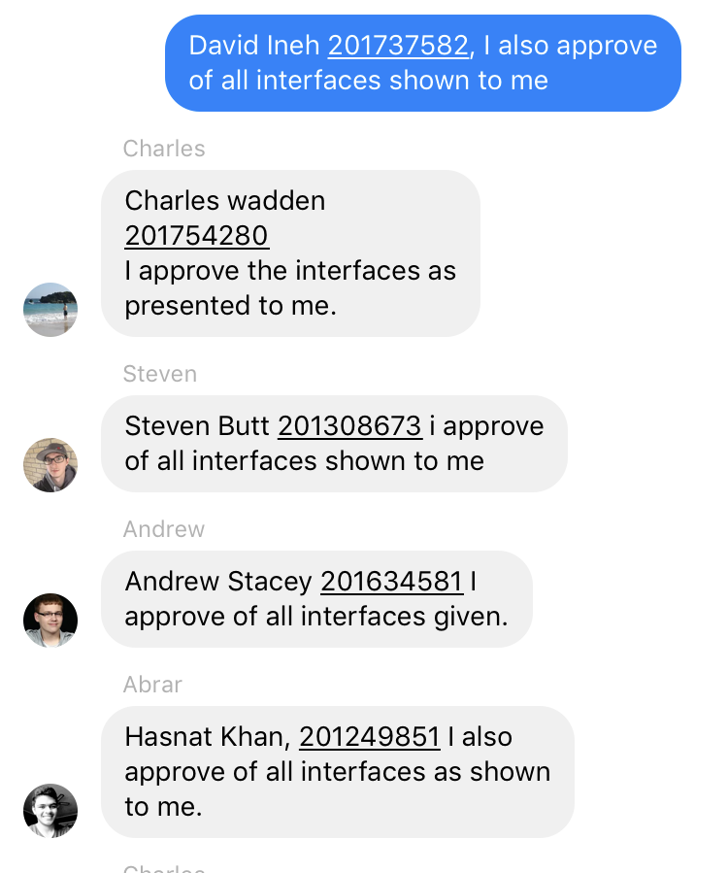

**A description (up to one page plus diagrams) of your assigned programming component for the project, per lecture note 14. Describe the functionality of your component in terms of the overall project**.

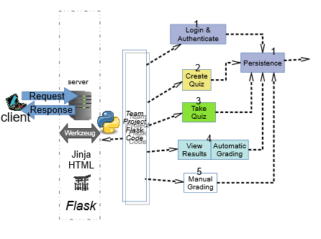

The project is divided into parts; Flask, team project flask code and individual components (1,2,3,4,5 according to the diagram above). We start programmer 1, he creates storage (1, persistence) that allows us store various objects and a user login authentication for an instructor and a student. Programmer 2 creates the quiz with question and correct answers to each question. Programmer 3 creates an object that enables the student to take the quiz. Programmer 4(me) enables the instructor to view the results a class or by each student, also the student can view their results for each attempt and the correct answers. Finally, programmer 5 enables the instructor to modify a quiz or change a grade.

**One use case describing the principal user interaction with your project component**.

**Title:** View Results

**Primary Actor:** Student, Instructor

**Stakeholders and Interests:**

**Instructor** - Wants to provide students with correct quiz answers. Can see the average of the class

**Student** - Wants to receive correct answers upon quiz completion

**Technician** - Wants log of quiz submissions and quiz solutions

**Precondition**: The deadline for submission has passed. User is logged in and has permission to view submissions.

**Trigger**: Student wants to see correct solutions. Instructor requests to view class submission data

**Main Scenario**:

1. Instructor would like to see the class participation in the quiz
2. Instructor requests quiz submission statistics
3. Instructor would like see students results
4. SuD determines the average score in the class
5. Student selects quiz by attempts in which they want to review correct answers
6. SuD lists actions the student can take with reference to selected quiz
7. Student selects option to review quiz
8. SuD displays the quiz with each question showing the correct answer specified

**Clear connection between your module and its responsibilities from a project requirements list**

**Requirements List**

1. Functional
2. Quiz Results
   1. Student View
      1. Students can view solutions to completed quiz

Once the quiz has been completed, and the quiz deadline for submission has passed, students will be able to view their quiz which now contains the correct solutions to each question along with their chosen answer.

author:cssg02@mun.ca; id:200917250; date: Thurs Jan 10 12:55:10 NST 2019

Lecture note #14. Use case [Provide Solutions](http://127.0.0.1:5500/usecases/provide_solutions.html)

Tester completes a quiz with the system and retrieves solutions after deadline passes

* + 1. Users can check the grades of their submissions

Users can access a seperate part of the system to check the grades they've received on previous quizzes.

author:cbowe; date: Fri Jan 11 16:03:17 NST 2019

Lecture note #14. Use Case [Take Quiz](http://127.0.0.1:5500/usecases/take_quiz.html) was provided by client.

Student logs in and views grade after completing a quiz.

* + 1. View attempts

Student can view each submitted quiz attempt showing answers wrong/right.

author:brown; date: Sun Fe 24 11:21:30 NST 2019

Client lecture note #14.

Logs into the system; acces attempt.

* + 1. Instructor View
       1. Instructor views class result statistics

View class participation, class average and histogram of class performance

author:brown; date: Sun Fe 24 11:21:30 NST 2019

Client lecture note #14.

Logs into the system; pick a quiz and view statistics.

* + - 1. Instructor views attempt statistics

Show class performance by each attempt, to see how performance improves from one attempt to the next.

author:brown; date: Sun Fe 24 11:21:30 NST 2019

Client lecture note #14.

Logs into the system; select quiz and see summary for each attempt.

* + - 1. Instructor views student statistics

Need ability to look at individual student performance, across quizzes or for a single quiz: Client wants to be able to see each question on each attempt on each quiz.

author:brown; date: Sun Fe 24 11:21:30 NST 2019

Client lecture note #14.

Logs into the system; select student, quiz, attempt and question to view answers and result.

