**Divya Mahajan || Student ID: W1650026 ||** [**dmahajan2@scu.edu**](mailto:dmahajan2@scu.edu)

Project Assignment PA1

# Table of Contents

Project Description 2

1. Executing Program steps 3

a. Both document_root and port are specified. 3

b. Only document_root is specified. (Default Port 8081) 3

c. Only port is specified. (Default document-root “www.scu.edu”) 3

d. Empty Arguments: Neither document_root nor port is specified. (Default Port 8081, Default document-root “www.scu.edu”) 3

2. 200 OK/ default page 4

a. Browser view 4

b. Terminal View => closing connection 4

3. 200 OK / Local host index.html 6

a. Browser View 6

b. Terminal View => closing connection 6

4. 400 Bad Request 7

a. Browser View 7

b. Terminal View => closing connection 7

5. 403 Permission denied. 8

a. Browser view 8

b. Terminal View => closing connection 8

6. 404 Page not found. 9

c. Browser View 9

d. Terminal View => closing connection 9

7. Multithreaded Approach 10

a. Browser View 10

b. Terminal View => closing connection 10

c. Code View 11

8. Header details 12

9. Shutting server Down 13

10. List of submitted files. 14

11. References 17

# Project Description

The goal of this programming assignment is to build a functional web server.

At a high level, a web server listens for connections on a socket (bound to a specific port on a host machine). Clients connect to this socket and use a simple text-based protocol to retrieve files from the server.

This assignment supports enough of the HTTP/1.0 and HTTP/1.1 protocol to allow an existing web browser (e.g., Firefox) to connect to the web server and retrieve the [Santa Clara University home page](http://www.scu.edu) contents from the server.

A multi-threaded approach will spawn a new thread for each incoming connection. That is, once the server accepts a connection, it will spawn a thread to parse the request, transmit the file, etc.

If the link ends with “/” for example "http://localhost:8701/example/" it is considered a folder and it will look for a file path <http://localhost:8701/example/index.html>

Below HTTP Codes are used

Note: If the link ends with"/", it is considered a folder, and “index.html” is attempted to locate in that folder

1. page found + permission granted (only home page) = 200 OK
2. page does not end with "/" and file type not provided = 400 Bad Request
3. if any other file other than “index.html” is tried to access = 403 Permission denied

No permission for: "ABOUT SCU", "ACADEMICS", "ADMISSION" etc.

1. Any folder or file does not exist: 404 File not found

# Executing Program steps

Make the port that the server listens on a command line option. Below command on terminal (inside the directory)

## Both document_root and port are specified.

python3 server.py -document_root "www.scu.edu" -port 8701

## Only document_root is specified. (Default Port 8081)

python3 server.py -document_root "www.scu.edu"

## Only port is specified. (Default document-root “www.scu.edu”)

python3 server.py -port 8701.

## Empty Arguments: Neither document_root nor port is specified. (Default Port 8081, Default document-root “www.scu.edu”)

# 200 OK/ default page

Go to link <http://localhost:8701/> (port and the corresponding link created is mentioned above)

## Browser view

## Terminal View => closing connection

* + 1. Connection is established.
    2. File is open.
    3. Text

       Description automatically generatedSending content of the file

* + 1. Client Socket connection closed.Text

       Description automatically generated

# 200 OK / Local host index.html

Go to the link <http://localhost:8701/index.html> (port is mentioned above)

## Browser View

## Terminal View => closing connection

# 400 Bad Request

Go to link <http://localhost:8701/NoFileTypeProvided>

## Browser View

## Terminal View => closing connection

# 403 Permission denied.

Click on any of the below buttons on your browser.



Clicked on Academics. => 403 Permission denied

## Browser view

## Terminal View => closing connection

# 404 Page not found.

Go to the link <http://localhost:8701/randomKeyword.html> (port is mentioned above)

**Please note:**

1. A valid file type is given i.e., "html", "jpg", "jpeg", "png", "css", "js", "json" otherwise it will be considered as bad request.
2. If the link ends with “/” for example <http://localhost:8701/randomKeyword/> it is considered as a folder and it will look for a file path <http://localhost:8701/randomKeyword/index.html>

## Graphical user interface, text, application, email Description automatically generatedBrowser View

## Text Description automatically generatedText Description automatically generatedTerminal View => closing connection

# Multithreaded Approach

## Browser View

Multiple tabs opened => multiple requests handled

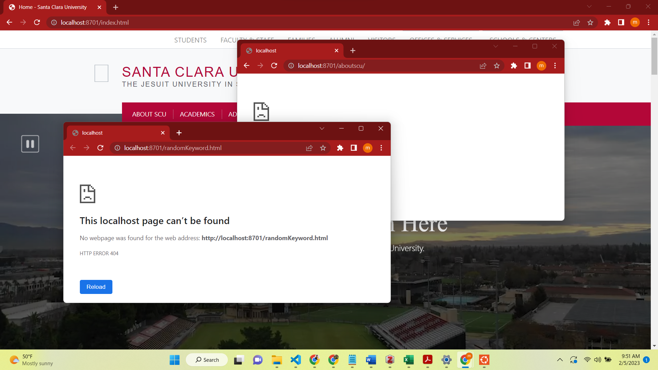

## Terminal View => closing connection

## Code View

# Header details

# Shutting server Down

Press CTRL + C to shutdown server. (Stop the terminal)

# List of submitted files.

PA1-Divya_Mahajan

├── Readme.docx

├── server.py

├── www.scu.edu

│   ├── aboutscu

│   │   └── index.html

│   ├── academics

│   │   └── index.html

│   ├── admission

│   │   └── index.html

│   ├── assets

│   │   ├── images

│   │   │   └── favicons

│   │   │   ├── android-chrome-192x192.png

│   │   │   ├── favicon-16x16.png

│   │   │   ├── favicon-32x32.png

│   │   │   ├── favicon-96x96.png

│   │   │   └── manifest.json

│   │   └── public

│   │   └── scu.js

│   ├── athletics

│   │   └── index.html

│   ├── campus-life

│   │   └── index.html

│   ├── giving

│   │   └── index.html

│   ├── globalengagement

│   │   └── index.html

│   ├── index.html

│   ├── media

│   │   ├── college-of-arts-and-sciences

│   │   │   └── mission-roses-hero1.jpg

│   │   ├── institutional-pages

│   │   │   ├── Copy-of-DSC_6685.jpeg

│   │   │   ├── JL160917_4111_CampusBeauty_0265-1160x774.jpeg

│   │   │   ├── about-scu

│   │   │   │   └── lg-1609-mission2.jpg

│   │   │   ├── academics

│   │   │   │   └── lg-1609-academics.jpg

│   │   │   ├── admission

│   │   │   │   └── images

│   │   │   │   ├── SCU-Fountain-Mission-Students-1156x419.png

│   │   │   │   └── marketing001-1000x667.jpg

│   │   │   ├── athletics

│   │   │   │   ├── lacrosse.jpg

│   │   │   │   ├── lg-1712-huddle.jpg

│   │   │   │   └── md-1606-bbf.jpg

│   │   │   ├── campus-life

│   │   │   │   └── images

│   │   │   │   ├── 3159_134-1160x774.JPG

│   │   │   │   ├── CB15_Vigil_3667_063-1160x774.JPG

│   │   │   │   ├── ISS---Bronco-Experience---Rico-Mok_Rev-750x499.jpg

│   │   │   │   ├── SCU_Day-1-5_15-091-1160x773.JPG

│   │   │   │   ├── SCU_Day-1-5_15-319-1160x773.JPG

│   │   │   │   ├── SCU_Day-2-5_15-189-1160x773.JPG

│   │   │   │   ├── Untitled12-783x520.png

│   │   │   │   ├── Untitled9-1025x681.png

│   │   │   │   ├── amy-tan.jpg

│   │   │   │   ├── laptop.jpg

│   │   │   │   ├── ohlone-life-211x167.jpg

│   │   │   │   └── orchestra.jpg

│   │   │   ├── giving

│   │   │   │   └── images

│   │   │   │   └── campaign-banner.png

│   │   │   └── news-amp-events

│   │   │   ├── Bronco_Boardwalk_1600x600.jpeg

│   │   │   ├── CampusBeauty2022-760x480.jpg

│   │   │   ├── IDPC760X480-760x480.jpg

│   │   │   ├── LawrenceLokmanPortrait-1-760x480-760x480.jpg

│   │   │   ├── Sofia_Brumbaugh_20221028_JG_0053-1-760x480.jpg

│   │   │   ├── VR_StFrancis_20221201_JG_21.JPG

│   │   │   ├── alvarez760x480-760x480.jpg

│   │   │   └── unnamed-3-760x480.jpg

│   │   ├── offices

│   │   │   ├── global-engagement

│   │   │   │   ├── Screen-Shot-2019-12-18-at-2.56.24-PM.png

│   │   │   │   ├── blog-import

│   │   │   │   │   └── global-engagement-photos

│   │   │   │   │   ├── 1-1.jpeg

│   │   │   │   │   ├── 1-33.JPG

│   │   │   │   │   ├── 1-6.jpg

│   │   │   │   │   ├── 1-8.jpg

│   │   │   │   │   ├── Big-Bazaar-in-Ahmedabad-Gujarat--Delaney-Bantillo.jpg

│   │   │   │   │   └── CB15_ChemLabs_3680_069.jpg

│   │   │   │   └── photo-contest-

│   │   │   │   └── 74-cropped-1160x658.jpg

│   │   │   └── umc

│   │   │   ├── press-release-images

│   │   │   │   └── 2022

│   │   │   │   ├── ATI-logo.png

│   │   │   │   └── heed_logo2022_tag-500x377-500x377.jpeg

│   │   │   └── web-design

│   │   │   └── crowd-pic-NEW_0001_20211203_Soccer_Fans_4446.jpg

│   │   ├── scu_aec_image-min_reduced.jpg

│   │   ├── scuedu

│   │   │   └── style-assets

│   │   │   ├── javascript

│   │   │   │   └── lazyloading.js

│   │   │   └── stylesheets

│   │   │   ├── f.css

│   │   │   └── preloading.css

│   │   ├── t4_3618369524530168582.jpg

│   │   └── t4_5283102727588396708.jpg

│   ├── news-and-events

│   │   └── index.html

│   └── robots.txt

└── ~$Readme.docx

39 directories, 67 files

# References

1. https://www.geeksforgeeks.org/socket-programming-python/
2. https://www.geeksforgeeks.org/creating-a-proxy-webserver-in-python-set-1/
3. https://www.youtube.com/watch?v=5EPxQJ6quZE
4. https://docs.python.org/3/library/signal.html