Features
- Chip Features
  - Built-in low-power 32-bit CPU, can also serve as an application processor
  - Main frequency supports 120MHz
  - Working voltage: 3.0V~3.6V
  - Peripherals: PWM / I2C / UART / SPI / SDIO / IrDA
  - 256 KB RAM Default 2MB FLASH (4MB optional)
- Wi-Fi Features
  - 802.11 b/g/n
  - Channel 1-14@2.4GHz
  - Support WEP, WPA/WPA2, WPA/WPA2 PSK (AES) security modes
  - +18 dBm output power in 802.11b mode
  - Support STA/AP/STA+AP working mode
  - Support SmartConfig and AP network configuration methods (including Android and IOS devices)
- Bluetooth Features
  - Support classic Bluetooth standard rate connection
  - Supports all BLE 5.1 rates and features.
  - Bluetooth mode supports 6 dBm transmission power
  - Complete Bluetooth coexistence interface

Module peripherals
  - 2xUART
  - 1xADC
  - 1xEn
  - 6 x PWM
  - 2 xI2C
  - Operating temperature range: -40℃-105℃
  - Module size: 1 7.5 mm* 15 mm*3 mm
  - Module color: blue

Application Scenario
● Smart Home ● Smart Building
● Electrical lighting ● Baby monitoring
● Webcam ● Wearable electronics
● Smart Bus ● Wireless Location Sensing
● Wireless positioning system beacon ● Industrial wireless control

Module Model
name | Antenna Type
XH-CB2S | Onboard PCB antenna
Module structure diagram
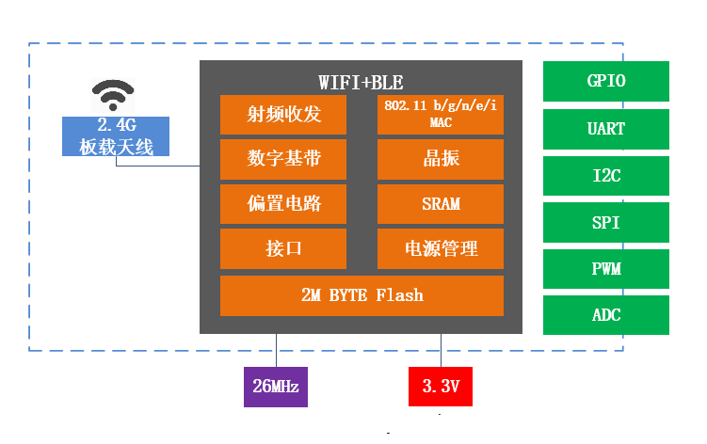

Document update notes

date | Version | Updates
20 23 - 10 - 20 | V 1.0 | Initial release

Order record

1. Product Overview 4
2. Interface Definition 6
3. Appearance and size
IV. Electrical Characteristics 9
5. RF power consumption 10
6. Wi-Fi RF characteristics 11
VII. Recommended furnace temperature curve 12
8. Module Minimum System 13
IX . Recommended PCB design (taking XH-C 2 F as an example) 14
10. Peripheral wiring suggestions 16
Disclaimer and Copyright Notice17

1. Product Overview
XH- CB 3 S has a built-in 32-bit MCU running at up to 120 MHz, built-in 2Mbyte (4M optional) ) flash memory and 256 KB RAM. The MCU's extended instructions for signal processing enable it to efficiently implement audio encoding and decoding.
XH- CB 3 S has rich peripherals, such as PWM, UART. Up to 6 channels of 32-bit PWM output make the chip very suitable for high-quality LED control.


Figure 1.1 Module structure diagram

Classification | project | parameter
Wi-Fi | Frequency range | 2.4G~2.5G(2400M~2483.5M)
 | Wi-Fi Standards | IEEE 802.11b/g/n (channel 1-14)
 | Receiving sensitivity | 11b:1,2,5.5, 11 (Mbps);
 |  | 11g:6,9,12,18,24,36,48,54(Mbps);
 |  | 11n: HT20 MCS0~7;
 |  | 11n: HT40 MCS0~7
 | antenna | PCB onboard antenna
hardware | CPU | 32- bit MCU with built-in 256 KB RAM
 | Peripherals | PWM / I2C / UART / SPI / SDIO / IrDA
 | Operating voltage | 3.0V ~ 3.6V
 | Working current | Average current: 100 mA , Peak current: > 400mA
 | Operating temperature | -40°C ~ 85°C
 | Ambient temperature range | -40°C ~ 125°C
 | Package size | 17.5 mm x 15 mm x 3 mm
software | Bluetooth Mode | Classic Bluetooth/Bluetooth 5.1
 | Wi-Fi Mode | Station/SoftAP/SoftAP+Station
 | Safety Mechanism | WEP,WPA/WPA2,WPA/WPA2 PSK (AES)
 | Built-in firmware | Tuya Smart/Smart Life/Matter/AT Firmware

2. Interface definition

The XH-CB2S interface definition is shown in the figure below.

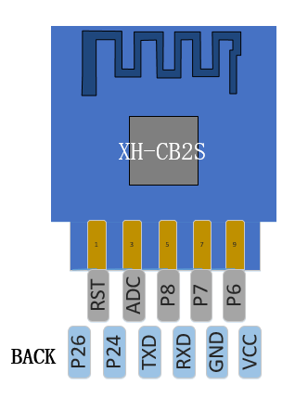
Figure 2.1 XH -CB2S pin definition
pin definitions of the module are shown in the following table .

Table 2. 1 -pin mode

model | CSN | RST
UA RT Download Mode | high | high
RF calibration test | Low | high

Table 2.2 Module pin function definition
Serial number | Pin Name | type | Functional Description
1 | RST | I /O | External reset signal (low level is valid), reset module; the module has a pull-up resistor inside
2 | P26 | I/O | General IO port or ADC1 or infrared receiver or PWM5
2 | ADC | I/O | General IO port P23 or ADC3 or JTAG TDO or Flash data output when downloaded using SPI
4 | P 24 | I/O | General IO port or ADC2 or low power clock 32.768K output or PWM4
5 | P8 | I/O | General IO port or BT_ACTIVE control or PWM2 for WIFI and BT coexistence
6 | T X D1 | I /O | UART_TX1, user data transmission port, corresponds to P11 of IC; pull-up is prohibited, the default state of the MCU docking serial port needs to be configured to low level or high impedance
7 | P 7 | I/O | General IO port or WIFI_ACTIVE control or PWM1 for WIFI and BT coexistence
8 | R X D 1 | I/O | UART_RX1, user data receiving port, corresponds to P10 of IC; pull-up is prohibited, the default state of the MCU docking serial port needs to be configured to low level or high impedance
9 | P6 | I/O | General IO port or crystal clock 1, 2, 4, 8 frequency division output or PWM0
10 | GND | P | Ground
11 | VCC | P | Module power supply: 3.3V / 350mA

3. Appearance and size


The module's dimensions are 17.5 mm x 15 mm x 3 mm (as shown in the figure).

3.1 Module size diagram

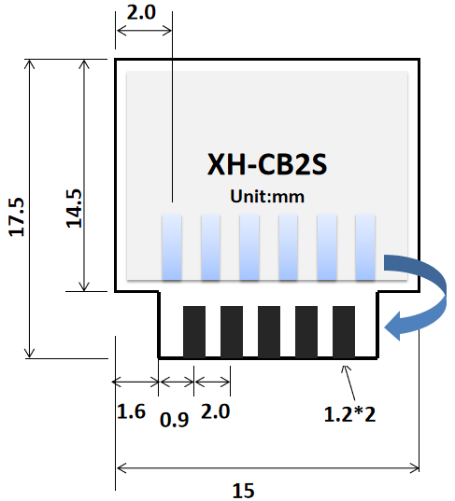

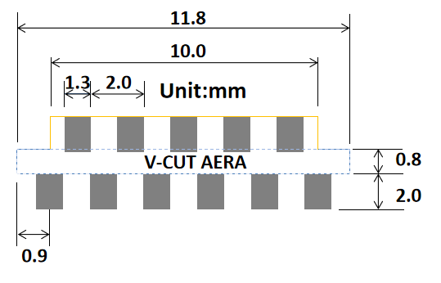

(a) Top view (b) Side view

Table 3.1 Module size comparison table

long | Width | high | P A D Dimensions (bottom) | Pin Foot spacing
1 7.5 mm | 15 mm | 3 mm | 0 . 9 mm x 1.7 mm | 1 mm

4. Electrical characteristics

Table 4.1 Absolute electrical parameters
parameter | describe | Minimum | Maximum | unit
Ts | Storage temperature | -55 | 125 | ℃
VBAT | Supply voltage | -0.3 | 3.9 | V
Electrostatic discharge voltage (human body model) | TAMB-25℃ | -4 | 4 | kV
Electrostatic discharge voltage (machine model) | TAMB-25℃ | -200 | 200 | V

Table 4.2 Normal working conditions

parameter | describe | Minimum | Typical Value | Maximum
Ta | Operating temperature | -40 | - | 85
VBAT | Supply voltage | 3 | 3.3 | 3.6
VOL | IO low level output | VSS | - | VSS+0.3
VOH | IO high level output | VBAT-0.3 | - | VBAT

5. RF Power Consumption
Table 5.1 Power consumption
Working status | model | rate | Transmit power/receive | average value | Peak value (typical) | unit
emission | 11b | 11Mbps | +16dBm | 260 | 300 | mA
emission | 11g | 54Mbps | +15dBm | 240 | 286 | mA
emission | 11n | MCS7 | +14dBm | 238 | 271 | mA
take over | 11b | 11Mbps | Continuous reception | 73 | 82 | mA
take over | 11g | 54Mbps | Continuous reception | 75 | 82 | mA
take over | 11n | MCS7 | Continuous reception | 75 | 82 | mA

Note ① : The test condition for the transmitting operating current is the module's 100% duty cycle packet transmission state.

Table 5.2 Working current

Working Mode | Working state, Ta=25℃ | average value | Maximum value (typical value) | unit
Quick connect network configuration status (Bluetooth network configuration) | The module is in the fast connection and network configuration state, and the Wi-Fi indicator flashes quickly. | 63 | 245 | mA
Quick connect network configuration status (AP network configuration) | The module is in hotspot configuration state, and the Wi-Fi indicator flashes slowly. | 80 | 270 | mA
Quick connection network status (EZ network configuration) | The module is in the fast connection network state, and the WIFI indicator flashes quickly. | 78 | 246 | mA
Network connection status | The module is in networking working state, and the Wi-Fi indicator is always on. | 25 | 342 | mA
Weak network connection status | The module and hotspot are in a weak network connection state, and the Wi-Fi indicator is always on. | 205 | 350 | mA
Network disconnection status | The module is in disconnected working state, and the Wi-Fi indicator is always off. | 63 | 242 | mA

Shutdown mode – When CEN=0, the system enters shutdown mode. When CEN=1 for a few milliseconds, the system powers on.
Enter working mode
Deep sleep mode - In this mode, the main MCU system is powered off, only the GPIO status is maintained and the AON part is
The GPIO edge change or AON counter interrupt can wake up the system to the working state.
Keep the content.
Normal Standby Mode – In this mode, the MCU stops running, but the peripherals can continue to work and generate interrupt calls.
Wake up the MCU and continue running
Low voltage Standby Low voltage standby mode – To further reduce leakage, the system can enter low voltage standby mode.
In this mode, the clocks of the MCU and all digital peripherals are stopped. Only GPIO interrupts and AON counter interrupts are available.
To wake up the system and restore it to normal voltage to continue running

Wi-Fi RF Characteristics
The data in the table below are measured at room temperature and a voltage of 3.3V.

Table 6.1 WiFi RF Characteristics
Parameters | Minimum | Typical Value | Maximum | unit
RF average output power, 802.11b CCK Mode 11M | - | 16 | - | dBm
RF average output power, 802.11g OFDM Mode 54M | - | 15 | - | dBm
RF average output power, 802.11n OFDM Mode MCS7 | - | 14 | - | dBm
Frequency Error | -20 | - | 20 | ppm

Table 6.2 WiFi reception characteristics
Parameters | Minimum | Typical Value | Maximum | unit
PER<8%, RX sensitivity, 802.11b DSSS Mode 11M | - | -88 | - | dBm
PER<10%, RX sensitivity, 802.11g OFDM Mode 54M | - | -74 | - | dBm
PER<10%, RX sensitivity, 802.11n OFDM Mode MCS7 | - | -73 | - | dBm
PER<10%, RX sensitivity, Bluetooth LE 1M | - | -96 | - | dBm

Table 6.3 Bluetooth transmission characteristics
Parameters | Minimum | Typical Value | Maximum | unit
Operating frequency | 2402 | - | 2480 | MHz
Air speed | - | 1 | - | Mbps
Transmit power | -20 | 6 | 20 | dBm
Frequency Error | -150 | - | 150 | KHz

Table 6.3 Bluetooth Receiver Characteristics
Parameters | Minimum | Typical Value | Maximum | unit
RX sensitivity | - | -96 | - | dBm
Maximum RF signal input | -10 | - | - | dBm
Intermodulation | - | - | -twenty three | dBm
Co-channel rejection ratio | - | 10 | - | dB

7. Recommended furnace temperature curve
The recommended furnace temperature curve is as follows:

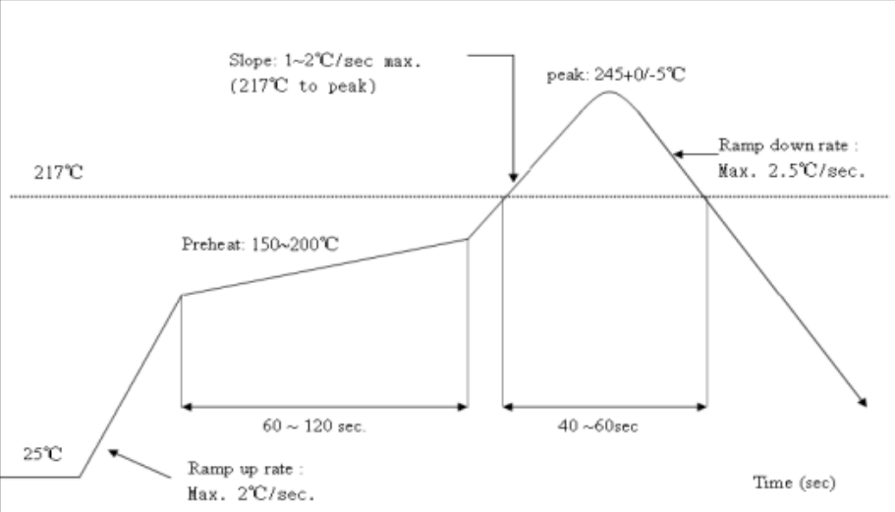
Figure 7.1 Recommended furnace temperature curve

8. Module Minimum System
The minimum system circuit diagram of the module is as follows (refer to XH-CB3S) :

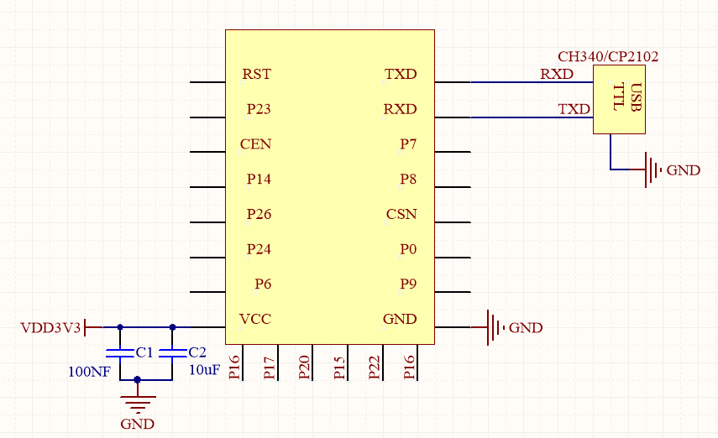
Figure 9.1 Minimum system
Note:
(1) The module power supply voltage is DC 3.3V;
(2) The maximum output current of Wi-Fi module IO is 12mA;
(2) The Wi-Fi module C EN enable pin is valid at high level;
(4) The Wi-Fi module enters RF calibration mode: CSN is at a low level, and then the module is reset and powered on;
(5) The RXD of the Wi-Fi module is connected to the TXD of the external MCU, and the TXD of the Wi-Fi module is connected to the RXD of the external MCU;

IX . Recommended PCB design (taking XH-C2F as an example)
Wi-Fi module can be directly soldered to the PCB. In order to achieve the best RF performance for your terminal product, please pay attention to the reasonable design of the module and antenna placement on the baseboard according to this guide. For the PCB antenna version module, there are three options to choose from.
For the external antenna version, since the antenna is external, the module placement is not very demanding, and you can refer to the layout suggestions of XH-C2F for adjustment as appropriate. The specifications of the external antenna connector are shown in the figure below.
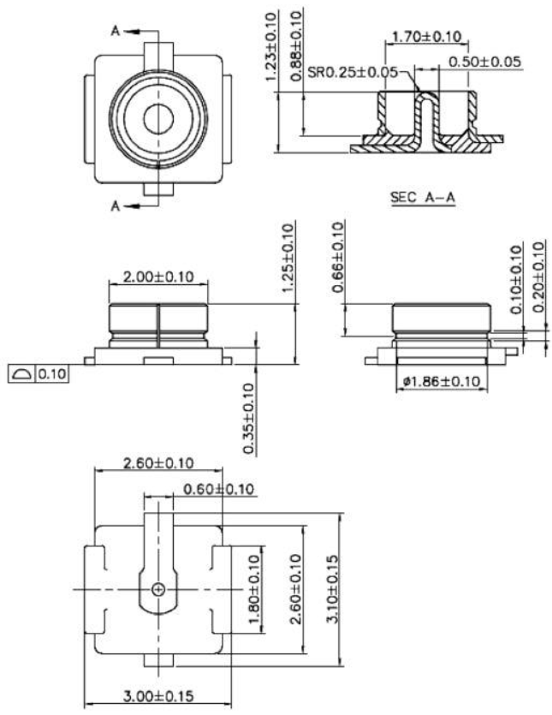

Solution 1: Preferred solution: The WiFi module is placed close to the edge of the board, and the antenna is completely exposed. There is no metal material around the antenna, including wires, metal casings, counterweight plates, etc.
Solution 2: Suboptimal solution: The WiFi module is placed close to the edge of the board, the antenna is hollowed out and a gap of at least 5mm is reserved with the surrounding PCB, and there is no metal material around the antenna, including wires, metal casings, counterweight plates, etc.
Solution 3: General solution: The WiFi module is placed close to the edge of the board, and the PCB area under the antenna is kept clear and no copper is allowed.
Note: The WiFi module cannot be placed in the middle of the motherboard, and other metal materials are not recommended around it.
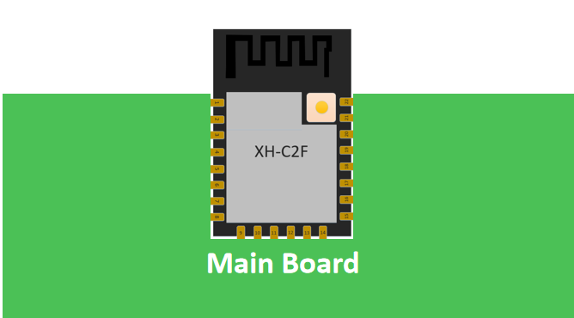

Figure 10.1 Solution 1 - Antenna outside the frame

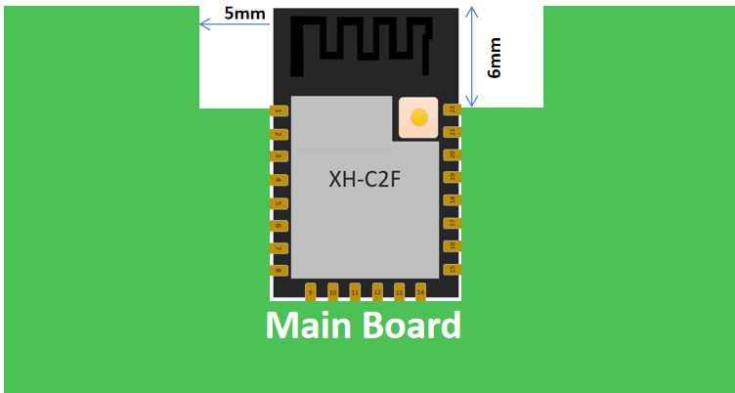
Figure 10. 2Scheme 2 - The antenna is placed along the edge of the board and the bottom is hollowed out

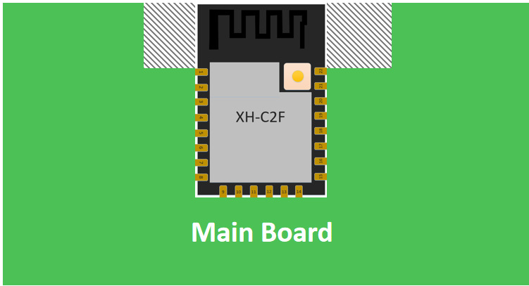
Figure 10. 3Scheme 3 - The antenna is placed along the edge of the board with no copper underneath

10. Peripheral wiring suggestions
The Wi-Fi module integrates high-speed GPIO and peripheral interfaces, which may generate severe switching noise. If some applications have high requirements for power consumption and EMI characteristics, it is recommended to connect a 10~100 ohm resistor in series on the digital I/O line. This can suppress overshoot when switching the power supply and make the signal smooth . At the same time, this practice can also prevent electrostatic discharge (ESD) to a certain extent.

Disclaimer and Copyright Notice

The information in this document, including URL references, is subject to change without notice.
The document is provided "as is" without warranty of any kind, including any warranty of merchantability, fitness for a particular purpose or non-infringement, and any warranty otherwise provided by any proposal, specification or sample. No liability is assumed with respect to this document, including liability for infringement of any patent arising from the use of the information in this document. No license, express or implied, by estoppel or otherwise, to any intellectual property right is granted by this document.
The Wi-Fi Alliance member logo is owned by the Wi-Fi Alliance.
All trade names, trademarks and registered trademarks mentioned herein are the property of their respective owners and are hereby acknowledged.


Note meaning
The contents of this manual may be changed due to product upgrades or other reasons. Shenzhen Spark Sichuang Technology Co., Ltd. reserves the right to modify the contents of this manual without any notice or reminder. This manual is only used as a guide. Shenzhen Spark Sichuang Technology Co., Ltd. tries its best to provide accurate information in this manual, but does not ensure that the contents of the manual are completely error-free, and all statements, information and suggestions in this manual do not constitute any express or implied warranty.

