Grocare India *Technical Bulletin*

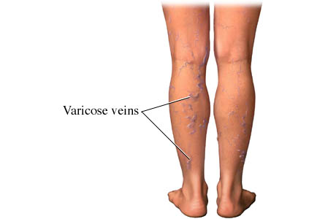

Varicose Veins may be Caused because the body is Too Acidic and is Lacking in the needed Alkaline Minerals, which may provide the Tissue of the body to have Elasticity, which means that the veins may be able to work like a Rubber Band and stretch and go back into the former shape after stretching !  
  
The Veins "Only" Bust because they are not able to stretch and Flex, because they are too Ridged, because of a lack of needed Alkaline Minerals !

***Cause of varicose veins***

Age and gravity are the enemies of healthy veins. With age, the walls of your veins can lose elasticity, causing them to stretch. The valves in the veins then become weak, allowing blood that should be moving towards your heart to flow backwards. [Blood pools](http://jamaica-gleaner.com/gleaner/20120703/lead/lead8.html) in your veins, and your veins enlarge and become varicose. These veins appear blue because they contain deoxygenated blood. Any other condition that can cause pressure in the pelvis like uterine fibroids or chronic constipation may also contribute to varicose veins.

A lack of stomach acid leads to poor digestion and nutrient absorption.  This in turn can lead to weakening of the blood vessels causing them to varicose.

***What is needed ?***

Restore body’s pH throughout the body, remove toxins and waste so that tissues can get regenerated and bring back elasticity, stimulate nerves and veins, normalize pressures within the body & correct metabolism.

***Our suggestion :***

Take NERVICA & ACIDIM twice daily after food. Benefits become visible within a week.

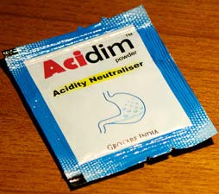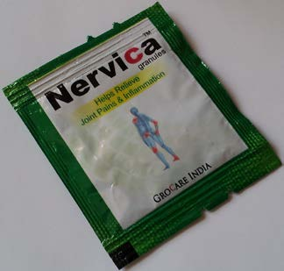

*For more information :*

Grocare India, Pune, India

[www.grocare.com](http://www.grocare.com)

www.facebook.com/grocare

Email : *info@grocare.com*