Grocare India Technical Bulletin

Acidity, Free Radicals, Headache and Aging

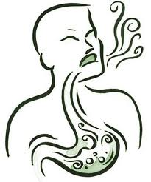There are 3 types of people.

1 Those who have never felt ‘Acidity’

2 Those who sometimes feel ‘Acidity’

3 Those who always feel ‘Acidity’

1 What actually happens in the body, when we ‘feel’ ‘Acidity’ ?

We feel ‘Acidity’ or ‘Sour Burps’ or ‘Burning’ when ‘Stomach Acid’ which is meant to digest the food that we eat, enters the ‘food pipe’.

2 Acid Reflux is when ‘Stomach Acid’ goes up the wrong way to Esophagus causing persistent cough, chest pain etc. Here, you may be treating cough with cough syrups & antibiotics, but they will be of no use, as the cause is “Acidity”, you may or may not feel it.

3 Less production of ‘Stomach Acid’ means incomplete digestion of food, which then ferments & produces Noxious gases. These vapors go into blood stream and cause headaches and Migraines. Here again, you may treat Migraine with strong medicines, but the underlying cause is “Acidity”, you may or may not feel it.

Our body is made of Trillions of cells. Each cell is living and needs oxygen to breathe and discharges Wastes & Free Radicals. These discharges become more pronounced as we age, and therefore, we become more acidic (we may or may not feel it) with age. The body of most aged individuals is very acidic, loaded with toxic wastes in the blood stream, cells and lymphatic system. These acidic wastes / Free Radicals come from many sources and must not be allowed to accumulate in the body.

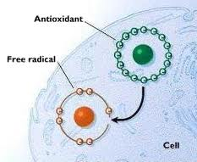It is increasingly being realized that many of today's diseases are due to the "oxidative stress" that results from an imbalance between formation and neutralization of pro-oxidants. Oxidative stress is initiated by free radicals, which seek stability through electron pairing with biological macromolecules such as proteins, lipids and DNA in healthy human cells and cause protein and DNA damage along with lipid peroxidation.

*Oxidation is unavoidable! So long as we breathe oxygen there will be oxidation in our body and thus the creation of free radicals will always continue!*

Can we take something which takes care of ‘Acidity’, Free Radicals and Oxidation ?

Acidim is a 100% natural remedy. Acidim cures acute acidity (instantly) as well as Chronic acidity (when taken regularly). Acidim cures acidity in 3 ways:  
  
• Neutralizes stomach acid  
• Regulates amount of acid in stomach  
• Increases gastric motility to expel acid out of the Stomach

Regulating the amount of acid & expelling acid out of the stomach through stool are unique actions of Acidim. That is why result is obvious so fast and across various problems.