Vakilim.az
Complete Platform Documentation
Lawyer–client marketplace & legal-document service for Azerbaijan
Version 2.0 · 12 July 2026 · matches codebase at sprint PL1 + Sentry

Contents

1. Platform overview
Vakilim.az connects clients in Azerbaijan with verified lawyers (advokat / hüquqşünas) for paid video and written consultations, and sells generated legal documents with cryptographic verification. The interface is fully trilingual — Azerbaijani, Russian, English — across 64 pages and 63 API endpoints.
Live domain: https://vakilim.az (all pages are locale-prefixed: /az, /ru, /en). Hosting: Vercel; database: Neon PostgreSQL; storage: Cloudflare R2; video: LiveKit; OTP: WhatsApp Cloud API (pending Meta verification); email: Resend; AI: Anthropic Claude; scheduler: cron-job.org; error monitoring: Sentry.
Stack: Next.js 16 (App Router, Turbopack) · TypeScript · Tailwind v4 · Prisma 7 · next-intl v4 · bcryptjs · vitest (56 tests) · design system “Aydın” (rounded-2xl, emerald #10B981, navy #0F2A43).

2. Roles & access model
Role | Obtained | Capabilities
CLIENT | any signup door | browse, favorite, book & pay, chat, call, review, dispute, buy documents, AI intake
LAWYER | client + approved application | everything a client has, plus services, availability, request decisions, replies, dispute responses, earnings
ADMIN | assigned in DB | verification, dispute resolution, review & chat moderation, recordings, template authoring
Access is enforced server-side on every page and route: public pages render for anyone; account pages require a session; lawyer pages require a profile (and APPROVED status where noted); admin pages require the ADMIN role.

3. Authentication system
Five doors, one session. Every successful authentication mints an identical 30-day session (hashed token in DB, hardened cookie).
Email + password: Primary door. Requires a verified email; wrong credentials return one deliberately vague message.
Two-phase signup: Details → OTP to the required phone → account created already phone-verified → email link (which itself signs the user in).
Phone OTP: The original door, kept for legacy and preference; international numbers accepted; verifies the phone on every success.
Google (OIDC): Hand-rolled, env-gated; linking law prevents duplicates; phoneless arrivals are walled at /complete-phone.
Two-factor (optional): Password + WhatsApp code; enabling requires proving the phone; disabling requires the password.

4. Page reference
Each page includes a schematic wireframe in the platform’s visual language (Aydın) — proportions and copy are illustrative; structure, controls and states are exact. Every page below exists under each locale prefix (/az, /ru, /en). Layout descriptions reflect the Aydın design system.

Public & marketing

Home — /{locale}
Layout: Hero with search intent, primary CTA into the directory, AI-assistant CTA, value blocks in the Aydın style (rounded-2xl cards, emerald accents, navy headings).
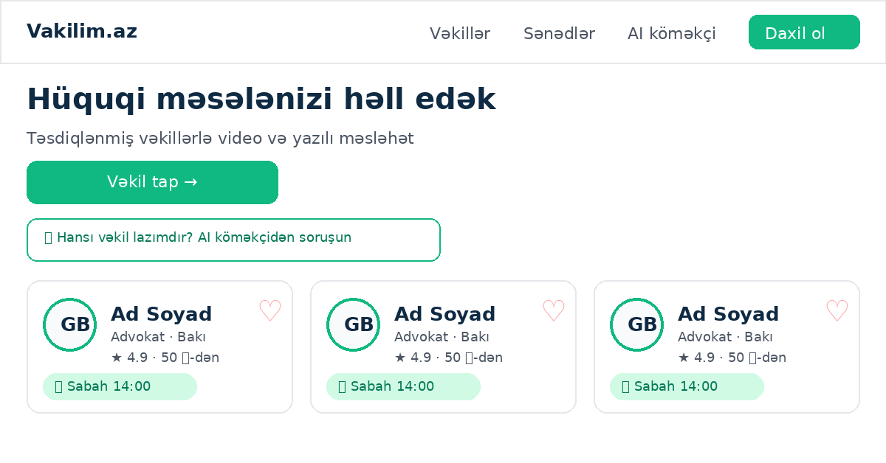
Logic & steps:
- Server component; localized metadata + hreflang.
- AI CTA links to /intake.
- Directory link carries no filters (defaults).
Access: Public.
Limitations: Static content besides translations.

Directory — /{locale}/lawyers
Layout: Filter bar (practice area, type, city, sort), paginated grid of lawyer cards: photo/initials ring, name, type · city, rating ★, from-price, next-available chip, favorite heart (clients only).
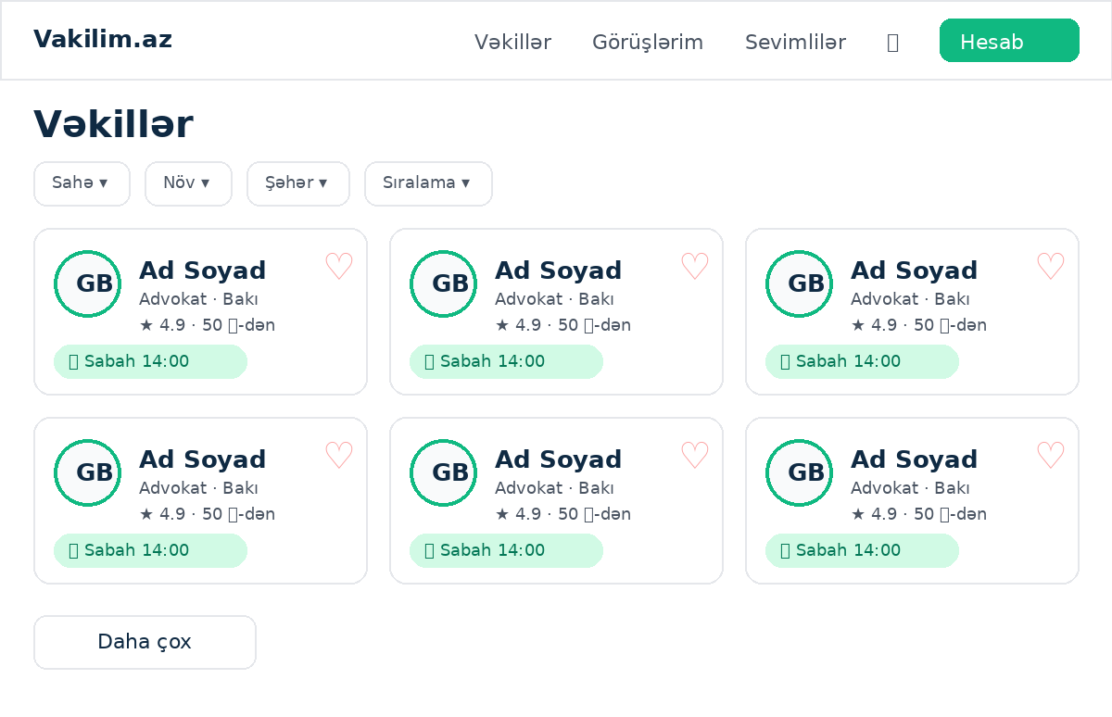
Logic & steps:
- Fetches APPROVED profiles with services, visible reviews, completed counts.
- Ranking blends rating, volume and recency.
- Next-available chip computed live from the slot engine (two batched queries).
- Heart toggles via POST /api/favorites without navigating (stopPropagation).
- Pagination via ?page with common.more control.
Access: Public; hearts render only for CLIENT role.
Limitations: Chip shows the nearest slot only; empty when no rules or fully booked.

Lawyer profile — /{locale}/lawyers/[slug]
Layout: Header: avatar, name, verified badge, favorite heart; per-locale bio; practice-area chips; services with prices/durations; availability picker; reviews with lawyer replies.
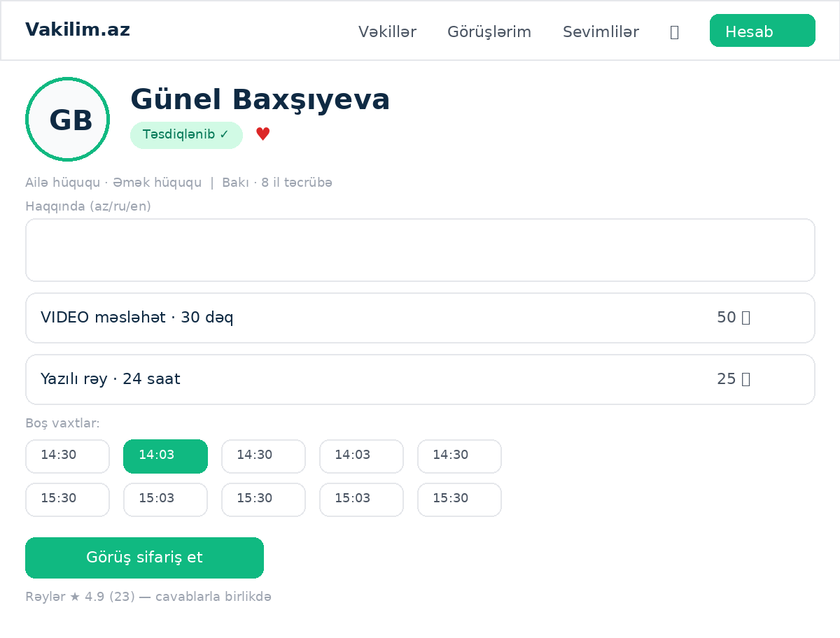
Logic & steps:
- Profile must be APPROVED, else 404.
- Slots fetched per service from /api/lawyers/[slug]/slots.
- Booking widget drives slot selection → POST /api/bookings → redirect to /pay/[bookingId].
Access: Public; booking requires login (widget prompts).
Limitations: Bio falls back to AZ when a locale version is empty.

AI legal assistant — /{locale}/intake
Layout: Title, subtitle, 5-row textarea with live character count (max 1200), analyze button; results: practice-area pill, orientation summary card, drafted first message with copy button, up to 3 matching lawyer cards; permanent not-legal-advice disclaimer.
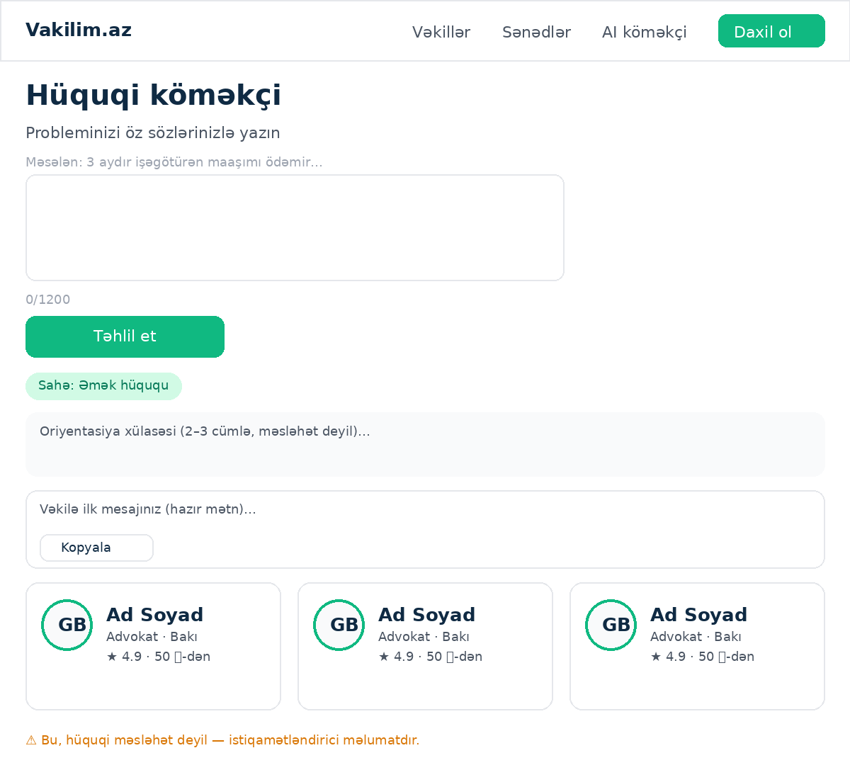
Logic & steps:
- POST /api/intake with text+locale.
- Claude classifies into a DB-provided area slug (or `other`); lawyers come from the database, never the model.
- No key configured → deterministic [AI DEV] echo keeps the flow demoable.
Access: Public (anonymous allowed).
Limitations: Rate-limited 5 requests / 10 min per IP; orientation only, never advice.

Document catalog — /{locale}/templates
Layout: Grid of paid legal document templates: title, description, price.
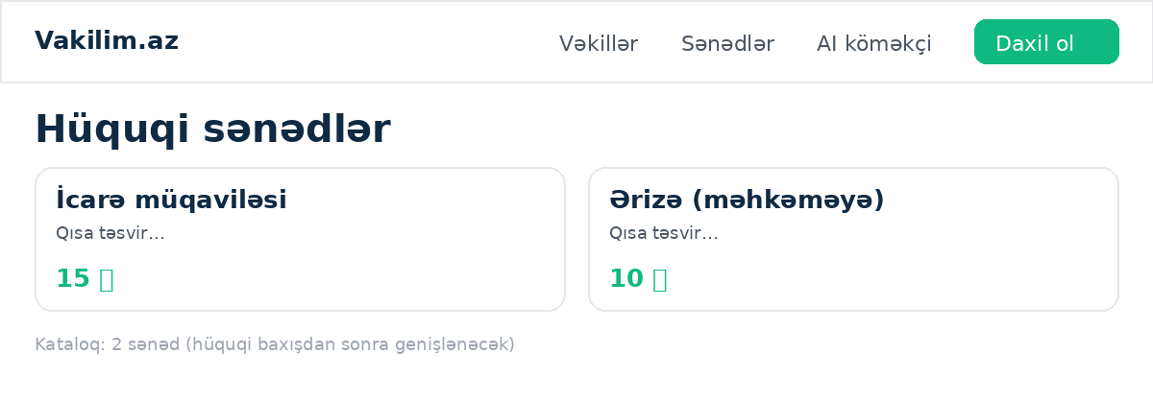
Logic & steps:
- Lists active templates in the requested locale edition.
Access: Public.
Limitations: Catalog currently seeded with 2 documents; expansion parked with legal review.

Template detail — /{locale}/templates/[slug]
Layout: Title, longer description, price, field preview, start-filling CTA.
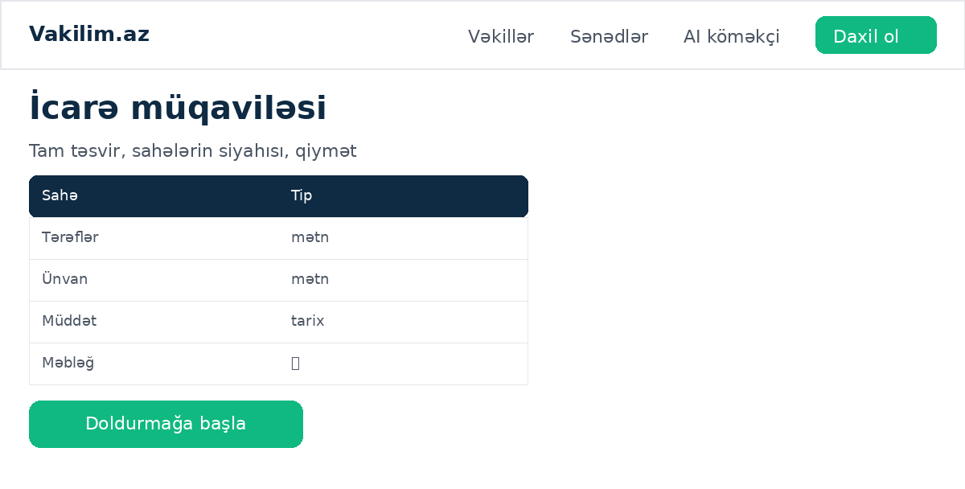
Logic & steps:
- Links into the fill wizard.
Access: Public.
Limitations: —

Fill wizard — /{locale}/templates/[slug]/fill
Layout: Step-by-step form generated from the template's field schema (text, date, select, money…), validation per field, review step, submit.
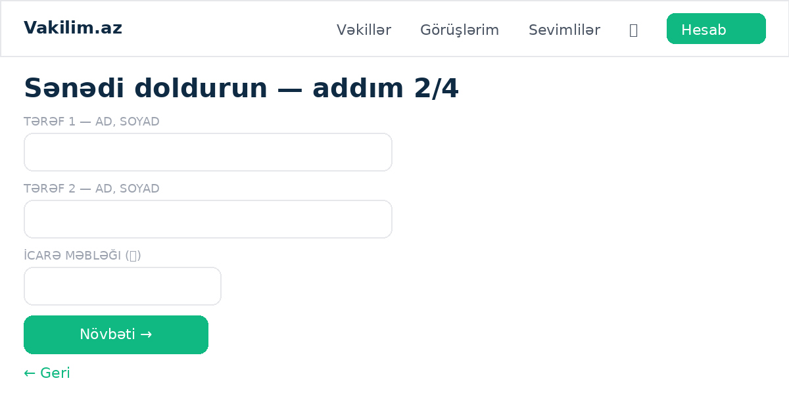
Logic & steps:
- Creates a document order (POST /api/doc-orders) → redirects to /doc-pay/[orderId].
Access: Login required.
Limitations: Field set is fixed per template version.

Document payment — /{locale}/doc-pay/[orderId]
Layout: Order summary and the mock payment form.
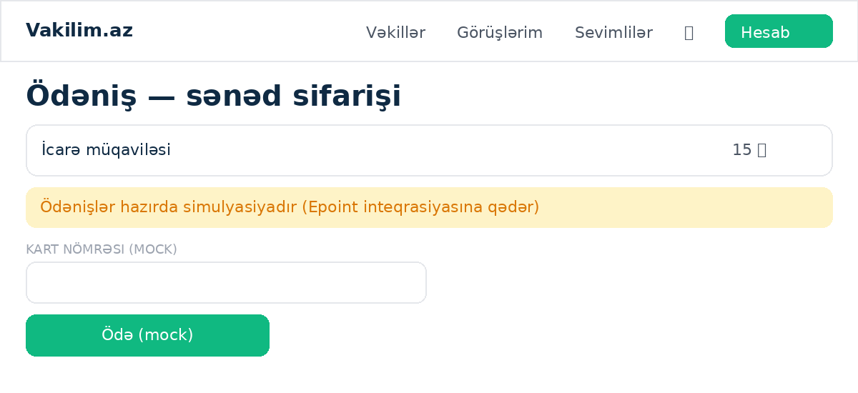
Logic & steps:
- POST /api/doc-orders/[id]/pay marks paid (simulated).
- On success the locked PDF becomes downloadable and a verification code is issued.
Access: Owner of the order only.
Limitations: Payments simulated until Epoint integration.

My documents — /{locale}/documents
Layout: List of the user's document orders with status and download links.
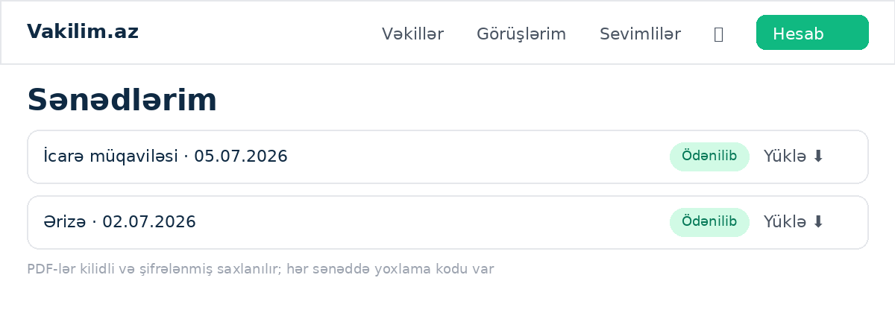
Logic & steps:
- Download proxies through /api/doc-orders/[id]/download (auth + ownership).
Access: Login required.
Limitations: Downloads are AES-GCM-encrypted-at-rest, decrypted on the fly.

Document verification — /{locale}/verify
Layout: Public code-entry form that confirms whether a generated document is authentic and unaltered.
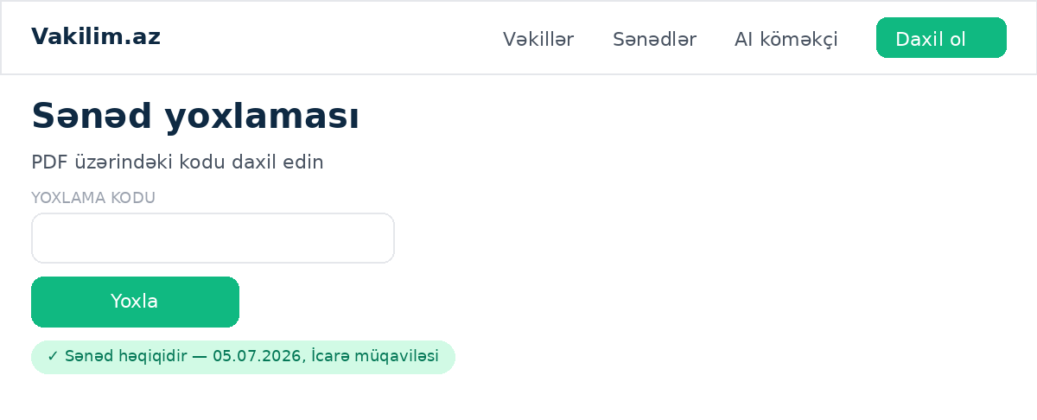
Logic & steps:
- Code printed on each paid PDF; lookup returns document metadata on match.
Access: Public.
Limitations: Verifies issuance, not legal validity.

Legal pages — /{locale}/terms · /privacy · /refund-policy
Layout: Long-form legal text in AZ with the LAYİHƏ (draft) banner and official-note chrome.
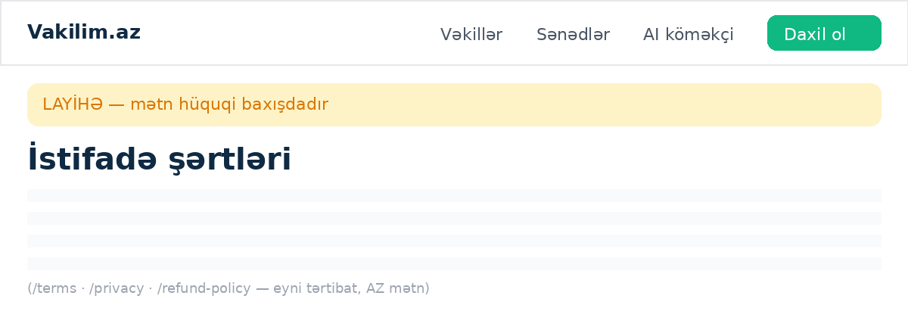
Logic & steps:
- Localized chrome; bodies currently AZ-only by design.
Access: Public.
Limitations: Drafts pending professional legal review; RU/EN translations parked.

Content & SEO surfaces

Blog — /{locale}/blog · /blog/[slug]
Layout: Card grid of articles (cover image, title, excerpt, date, author); article page renders lite-markdown with cover, byline and per-locale body.
Logic & steps:
- Post model with kind=BLOG; published when publishedAt is set and in the past.
- Lite-markdown renderer escapes HTML first, then permits ## headings, **bold** and [links](url).
- Article OG metadata carries the cover image.
- Lawyer-authored articles appear here once an admin publishes them.
Access: Public.
Limitations: Cover URLs must be https (validated); no comment system by design.

News — /{locale}/news · /news/[slug]
Layout: Same machinery as the blog with kind=NEWS; platform announcements.
Logic & steps:
- Shares the post-list and post-article components with the blog.
Access: Public.
Limitations: —

Q&A — /{locale}/qa
Layout: Accordion of frequently-asked legal questions grouped by practice area, with FAQPage JSON-LD for rich search results.
Logic & steps:
- QaEntry model; native <details> elements (no JS).
- Entries optionally tagged to a practice area, surfacing on that area's landing page.
Access: Public.
Limitations: Content is admin-authored; not legal advice.

Laws library — /{locale}/laws · /laws/[slug]
Layout: List of Azerbaijani codes and laws; detail page renders the text with an auto-generated table of contents from ## headings.
Logic & steps:
- LawDoc model with kind CODE|LAW.
- TOC extracted from the markdown headings at render time.
- Each document carries its e-qanun.az source link.
Access: Public.
Limitations: Seeded with Əmək Məcəlləsi (real text) plus two source-linked entries; full texts uploaded via the admin editor. Official texts are public-domain acts.

Practice-area landings — /{locale}/areas · /areas/[slug]
Layout: Index of the ten practice areas; each landing gathers matching lawyers (with live next-available chips and hearts), tagged Q&A entries and tagged articles on one SEO-shaped URL.
Logic & steps:
- The lawyer cards and chip computation are lifted verbatim from the directory, so they can never drift apart.
- Landing filters to APPROVED, slugged profiles in the area.
- Per-locale area names via lib/locale-pick.
Access: Public; hearts for clients only.
Limitations: Chips depend on the lawyer having availability rules.

Trust trio — /{locale}/about · /how-it-works · /contact
Layout: About: mission and three value cards. How it works: two numbered three-step ladders (client-side, lawyer-side) each with its CTA. Contact: support email as a mailto card plus two self-serve doors.
Logic & steps:
- Fully keyed in three languages.
- Contact is deliberately a mailto card, not a form — no backend, no spam surface during beta.
- SUPPORT_EMAIL is a single constant at the top of the contact page.
Access: Public.
Limitations: About states only verifiable facts — no invented team section.

Legal calculators — /{locale}/tools/rusum · /tools/muddet
Layout: Fee calculator: claim amount → estimated court fee, with the full bracket table rendered on the page for auditability. Deadline calculator: decision date + case type + stage → last day to appeal, with weekend shifting and days-remaining.
Logic & steps:
- Bracket and period figures live as labeled constants at the top of each file.
- Month arithmetic follows the procedural rule (same day next month, else the month's last day).
- Both pages ship robots noindex and stay out of the sitemap.
Access: Public.
Limitations: LAYİHƏ (draft) status: figures are unverified against e-qanun.az; indexing is gated on that verification. Public holidays are not modeled.

Lawyer authorship

My articles — /{locale}/lawyer/articles
Layout: List of the lawyer's own articles with status pills (Baxılır / Dərc olunub); editor for trilingual title, excerpt and lite-markdown body with auto-slug and practice-area tag.
Logic & steps:
- APPROVED lawyers only; others redirect to the dashboard.
- Submissions save as drafts (publishedAt null) awaiting admin acceptance.
- Drafts are editable and deletable by their author; published articles lock (edit via admin).
- Accepted articles surface on the blog and in the author's public profile.
Access: Login + APPROVED lawyer profile.
Limitations: Rate-limited 10 creates/hour, 30 edits/hour.

Authentication & account

Sign in — /{locale}/login
Layout: Email-first form (autofocus, autocomplete, show-password eye), forgot link, Google button (env-gated), Apple button (env-gated), divider, inline switch to the phone-code door; notices for failed email verification / Google errors.
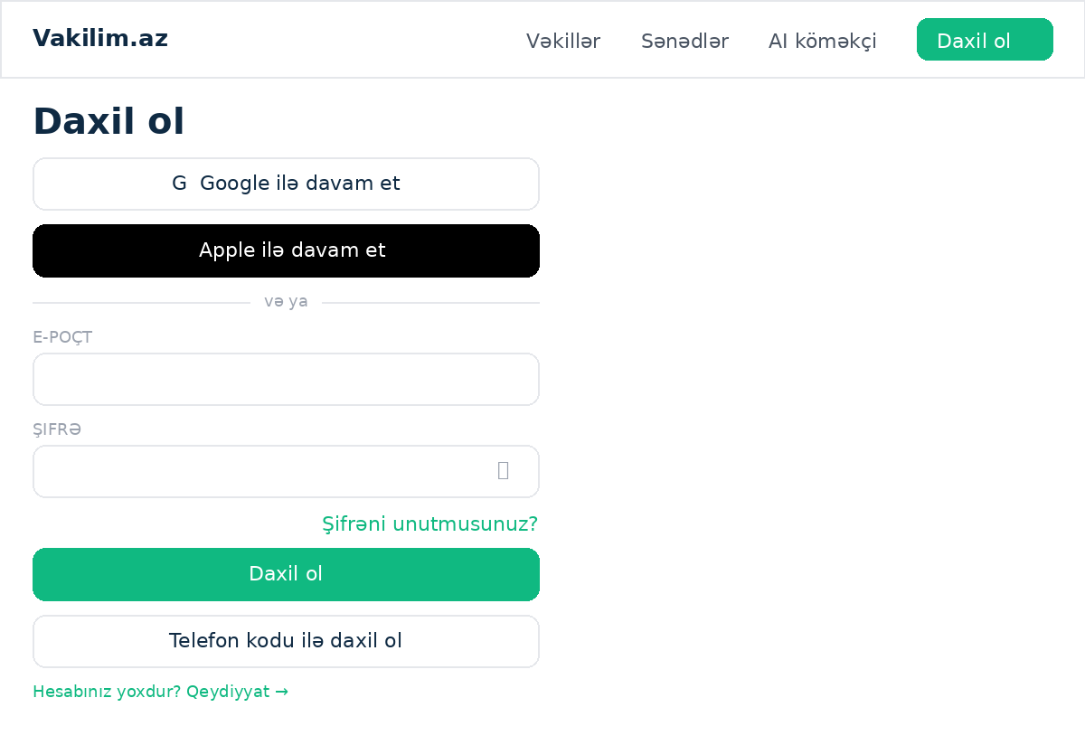
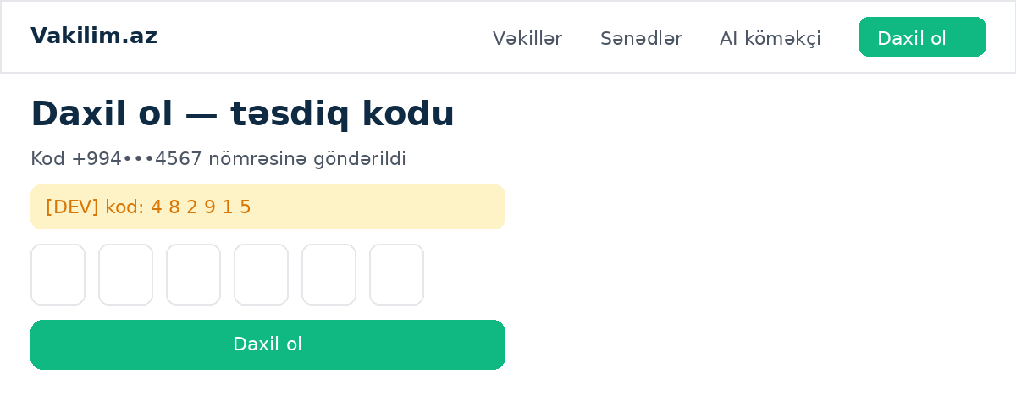
Logic & steps:
- Email+password → POST /api/auth/login; on twoFactor:true response the form swaps to a 6-digit code step (masked phone shown) → POST /api/auth/login-2fa.
- Phone mode: request-code → verify, minting the same session.
- ?next=path honored (same-origin only).
Access: Public.
Limitations: One deliberately vague error for bad credentials (anti-enumeration).

Registration (two-phase) — /{locale}/signup
Layout: Step 1: name, email, password (min 8, hint), REQUIRED phone with international hint, terms checkbox, social buttons. Step 2: 6-digit code to the phone ([DEV] echo box in beta). Done screen: check-your-inbox with [DEV] verification link.
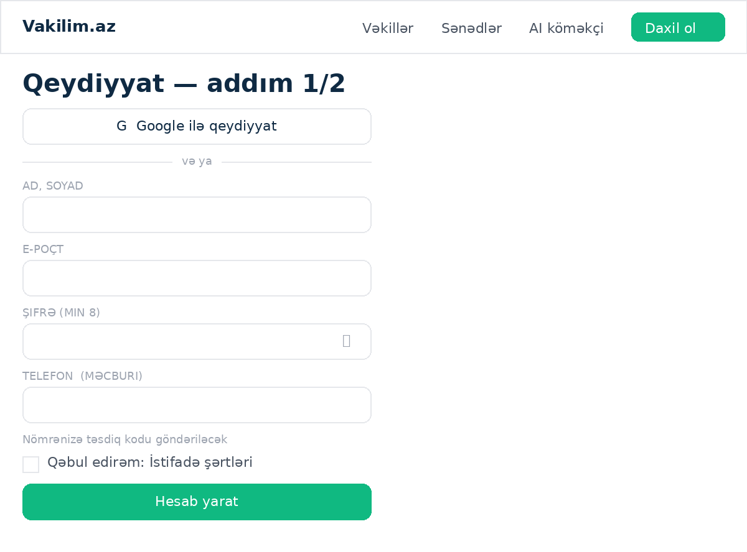
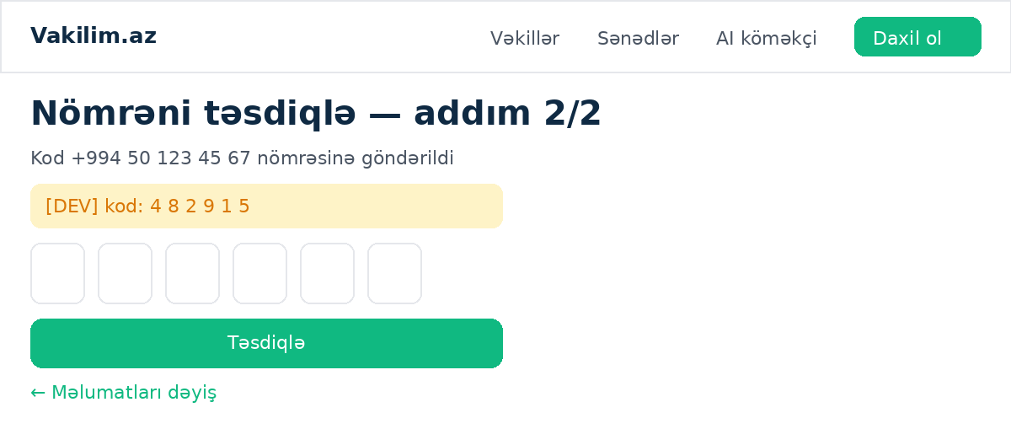
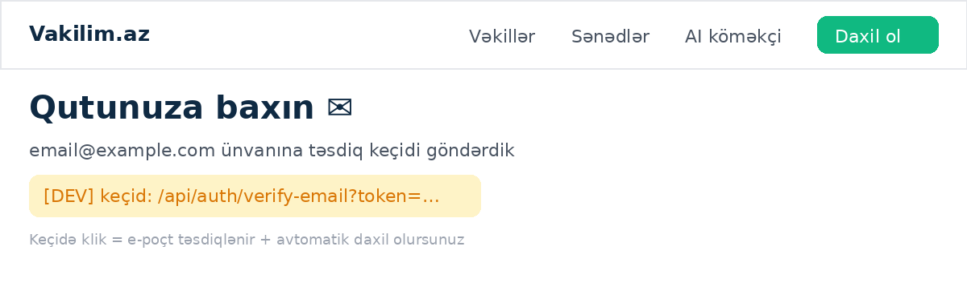
Logic & steps:
- Step 1 → POST /api/auth/signup-start (clash-check + OTP send; no user yet).
- Step 2 → POST /api/auth/signup-complete (code verified → user created with phoneVerifiedAt → verification email sent).
- Email link → GET /api/auth/verify-email → marks verified, signs the user in, redirects home.
Access: Public.
Limitations: Account cannot exist without a code-confirmed phone; email must be verified before password login works.

Password recovery — /{locale}/forgot · /{locale}/reset
Layout: Email form → always the same 'sent' answer; reset page takes ?token and a new password.
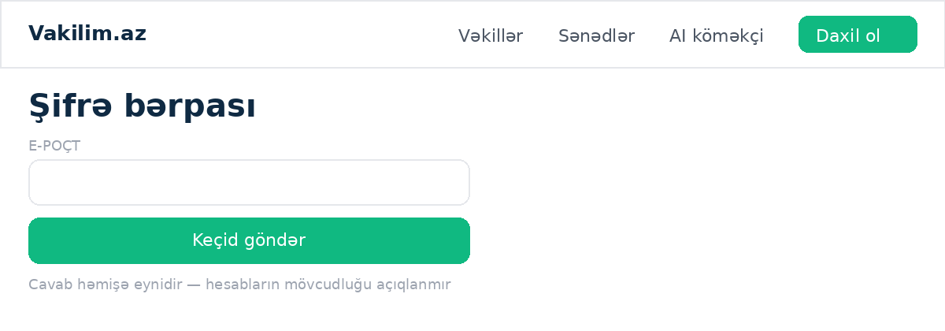
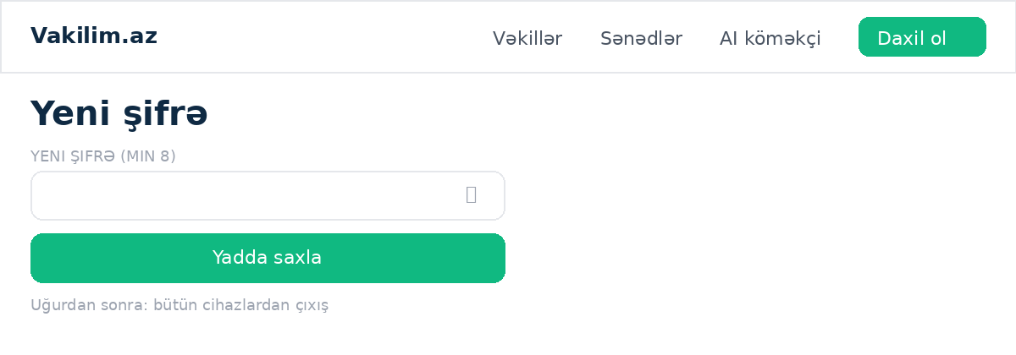
Logic & steps:
- POST /api/auth/forgot issues a 60-min single-use token (only if account+password exist) — response identical either way.
- POST /api/auth/reset consumes the token, rehashes, and deletes every session (sign-out-everywhere).
Access: Public.
Limitations: Token single-use; expired/consumed → explicit error with retry path.

Phone wall — /{locale}/complete-phone
Layout: Phone input → code step; brief explanation of why the number is required.
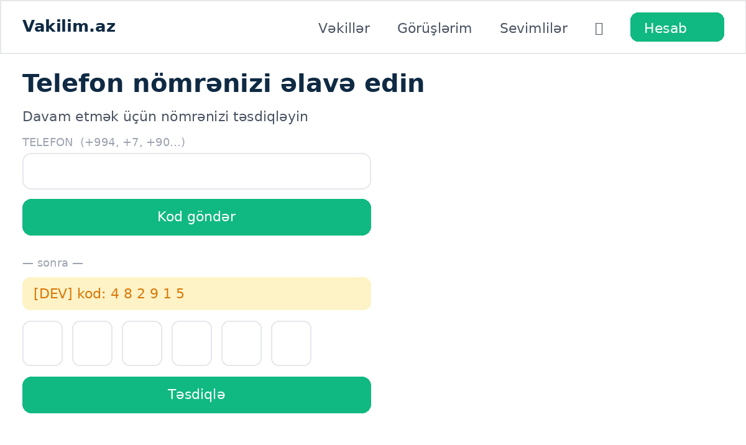
Logic & steps:
- Shown to signed-in users without a phone (Google arrivals are redirected here by the callback with ?next preserved).
- Uses /api/me/phone start/confirm; on success continues to next.
Access: Login required; users who already have a phone are bounced to next.
Limitations: Same-origin next paths only.

Profile & security — /{locale}/settings
Layout: Profile form (name, email, locale); phone shown read-only with a 'Change' flow (new number → code → saved); 'Sign-in methods' panel: email + verified badge, set/change password (current required when one exists), two-step toggle with enable-code / disable-password flows, Google linked-state or link button.
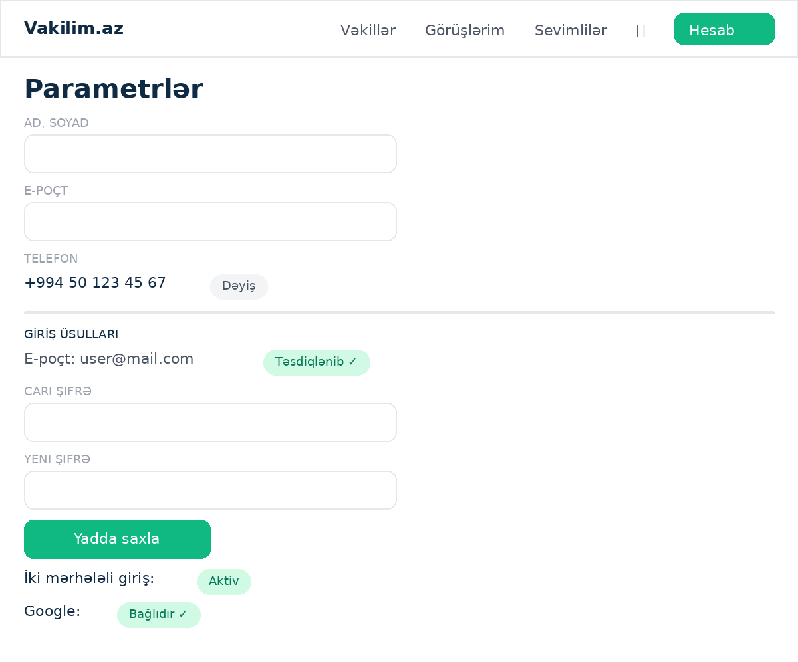
Logic & steps:
- Profile PATCH via /api/me (phone not accepted there).
- Phone change via /api/me/phone with clash-check against other accounts.
- 2FA via /api/me/2fa; enabling also stamps phone verification.
- Google link uses the standard OAuth flow with the session attached.
Access: Login required.
Limitations: Changing phone always re-verifies; disabling 2FA requires the password when set.

Client area

My bookings — /{locale}/bookings
Layout: Cards per booking: lawyer, service, date/time (Baku), status pill, price; actions by status: pay, cancel, reschedule, chat, join call, add-to-calendar, review, open dispute.
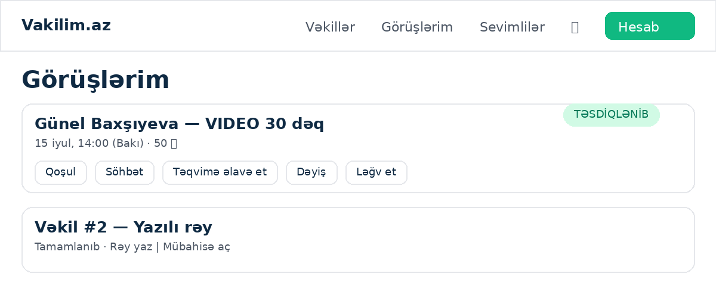
Logic & steps:
- Join appears inside the call window only.
- Add-to-calendar is a plain <a> to the ICS route (CONFIRMED only).
- Cancel applies the tiered refund policy; reschedule proposes a new slot for lawyer approval.
Access: CLIENT (own bookings).
Limitations: History pagination capped; completed items age into the archive view.

Booking payment — /{locale}/pay/[bookingId]
Layout: Order summary + mock card form.
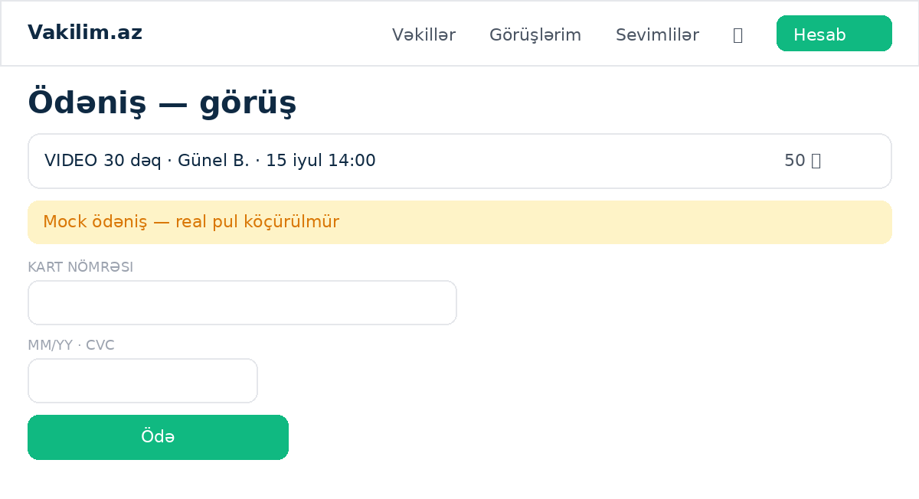
Logic & steps:
- POST /api/payments/mock flips the booking to paid/CONFIRMED-pending-acceptance per flow.
- Idempotent against double-submit.
Access: Booking's client only.
Limitations: Simulated until Epoint.

Reschedule — /{locale}/reschedule/[bookingId]
Layout: Current slot, new-slot picker from live availability, confirm.
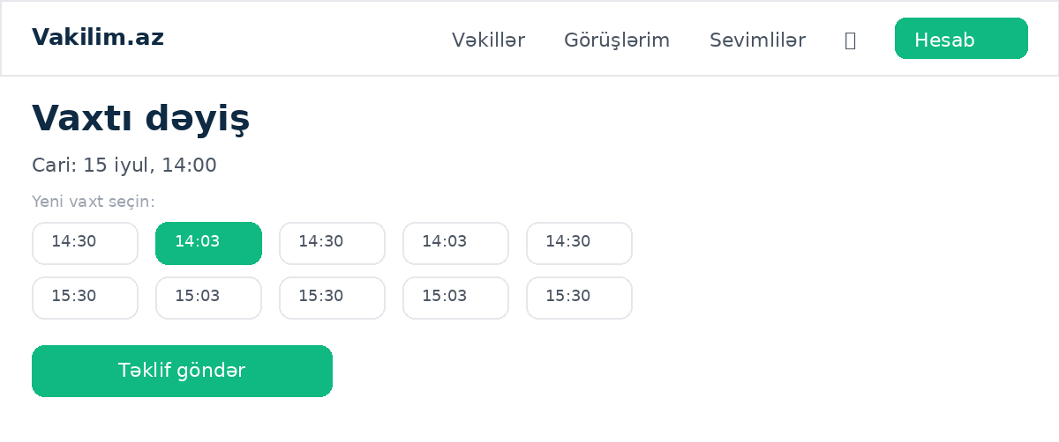
Logic & steps:
- POST /api/bookings/[id]/reschedule; counterpart notified; acceptance rules per policy.
Access: Participants only.
Limitations: Limited to policy windows; blocked close to start.

Leave review — /{locale}/review/[bookingId]
Layout: Stars, tag chips, free text, submit.
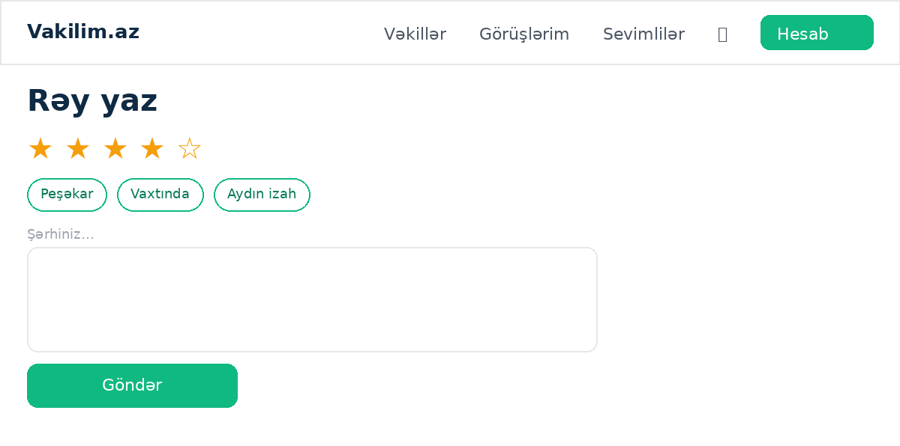
Logic & steps:
- POST /api/bookings/[id]/review; one review per booking; lawyer may reply once.
Access: Client of a COMPLETED booking, within the review window.
Limitations: Admin can hide abusive reviews (excluded from rating everywhere).

Open dispute — /{locale}/dispute/[bookingId]
Layout: Reason select, description, evidence note, submit.
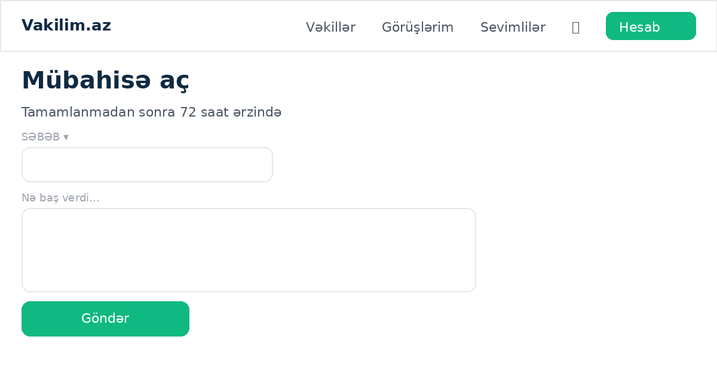
Logic & steps:
- POST /api/bookings/[id]/dispute within 72h of completion; lawyer gets a 48h response window with automatic nudge; admin resolves with an optional refund amount.
Access: Client of the booking.
Limitations: Refund amounts feed the lawyer's net earnings.

Favorites (Sevimlilər) — /{locale}/favorites
Layout: Stacked cards of hearted lawyers: avatar, name, type · city, from-price, heart to remove.
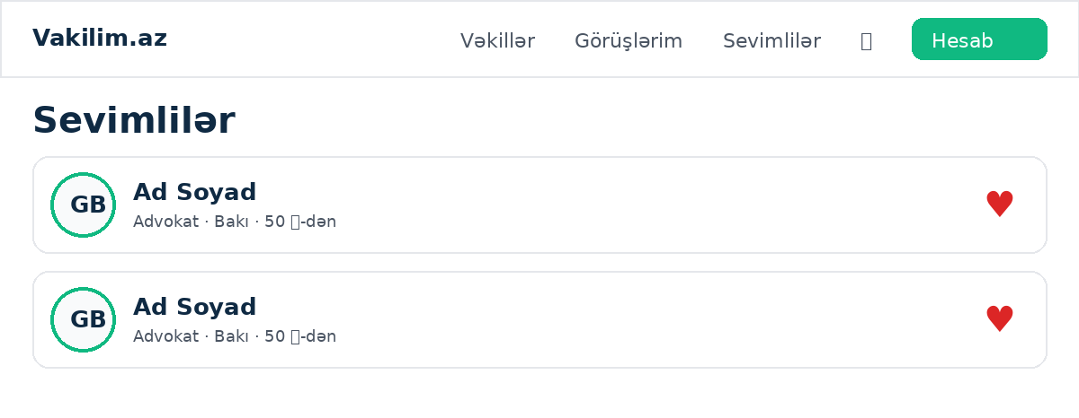
Logic & steps:
- Reads the Favorite join table (unique per user+lawyer); heart toggles optimistically.
Access: CLIENT only (nav link hidden otherwise).
Limitations: Capped at 100 most recent.

Chat — /{locale}/chat/[bookingId]
Layout: Message thread with attachments, unread markers, input; visible per booking.
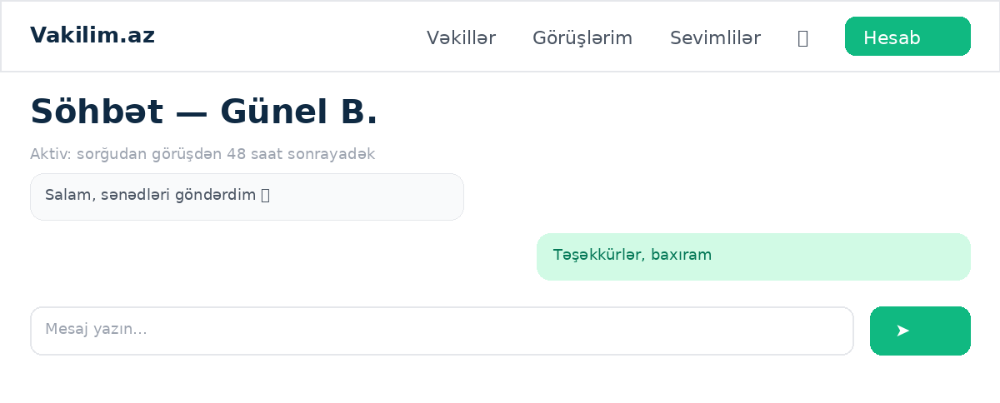
Logic & steps:
- Active from request until 48h after the meeting ends.
- Attachments proxied with auth via the attachments route.
- Silent moderation flags feed the admin queue.
Access: The booking's two participants.
Limitations: Rate-limited; closed threads read-only.

Video call — /{locale}/call/[bookingId]
Layout: LiveKit room UI: video tiles, mic/cam toggles, timer, consent-to-record banner, recording control per policy.
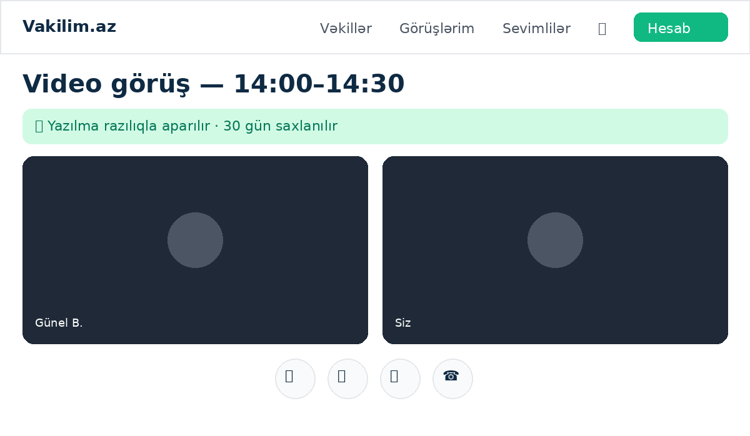
Logic & steps:
- Token from /api/bookings/[id]/call-token inside the join window (opens 10 min before start).
- Recording start via its route; files land in R2, playable to admin.
Access: Participants, CONFIRMED bookings, inside the window.
Limitations: Recordings retained 30 days; browser/network quality is the dominant failure mode.

Notifications — /{locale}/notifications
Layout: Reverse-chronological list; unread emphasis; each row deep-links to its subject.
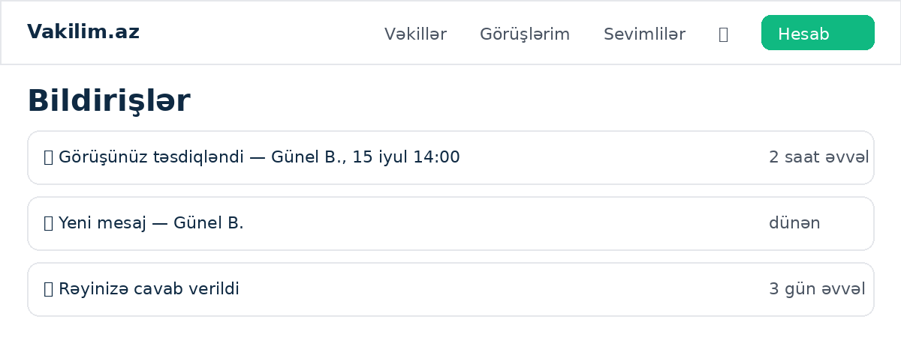
Logic & steps:
- Stored as type+params, rendered in the reader's language at view time; mirrored to email when Resend is configured.
Access: Login required.
Limitations: In-app list capped with pagination.

Lawyer area

Application — /{locale}/lawyer/apply
Layout: Multi-section form: personal, type (ADVOKAT/HÜQUQŞÜNAS), license number, experience, city, per-locale bios, practice areas, photo upload, license + ID document uploads.
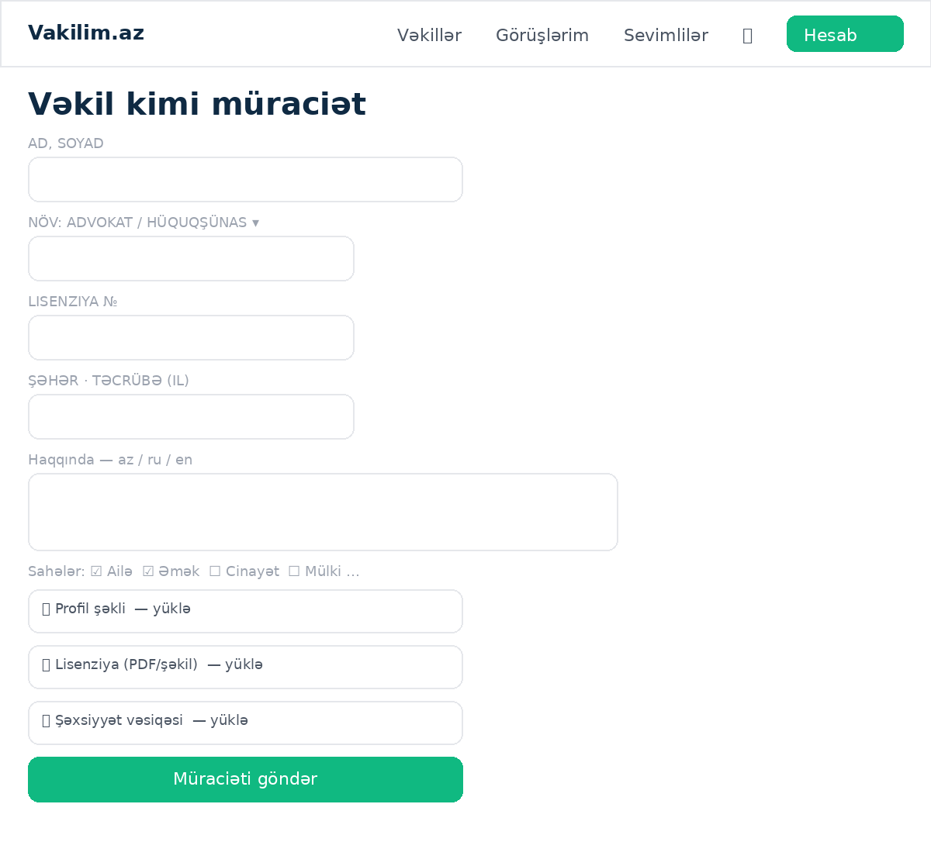
Logic & steps:
- Documents and photo go to R2 via presigned uploads.
- Submission creates a PENDING profile; user keeps client abilities meanwhile.
- Phone comes from the (verified) account.
Access: Login required; AZ phone numbers by design for lawyers.
Limitations: Rate-limited 3 applications / hour; re-apply allowed after rejection.

Dashboard — /{locale}/lawyer/dashboard
Layout: Status banners (pending / rejected with reason / approved); when approved: three stat tiles — meetings this month, net earnings this month, live rating — plus Details link and action cards to every lawyer tool.
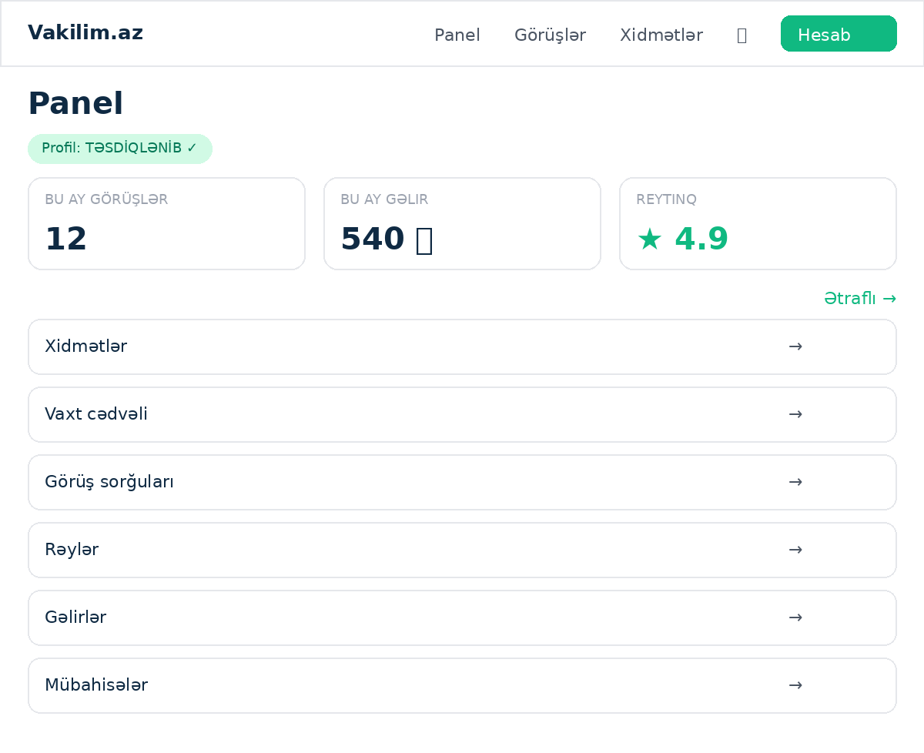
Logic & steps:
- Baku-month boundaries via UTC+4 arithmetic.
- Net = gross of COMPLETED bookings minus resolved-dispute refunds.
- Rating aggregates visible reviews with the same filter as the public directory.
Access: Lawyer (any status).
Limitations: Tiles hidden until APPROVED.

Services — /{locale}/lawyer/services
Layout: List + editor: type (VIDEO/WRITTEN), title per locale, duration, price, active toggle.
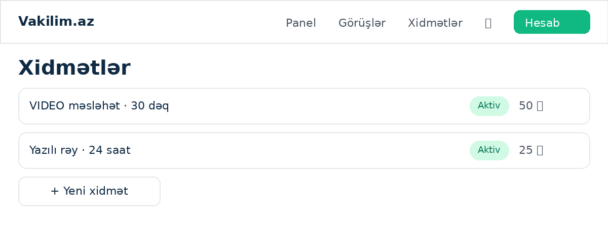
Logic & steps:
- CRUD via /api/lawyer/services[/id]; price stored in qəpik.
Access: APPROVED lawyer.
Limitations: Deactivating hides from booking but preserves history.

Availability — /{locale}/lawyer/availability
Layout: Weekly rule editor (day, start–end), buffer minutes, exceptions.
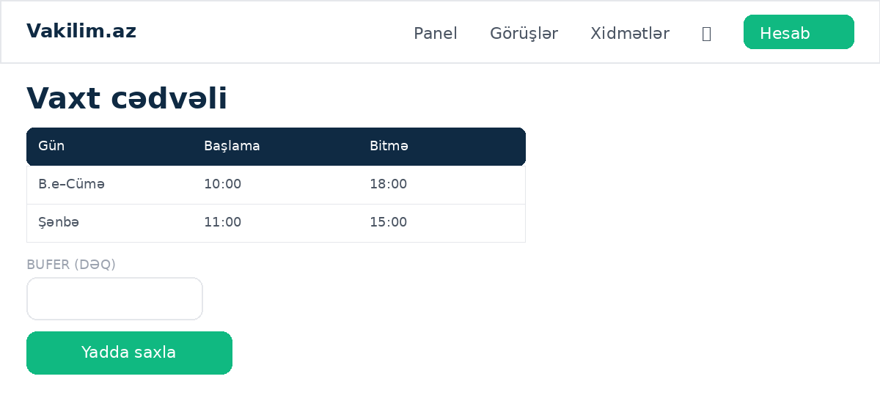
Logic & steps:
- Rules feed the slot engine; buffer applied between meetings; busy times subtract existing bookings.
Access: APPROVED lawyer.
Limitations: Rolling booking horizon; timezone fixed to Asia/Baku.

Requests & schedule — /{locale}/lawyer/bookings
Layout: Incoming REQUESTED cards with accept/decline, upcoming CONFIRMED with join/chat/add-to-calendar, history.
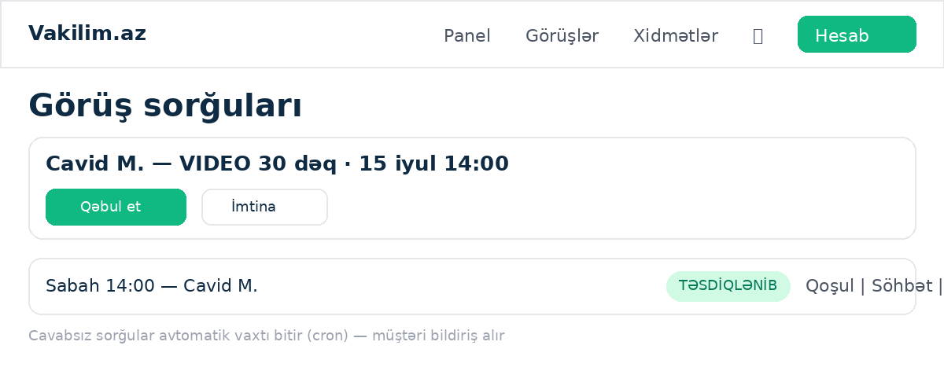
Logic & steps:
- Decision via /api/lawyer/bookings/[id]/decision; unanswered requests auto-expire via the cron tick with client notification.
Access: APPROVED lawyer.
Limitations: Expiry window enforced by jobs, not the page.

Reviews — /{locale}/lawyer/reviews
Layout: Received reviews with one-time reply box per review.
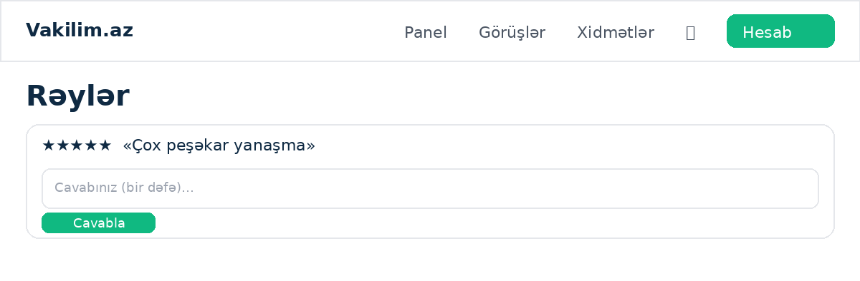
Logic & steps:
- Reply via /api/reviews/[id]/reply; single reply enforced.
Access: APPROVED lawyer.
Limitations: Hidden reviews excluded.

Earnings — /{locale}/lawyer/earnings
Layout: Six-month table (month · meetings · gross · refunds in red · net bold) + this-month meeting list (date · client first name · amount).
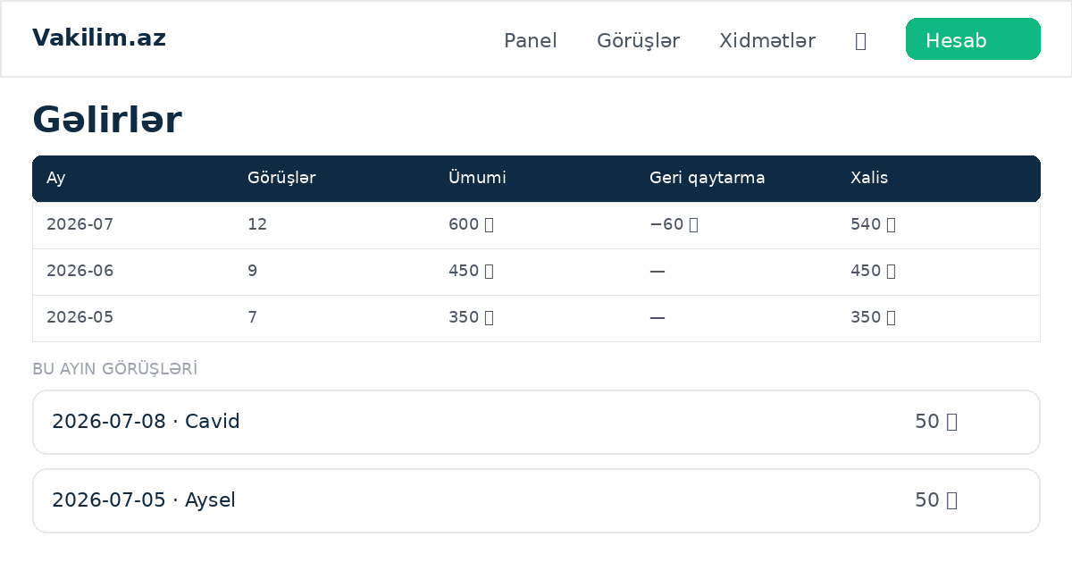
Logic & steps:
- Single window query bucketed into Baku months; dispute refunds mapped per booking.
Access: Lawyer with a profile.
Limitations: Months labeled YYYY-MM (locale-neutral).

Disputes — /{locale}/lawyer/disputes
Layout: Open disputes against the lawyer with the response form and deadline indicator.
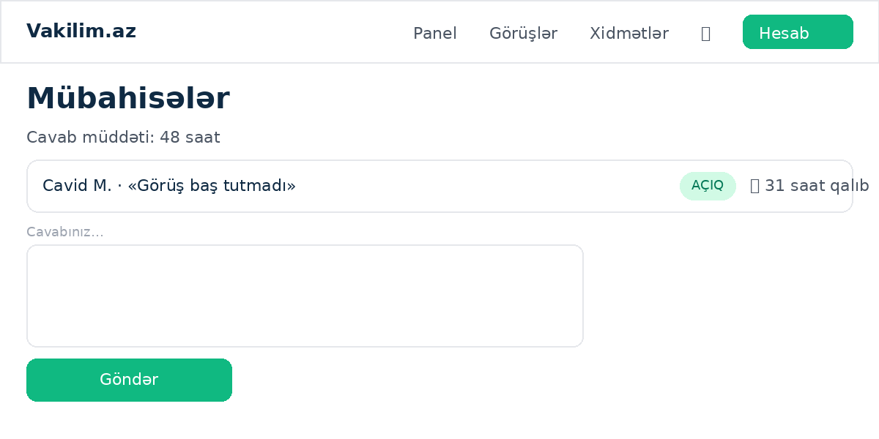
Logic & steps:
- Response via /api/lawyer/disputes/[id]/response inside the 48h window.
Access: APPROVED lawyer.
Limitations: Silence past deadline weighs against the lawyer at resolution.

Admin area

Verification queue — /{locale}/admin/verifications
Layout: Pending applications as cards: photo above name, all fields, license/ID document viewers (presigned), approve / reject-with-reason; decided list below.
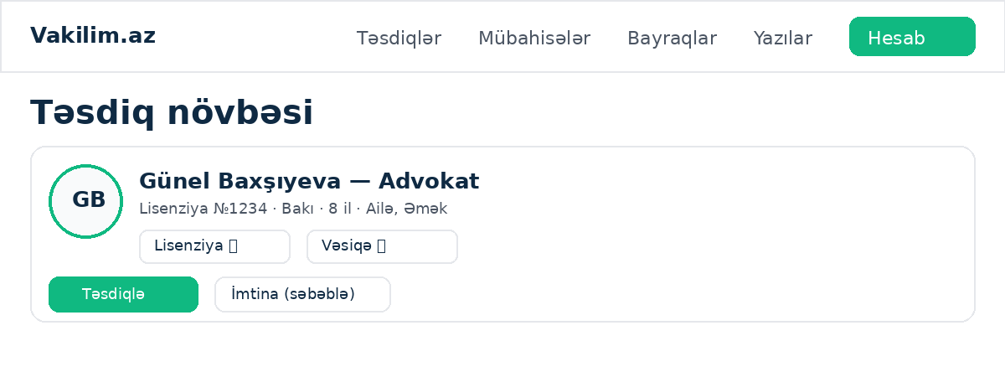
Logic & steps:
- Decision via /api/admin/verifications/[id]; approval publishes the profile and slugs it into the directory/sitemap.
Access: ADMIN.
Limitations: Documents stream through a presign redirect; links expire.

Dispute resolution — /{locale}/admin/disputes
Layout: Open disputes with both sides' statements, booking context, links to chat/recording, resolve form with refund amount (qəpik).
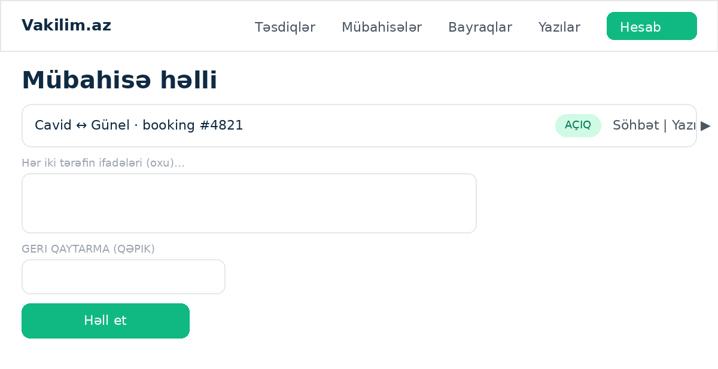
Logic & steps:
- Resolve via /api/admin/disputes/[id]/resolve; refund recorded and reflected in lawyer net earnings; both parties notified.
Access: ADMIN.
Limitations: Refunds are ledger entries until real payments exist.

Moderation flags — /{locale}/admin/flags
Layout: Silently-flagged chat messages queue with context and dismiss/act controls.
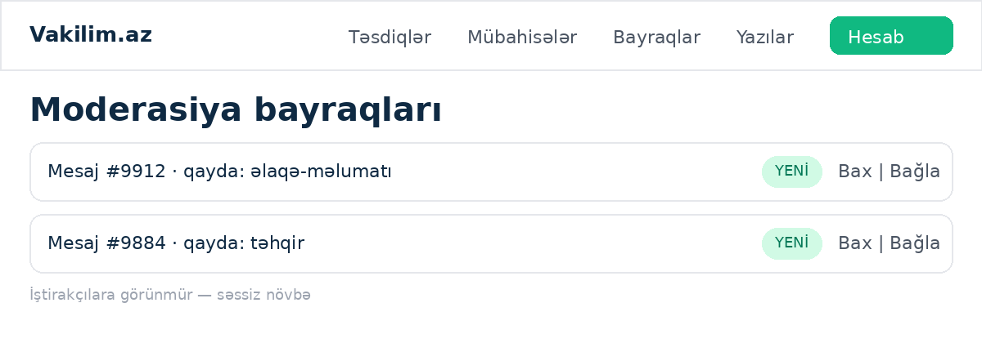
Logic & steps:
- Flags created automatically by content rules; admin action is manual.
Access: ADMIN.
Limitations: Deliberately invisible to participants.

Review moderation — /{locale}/admin/reviews
Layout: Recent reviews with hide/unhide toggles.
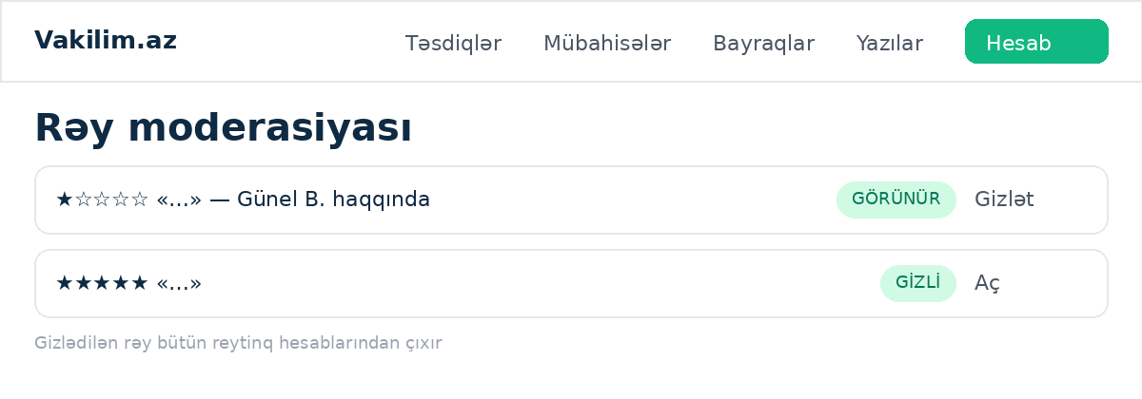
Logic & steps:
- Hide via /api/admin/reviews/[id]/hide; hidden reviews vanish from profiles, tiles and rating math everywhere.
Access: ADMIN.
Limitations: —

Recordings — /{locale}/admin/recordings
Layout: Per-booking recording list with in-browser playback via short-lived presigned URLs.
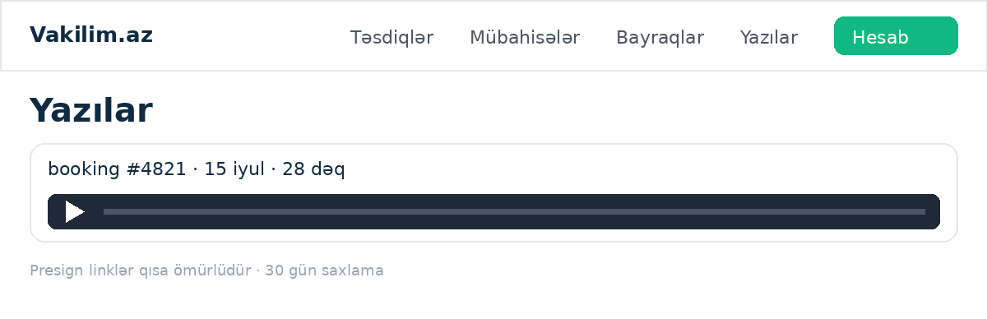
Logic & steps:
- Playback URL minted on demand; nothing public.
Access: ADMIN.
Limitations: 30-day retention; large files stream from R2.

Template authoring — /{locale}/admin/templates
Layout: Document template list with create/edit (fields schema, prices, editions) and active toggles.
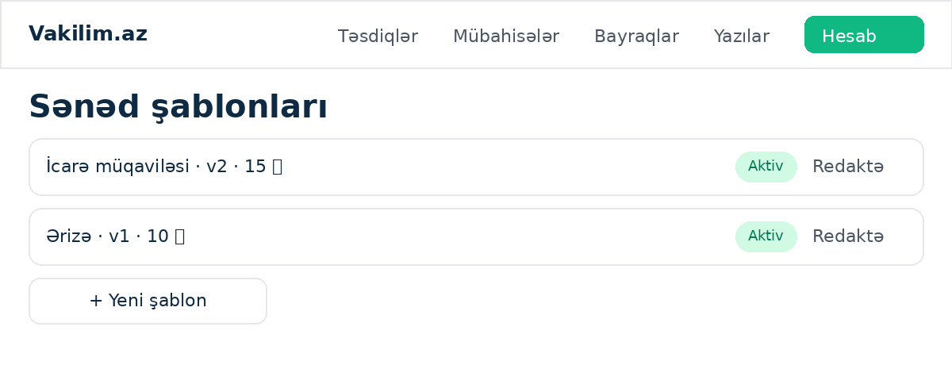
Logic & steps:
- CRUD via /api/admin/templates[; /toggle].
Access: ADMIN.
Limitations: Field-schema changes version the template.

5. API reference
All mutation routes validate with zod, return { ok, error? } JSON, and sit behind the rate limiter where noted.

Content & authorship
Endpoint | Input | Behavior | Guard
POST /api/lawyer/articles | slug, titles, excerpts, bodies, area? | APPROVED lawyers create an article as a draft (publishedAt null) awaiting admin acceptance; slug clash → 409. | 10/h
PATCH /api/lawyer/articles/[id] | partial fields | Edits an own, unpublished draft only; published articles are locked (NOT_EDITABLE). | 30/h
DELETE /api/lawyer/articles/[id] | — | Deletes an own, unpublished draft. | 30/h
POST /api/me/photo-file | multipart photo | Uploads an avatar (jpeg/png/webp ≤3MB) to R2, saves User.photoKey and mirrors it to the lawyer profile so the directory updates. | 10/10min
GET /api/me/photo-file | — | Redirects to a short-lived presigned URL for the caller's own avatar. | session
POST/PATCH /api/admin/posts · /qa · /laws | content fields | Admin authoring for blog/news posts, Q&A entries and law documents; publishing a lawyer's draft is what accepts it. | admin

Authentication
Endpoint | Input | Behavior | Guard
POST /api/auth/signup-start | — | Validates details, clash-checks email+phone, sends OTP to the phone. No user created. | 5/h per IP
POST /api/auth/signup-complete | — | Verifies the code, re-checks clashes, creates the user (phoneVerifiedAt set) and emails the verification link. | 10/h per IP
POST /api/auth/signup | — | Retired one-shot signup — returns 410 GONE. | —
GET /api/auth/verify-email | token, locale | Consumes the single-use token, stamps emailVerifiedAt, mints a session, redirects to /{locale}/. Failure → /login?verify=failed. | —
POST /api/auth/login | email, password, locale? | Uniform INVALID_CREDENTIALS; EMAIL_NOT_VERIFIED gate; on 2FA accounts returns twoFactor:true + masked phone and sends a code instead of a session. | 10/10min
POST /api/auth/login-2fa | email, password, code | Stateless second step: re-verifies the password, consumes the OTP, mints the session. | 10/10min
POST /api/auth/request-code | phone, locale | Sends a login OTP (WhatsApp transport, [OTP DEV] echo fallback). International numbers accepted. | throttled
POST /api/auth/verify | phone, code | Phone-door login: attempt caps, consume-once, upserts the user and stamps phoneVerifiedAt (self-healing), mints the session. | attempt cap 5
POST /api/auth/forgot | email, locale | Always returns ok (anti-enumeration); issues a 60-min reset token when applicable. | 5/h
POST /api/auth/reset | token, password | Consumes the token, rehashes, deletes all sessions (sign-out-everywhere). | 10/h
GET /api/auth/google | next? | Sets the anti-CSRF state cookie and redirects to Google (select_account). | —
GET /api/auth/google/callback | code, state | Exchanges the code, applies the linking law (known sub → sign-in; verified email → link; new → create pre-verified; logged-in → attach; claimed elsewhere → inuse). Phoneless users are redirected to /complete-phone. | —

Account (me)
Endpoint | Input | Behavior | Guard
PATCH /api/me | fullName, email… | Profile fields; phone deliberately not accepted here. | throttled
POST /api/me/password | current?, password | Set/rotate password; current required when one exists. | 10/10min
POST /api/me/phone | action start|confirm, phone, code? | Change/complete phone with OTP; clash-checked; stamps phoneVerifiedAt. | 8/10min
POST /api/me/2fa | action start|enable|disable | OTP-confirmed enable (also stamps phone verification); password-gated disable. | 10/10min
POST /api/me/locale | locale | Persists the interface language to the account (LocaleSync). | —

Directory & profiles
Endpoint | Input | Behavior | Guard
GET /api/lawyers/[slug]/slots | service, range | Free slots from rules + buffer minus busy bookings; Asia/Baku. | —
GET /api/avatars/[id] | — | Presign-redirect to the profile photo; 404 when absent or storage unconfigured. | cached 5 min
POST /api/favorites | lawyerProfileId | Toggle; CLIENT only; APPROVED profiles only. | —

Bookings & meetings
Endpoint | Input | Behavior | Guard
POST /api/bookings | lawyer, service, slot | Creates REQUESTED booking with price snapshot; double-book guarded by unique constraint. | —
POST /api/payments/mock | bookingId | Simulated payment; idempotent. | —
POST /api/lawyer/bookings/[id]/decision | accept|decline | Lawyer decision; notifications both ways. | —
POST /api/bookings/[id]/cancel | — | Tiered refund by notice window; both notified. | —
POST /api/bookings/[id]/reschedule | newSlot | Proposes/moves per policy; counterpart notified. | —
GET /api/bookings/[id]/calendar | — | ICS download for CONFIRMED bookings; event text in the requester's saved language; 409 otherwise. | participants only
GET /api/bookings/[id]/call-token | — | LiveKit token inside the join window only. | participants
POST /api/bookings/[id]/recording/start | — | Starts room recording to R2 per consent flow. | participants
GET/POST /api/bookings/[id]/messages | text/attachment | Chat thread within the messaging window. | 60/min
GET /api/bookings/[id]/attachments/[messageId] | — | Authenticated attachment proxy. | participants
POST /api/bookings/[id]/review | stars, tags, text | One review per completed booking inside the window. | 5/h
POST /api/reviews/[id]/reply | text | Lawyer's single reply. | throttled
POST /api/bookings/[id]/dispute | reason, text | Opens a dispute within 72h of completion. | 5/h
POST /api/lawyer/disputes/[id]/response | text | Lawyer statement inside the 48h window. | —

Documents
Endpoint | Input | Behavior | Guard
POST /api/doc-orders | template, answers | Creates an order from the fill wizard. | —
POST /api/doc-orders/[id]/pay | — | Mock payment; unlocks download + issues verification code. | owner
GET /api/doc-orders/[id]/download | — | Decrypts (AES-GCM at rest) and streams the locked PDF. | owner

Lawyer self-service
Endpoint | Input | Behavior | Guard
POST /api/lawyer/apply | profile + uploads | Creates/updates the PENDING application. | 3/h
CRUD /api/lawyer/services[/id] | service fields | Service management. | —
CRUD /api/lawyer/availability[/id] | rules, buffer | Weekly rules and buffer. | —
PATCH /api/lawyer/settings | profile fields | Lawyer-side profile settings. | throttled

Admin
Endpoint | Input | Behavior | Guard
POST /api/admin/verifications/[id] | approve|reject+reason | Publishes or rejects an application. | ADMIN
GET /api/admin/verification-docs/[profileId]/[kind] | — | Presigned license/ID document access. | ADMIN
POST /api/admin/disputes/[id]/resolve | outcome, refundQepik | Resolves with optional refund; feeds earnings math. | ADMIN
POST /api/admin/reviews/[id]/hide | hide|unhide | Moderation toggle affecting all rating math. | ADMIN
CRUD /api/admin/templates[…/toggle] | template schema | Document template authoring. | ADMIN

Platform
Endpoint | Input | Behavior | Guard
GET /api/jobs/tick | key | Cron heartbeat: reminders, request expiry, cleanups. Driven by cron-job.org. | keyed
POST /api/intake | text, locale | AI triage: area classification (DB-constrained), orientation summary, drafted first message, matching lawyers. | 5/10min per IP

6. Core mechanics

Lawyer authorship & acceptance
Approved lawyers write trilingual articles at /lawyer/articles; submissions land as drafts. The admin's existing publish button is the acceptance gate — lawyer submissions appear in the Yazılar queue wearing a 'Vəkil məqaləsi' badge. Accepted articles flow onto the blog, their practice-area landing, and the author's public profile. Published pieces lock for the author (edits go through the admin).

Avatar pipeline
One route (/api/me/photo-file) handles every role: multipart upload, type and size validation, R2 write under avatars/{userId}/{ts}, User.photoKey saved, and — for lawyers — mirrored onto LawyerProfile.photoKey so the directory and profile update instantly. Reads go through a presigned redirect. Without R2 credentials the route returns an honest 503.

Practice-area landings
Ten SEO-shaped URLs where the directory's own lawyer cards and next-available chips (harvested verbatim, not reimplemented) meet the area's Q&A entries and articles. The shared code path guarantees the chips can never drift from the directory's.

Security headers & CSP posture
next.config.ts serves nosniff, X-Frame-Options DENY, strict-origin-when-cross-origin referrer policy, and a Permissions-Policy that keeps camera/microphone on-origin (LiveKit needs them) while disabling geolocation and payment. A full CSP is planned report-only during beta, enforced after. The Sentry wrapper composes around the next-intl plugin without disturbing these.

Boot-time env validation
lib/env.ts zod-parses AUTH_SECRET and DATABASE_URL at import (pulled in by the root layout): a missing or malformed secret fails the build with a named error rather than a runtime mystery. Gated integrations stay deliberately optional.

Error monitoring
Sentry (@sentry/nextjs) captures unhandled client, server and edge exceptions with source-mapped stack traces; instrumentation hooks plus app/global-error.tsx. Initializes to a no-op without a DSN, so local development stays quiet.

Query bounds guard
scripts/query-bounds.mjs walks every findMany call and flags any lacking a take: unless annotated 'unbounded-ok'. It runs in report mode in the pre-delivery chain; the census classifies the remaining unbounded sites as naturally bounded (ownership-scoped or in-ids fetches).

Sessions & cookies
A 30-day random token lives in the vakilim_session cookie (httpOnly, sameSite=lax, secure in production, path=/); only its salted SHA-256 hash is stored (Session.tokenHash). Every login door — password, phone OTP, Google, 2FA — mints identically via createSession + sessionCookie. Password reset deletes all sessions.

Mandatory verified phone (L4)
An account cannot be born without answering an OTP: signup is two-phase and the retired one-shot endpoint returns 410. Google arrivals without a phone are walled at /complete-phone. Phone-OTP logins stamp phoneVerifiedAt (self-healing for legacy users). Changing a phone in settings re-verifies it and clash-checks other accounts.

Slot engine
Weekly rules + per-lawyer buffer generate candidate slots in Asia/Baku (fixed UTC+4 arithmetic); existing bookings subtract as busy; the same engine feeds the profile picker and the directory's next-available chips.

Booking lifecycle
REQUESTED → (mock) paid → lawyer accepts → CONFIRMED → COMPLETED, or CANCELLED with tiered refunds by notice window (full / partial / none per the published refund policy). Unanswered requests expire via the cron tick with notification. Reschedules propose a new slot to the counterpart.

Reviews & rating
One review per completed booking within a limited window; one lawyer reply; admin hide removes a review from profiles, tiles and every rating aggregate (single hidden:false filter shared by directory and dashboard).

Disputes & refunds
Client opens within 72h of completion; lawyer answers within 48h (auto-nudge); admin resolves with an optional refund in qəpik that is subtracted from the lawyer's net earnings.

Notifications
Stored as type + params and rendered in the reader's language at read time; mirrored to email when Resend is configured; throttled to avoid storms.

Video & recordings
LiveKit rooms; join window opens 10 minutes before start; consent precedes recording; files persist to R2 with 30-day retention and admin-only playback.

Document engine
Templates carry a typed field schema; the wizard validates and creates an order; mock payment unlocks an AES-GCM-encrypted, locked PDF carrying a public verification code checkable at /verify.

AI intake
The prompt embeds the live practice-area list as the only permitted answers; the parser validates the returned slug (unknown → other); lawyers always come from the database. Without an API key the route returns a deterministic [AI DEV] echo.

Internationalization
az / ru / en route prefixes; 892 parallel keys guarded by scripts/i18n-check.mjs; per-locale metadata, hreflang, sitemap (approved, slugged profiles only) and robots; the account remembers its language (LocaleSync).

Jobs & rate limiting
cron-job.org drives /api/jobs/tick (reminders, expiries). An in-memory limiter guards messages (60/min), reviews & disputes (5/h), applications (3/h), intake (5/10min) and every auth mutation.

7. Environment variables
Variable | Purpose | Status
AUTH_SECRET | Session/OTP hashing salt | required
DATABASE_URL | Neon Postgres | required
LIVEKIT_URL / _API_KEY / _API_SECRET | Video calls | required for calls
R2 / S3 credentials (lib/storage) | Documents, photos, recordings | required for uploads
RESEND_API_KEY | Transactional email | beta gate №1
OTP_DEV_ECHO | true → codes/links echoed on-screen ([DEV]) | beta mode switch
WHATSAPP_* (per README-whatsapp) | Real OTP delivery | beta gate №2 for strangers
GOOGLE_CLIENT_ID / _SECRET / NEXT_PUBLIC_GOOGLE_LOGIN | Google sign-in | 5-min Console setup
NEXT_PUBLIC_APPLE_LOGIN (+ future APPLE_*) | Apple button (route pending $99 program) | dormant
ANTHROPIC_API_KEY / ANTHROPIC_MODEL | AI intake brain | optional (echo fallback)
JOBS_KEY (tick ?key) | Cron authentication | required
NEXT_PUBLIC_GAـID (GA4) | Analytics | optional
SENTRY_DSN / SENTRY_AUTH_TOKEN | Error monitoring + source-map upload | ✅ wired (wizard)
NEXT_PUBLIC_SUPPORT_EMAIL (const today) | Contact page address | confirm value

8. Known limitations & honest gaps
- Payments are simulated end-to-end (bookings and documents); Epoint integration is one sprint away on the bank's approval. Refunds are ledger entries until then.
- Phone verification is cryptographically real only when WhatsApp delivery is live; with OTP_DEV_ECHO=true the code is shown on the requesting screen, so ownership is not proven (disclosed beta mode).
- Email delivery requires the Resend key; without it verification/reset links exist only as on-screen [DEV] links.
- Legal page bodies are AZ-only drafts (LAYİHƏ) pending professional review; RU/EN legal translations parked.
- Testing remains the weakest category: 56 unit tests cover pure logic, but there is no integration/E2E net — a Playwright smoke suite is the first post-beta sprint.
- Document catalog ships with 30 seeded templates (10 families × az/ru/en); bodies share one field-schema mold pending per-template legal drafting.
- Legal calculators (rüsum, müddət) ship noindex with LAYİHƏ banners: the fee brackets and appeal periods are unverified drafts awaiting an e-qanun.az check. Verification flips indexing on in two lines.
- Laws library seeded with one real code text (Əmək Məcəlləsi) plus two source-linked entries; full texts await upload through the admin editor.
- Demo content (50 lawyers, 21 posts, 20 clients) is seeded fiction with ASCII-transliterated AZ titles in the seed script; it exists to be replaced by real content.
- Apple sign-in: button ships dormant; routes await Apple Developer Program credentials (ES256 client-secret flow).
- Russian dictionary awaits a native-speaker review pass (machine-consistent today).
- Rate limiter is in-memory per serverless instance — adequate at beta scale, not a hard global guarantee.
- Recordings retained 30 days; no user-facing playback (admin only, by design).
- Vercel Hobby plan limits apply (bandwidth/function duration); fine at beta scale.
- Admin actions are trusted-operator tools: minimal confirmation friction by design.

9. Test accounts (development)
Phone | Role | Notes
+994 50 123 45 67 | CLIENT | primary client walkthroughs
+994 55 987 65 43 | LAWYER (approved) | Günel Baxşıyeva — VIDEO 30 min / 50 ₼, WRITTEN 25 ₼; Ailə + Əmək areas
+994 70 111 22 33 | ADMIN | all admin queues
+994 51 222 33 44 | LAWYER #2 | secondary lawyer
+994 55 111 22 33 | CLIENT | application-flow tests

10. Progress status
Sprint | Scope | Status | %
S1–S14 | Marketplace core (auth, apply/verify, directory, services, slots, bookings, reviews, notifications, video, chat, disputes, documents, jobs, legal drafts) | ✅ deployed | 100 (payments mock)
A1–A4 | Internationalization: routing, 685-key dictionaries, per-reader notifications, SEO/hreflang/sitemap | ✅ deployed | 100
— | Domain vakilim.az (Vercel NS, HTTPS) | ✅ live | 100
F1 | Hardening: pagination, error UX, rate limits, i18n guard, robots/sitemap | ✅ deployed | 100
W1 | WhatsApp OTP transport + trilingual templates | ✅ code / 🔄 Meta verification | 95 / delivery 0
U1–U2 | Aydın design system sitewide + lawyer photo pipeline | ✅ deployed | 100
N1 | Next-available chips on directory | ✅ deployed | 100
V1 | Client favorites (hearts + Sevimlilər) | ✅ deployed | 100
C1 | ICS calendar export (per-locale) | ✅ deployed | 100
E1 | Dashboard stat tiles + six-month earnings ledger | ✅ deployed | 100
AI-1 | Claude-powered intake assistant (echo fallback) | ✅ deployed | 100
L1 | Email+password auth, two of email verification, reset, intl phone, settings security panel | ✅ deployed | 100
L2 | Google sign-in with linking law + Console README | ✅ deployed (env-gated) | 100
L3 | Two-factor login + Apple-ready buttons | ✅ deployed | 100
L4 | Mandatory verified phone at every door | ✅ deployed | 100
Ops | Beta runbook v2 (gates, smoke test, incident playbooks) | ✅ delivered | 100
Ext | Resend key · Sentry · Google Console · housekeeping trio | 🔄 your keys (~25 min total) | —
Ext | Meta business verification (real OTP delivery) | 🔄 in progress (your side) | —
Ext | Epoint payments | 🔄 bank talks (1 sprint on yes) | —
Ext | Apple Developer Program | 🔄 on your word ($99 + 1 sprint) | —
Parked | Lawyer recruitment · legal translations · catalog content · promo codes | ⏸️ by directive | —
B1 | Blog & news platform (Post model, lite-markdown, trilingual) | ✅ deployed | 100
AP1 | Admin panel (sidebar layout, registries, forced admin 2FA) | ✅ deployed | 100
QL1 | Q&A + Laws library (FAQPage JSON-LD, TOC extraction) | ✅ deployed | 100
D1–D2 | Header/signup role cards + navigation polish | ✅ deployed | 100
AL1 | Practice-area landing pages (SEO multiplier; chips harvested from the directory) | ✅ deployed | 100
T1 | Trust trio — Haqqımızda · Necə işləyir · Əlaqə | ✅ deployed | 100
K1 | Legal calculators (rüsum, müddət) — draft-gated, noindex | ✅ deployed | figures unverified
S1 | Hardening pass: security headers, 18 rate limits, locale-pick refactor (as-never 31→12), aria + skip link, OG metadata, env boot guard, query-bounds script | ✅ deployed | 100
PL1 | Lawyer articles with admin acceptance · photo upload (all roles) · H1 alignment sweep · services min-bug fix | ✅ deployed | 100
Seed | Demo world: 50 lawyers, 30 templates, 21 posts, 3 laws, 20 clients, deterministic + self-reporting | ✅ run | 100
Sentry | Error monitoring wired via wizard (DSN gated) | ✅ deployed | 100
Ext | Resend account ready — sendMail() send-path still unbuilt | 🔄 code sprint pending | —
Σ | Overall readiness | code ≈ 97% · launch ≈ 88% | —
Weighted overall: the codebase stands at ≈97% of the real-money launch target; remaining distance is owned almost entirely by external keys (Resend, Meta, Google Console, Epoint, Apple) and the deliberately parked drawer.

