
(An Autonomous Institution, Affiliated to Anna University, Chennai)
MINI PROJECT
IPL CRICKET PERFORMANCE ANALYTICS USING PYTHON, POWER BI, AND TABLEAU
Framework for Data Visual Analytics

DIVAKAR M

241501050
ABSTRACT

This mini project, carried out for the subject Framework of Data Visual Analytics (FDVA),
analyzes Indian Premier League (IPL) cricket match data using Python, Microsoft Power BI
and Tableau. The matches dataset contains 1,095 records and 20 columns, including season,
teams, venue, toss decision, match winner, player of the match and match result. A ball-by-ball
deliveries dataset containing 260,920 records is also used for innings-level analysis. Python
with Pandas is used to inspect and prepare the data, while Matplotlib is used to create eight
visualizations, including team-wise wins, matches by season, toss decisions, player awards and
innings-run distribution. Interactive dashboards are developed in Power BI and Tableau to
summarize match statistics and compare team performance. The analysis shows that Mumbai
Indians have the highest recorded wins in the matches dataset, Eden Gardens has the highest
recorded match count among venues, and the team winning the toss also won approximately
50.8% of matches where both winner fields are available. The project demonstrates how data
visualization can make cricket statistics easier to understand and compare.

1. Data Preprocessing
The project uses matches(1).csv with 1,095 rows and 20 columns, and deliveries.csv with 260,920 ball-by-ball records. Python and Pandas are used to inspect the datasets before visualization.

Loading and inspecting the data

matches = pd.read_csv("matches(1).csv")
matches.shape, deliveries.shape
The matches dataset contains match-level details, while the deliveries dataset contains ball-by-ball information such as innings and runs.

Missing values and duplicates

print(matches.isnull().sum())
print("Duplicate rows:", matches.duplicated().sum())
Missing values occur in fields such as city, player_of_match, winner, result_margin and method. Missing values are retained where they represent unavailable match information.

Checking data types

matches["date"] = pd.to_datetime(
matches["date"],
errors='coerce')
matches["season"] = matches["season"].astype(str)
print(matches.dtypes)
# Inspect columns before visualization
The date column is converted to datetime format, and season is treated as a category for grouping. Team and venue names are kept as recorded in the dataset.

Preparing innings-level data

innings = deliveries.groupby(["match_id", "inning"])["total_runs"]
.sum()
.reset_index()
innings.rename(columns={'total_runs': 'innings_runs'}, inplace=True)
The deliveries dataset is grouped by match and innings to calculate total runs per innings. This prepared data is used for the innings-run distribution chart.
Data inspection helps identify missing values, field types and available categories before creating the visualizations.

Creating the innings summary

innings = deliveries.groupby(["match_id", "inning"])["total_runs"].sum()
.reset_index()
# Each row represents one match innings
innings.rename(columns={"total_runs": "innings_runs"}, inplace=True)
print(innings.head())
The innings summary provides one total-run value for each match innings and supports score distribution analysis.

Saving the prepared data

matches.to_csv("IPL_Matches_Inspected.csv", index=False)
innings.to_csv("IPL_Innings_Summary.csv", index=False)
print("Matches:", matches.shape, "Innings:", innings.shape)
The original datasets are retained, and the innings summary is created for visualization. No match outcomes are invented or filled in.

2. Data Visualization Using Python
Eight charts were created from the IPL datasets using Pandas and Matplotlib. Each chart is shown with a figure caption and a short result.
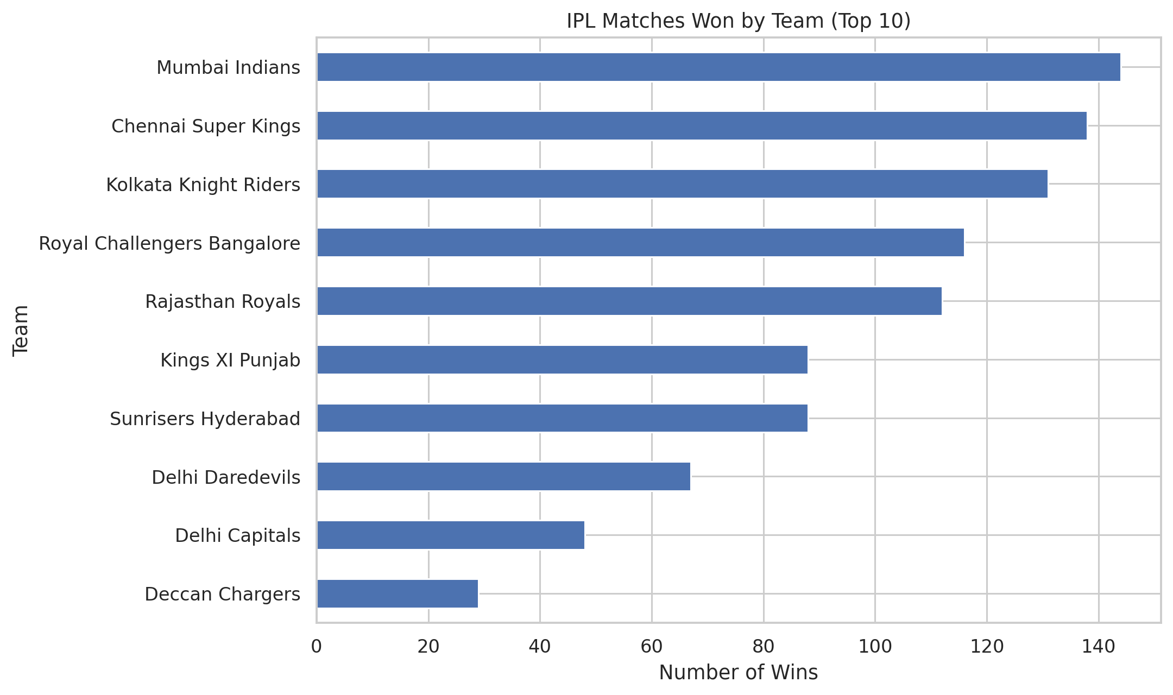
Figure 2.1: Matches won by team (horizontal bar chart)
Result: Mumbai Indians recorded the highest number of wins (144), followed by Chennai Super Kings (138) and Kolkata Knight Riders (131).
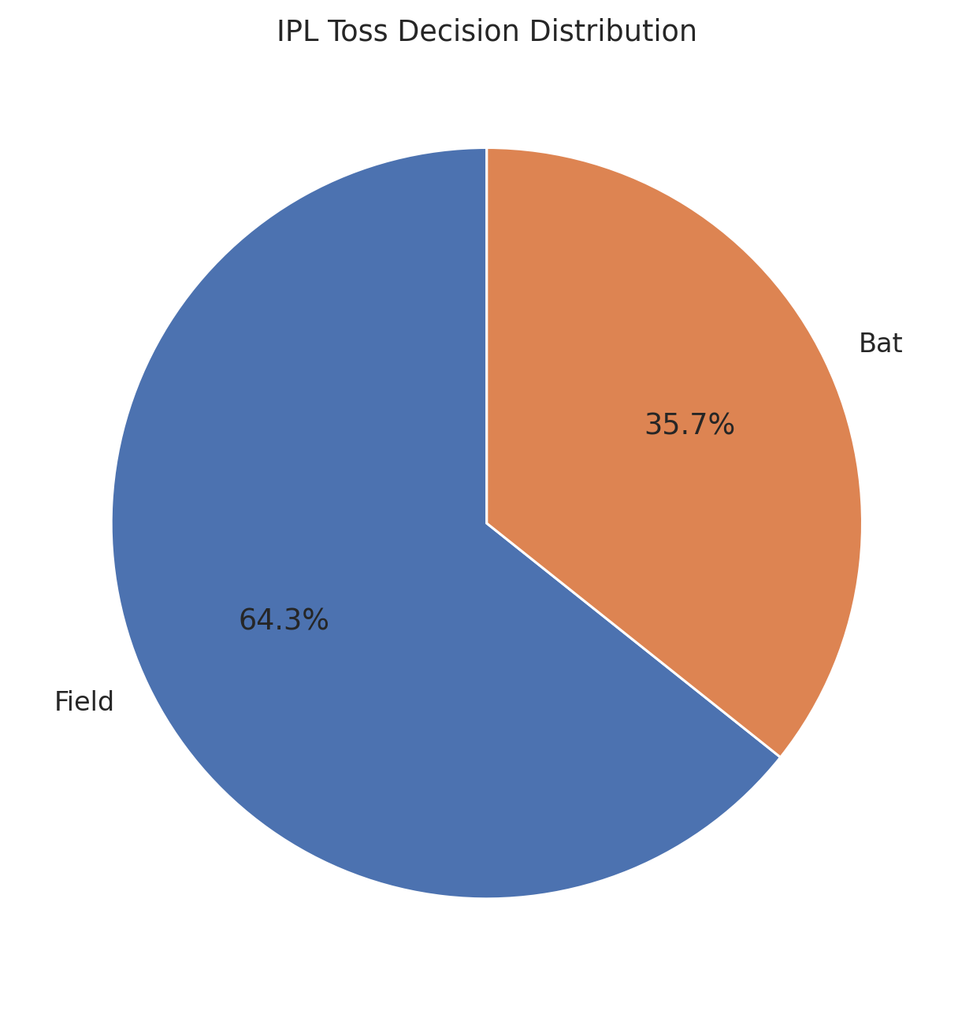
Figure 2.2: Toss decision distribution (pie chart)
Result: Fielding was selected 704 times, while batting was selected 391 times in the matches dataset.
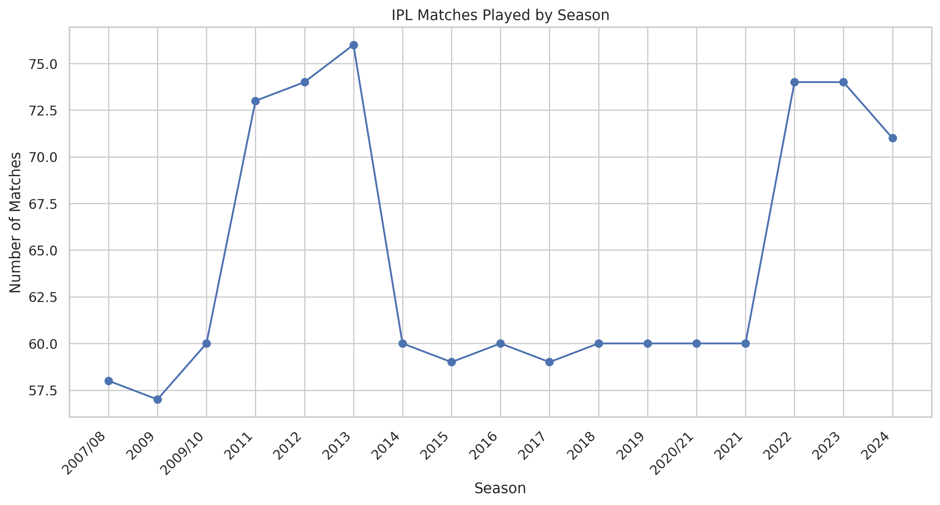
Figure 2.3: Matches by season (line chart)
Result: The 2013 season has the highest match count (76); the 2022 and 2012 seasons each contain 74 matches.
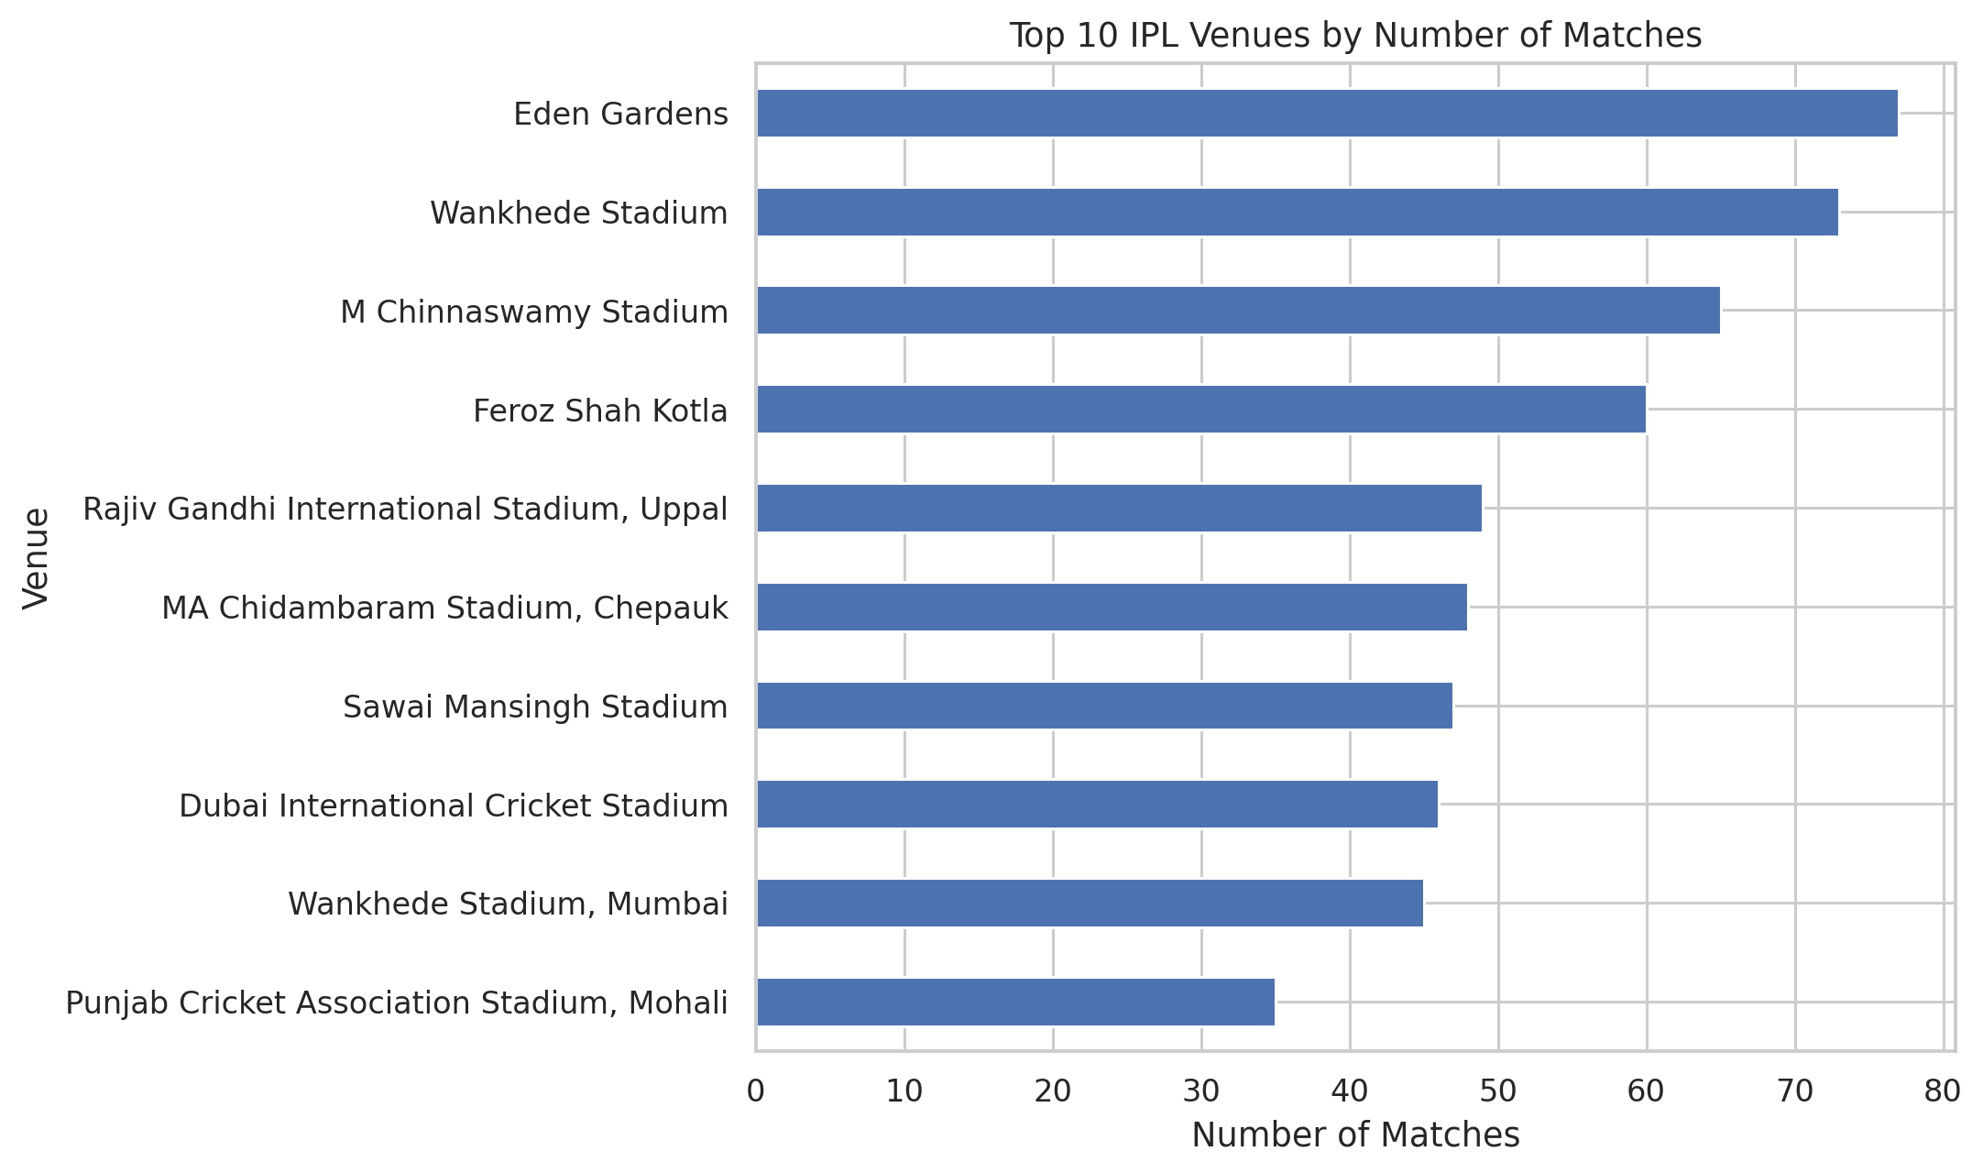
Figure 2.4: Top venues by match count (bar chart)
Result: Eden Gardens recorded 77 matches, followed by Wankhede Stadium with 73 and M Chinnaswamy Stadium with 65.
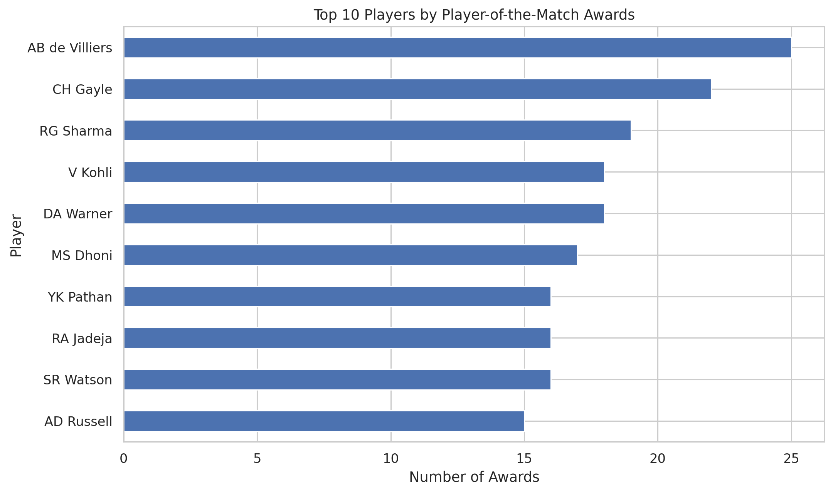
Figure 2.5: Player of the Match awards (bar chart)
Result: AB de Villiers has the highest recorded award count (25), followed by CH Gayle (22) and RG Sharma (19).
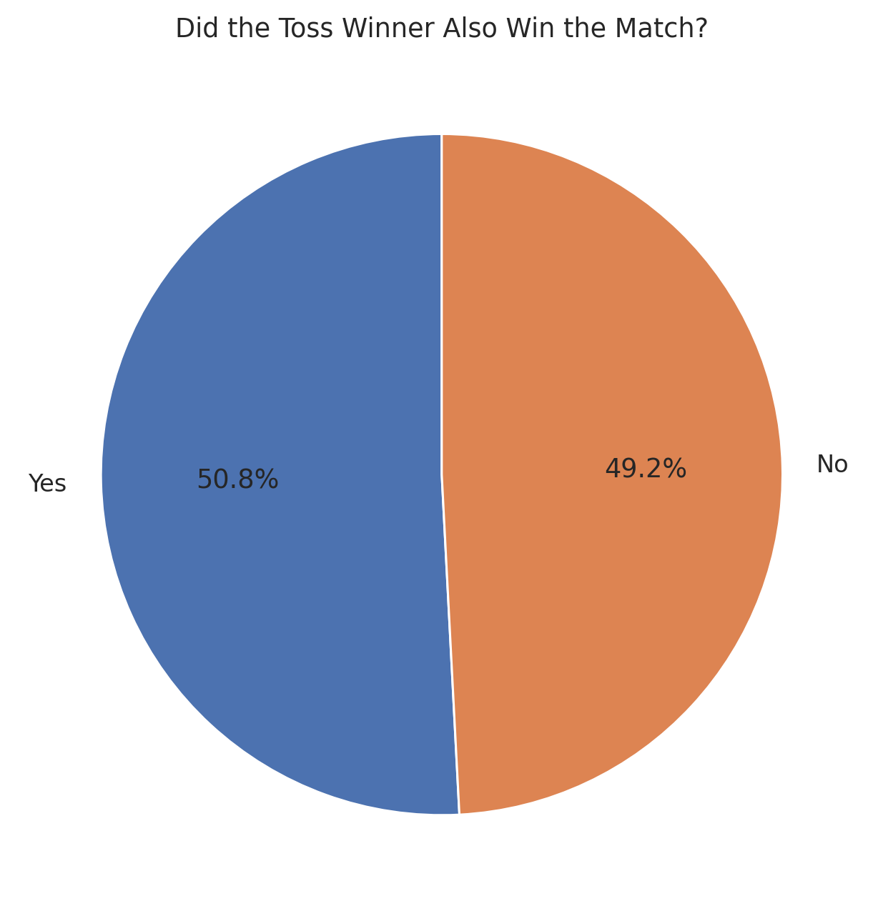
Figure 2.6: Toss winner versus match winner (bar chart)
Result: Among 1,090 records with both winner fields available, the toss-winning team also won 554 matches, approximately 50.8%.
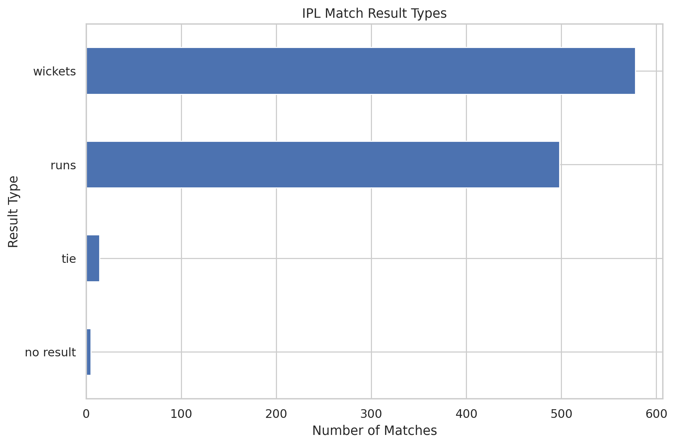
Figure 2.7: Match result types (bar chart)
Result: The dataset contains 578 wins by wickets, 498 wins by runs, 14 ties and 5 no-result matches.
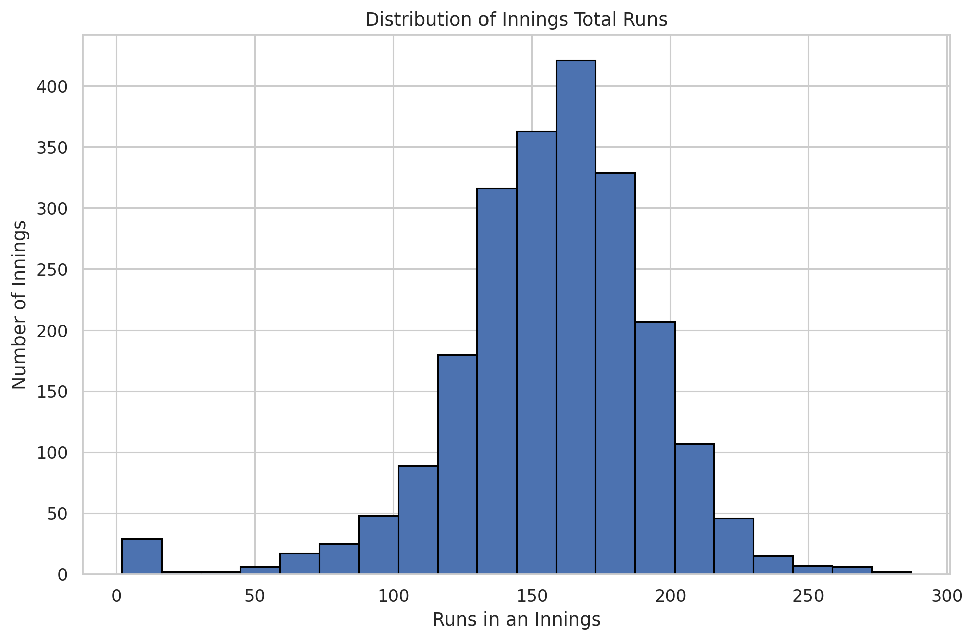
Figure 2.8: Innings runs distribution (histogram)
Result: The innings summary contains 2,217 match-innings records, with an average of approximately 156.9 runs and a median of 160 runs.
Overall, the charts compare team performance, season-wise match counts, toss decisions, venue usage, player awards, match results and innings scoring patterns.

3. Power BI Dashboard
Power BI was used to build interactive dashboards from the IPL matches dataset.
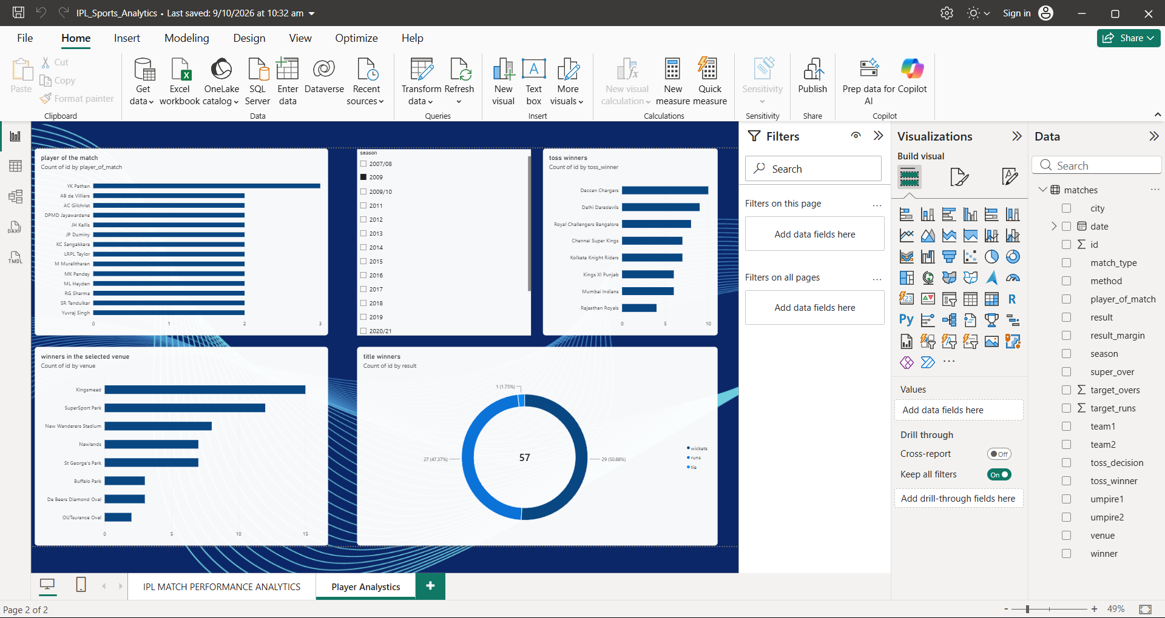
Figure 3.1: IPL Match Performance Analytics dashboard in Power BI
- Slicers: Season and other category filters can be used to explore the match records, depending on the filters configured in the report.
- KPI cards: Total match records – 1,095; distinct team names across both team columns – 19; distinct seasons – 17.
- Charts: matches by season, matches won by team, toss decision distribution, top Player of the Match awards and top venues.
- Insights: Mumbai Indians have the highest recorded wins; Eden Gardens has the highest venue match count; fielding is the more frequent toss decision.
- Note: Use the values displayed by the final Power BI dashboard when adding any additional numerical findings.

4. Tableau Dashboard
Tableau was used to create the “IPL Sports Analytics Dashboard” using the IPL matches dataset.
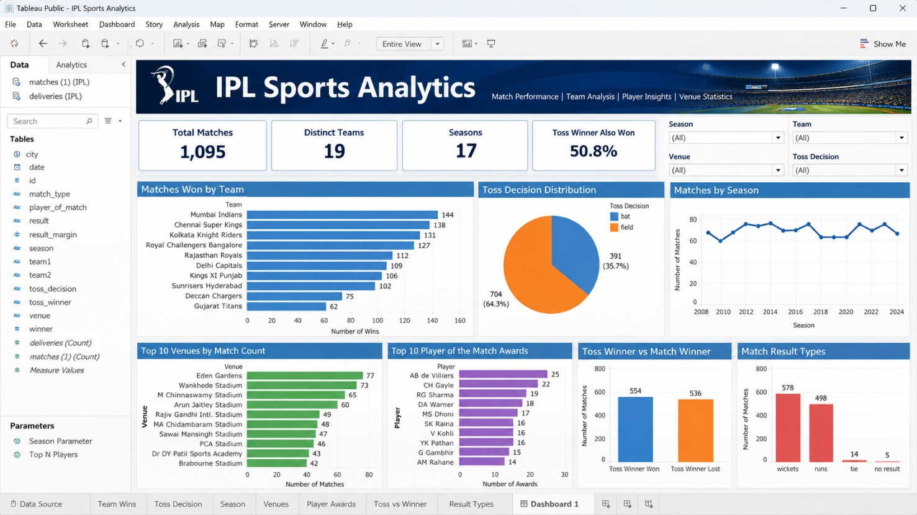
Figure 4.1: IPL Sports Analytics Dashboard in Tableau (layout preview)
- Filters: Season, team, venue and toss decision can be added as interactive filters to explore different match categories.
- KPIs: Total Matches 1,095; Teams 19 distinct recorded team names; Seasons 17; Toss Winner Also Won Match approximately 50.8% among records with both winner fields available.
- Charts: matches won by team, matches by season, toss decision distribution, Player of the Match awards, top venues and toss winner versus match winner.
- Insights: Mumbai Indians recorded 144 wins; AB de Villiers received 25 Player of the Match awards; Eden Gardens recorded 77 matches. Replace this layout preview with a screenshot of the completed Tableau dashboard before submission.

