Week 3 – 1:

--Coding-C-Language Features-Optional.

ROLL NO.:241501050

Name: DIVAKAR M

Q1) Write a program to read two integer values and print true if both the numbers end with

the same digit, otherwise print false.

Example: If 698 and 768 are given, program should print true as they both end with 8.

Sample Input 1

25 53

Sample Output 1

false

Sample Input 2

27 77

Sample Output 2

true

Code:

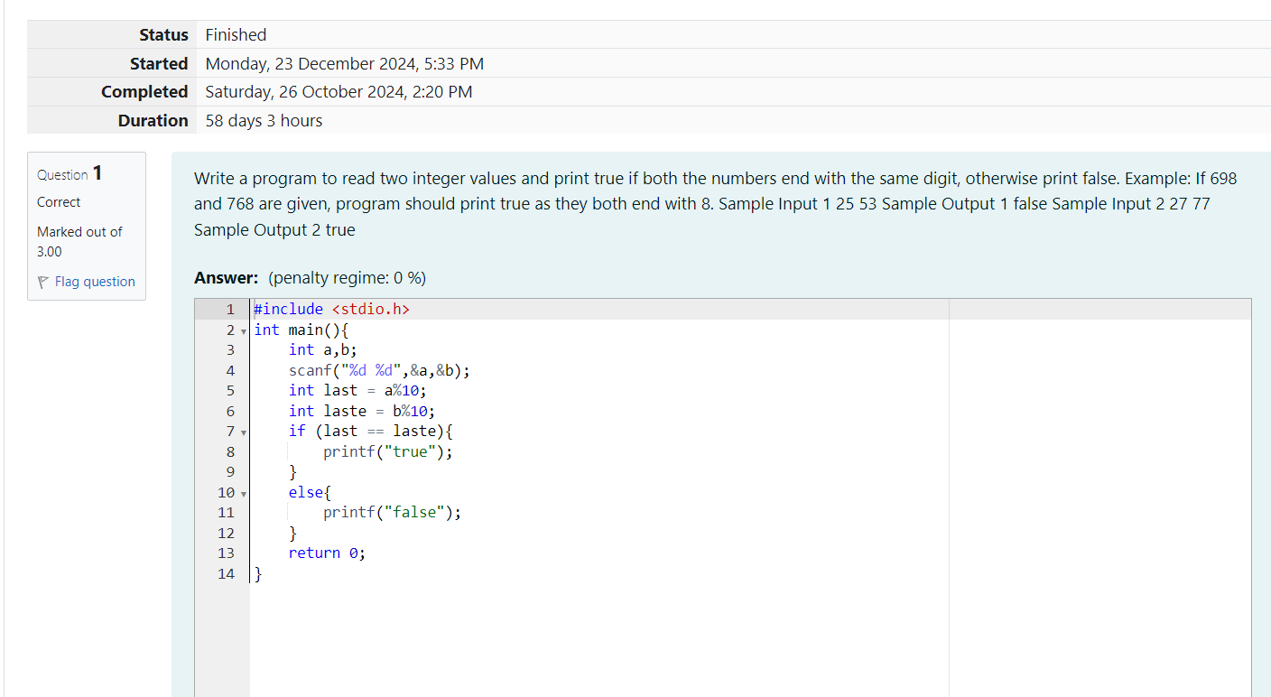

OUTPUT:

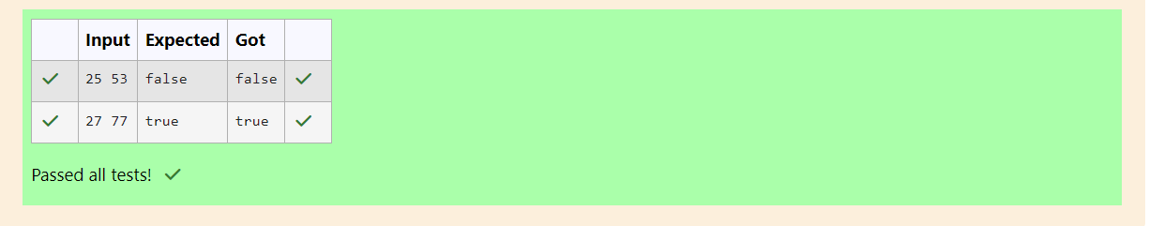

Q2) In this challenge, we're getting started with conditional statements.

Task

Given an integer, n, perform the following conditional actions:

• If n is odd, print Weird

• If n is even and in the inclusive range of 2 to 5, print Not Weird

• If n is even and in the inclusive range of 6 to 20, print Weird

• If n is even and greater than 20, print Not Weird

Complete the stub code provided in your editor to print whether or not n is weird.

Input Format

A single line containing a positive integer, n.

Constraints

• 1 < n < 100

Output Format

Print Weird if the number is weird; otherwise, print Not Weird.

Sample Input 0

3

Sample Output 0

Weird

Code:

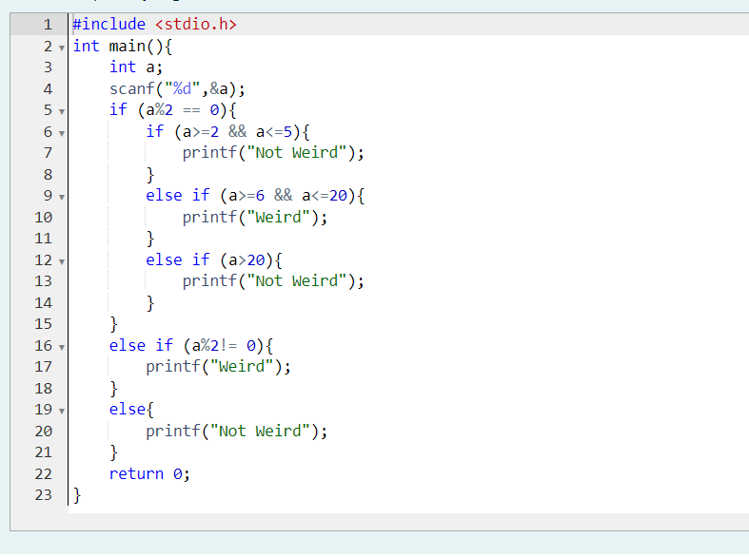

OUTPUT:

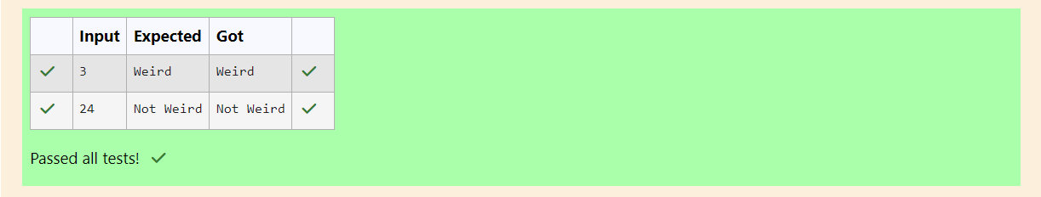

Q3) Three numbers form a Pythagorean triple if the sum of squares of two numbers is equal to

the square of the third.

For example, 3, 5 and 4 form a Pythagorean triple, since 3\*3 + 4\*4 = 25 = 5\*5

You are given three integers, a, b, and c. They need not be given in increasing order. If

they form a Pythagorean triple, then print "yes", otherwise, print "no". Please note that the

output message is in small letters.

Sample Input 1

3

5

4

Sample Output 1

Yes

Code:

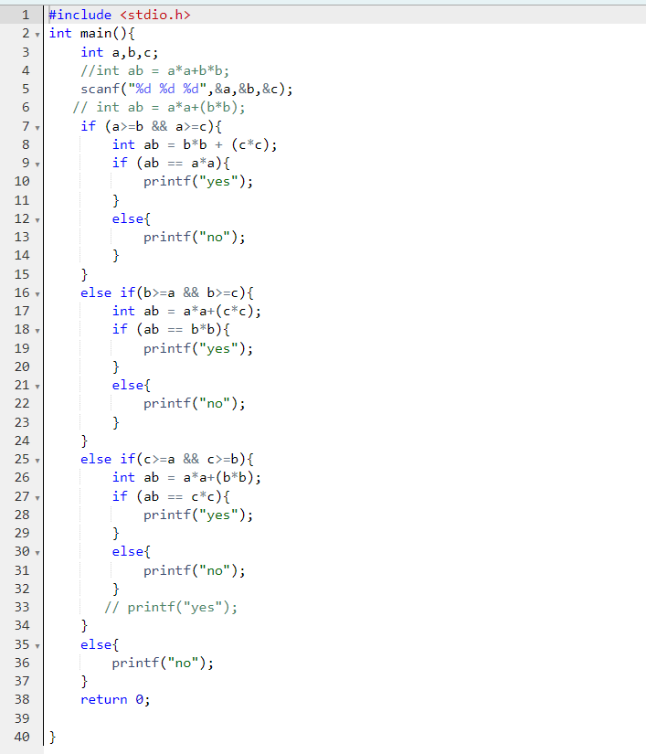

OUTPUT:

