**SQL Assignment**

**Assignment- 1:-**

1. Created the database and using the database.

1. Created 4 tables: gold_member_users, users, sales, and product under the sql_assignment1 database.

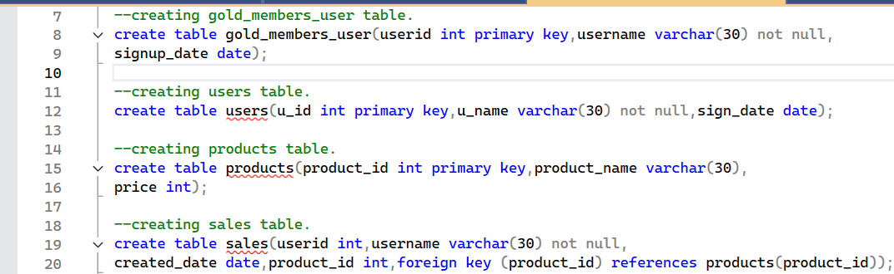

1. Inserted the provided values into all 4 tables with correct datatypes.

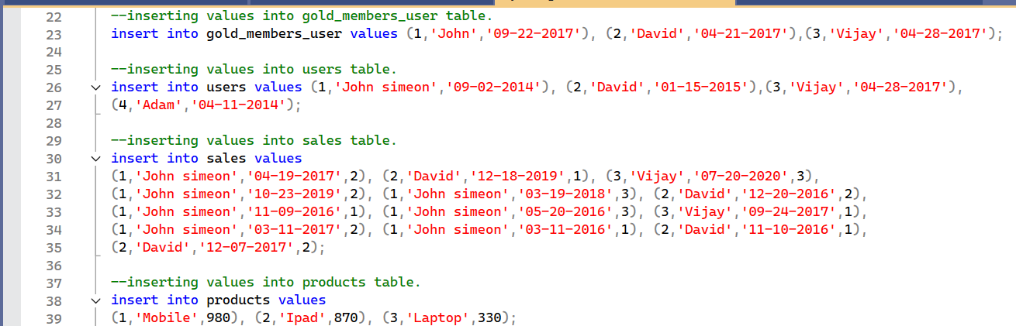

1. Displayed all tables present in the sql_assignment1 database.

1. Counted all records from all four tables using a single query.

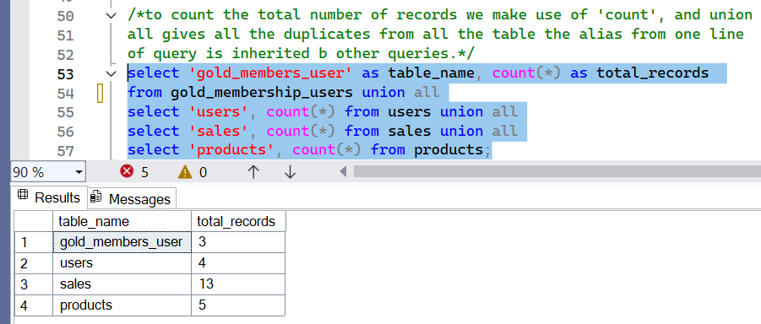

1. Retrieved the total amount each customer spent on the ecommerce platform.

1. Fetched distinct dates each customer visited the website with customer names.

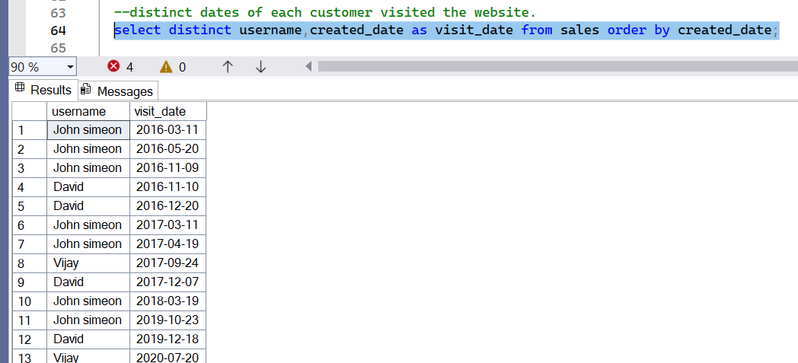

1. Identified the first product purchased by each customer using users, sales, and product tables.

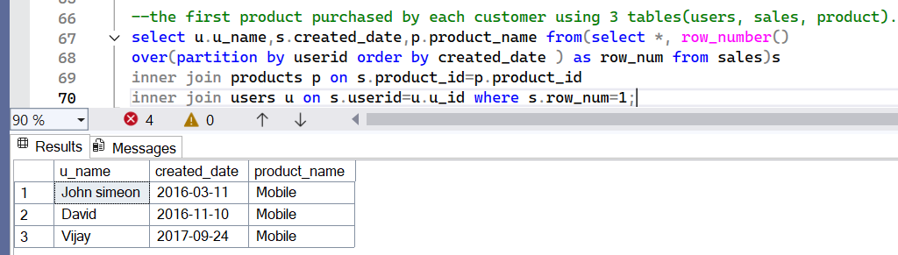

1. Found the most purchased item of each customer and how many times it was bought.

1. Retrieved customers who are not gold members.

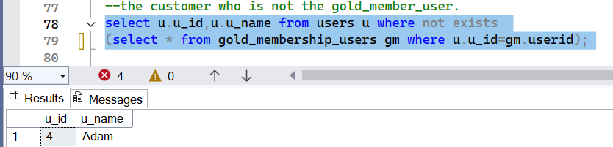

1. Calculated the amount spent by each customer while being a gold member.

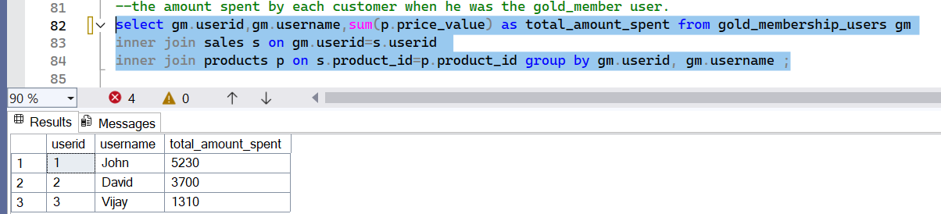

1. Listed customer names that start with the letter A.

1. Displayed distinct customer IDs.

1. Renamed the column price to price_value in the product table.

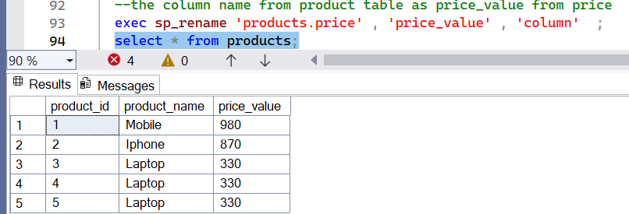

1. Updated the value of product_name from *Ipad* to *Iphone* in the product table.

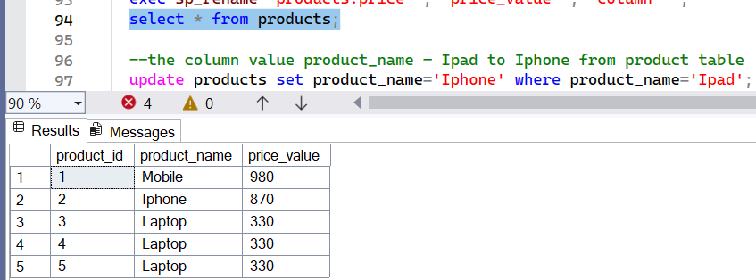

1. Renamed the table gold_member_users to gold_membership_users.

1. Added a new column Status to the gold_membership_users table with values Yes or No based on gold membership.

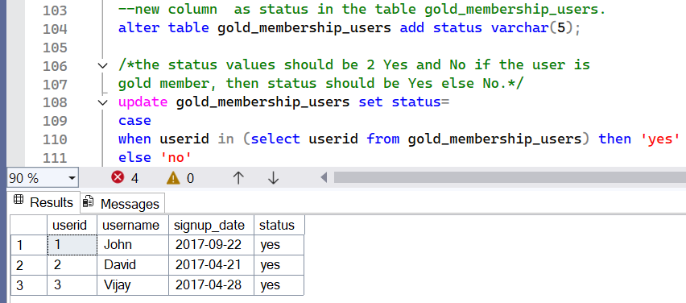

1. Deleted users with user_ids 1 and 2 from the users table and successfully rolled back the changes after deletion.

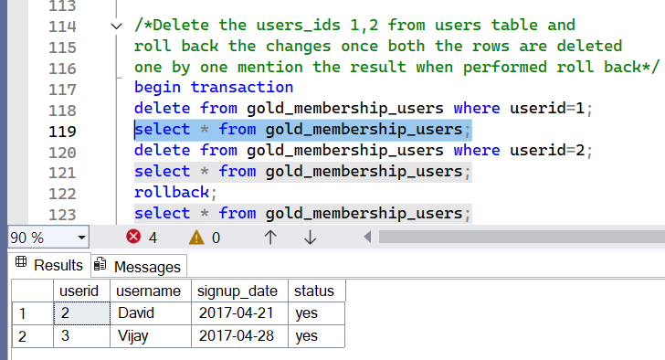

1. Inserted a duplicate record (3, 'Laptop', 330) into the product table.

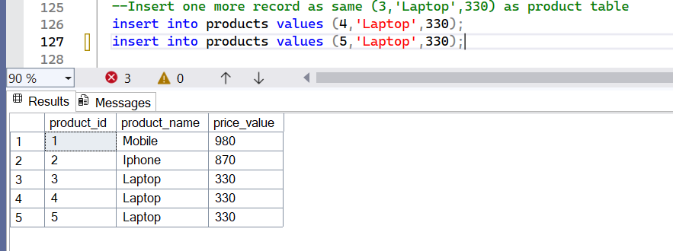

1. Wrote a query to find duplicate records in the product table.

**Assignment- 2:-**

1. Created a product_details table and inserting values into the table.

1. Found number of different products sold on each date & their names

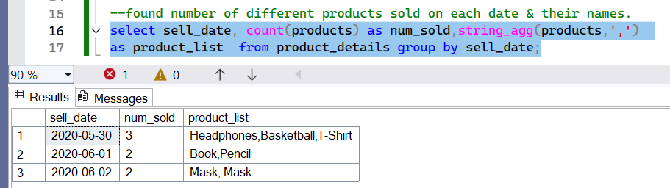

**Assignment- 3:-**

1. Created a table dept_tbl and inserting values into the table.

1. Found total salary of each department.

**Assignment- 4:-**

1. Created a email_signup table and inserted values into the table.

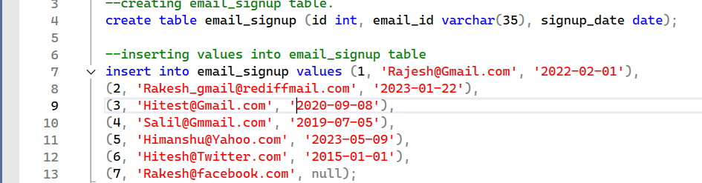

1. Found gmail accounts with latest & first signup dates & difference and inserted a value in place of null.

**Assignment- 5:-**

1. Created a sales_data table and inserted a values in it.

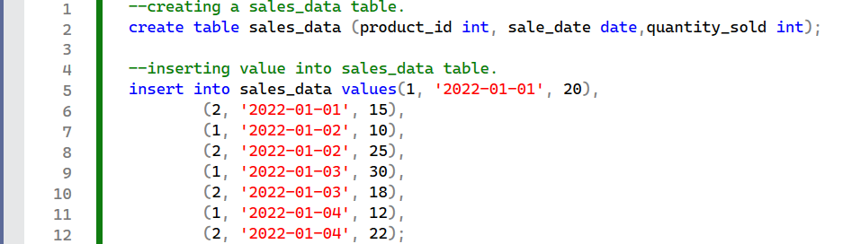

1. Solved window function queries.

* Assigned Rank by Partition for Each product_id.

* Retrieved quantity_sold from Previous Row.

* Retrieved First and Last Values for Each product_id.

