Output
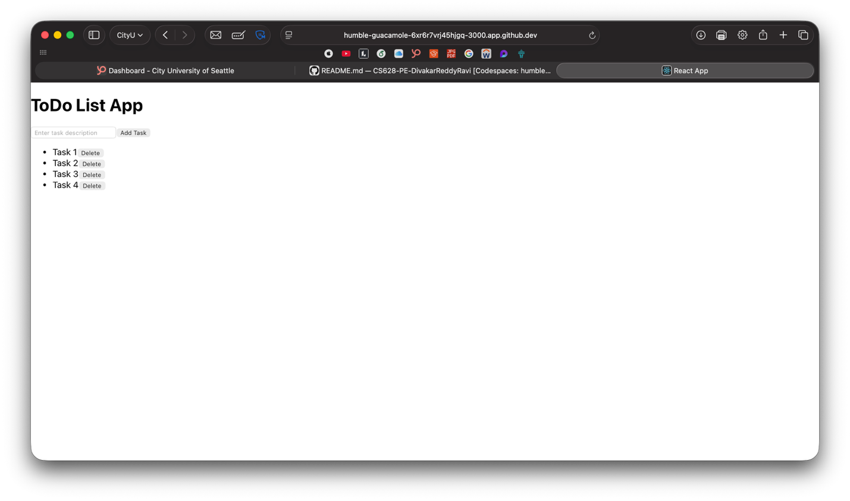

Summary
Input: Describes how users enter task descriptions via the text input field and interact with Add Task and Delete buttons
Process: Explains the React state management using useState and useReducer hooks, including ADD_TASK and DELETE_TASK actions for managing the task list
Output: Details how tasks are displayed as a list with delete buttons and how the input field clears after adding a task

GITHUB LINK:
https://github.com/divakar-reddy/CS628-PE-DivakarReddyRavi/tree/main/PE03

