OptiStock – Supply Chain & Inventory Optimization
Power BI Dashboard Documentation
Executive Summary
This project analyzes inventory performance, stock health, and demand forecasting using sales and inventory data. The dashboard identifies excess stock, shortage risks, turnover inefficiencies, and future demand projections to support strategic supply chain decisions.
• Project Goal:
To design a comprehensive Supply Chain & Inventory Optimization dashboard that monitors inventory health, detects overstock/stockout risks, and forecasts future demand trends.
• Key Insight:
Several SKUs fall into the excess inventory category (>180 Days of Supply), indicating capital blockage and slow-moving stock.
• Recommendation:
Reduce overstocked inventory levels, improve demand-based replenishment planning, and use forecast insights for procurement optimization.

Objective / Business Questions
- Identify products at risk of stockout
- Detect excess and slow-moving inventory
- Measure inventory turnover efficiency
- Analyze warehouse-level stock distribution
- Monitor inventory aging and coverage buckets
- Forecast future demand using historical sales data
- Evaluate monthly sales growth and volatility

Project Overview and Data Sourcing
This section describes the foundation of the dashboard.
• Dashboard Title:
"OptiStock – Supply Chain & Inventory Optimization Report"
• Target Audience:
Supply Chain Managers, Operations Team, Inventory Planners, Executive Leadership.
• Data Sources:
Sales Transactions
Inventory Snapshot Records
Purchase Orders
Product Master Data
Warehouse Master Data
Date Dimension Table
• Data Preparation & Cleaning:
Removed duplicate records
Standardized date formats
Created Year-Month hierarchy
Built Date table for time intelligence
Validated product and warehouse relationships
• Tools Used:
Power BI
Power Query
DAX
Power BI Forecast Analytics

Data Model Design (The Schema)
• Schema Type: Star Schema
• Fact Tables:
FactSales
FactInventorySnapshots
FactPurchaseOrders
• Dimension Tables:
DimProduct
DimDate
DimWarehouse
DimSupplier
Relationships ensure accurate filtering, aggregation, and time-based analysis.
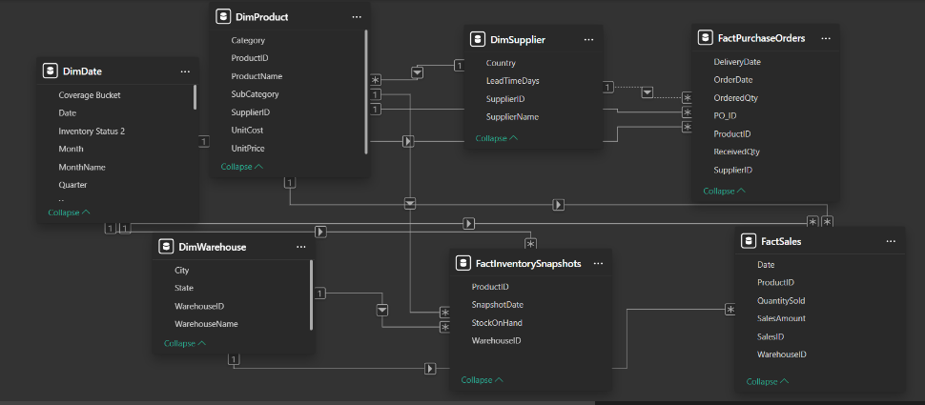

Key Performance Indicators (KPIs)
• Total Inventory Value
• Total Inventory Units
• Available Inventory Units
• Stock In Hand
• Days of Supply (Days on Hand)
• Inventory Turnover Ratio
• Average Daily Sales
• Excess Stock %
• Excess Inventory Value
• Inventory Health Score
• MoM Growth %
• Peak Sales Value
• Next Month Forecast
• Forecast Gap
• Sales Volatility
• Total Sales (2 Years)

Page 1 – Inventory Overview
KPI Cards:
Shows overall inventory performance including value, units, coverage, and turnover.
Top 10 Fast Moving Products:
Bar chart highlighting high turnover SKUs.
Top 10 Slow Moving Products:
Identifies low turnover and potential overstock items.
Stock Position vs Sales Volume:
Combo chart comparing Stock in Hand vs Sales Quantity.
Inventory Distribution by Category:
Donut chart showing stock allocation across categories.
Inventory by Warehouse:
Warehouse-level stock distribution.
Procurement Fulfillment Rate:
Ordered vs Received quantity comparison.
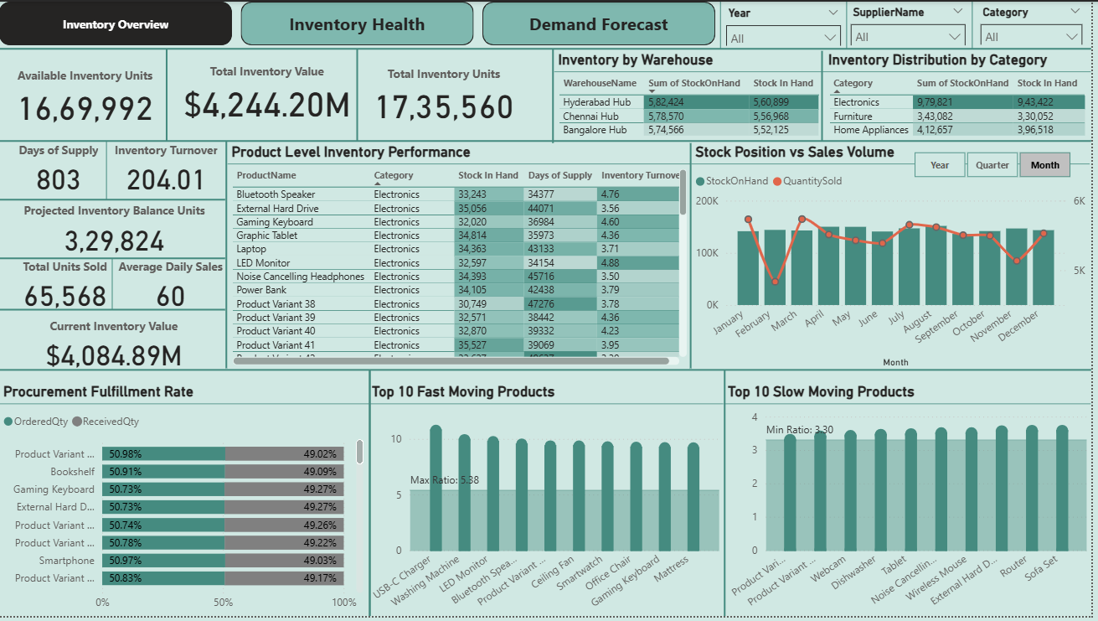

Page 2 – Inventory Health
Inventory Health Score:
Composite score indicating overall stock condition.
Excess Stock %:
Percentage of inventory exceeding optimal coverage.
Excess vs Shortage Risk Matrix (Scatter Plot):
X-Axis: Days of Supply
Y-Axis: Inventory Value
Bubble Size: Stock In Hand
Color: Inventory Status
This visual identifies high-value excess stock and low-coverage risk SKUs.
Inventory Coverage Distribution:
Distribution of products across coverage buckets:
0–30, 31–60, 61–90, 91–180, >180 Days.
Stock in Hand by Category:
Category-level inventory concentration.
Avg Days of Supply by Warehouse:
Compares warehouse health and coverage levels.
Detailed Inventory Health View:
Product-level diagnostic table including:
Stock In Hand
Days of Supply
Inventory Turnover
Inventory Value
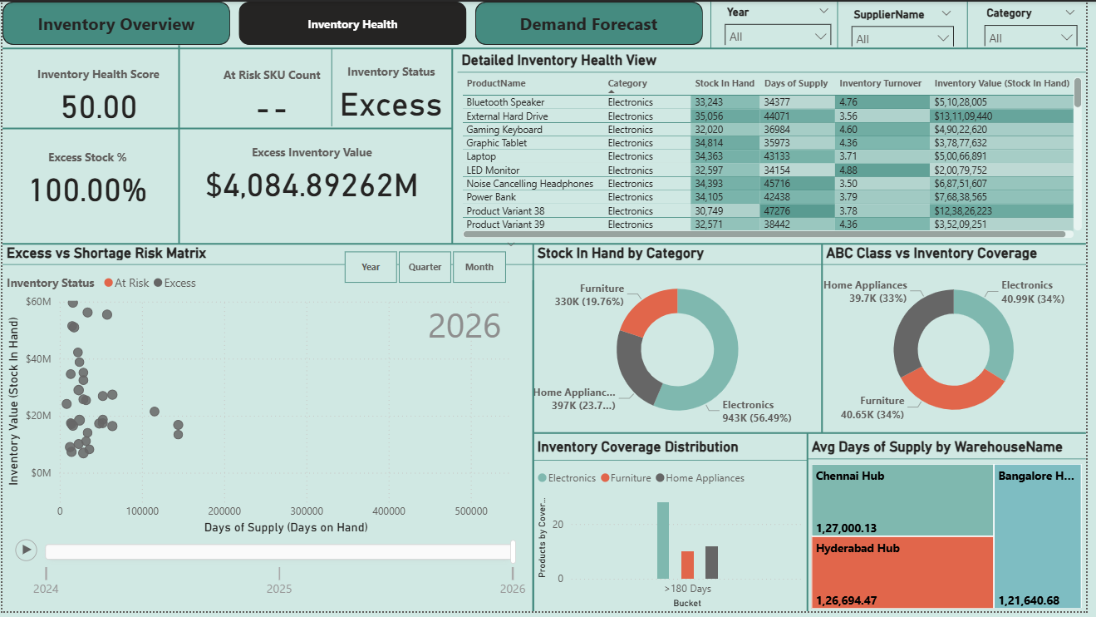

Page 3 – Demand Forecast
Monthly Sales Trend & Demand Forecast:
Line chart with Power BI Forecast feature enabled to predict future sales.
Monthly Inventory Coverage Trend & Forecast:
Tracks projected Days of Supply over time.
Monthly Inventory Turnover Trend:
Measures efficiency trend across months.
Cumulative Sales by Quarter:
Quarter-wise progressive sales growth.
Total Sales by Warehouse:
Regional sales contribution comparison.
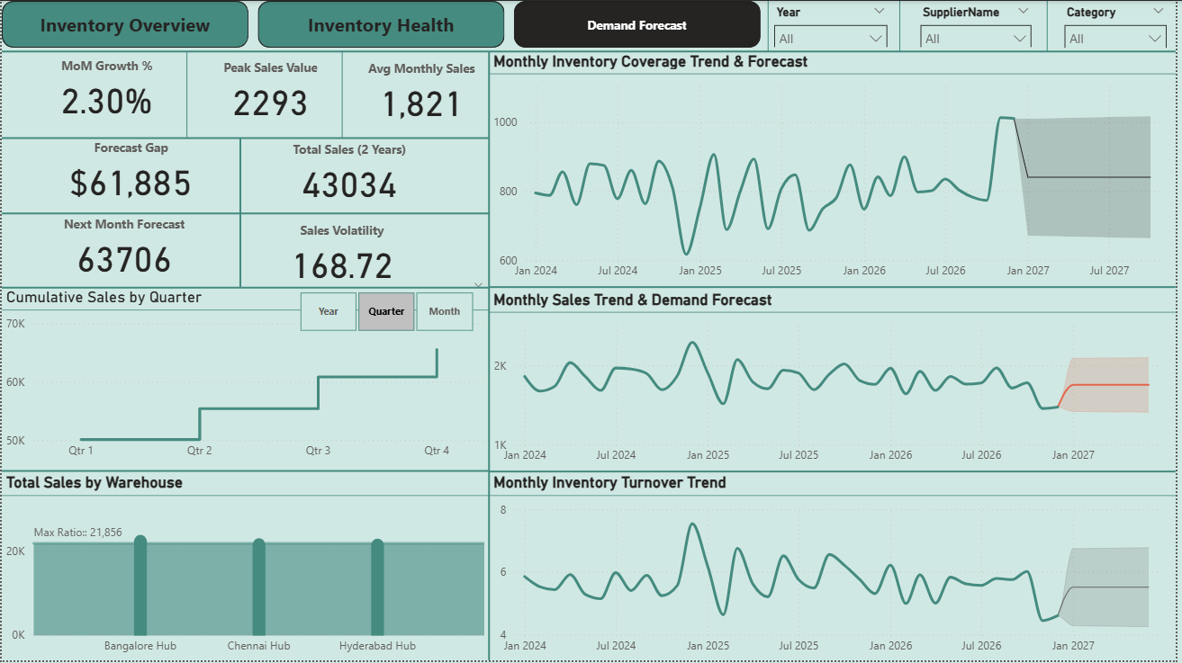

Insights & Findings
• High concentration of inventory in >180 days bucket
• Excess inventory observed in certain product categories
• Some warehouses show significantly higher average coverage
• Sales show seasonal patterns and periodic volatility
• Forecast suggests moderate demand growth next period
• Inventory turnover fluctuates during demand spikes
Business Recommendations
• Reduce excess stock through promotional clearance
• Implement demand-based replenishment planning
• Monitor Days of Supply thresholds regularly
• Optimize procurement cycles based on forecast
• Rebalance warehouse inventory levels
• Improve turnover by aligning supply with seasonal demand
Conclusion
This dashboard enables stakeholders to:
• Monitor real-time inventory performance
• Identify excess and shortage risks
• Improve capital efficiency
• Forecast demand accurately
• Make data-driven supply chain decisions
The OptiStock solution transforms operational inventory data into strategic insights for better planning and optimization.

