HR ANALYTICS DASHBOARD – PROJECT REPORT

1. Executive Summary
- This project focuses on analysing HR workforce data using Power BI.
- The dashboard provides insights into employee headcount, attrition, retention, and new hiring trends.
- It helps HR teams and management to understand workforce health and make data-driven decisions.
Project Goal:
To analyse workforce structure, identify attrition patterns, and understand hiring trends.
Key Insight:
Attrition and hiring patterns vary significantly across departments, job roles, age groups, and education levels.
2. Objectives / Business Questions
- What is the current employee headcount and workforce distribution?
- Which departments and job roles have higher attrition?
- What are the major reasons for employee attrition?
- What is the attrition trend over the years?
- Which departments, roles, and demographics contribute most to new hires?
- How has hiring changed over recent years?

3. Project Overview and Data Sourcing
- Dashboard Title: HR Workforce Overview, Attrition Insights, and New Hire Insights
- Target Audience: HR Team, HR Business Partners, Management
- Data Source: HR Employee dataset (CSV file)
- Tools Used: Power BI Desktop, Power Query, DAX
Data Preparation:
- Removed duplicate employee records
- Handled missing values
- Created calculated columns and DAX measures
- Grouped age into age bands
- Used joining year and leaving year for trend analysis
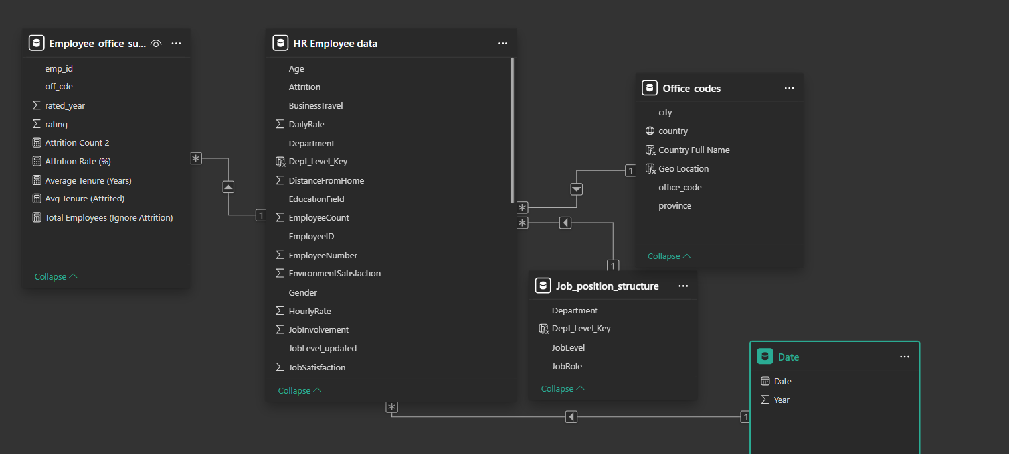
4. Data Model Design
- The project uses a simple data model based on employee-level data.
- Key dimensions include:
  - Department
  - Job Role
  - Gender
  - Age Group
  - Education
  - Joining Year
  - Leaving Year
- The model supports filtering and slicing across all visuals.
5. Key Performance Indicators (KPIs)
- Total Employees
- Active Employees
- Attrition Count
- Attrition Rate (%)
- Retention Rate (%)
- Average Tenure
- Average Monthly Income
- New Hire Count
- New Hire Rate (%)

6. Dashboard Pages Explanation
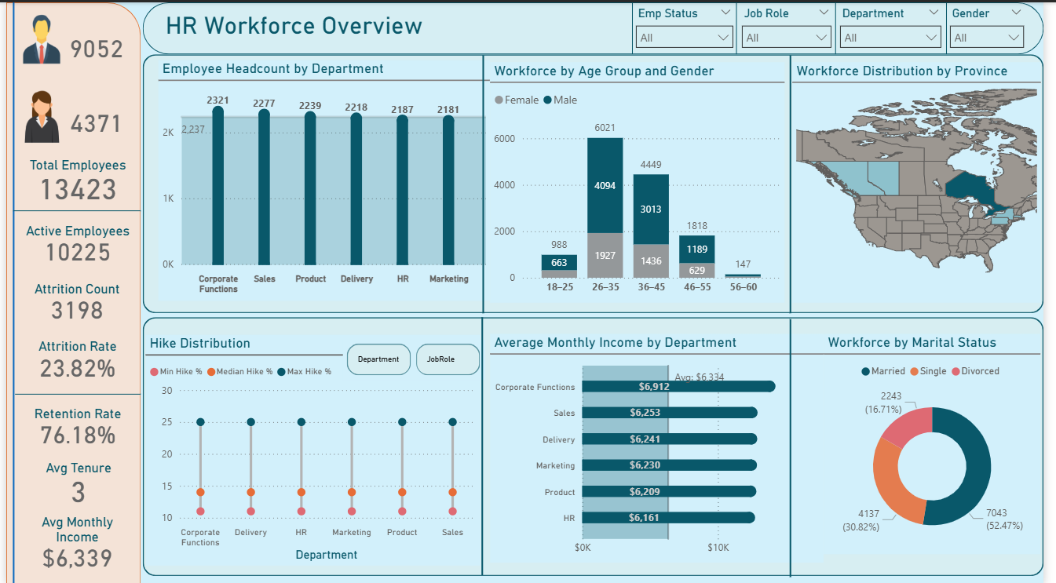

Purpose:
To provide a high-level snapshot of the organization’s workforce.
Key Visuals & Insights:
- Total employees and active employees KPI cards
- Headcount by department
- Workforce distribution by age group and gender
- Workforce distribution by location (province)
- Average monthly income by department
- Hike distribution by department and role
- Workforce distribution by marital status
Outcome:
This page helps management understand overall workforce composition and demographics.

Page 2: Employee Attrition Insights
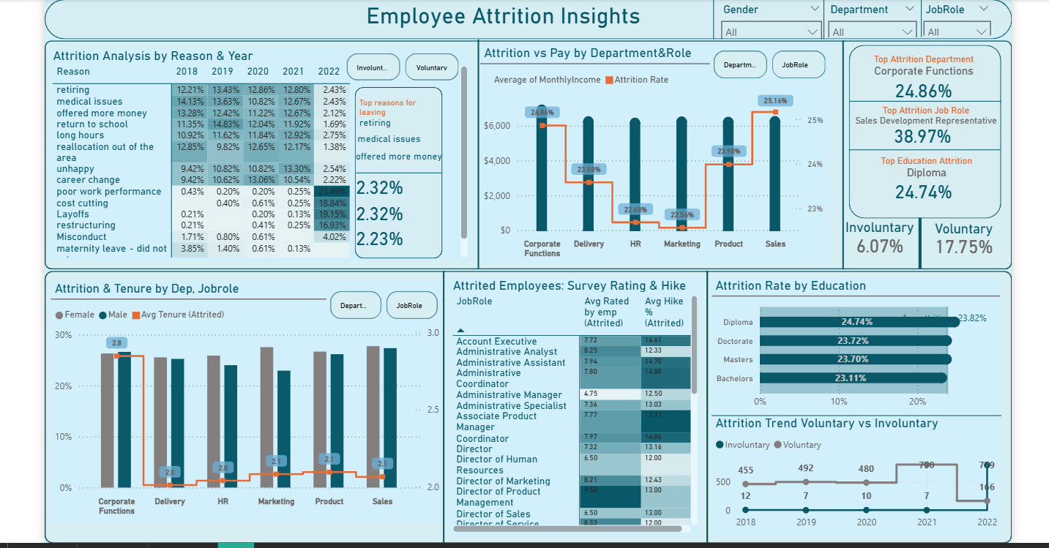

Purpose:
To analyze employee attrition patterns and identify key drivers of attrition.
Key Visuals & Insights:
- Attrition analysis by reason and year
- Attrition rate vs average monthly income by department and role
- Attrition by education level
- Attrition and tenure by department and job role
- Voluntary vs involuntary attrition trend over years
- KPI cards highlighting top attrition department, role, and education
Outcome:
This page helps HR identify high-risk areas and understand why employees are leaving.

Page 3: New Hire Insights
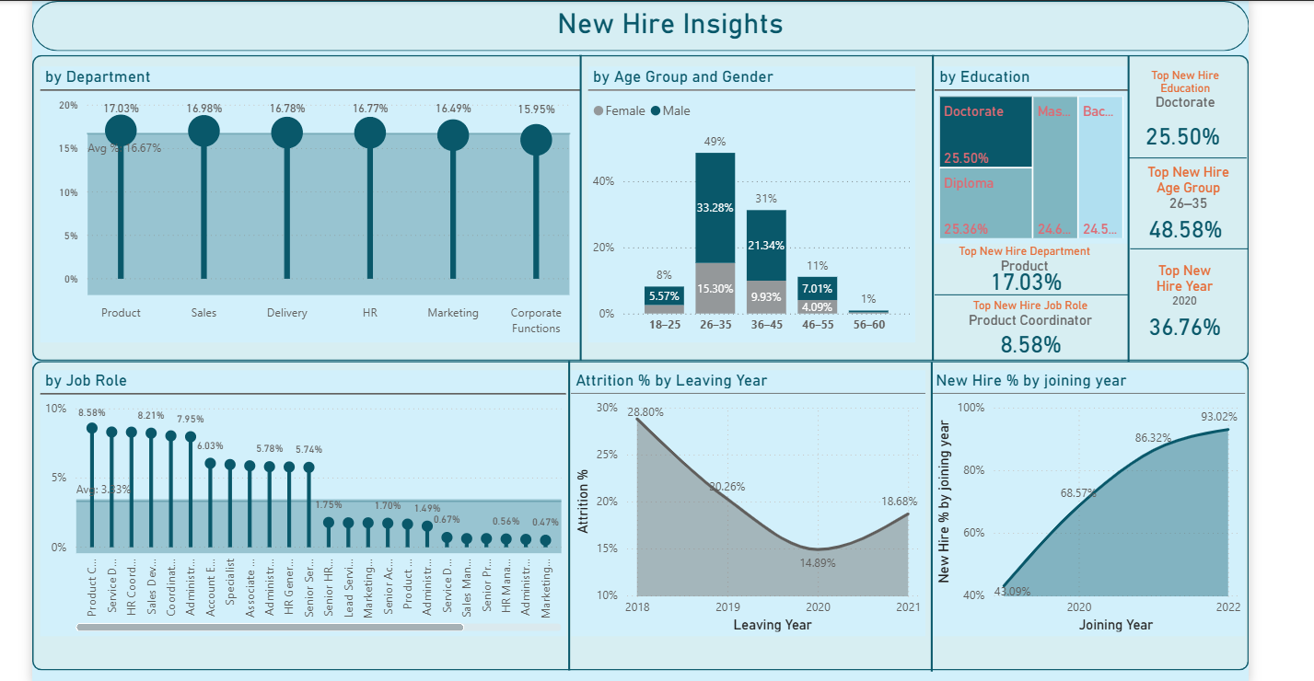

Purpose:
To analyze hiring trends and workforce intake.
Key Visuals & Insights:
- New hire percentage by department
- New hire distribution by age group and gender
- New hire distribution by education
- New hire percentage by job role
- New hire percentage trend by joining year
- KPI cards showing:
  - Top hiring department
  - Top hiring job role
  - Top hiring education
  - Top hiring age group
  - Top hiring year
Outcome:
This page helps HR understand where hiring is concentrated and how hiring trends change over time.

7. Role-Level Security (RLS)
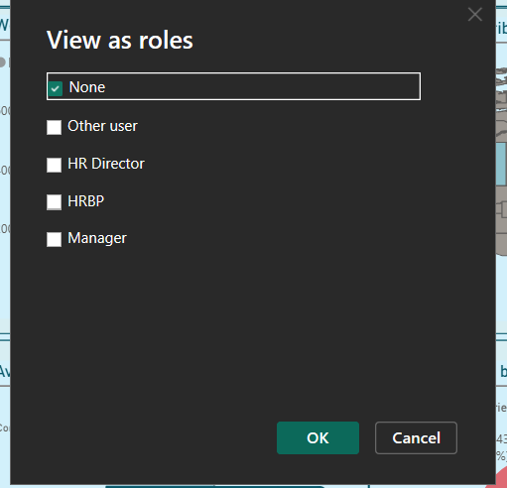
Roles Implemented (Demo Scope)Since this is an internship project and real user-role mappings were not available, logical demo roles were created:
1. HRBP (Department Level Access)
- Can view data only for their department
2. HR Director (Full Access)
- Can view all departments and employees
- No filters applied
Notes
- RLS was configured in Power BI Desktop before publishing.
- Role behavior can be tested using View as Role.
- In production, roles would be mapped to actual user email IDs.

8.Data Refresh Strategy
Refresh Type Used
- Manual Refresh
Reason
- The dataset uses local CSV files (offline data sources).
- Power BI Service cannot schedule refresh for local file paths.
Service Limitation
- Scheduled refresh is disabled because:
  - Data is not hosted on OneDrive, SharePoint, or a cloud database.
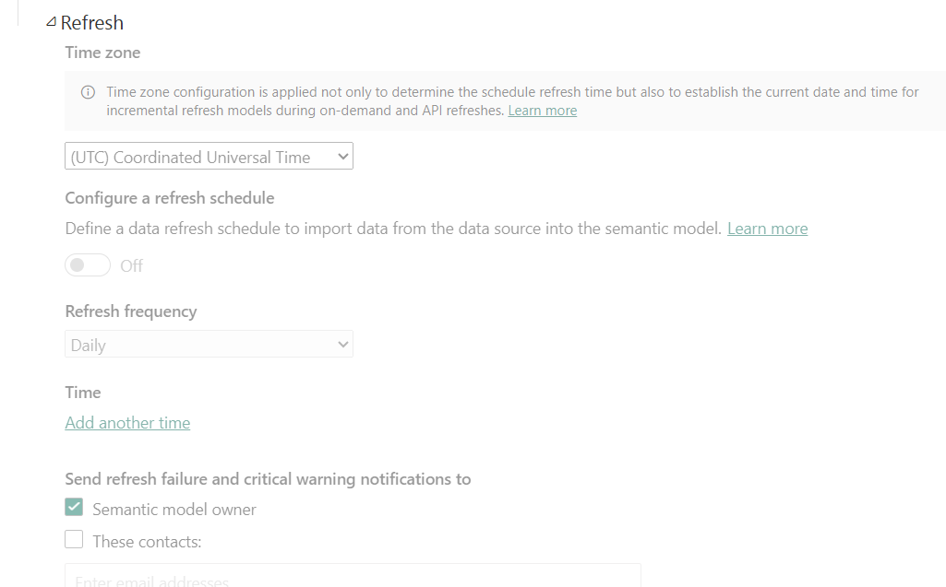

9.App Sharing & Distribution
Publishing Process
- Report created in Power BI Desktop
- Published to Power BI Service → My Workspace
- Dataset and report successfully deployed
App Creation (Conceptual)
- In a real organization, the report would be published as a Power BI App
- App would be shared with:
  - HR Team
  - HR Business Partners
  - Leadership
Access Control
- Access managed using:
  - RLS roles
  - Workspace permissions
- Ensures users see only authorized data
Internship Context
- App sharing is documented conceptually
- Actual sharing was not performed due to:
  - No corporate email IDs
  - Internship environment constraints

10. Insights & Findings
- Certain departments and job roles show consistently higher attrition.
- Voluntary attrition is higher than involuntary attrition.
- Attrition is influenced by factors such as pay, tenure, and education.
- Hiring is concentrated in specific age groups and education levels.
- Recent years show increased hiring activity compared to earlier years.
11. Business Recommendations
- Focus retention strategies on high-attrition departments and roles.
- Improve employee engagement and career growth opportunities.
- Align hiring plans with departments experiencing high attrition.
- Regularly monitor hiring and attrition trends using dashboards.
12. Conclusion
- This project demonstrates end-to-end HR analytics using Power BI.
- The dashboard provides clear insights into workforce structure, attrition drivers, and hiring trends.
- It supports HR teams in making informed and data-driven workforce decisions.

