Aim:

To develop an event tracking system. Users can login and add simple events. Events created by respective users can be managed only by themselves.

Tools and frameworks used:

- Spring boot, web, spring security, spring data
- In memory hsqldb
- bootstrap, jsp for front end

Flow of Actions:

User tries to access the system at http://localhost:8081
Prompted with login page with a provision to create new user account
Validations are provided for user creation and authentications
Once logged in, user will be in home page with provision to add new events and mange existing event.

Screens:

Login-Page

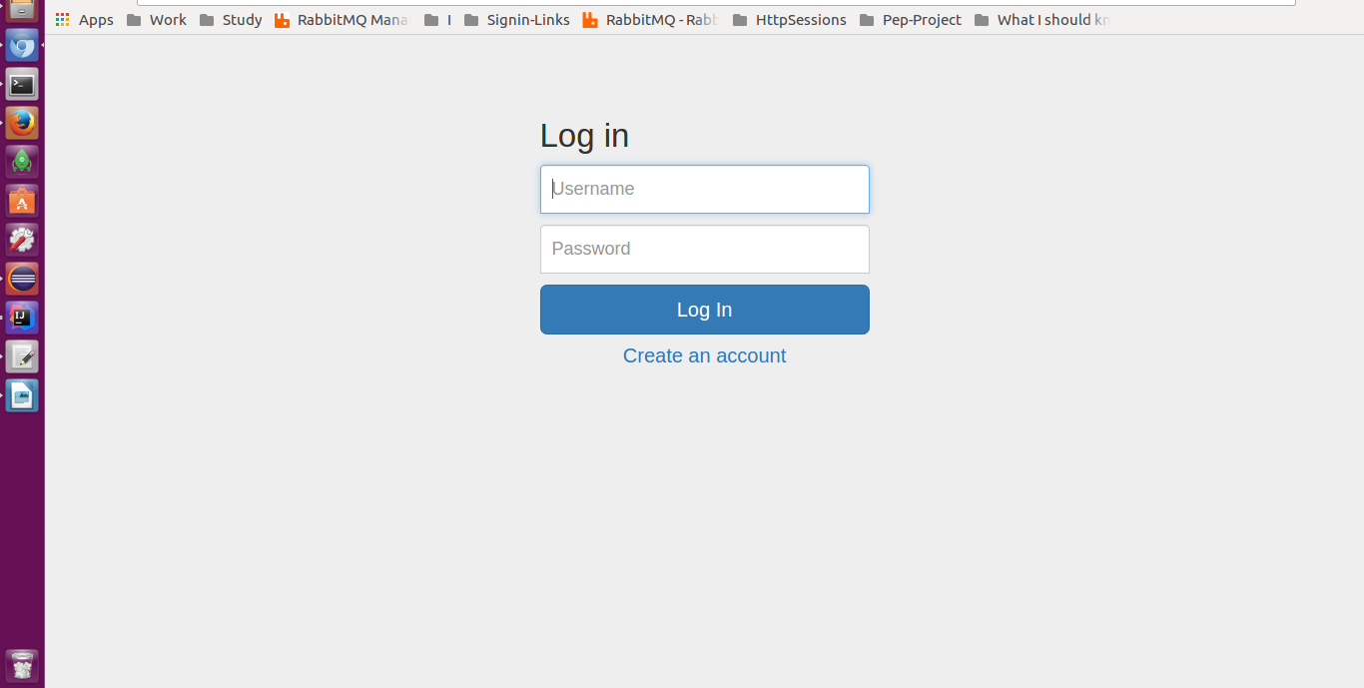

User Creation

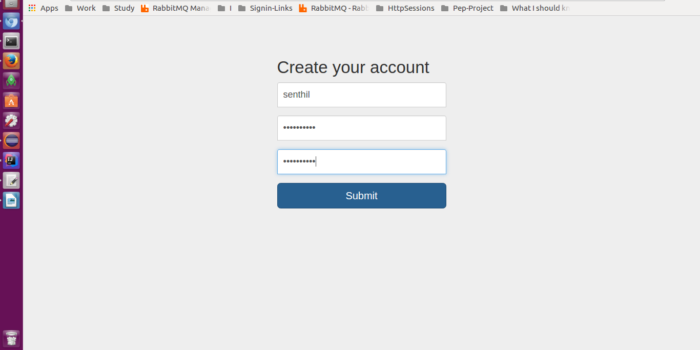

Home
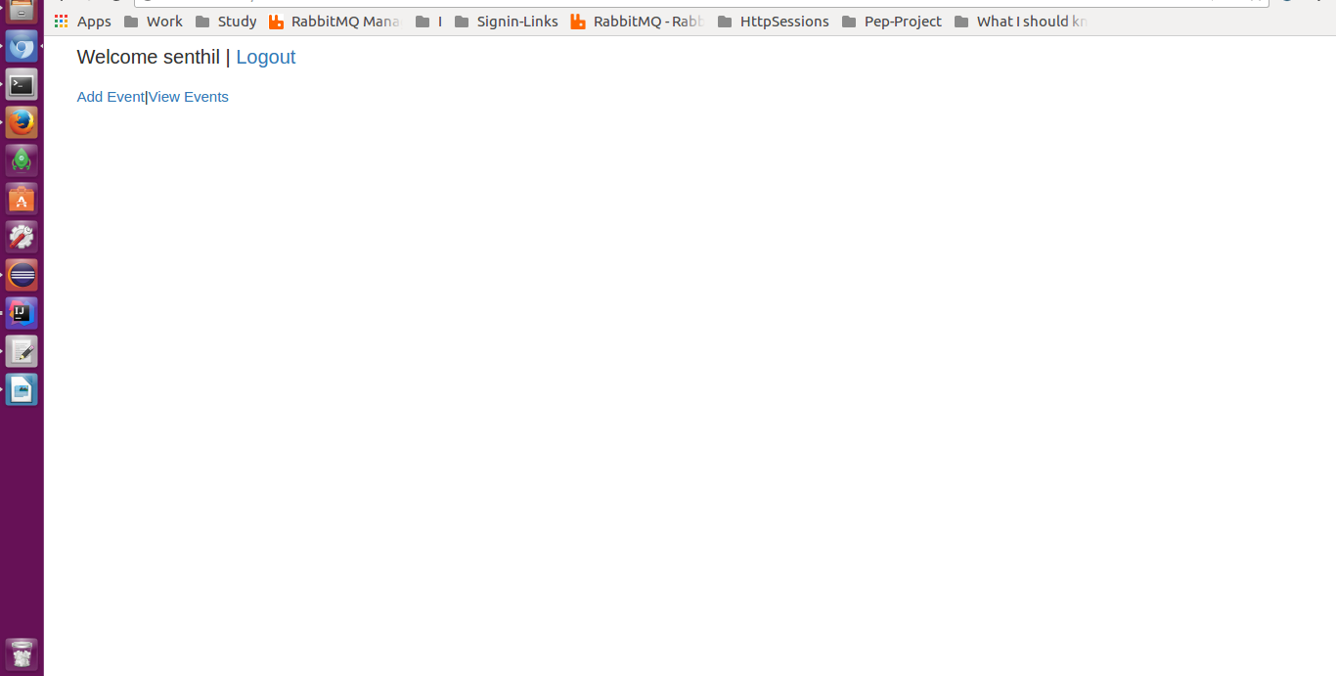

Add-Event

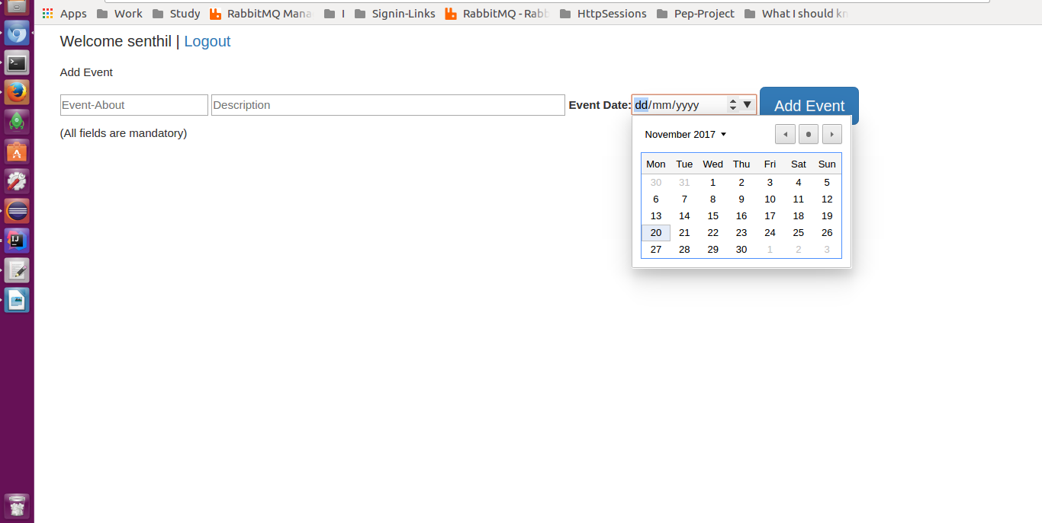

Manage Event
