**What is Clean Architecture**

Clean Architecture is a software design philosophy that aims to create systems that are both flexible and maintainable by emphasizing separation of concerns. It also helps create systems that are more resilient to change, easier to test, and simpler to understand. The goal is to build software that remains robust and adaptable over time, even as new requirements and technologies emerge.

**Here are the key principles and layers involved in Clean Architecture:**

Separation of Concerns

Dependency Rule

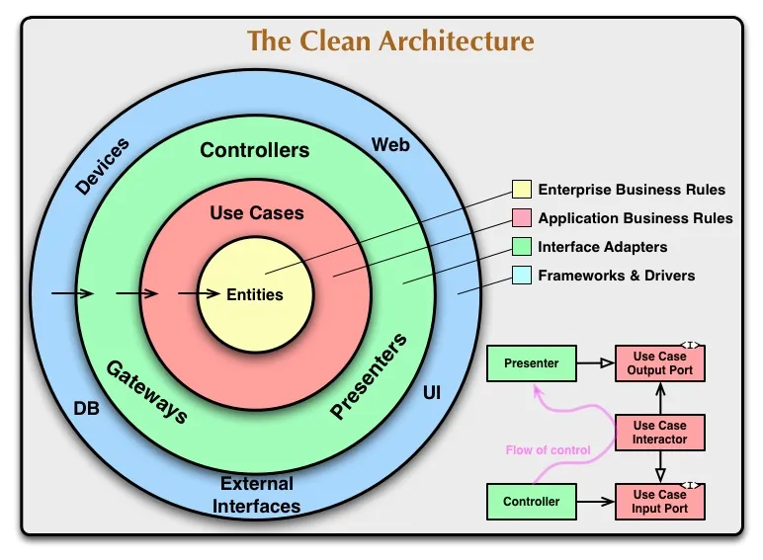

**Why**

Clean architecture ensures separation of concerns, making your batch process more modular, testable, and maintainable. It helps in managing dependencies better and facilitates easier updates or changes by isolating different layers of your application. This flexibility makes it easier to adapt your batch process to new requirements or technologies. For example, you can switch from one database to another or update the scheduling mechanism with minimal changes to your business logic. You can write unit tests for your business logic without needing to rely on the database or external services. This isolation leads to more reliable and faster tests, helping you identify issues early

Coming to Spring Batch is a powerful framework for batch processing in Java, and it is well-suited for processing large volumes of data efficiently. In the context of the dataset you provided, which contains information about insurance incidents, Spring Batch can be utilized to perform various batch processing tasks effectively. Here are some benefits of using Spring Batch with this data:

### 1. **Efficient Data Processing**

**Benefit**: Spring Batch handles large amounts of data efficiently by processing records in chunks rather than loading the entire dataset into memory.

**Example**: With the dataset provided, Spring Batch can process records in manageable chunks (e.g., 100 or 1000 records at a time). This approach helps in optimizing memory usage and ensures that the application performs well even with a large dataset.

### 2. **Automated and Reliable Batch Jobs**

**Benefit**: Spring Batch provides robust job management, including job scheduling, restartability, and retry mechanisms. It ensures that jobs run automatically and can recover from failures.

**Example**: If a job fails while processing a specific record (e.g., due to a data inconsistency or external service issue), Spring Batch can be configured to retry the job or skip the problematic record. For instance, if there’s an issue with processing records where `incidentLocation` is not in a valid format, Spring Batch can retry processing or log the error and continue with the next records.

### 3. **Customizable Processing Logic**

**Benefit**: Spring Batch allows for customization of processing logic through ItemProcessors, which can be used to transform or filter data as required.

**Example**: You can use an `ItemProcessor` to apply business rules to the data. For example, you might want to filter out records where the `policyDeductable` is above a certain threshold or transform the `autoYear` to a specific format before further processing.

### 4. **Data Validation and Transformation**

**Benefit**: With Spring Batch, you can validate and transform data during the processing stage to ensure data quality and consistency.

**Example**: You might want to validate that all `policyNumber` values conform to a specific format or transform `autoYear` from an integer to a string representation. Spring Batch allows you to implement these validations and transformations seamlessly within the batch job.

### 5. **Integration with Other Systems**

**Benefit**: Spring Batch supports integration with various data sources and sinks, including databases, file systems, and message queues.

**Example**: If you need to read data from a CSV file, process it, and then write the results to a database or another file, Spring Batch can handle these integrations. For instance, you could read incident records from a file, process them, and then store the results in a database for further analysis.

### 6. **Monitoring and Reporting**

**Benefit**: Spring Batch provides built-in support for monitoring and reporting job execution status, which helps in tracking job performance and identifying issues.

**Example**: You can use Spring Batch’s job repository to monitor the status of each batch job, including metrics like the number of records processed, skipped, or failed. This information is valuable for auditing and troubleshooting.

### Practical Application Example:

Suppose you need to analyze and process this dataset to generate various reports, such as:

- A summary report of incidents by `incidentState`.

- A detailed report on claims with `policyDeductable` over $1000.

- An analysis of the average age of drivers by `autoMake`.

Using Spring Batch, you can create a job that:

1. **Reads** the dataset from a file or database.

2. **Processes** each record to apply necessary transformations or calculations.

3. **Writes** the results to different output formats or systems (e.g., generating CSV reports, updating databases).

By leveraging Spring Batch, you ensure that the process is efficient, reliable, and scalable, accommodating the needs of handling and processing large datasets effectively.

Below are the snap shots of testing and job completing successfully.

**How**

Here’s a simplified example of how a project might be structured:

Some updates I will be making in src main will be adding entitits, usercase, interface adaptors and frameworks and drivers.

**Where**

In the provided code snippet, configuring a Spring Batch job, and Clean Architecture principles can be applied to enhance its structure. Here’s how the code aligns with Clean Architecture and suggestions for improvements:

**\*\*1. Usage of Clean Architecture Principles**

* **Separation of Concerns:**
  + **Step Configuration**: The steps method configures a step in the Spring Batch job. It separates the configuration logic for batch processing from business logic.
  + **Component Separation**: ItemReader, ItemProcessor, and ItemWriter are separated, each handling different aspects of batch processing (reading, processing, writing).

**\*\*2. Applying Clean Architecture Principles**

1. **Domain Layer:**
   * **Entities**: Ensure Product is a domain entity representing business logic and data structure. This layer should be kept free from Spring Batch dependencies and focus solely on business rules.
2. **Application Layer:**
   * **Use Cases**: Consider extracting batch processing logic into a service or use case class. For example, creating a BatchProcessingService that orchestrates the batch job execution can isolate business logic from configuration details.
   * **Example**:

java

Copy code

@Service

public class BatchProcessingService {

public Step createStep(JobRepository jobRepository, DataSourceTransactionManager transactionManager) {

return new StepBuilder("jobStep", jobRepository)

.<Product, Product>chunk(8, transactionManager)

.reader(reader())

.processor(itemProcessor())

.writer(itemWriter(dataSource()))

.build();

}

}

1. **Interface Adapters:**
   * **Configuration and Adapters**: The reader, itemProcessor, and itemWriter methods are part of the interface layer, adapting raw data and business logic for batch processing. Ensure that these beans only handle the data and logic required for interfacing with the batch framework.
2. **Frameworks and Drivers:**
   * **Spring Batch Integration**: The usage of FlatFileItemReader, JdbcBatchItemWriter, and StepBuilder is part of the framework layer. These implementations should be isolated from business logic and only handle interaction with the Spring Batch framework and external systems (like databases).

**\*\*3. Refactoring Suggestions**

1. **Encapsulate Configuration:**
   * Move batch job configuration (e.g., steps method) to a dedicated configuration class or service to keep it separate from business logic.
2. **Decouple Dependencies:**
   * Avoid direct dependency on Spring Batch-specific classes within domain or use case logic. Use abstractions where possible to adhere to Clean Architecture principles.

**Example Refactoring**

java

@Configuration

public class BatchConfig {

@Bean

public FlatFileItemReader<Product> reader() {

// Configuration for reader

}

@Bean

public ItemProcessor<Product, Product> itemProcessor() {

// Configuration for processor

}

@Bean

public ItemWriter<Product> itemWriter(DataSource dataSource) {

// Configuration for writer

}

@Bean

public Step batchStep(JobRepository jobRepository, DataSourceTransactionManager transactionManager) {

return new StepBuilder("jobStep", jobRepository)

.<Product, Product>chunk(8, transactionManager)

.reader(reader())

.processor(itemProcessor())

.writer(itemWriter(dataSource))

.build();

}

}

By separating concerns and ensuring each component adheres to Clean Architecture principles, you enhance maintainability and scalability.