**Lab-9**

**Name : Divan MunafSha Salimsha**

**Roll No : CE035**

**Subject : NIS**

**Student ID: 19CEUBG006**

**Aim: Write a program to implement Elliptical Curve Cryptography.**

* **Key Generation**
* **Encryption**
* **Decryption**

**Source Code:**

**Programming Language : C++**

**Ans:**

#include "functions.h"

#define Point pair<int, int>

struct Keys

{

    Point ep, e1, e2;

    int p;

    int d;

};

void printPoint(vector<Point> points)

{

    for (auto i : points)

        cout << "(" << i.first << " , " << i.second << ")" << endl;

}

Point addP(Point p1, Point p2, int a, int p)

{

    int x1 = p1.first, x2 = p2.first, y1 = p1.second, y2 = p2.second;

    int inverse = multiplicativeInverse(doModP(x2 - x1, p), p);

    int lamda = doModP(inverse * (y2 - y1), p) % p;

    int x3 = doModP((power(lamda, 2) - x1 - x2), p);

    int y3 = doModP(lamda * (x1 - x3) - y1, p);

    return make_pair(x3, y3);

}

Point multiplyP(int scalar, Point p1, int a, int p)

{

    if (scalar == 1)

    {

        return p1;

    }

    if (scalar == 2)

    {

        int x1 = p1.first, y1 = p1.second;

        int lamda = (((3 * power(x1, 2)) + a) * multiplicativeInverse(2 * y1, p)) % p;

        int x3 = doModP((power(lamda, 2) - 2 * x1), p);

        int y3 = doModP((lamda * (x1 - x3) - y1), p);

        return make_pair(x3, y3);

    }

    if (scalar % 2 == 1)

    {

        Point p2 = multiplyP(scalar - 1, p1, a, p);

        return addP(p1, p2, a, p);

    }

    if (scalar % 2 == 0)

    {

        Point p2 = multiplyP(scalar / 2, p1, a, p);

        return multiplyP(2, p2, a, p);

    }

    return make_pair(-1, -1);

}

vector<Point> pointGeneration(int a, int b, int p)

{

    vector<Point> points;

    for (int x = 0; x < p; ++x)

    {

        int w = (power(x, 3) + (a * x) + b) % p;

        int rem = squareAndMultiply(w, ((p - 1) / 2), p);

        if (rem == 1)

        {

            while (sqrt(w) * sqrt(w) != w)

                w += p;

            points.push_back(make_pair(x, sqrt(w)));

            points.push_back((make_pair(x, doModP(-sqrt(w), p))));

        }

        else if (rem == 0)

            points.push_back(make_pair(x, 0));

    }

    return points;

}

Keys keyGeneration(int a, int b, int p)

{

    Keys keys;

    vector<Point> points = pointGeneration(a, b, p);

    printPoint(points);

    keys.ep = make_pair(a, b);

    keys.d = 1 + (rand() % 10);

    keys.p = p;

    keys.e1 = points[1 + (rand() % points.size())];

    keys.e2 = multiplyP(keys.d, keys.e1, a, p);

    return keys;

}

void printP(Point p)

{

    cout << " (" << p.first << " , " << p.second << ")" << endl;

}

pair<Point, Point> encryption(Point M, Keys keys)

{

    int r = 1 + rand() % 3;

    Point c1 = multiplyP(r, keys.e1, keys.ep.first, keys.p);

    Point c2 = addP(M, multiplyP(r, keys.e2, keys.ep.first, keys.p), keys.ep.first, keys.p);

    return make_pair(c1, c2);

}

Point decryption(pair<Point, Point> cipher, Keys keys)

{

    Point m, c1 = cipher.first, c2 = cipher.second;

    m = multiplyP(keys.d, c1, keys.ep.first, keys.p);

    m = make_pair(m.first, -m.second);

    Point M = addP(c2, m, keys.ep.first, keys.p);

    return M;

}

int main()

{

    pair<Point, Point> cipher;

    Point decrypted, msg;

    int a, b, p, m1, m2;

    cout << "Enter a,b and p for ECC: ";

    cin >> a >> b >> p;

    cout << "Select your msg from following Points: " << endl;

    Keys keys = keyGeneration(a, b, p);

    cout << "Enter: ";

    cin >> m1 >> m2;

    msg = make_pair(m1, m2);

    cout << "--------------------------------" << endl;

    cout << "Key: " << endl;

    cout << "d: " << keys.d << endl;

    cout << "e1: ";

    printP(keys.e1);

    cout << "e2: ";

    printP(keys.e2);

    cout << "ep: ";

    printP(keys.ep);

    cout << "--------------------------------" << endl;

    cipher = encryption(msg, keys);

    cout << "C1: ";

    printP(cipher.first);

    cout << "C2: ";

    printP(cipher.second);

    cout << "--------------------------------" << endl;

    Point d = decryption(cipher, keys);

    cout << "Decrypted: ";

    printP(d);

    return 0;

}

**Input & Output Screenshots:**

**1)**

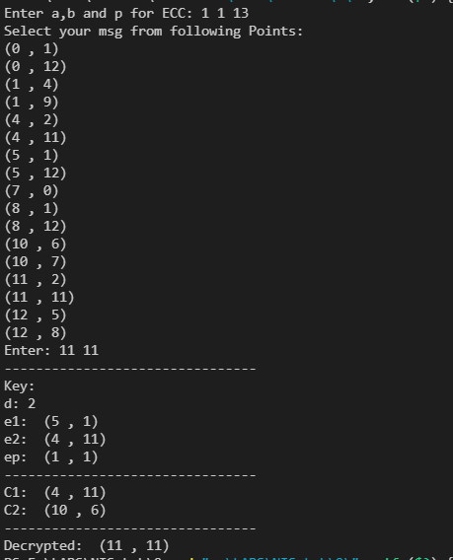

**2)**

