## DO NOT DISTURB (DND SERVICE)

A Dissertation submitted in partial fulfillment of the requirements for the award of degree of

# MASTER OF COMPUTER APPLICATIONS

By

**ROHINI**

**1NZ18MCA31**

Under the Guidance of

**PRO KAVITA**

**DEPARTMENT OF MASTER OF COMPUTER APPLICATIONS**



Ring Road, Near Marathalli,

Bangalore – 560 103

**2018-2019**

## <PROJECT TITLE>

A Dissertation submitted in partial fulfillment of the requirements for the award of degree of

# MASTER OF COMPUTER APPLICATIONS

By

**ROHINI**

**1NZ18MCA31**

Under the Guidance of

**Guide Name**

Designation

**DEPARTMENT OF MASTER OF COMPUTER APPLICATIONS**



Ring Road, Near Marathalli,

Bangalore – 560 103

**2018-2019**



Ring Road, Near Marathalli,

Bangalore – 560 103

**DEPARTMENT OF MASTER OF COMPUTER APPLICATIONS**

**CERTIFICATE**

This is to certify that **ROHINI,** bearing has successfully completed his/her fourth semester mini project work entitled **PROJECT TITLE** as a partial fulfillment of the requirements for the award of **MASTER OF COMPUTER APPLICATIONS** degree, during the Academic Year **2018-19** under my supervision. This report has not been submitted to any other Organization/University for any award of degree.

**Signature of the Guide Head of the Department Principal**

**External Viva**

Internal Examiner External Examiner

Date:

**DECLARATION**

I, **ROHINI**, student of II Semester MCA, bearing USN 1NZ18MCA31 hereby declare that the project work entitled <PROJECT TITLE> has been carried out by me under the supervision of Guide <Name of the Guide>, <Designation of Guide> submitted in partial fulfillment of the requirements for the award of the Degree of Master of Computer Applications by Department of Master of Computer Applications, New Horizon College of Engineering, an Autonomous Institution, Affiliated to Visvesvaraya Technological University during the academic year **2018-19**. This report has not been submitted to any other Organization/University for any award of degree.

Name :

Signature :

Date :

**ACKNOWLEDGEMENT**

I would like to thank Dr. Mohan Manghnani, Chairman of New Horizon College of Engineering for providing good infrastructure and Hi-Tech lab facilities to develop and improve student’s skills.

I sincerely express my gratitude to the college Principal Dr. Manjunatha for supporting the students in all their technical activities and giving guidance to them. I would like to thank Dr. V. Asha, HoD, Department of MCA, New Horizon College of Engineering for granting permission to undertake this project. I would like to express my gratitude to the project guide Prof. for giving all the instructions and guidelines at every stage of the Project work.

I thank all the staff members of the Department of Master of Computer Applications, for extending their constant support to complete the project. I express my heartfelt thanks to my parents and friends who were a constant source of support and inspiration throughout the project.

**TABLE OF CONTENTS**

|  |  |  |
| --- | --- | --- |
| **Chapter**  **No.** | **Title** | **Page No** |
|  | **ABSTRACT**  **LIST OF TABLES**  **LIST OF FIGURES** | (i)  (ii)  (iii) |
| **1**  1.1  1.2  1.3  1.4  1.5  1.6 | **INTRODUCTION**  General Introduction  Problem Statement  Existing System  Objective of the Work  Proposed System with Methodology  Feasibility Study | 1 |
| **2**  2.1 | **REVIEW OF LITERATURE**  Review Summary |  |
| **3**  3.1  3.2 | **SYSTEM CONFIGURATION**  Hardware requirements 4GB RAM, 4 Core Processor  Software requirements GCC, |  |
| **4**  4.1  4.2 | **MODULE DESCRIPTION**  DND Persistence Storage  DND In-Memory Storage  DND Loader  DND Service |  |
| **5**  5.1  5.2 | **SYSTEM DESIGN**  DFD / UML Diagrams  Data Base Design |  |
| **6**  6.1  6.1.1  6.1.2  6.2 | **SYSTEM IMPLEMENTATION**  Implementation  Pre – Implementation Technique  Post – Implementation Technique  Screen Shots |  |
| **7**  7.1  **7.2** | **SYSTEM TESTING**  Test Cases  Maintenance |  |
| **8**  8.1  8.2  8.3 | **RESULTS AND DISCUSSIONS**  Conclusion  Limitations  Future Enhancements |  |
| **9**  9.1  9.2 | **REFERENCES**  Text Reference  Web Reference |  |

**ABSTRACT**

**DND stand for Do Not Disturb.**

**DND Service is subscription model. Any user can subscribe to this service.**

**DND Service has a Database (file based) which holds**

**The subscribed User’s Mobile number.**

**Subscribed User can opt out any time from this DND Service.**

**DND Service can be used by any other Services which**

**Need to filter out the DND Subscribed User from its**

**Promotion (like SMS,call,Email notification). By using**

**This service User can block the Unwanted commercial**

**Calls / SMS….**

**LIST OF TABLES**

|  |  |  |  |
| --- | --- | --- | --- |
| **Sl. No.** | **Table No.** | **Title** | **Page No.** |
| 1 |  |  |  |
| 2 |  |  |  |
| 3 |  |  |  |
| 4 |  |  |  |

**LIST OF FIGURES**

|  |  |  |  |
| --- | --- | --- | --- |
| **Sl. No.** | **Figure No.** | **Title** | **Page No.** |
| 1 |  |  |  |
| 2 |  |  |  |
| 3 |  |  |  |

**INTRODUCTION**

General Introduction

DND Service has all the Do Not Disturb mobile number in Memory. Because of that it is very fast compare to File based search.

Problem Statement

Any operator has a millions of mobile number and at least 10% customer subscribe to the DND service. So all the mobile numbers are stored in file which is persistence storage. It is not loss any data while DND service is stopped. But searching the mobile number in file is a expensive job. So reduce the time taken to search the DND subscribed number, DND Service loads all the mobile numbers, which are present in DND file, in memory. So it becomes very fast

Existing System

Current System searches the mobile number in file, because of that it is very slow.

Objective of the Work

Make the System fast enough to the search the mobile number in DND.

Proposed System with Methodology

Load all the mobile number in Memory to make the DND service faster.

Feasibility Study

Trying with the below data structures to make DND Service fatser

* List
* Binary Search Tree
* Digital Trie

With LinkList it is much faster then the file search.

**INTRODUCTION**

DND is Do Not Disturb.It is a feauture, to block the Unwanted commercial calls.

This is DND facility is accessible from all telecom Operators. Once a mobile phone

user/Land line user register his number at DND database for blocking, he will

not get any commercial telemarking calls/SMS. This service is mainly to block

unwanted Calls/SMS from Telemarketers.

Existing System

On daily basis we are getting a lot of junk Calls, SMSs and APP/Email Notification.

As per TRAI regulation, every mobile service provider in India is required to set up a

Do Not Disturb (DND) registry. TRAI stand for Telecom Regulatory Authority of India.

If user want to block the unwanted Calls, SMS and notification, then we need a service

Which can solve this problem.

Proposed System with Methodology

As per TRAI regulation, a Service should maintain a DND Subscribed user’s. mobile

Number which will be used by the other service to filter out those mobile numbers

From promotion.

DND Service provides a Database which stores those mobile numbers and also provides

Various methods to interact with the DND Database.

DND Service usages the text file as Database to store the mobile numbers.

DND Service’ storage file contains per line as mobile number.

DND Service library provides the various method to interact with the DND storage.

DND Service stores all subscribed user’s mobile number is a test file. This test file

Contains all subscribed mobile number.

Add method will add the mobile number in text file.

Remove method will remove the mobile number from text file.

Load method loads all mobile number in-memory data structure.

IsDNDBlackList method returns the 1 if mobile number presents in-memory

DataStructure and 0 if mobile number does not present in in-memory DataStructure.

**SYSTEM CONFIGURATION**

Hardware requirements :

4GB RAM,

4 Core Processor

Software requirements :

GCC,

Bluefix Text Editor,

Bash Terminal

**MODULE DESCRIPTION**

DND Persistence Storage

This module stores the mobile number in file. DND service expose a method through which all the in-memory mobile numbers will store to file system. There is “dnd.txt” file holds those mobile numbers information.

DND In-Memory Storage

It is Linklist implementation. All the above mobile numbers will build the linklist.

DND Loader

DND service exposes a method which load the data from “dnd.txt” into Linklist.

DND Service

DND Service exposes methods like DND subscription exist or not, remove moile number from DND store.

**SYSTEM IMPLEMENTATION**

Implementation

Pre – Implementation Technique

Dnd.txt should be exist in the current directory of the software.

Dnd.txt file should have pre loaded the mobile numbers which are existing DND service subscribers.

Post – Implementation Technique

Dnd.txt should not delete. It should be persisted. So that when next time DND service will up, it loads all the last run mobile n umbers.

Screen Shots

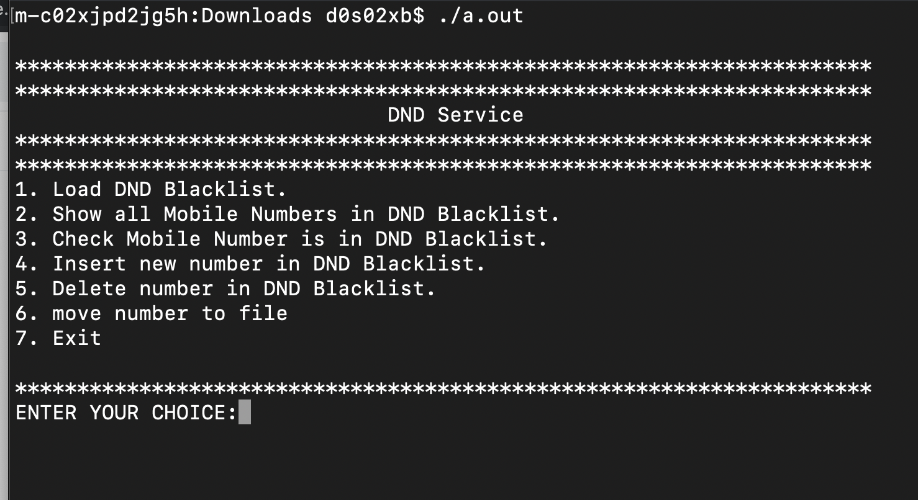

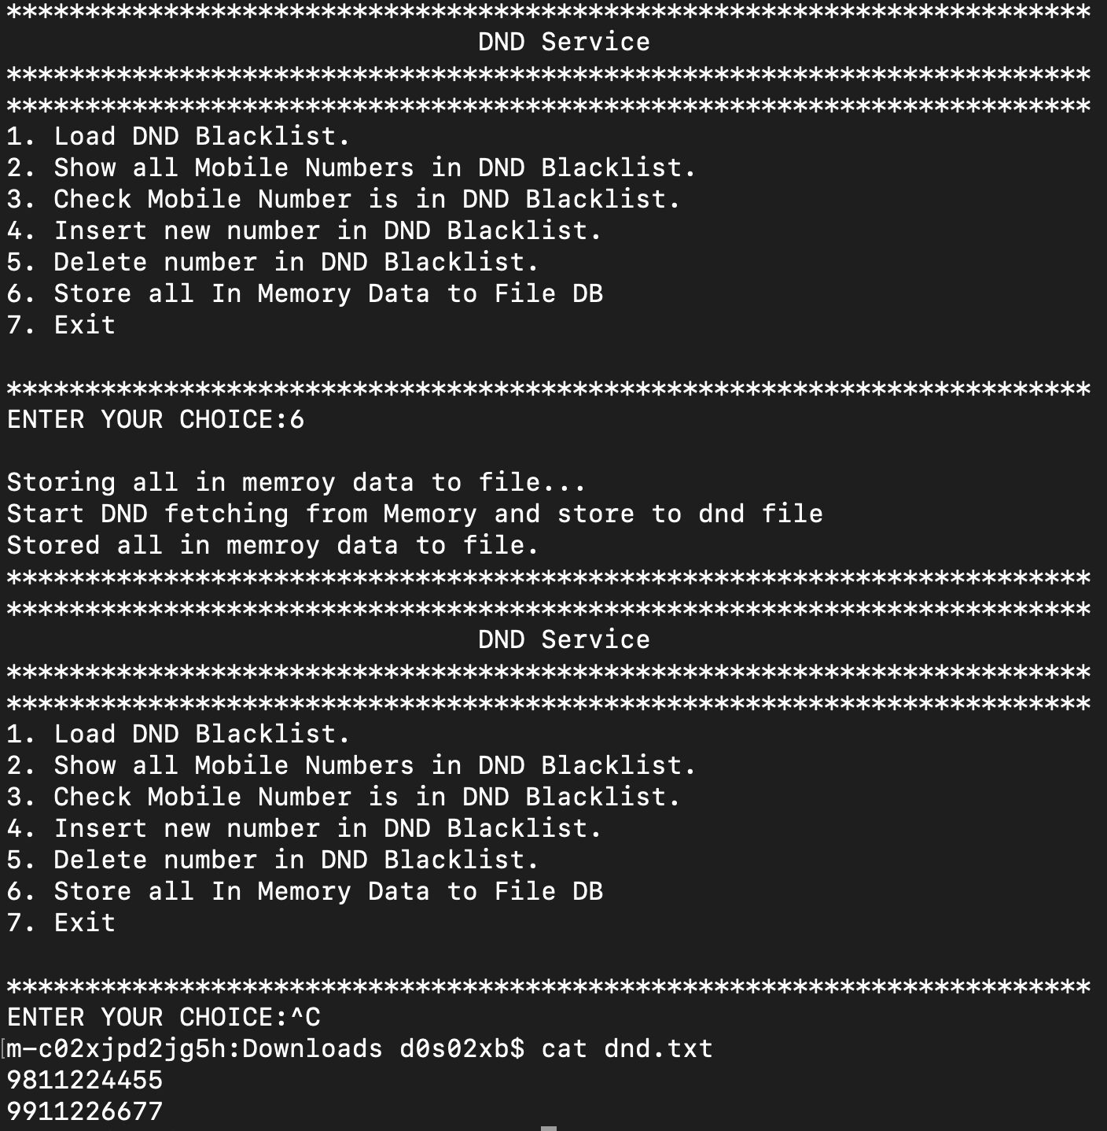

**SYSTEM DESIGN**

DFD

Data Base Design

File System : All mobile numbers are styore in dnd.txt file.