NAME: DIVANKAR SINGH
CLASS: CSE B
ROLL NO: 202401100200132
Submission Evidence
Submit the following:
- GitHub repository URL
github.com/divankarrr/github-skills-challenge
- Pull request URL used to validate the workflows
https://github.com/divankarrr/github-skills-challenge/pull/1

- Screenshot showing the GitHub Actions workflows
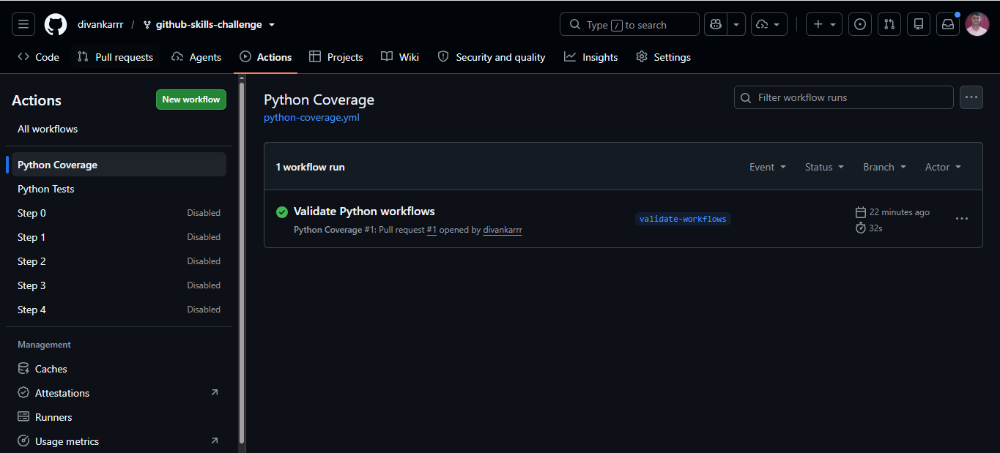
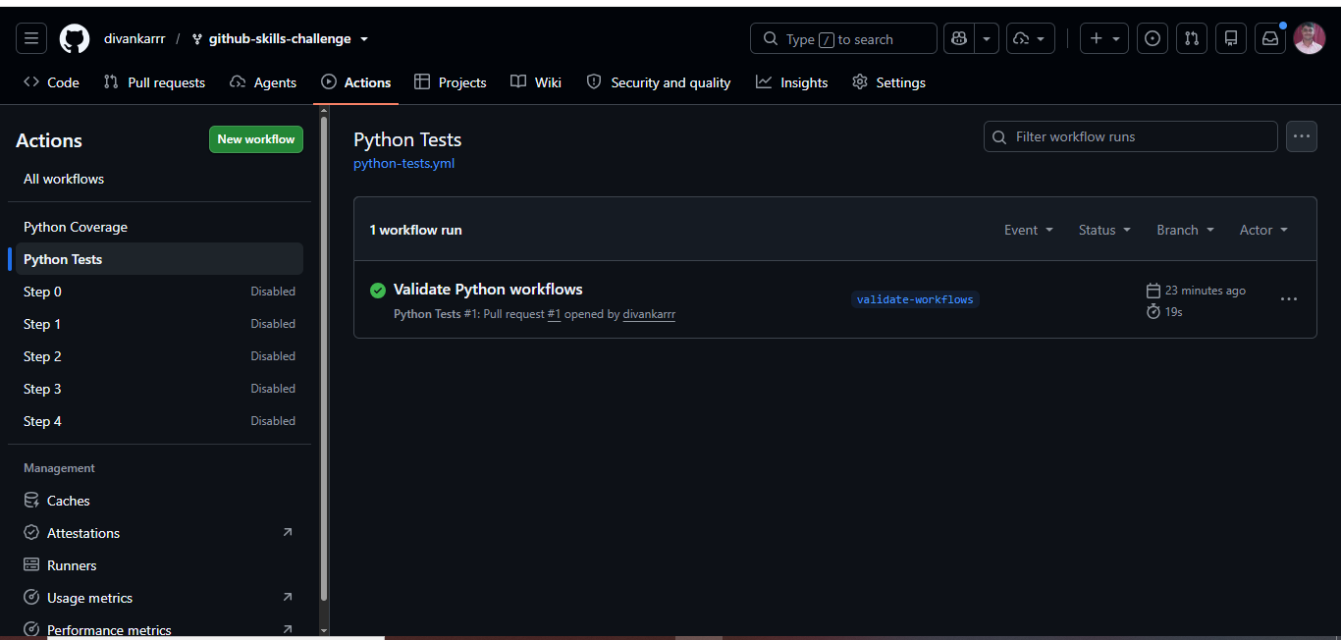

- Screenshot showing a successful test workflow execution
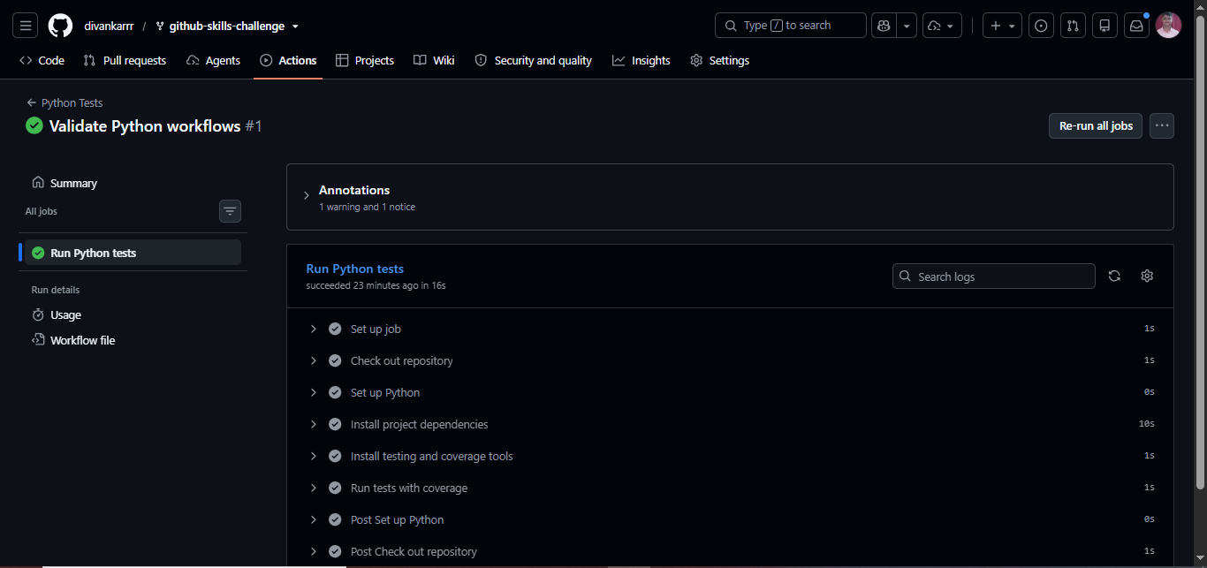

- Screenshot showing the coverage result/comment on the pull request
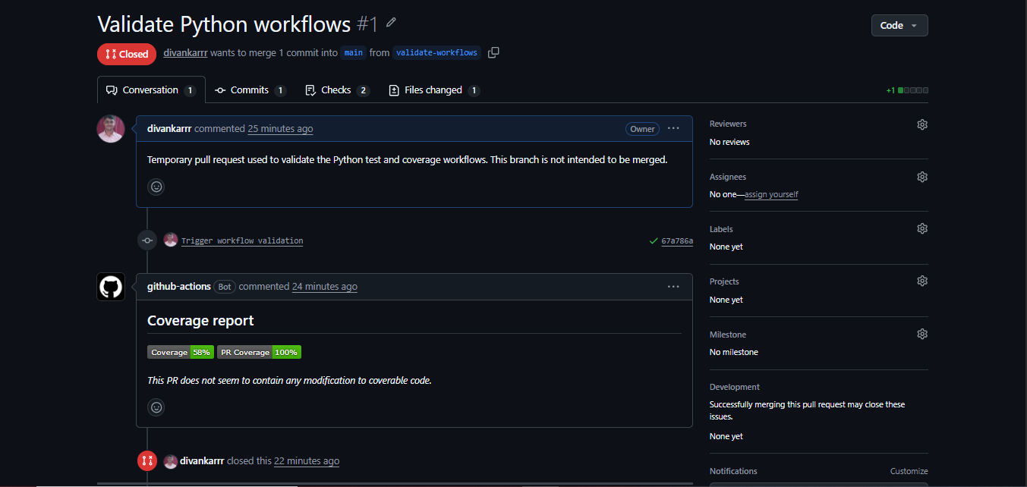
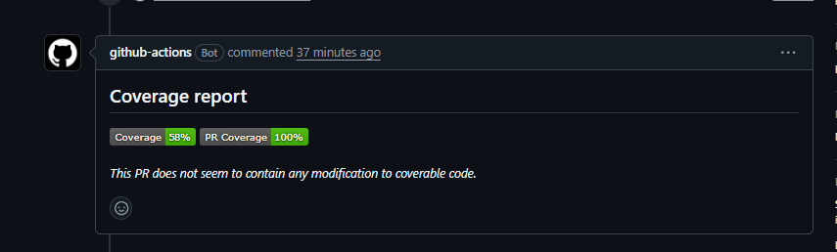

- Screenshot showing the final repository/workflow files
PYTHON-TESTS.YML
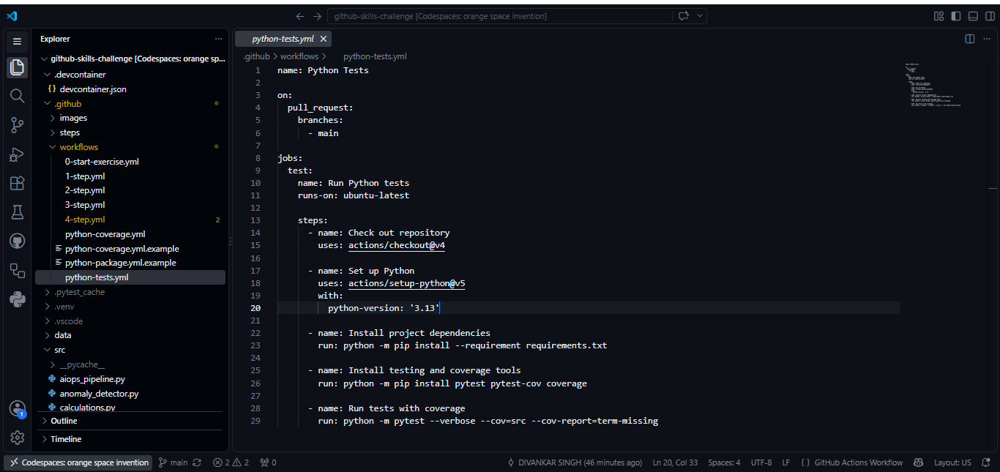

PYHTON-COVERAGE.YML
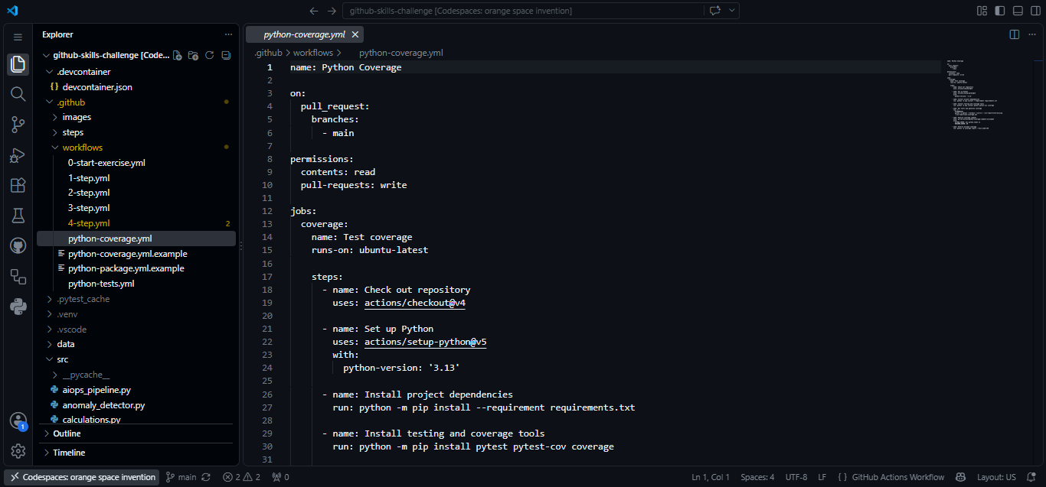
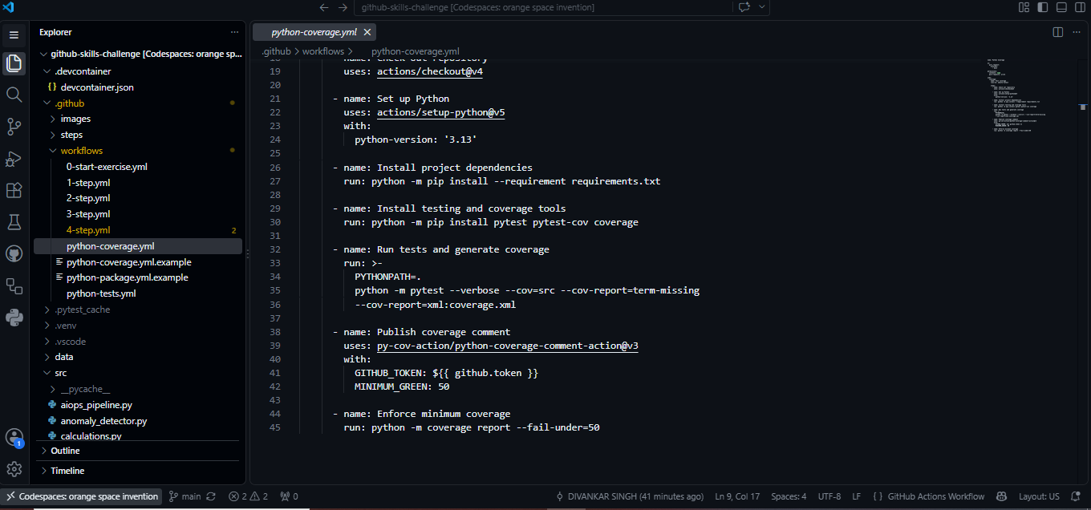
Your repository and submitted evidence must represent the final version of your implementation.

