PROBLEM STATEMENT:

The project aims to build a machine learning regression model that predicts house prices based on property features such as location, area, number of bedrooms, and amenities. The system will help users estimate property values more accurately using data-driven insights.

OBJECTIVE :

The objective of this project is to develop an automated house price prediction system that analyzes housing data and predicts property prices using machine learning algorithms.

DATASET :

https://www.kaggle.com/datasets/ruchi798/housing-prices-in-metropolitan-areas-of-india
The dataset contains several features related to residential properties that influence house prices. These include the area of the house (in square feet), number of bedrooms, number of bathrooms, and number of stories, which describe the size and structure of the property. It also includes amenities such as parking availability, guest room, basement, hot water heating, and air conditioning, along with location-related information like main road access and preferred area. Additionally, the dataset provides the furnishing status of the house (furnished, semi-furnished, or unfurnished). The price of the house is the target variable that the machine learning model aims to predict based on these features.

MACHINE LEARNING MODEL TO USE:

Linear Regression
Random Forest
XGBoost Regressor

WORKFLOW METHODOLOGY:

Data Collection
Data Preprocessing
Exploratory Data Analysis (EDA)
Feature Engineering
Train-Test Split
Model Training
Model Evaluation
Model Selection
Model Deployment

EVALUATION METRICS:

RMSE (Root Mean Squared Error) – measures prediction error
MAE (Mean Absolute Error) – average prediction difference
R² Score – explains model accuracy

TECH STACK:

Libraries:
Pandas
NumPy
Scikit-learn
XGBoost
Matplotlib
Seaborn

Deployment:
Streamlit (for web interface)

Development Environment:
Google Colab

EXPECTED OUTCOME:

The final output will be a trained machine learning model capable of predicting house prices based on property features. Users will be able to input property details through a web interface and receive a predicted house price instantly.

FINAL ARCHITECTURE:

Dataset → Data Cleaning → Feature Engineering → Model Training → Model Evaluation → Best Model → Web Interface for Prediction

RESULTS :

- EDA:
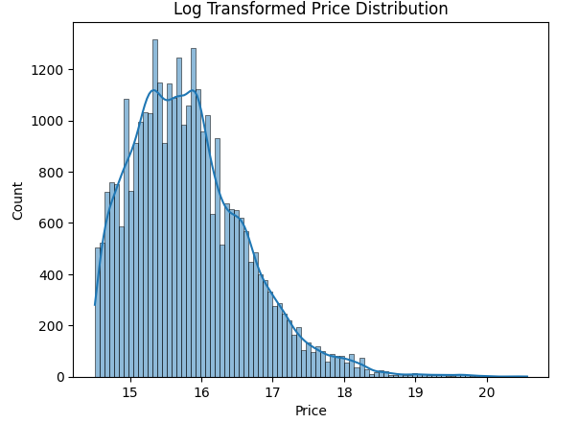

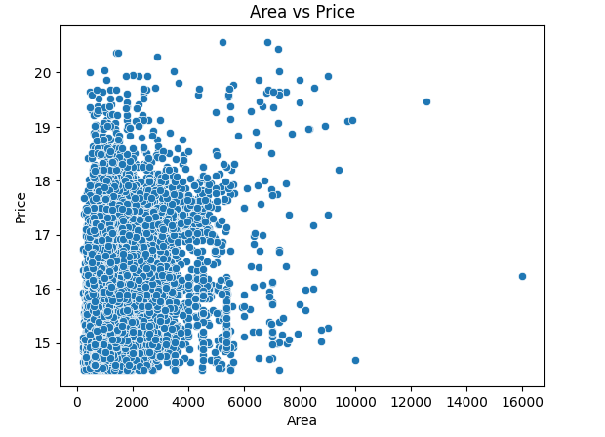
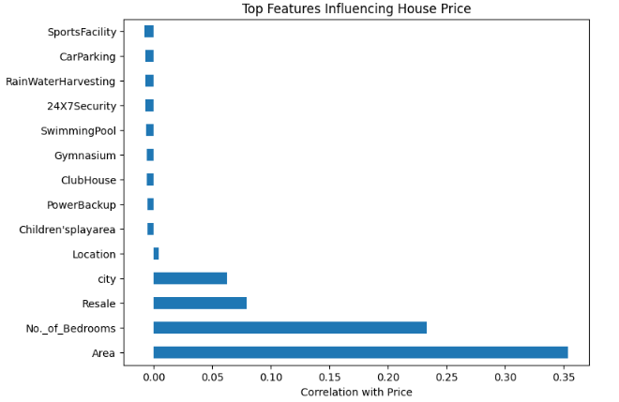

- MODEL EVALUATION :
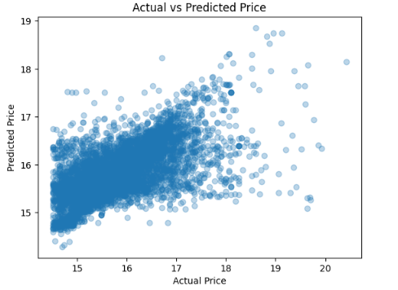
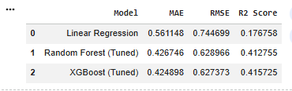

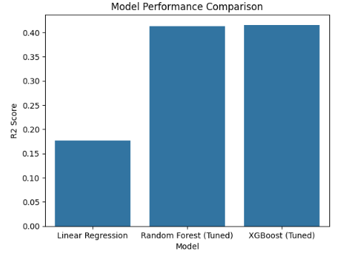
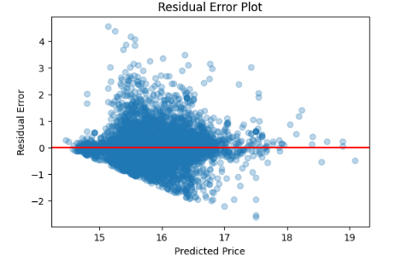

CHALLENGES:
- Data Quality Issues: The dataset required preprocessing to handle inconsistent feature formats and ensure all variables were suitable for model training.
- Skewed Price Distribution: House prices were highly skewed, requiring log transformation to stabilize variance and improve regression performance.
- Feature Alignment During Deployment: The deployed model required the same feature structure as training, which required dynamically generating the feature vector to avoid prediction errors.
- Model Selection: Multiple models were trained and compared, and selecting the best model required evaluating performance using MAE, RMSE, and R² metrics.

